Experiment 3: failure cases of the local search
Answer to referee 3, comment 3. Results of the full benchmark run of 2 November 2026.

1. The referee's comment and the design
The referee writes: “The paper provides no analysis of failure modes. On small-scale instances, 28 out of 115 same-fleet cases have worse cost than the BKS. On large-scale instances, the method requires more vehicles in several classes (U400, V100). What characterizes these failures? Is it instance size, constraint tightness (narrow time windows, binding location capacities), option density, or something else? Identifying the boundary where local search stops sufficing would be the paper's most valuable practical contribution.”
The experiment has two parts.
- 3A, feature correlation. For every benchmark instance, structural features are extracted from the instance file (scale, option density, time windows, locker capacity, vehicle capacity and the bin-packing bound, geometry) and correlated with two degradation metrics: vehicle inflation (vehicles of the local search minus vehicles of the best-known solution, BKS) and the cost gap to the BKS on the same-fleet cases.
- 3B, case study. Every fleet failure, the worst same-fleet cost gaps and one control per affected class are solved with the per-iteration trace on, and the final solution is dissected: load profile, time structure, and an absorption test of the lightest routes that shows whether the extra vehicle is a bin-packing tail that no single relocation or option flip can remove.

1.1 The run
All 240 benchmark instances (120 of Tilk et al., 120 of Dumez et al.) were solved once with the paper's budget of 15 restarts x 15,000 iterations, the integer metric for Tilk et al. and the double metric for Dumez et al., on a 32-core machine in 74 minutes of wall-clock time (38 CPU-hours). Every solve was feasible. The solver is the revised one, with the exchange move switched on (20 candidates per iteration); the per-iteration trace added for this experiment does not alter the search.
The run reproduces the result spreadsheets of the revision (new_sols_paper1.xlsx and new_sols_paper2.xlsx) exactly: the same fleet on all 240 instances and every cost within 0.0005 of the spreadsheet value. The analysis below is of these results, which are the ones the revised paper reports; the counts therefore differ from the ones the referee quotes from the submission.
The BKS values are those of the result tables (Tilk et al.: exact method, 13 instances without a reference solution; Dumez et al.: their matheuristic). The BKS costs are quoted to three decimals, so a cost within 0.002 of the BKS is counted as equal.

2. The referee's claim, re-derived
Same-fleet cases are the instances where the local search ends with the BKS number of vehicles; worse, equal and better compare the distance on those cases. Instances without a BKS are excluded.
class | instances | with BKS | same fleet | worse | equal | better | more veh. | fewer veh. | mean gap same fleet %
tilk (all) | 120 | 107 | 102 | 3 | 77 | 22 | 0 | 5 | -0.75
U_25_large | 10 | 10 | 10 | 0 | 9 | 1 | 0 | 0 | -0.19
U_25_medium | 10 | 10 | 9 | 0 | 9 | 0 | 0 | 1 | 0.00
U_25_small | 10 | 10 | 10 | 0 | 10 | 0 | 0 | 0 | 0.00
U_50_large | 10 | 5 | 5 | 0 | 1 | 4 | 0 | 0 | -2.30
U_50_medium | 10 | 9 | 8 | 0 | 1 | 7 | 0 | 1 | -5.06
U_50_small | 10 | 8 | 7 | 1 | 5 | 1 | 0 | 1 | -0.53
V_25_large | 10 | 10 | 10 | 1 | 9 | 0 | 0 | 0 | 0.01
V_25_medium | 10 | 10 | 10 | 0 | 10 | 0 | 0 | 0 | 0.00
V_25_small | 10 | 10 | 10 | 0 | 10 | 0 | 0 | 0 | 0.00
V_50_large | 10 | 7 | 6 | 0 | 2 | 4 | 0 | 1 | -1.81
V_50_medium | 10 | 8 | 8 | 1 | 5 | 2 | 0 | 0 | -0.34
V_50_small | 10 | 10 | 9 | 0 | 6 | 3 | 0 | 1 | -0.63
dumez (all) | 120 | 120 | 105 | 27 | 17 | 61 | 14 | 1 | -2.96
U_50 | 10 | 10 | 9 | 4 | 3 | 2 | 0 | 1 | 0.19
U_100 | 10 | 10 | 10 | 7 | 0 | 3 | 0 | 0 | 0.56
U_200 | 10 | 10 | 9 | 0 | 0 | 9 | 1 | 0 | -9.55
U_400 | 10 | 10 | 6 | 0 | 0 | 6 | 4 | 0 | -5.42
UBC_50 | 10 | 10 | 10 | 0 | 8 | 2 | 0 | 0 | -0.59
UBC_100 | 10 | 10 | 10 | 1 | 2 | 7 | 0 | 0 | -1.00
UBC_200 | 10 | 10 | 10 | 1 | 0 | 9 | 0 | 0 | -3.13
UBC_400 | 10 | 10 | 9 | 0 | 0 | 9 | 1 | 0 | -9.10
V_50 | 10 | 10 | 10 | 4 | 4 | 2 | 0 | 0 | -0.28
V_100 | 10 | 10 | 7 | 6 | 0 | 1 | 3 | 0 | 0.85
V_200 | 10 | 10 | 8 | 2 | 0 | 6 | 2 | 0 | -3.94
V_400 | 10 | 10 | 7 | 2 | 0 | 5 | 3 | 0 | -6.07
all | 240 | 227 | 207 | 30 | 94 | 83 | 14 | 6 | -1.87
Table 1. Per class: same-fleet cases and their cost against the BKS; fleet differences. Negative gaps mean the local search is cheaper.
On the revised results the referee's three statements read as follows.
- Same-fleet cases worse than the BKS: 27 of 105 on the Dumez et al. set and 3 of 102 on the Tilk et al. set. Across both sets 30 of 207 same-fleet cases are worse, 94 equal and 83 better.
- The worse cases are not “small-scale” in the Tilk et al. sense (25 and 50 customers, where the exact method gives the reference): there the local search matches or beats the reference on 99 of 102 cases. They sit in the 50 and 100-customer classes of Dumez et al., where the reference is a matheuristic with a set-partitioning component.
- The fleet failures are 14, all on Dumez et al. instances, in the classes U_200 (1), U_400 (4), UBC_400 (1), V_100 (3), V_200 (2) and V_400 (3). No Tilk et al. instance needs an extra vehicle, and on 6 instances the local search uses one vehicle fewer than the reference.

3. Experiment 3A: which features go with the failures

3.1 Fleet failures
Vehicle inflation on the 120 Dumez et al. instances against the features the referee names, plus the two fleet-tightness features derived from the BKS: the fill of the BKS fleet (total demand / (capacity x BKS vehicles)) and the slack of the BKS fleet over the bin-packing bound ceil(total demand / capacity).
feature | n | Pearson r | p | Spearman rho | p
fill_bks | 120 | 0.42 | <0.001 | 0.52 | <0.001
fleet_slack_bks | 120 | -0.20 | 0.030 | -0.18 | 0.043
n_customers | 120 | 0.30 | <0.001 | 0.30 | <0.001
options_per_customer | 120 | -0.19 | 0.035 | -0.19 | 0.035
tw_private_mean | 120 | -0.19 | 0.042 | -0.10 | 0.280
tw_compat_private | 120 | -0.18 | 0.045 | -0.09 | 0.324
locker_tightness | 120 | 0.15 | 0.112 | 0.15 | 0.108
Table 2. Correlation of the features with vehicle inflation (LS - BKS vehicles), Dumez et al., n = 120.
The fill of the BKS fleet is the only feature with a strong relation (Spearman 0.52, p < 1e-9). Instance size follows at a distance (0.30), the time-window features and the option density are at the noise level, and locker tightness is not significant. The same ordering holds on the pooled 227 instances.
BKS fleet slack | BKS fill | instances | fleet failures | failure rate % | cost failures | mean gap %
0 | <=0.95 | 45 | 0 | 0.0 | 10 | -1.51
0 | 0.95-0.98 | 21 | 0 | 0.0 | 5 | -1.30
0 | 0.98-0.99 | 23 | 0 | 0.0 | 7 | -4.24
0 | 0.99-0.995 | 8 | 2 | 25.0 | 2 | -9.31
0 | >0.995 | 19 | 12 | 63.2 | 3 | -11.15
1 | <=0.95 | 1 | 0 | 0.0 | 0 | 0.08
1 | 0.95-0.98 | 3 | 0 | 0.0 | 0 | -7.91
Table 3. Dumez et al. instances by the tightness of the BKS fleet: how many lose a vehicle to the local search.
Every fleet failure has the BKS fleet exactly at the bin-packing bound and a fill of at least 0.992. Among the 89 instances with fill at or below 0.99, none loses a vehicle; among the 27 with fill above 0.99, 14 do, and above 0.995 the rate is 12 of 19. The cost gap on the instances above 0.99 is also the largest in the benchmark (about -9 to -11 percent, with the extra vehicle), because the matheuristic's reference solutions on those instances are the ones most constrained by the fleet.
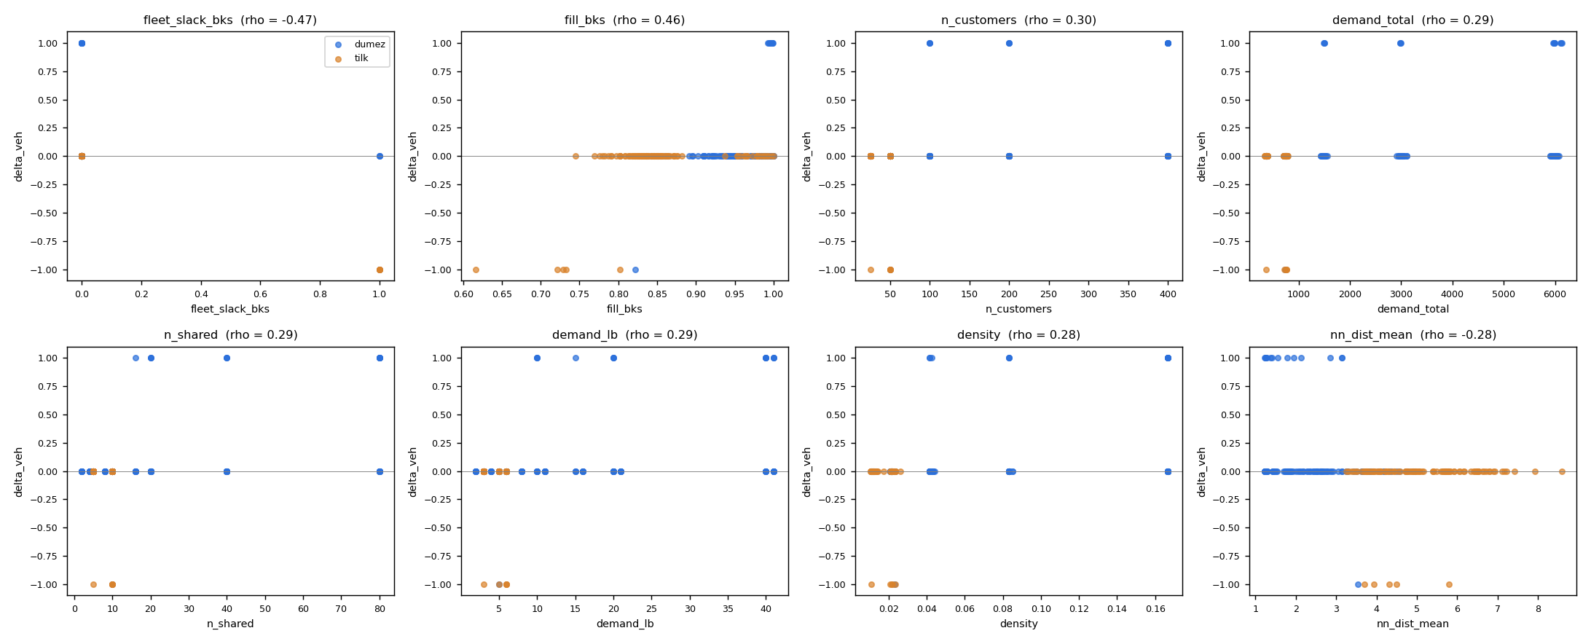
Figure 1. Vehicle inflation against the eight strongest features (pooled, Spearman rho in the titles). The fleet failures (delta = +1) lie at fleet slack 0 and fill close to 1.
instance | LS veh. | BKS veh. | bound | BKS fill | private TW (min) | TW compat. | locker tightness | cost gap %
U_200_9 | 21 | 20 | 20 | 0.997 | 240.0 | 0.74 | 0.92 | -27.2
U_400_2 | 42 | 41 | 41 | 0.992 | 242.4 | 0.74 | 0.87 | -13.0
U_400_4 | 41 | 40 | 40 | 0.997 | 236.7 | 0.74 | 0.88 | -8.0
U_400_7 | 42 | 41 | 41 | 0.996 | 240.0 | 0.74 | 0.89 | -12.6
U_400_9 | 41 | 40 | 40 | 0.997 | 246.6 | 0.75 | 0.88 | -14.2
UBC_400_3 | 16 | 15 | 15 | 0.998 | 231.3 | 0.74 | 0.81 | -23.3
V_100_2 | 11 | 10 | 10 | 0.999 | 60.0 | 0.54 | 0.89 | -9.5
V_100_3 | 11 | 10 | 10 | 0.999 | 60.0 | 0.53 | 1.07 | -11.3
V_100_9 | 11 | 10 | 10 | 0.997 | 60.0 | 0.53 | 0.92 | -3.8
V_200_2 | 21 | 20 | 20 | 0.996 | 60.0 | 0.53 | 0.98 | -15.8
V_200_8 | 21 | 20 | 20 | 0.995 | 60.0 | 0.53 | 0.97 | -18.9
V_400_3 | 41 | 40 | 40 | 0.998 | 255.8 | 0.75 | 0.87 | -12.0
V_400_4 | 41 | 40 | 40 | 0.993 | 237.6 | 0.74 | 0.86 | -7.2
V_400_7 | 42 | 41 | 41 | 0.998 | 233.7 | 0.74 | 0.84 | -15.2
Table 4. The 14 fleet failures. Bound = ceil(total demand / capacity). The V_100 and V_200 sets have 60-minute private windows; every other set about 235 minutes.
The time windows matter only in combination with the fill: the V_100 and V_200 sets, with 60-minute private windows against about 235 minutes elsewhere, hold 5 of the 14 failures, but the 400-customer failures all have wide windows. Medians of the failing and non-failing instances (Mann-Whitney test) tell the same story: the failures have a median BKS fill of 0.997 against 0.956 (p < 0.001), and are larger (400 against 100 customers, p = 0.002), denser and with more lockers, which are all size effects of the benchmark design.

3.2 Cost failures on the same fleet
feature | n | Pearson r | p | Spearman rho | p
n_customers | 105 | -0.56 | <0.001 | -0.60 | <0.001
fill_bks | 105 | -0.35 | <0.001 | -0.22 | 0.026
options_per_customer | 105 | -0.10 | 0.320 | -0.17 | 0.092
tw_private_mean | 105 | -0.12 | 0.225 | -0.20 | 0.041
tw_compat_private | 105 | -0.12 | 0.233 | -0.23 | 0.019
locker_tightness | 105 | 0.16 | 0.105 | 0.24 | 0.014
Table 5. Correlation of the features with the cost gap on the same-fleet cases, Dumez et al., n = 105.
customers | same-fleet cases | worse than BKS | share worse % | mean gap %
50 | 29 | 8 | 27.6 | -0.24
100 | 27 | 14 | 51.9 | 0.06
200 | 27 | 3 | 11.1 | -5.51
400 | 22 | 2 | 9.1 | -7.13
Table 6. Dumez et al. same-fleet cases by instance size.
The cost gap is a scale effect and nothing else. Instance size and its proxies (number of locations, options, locker slots, density, nearest-neighbour distance) correlate at -0.6 with the gap; the time-window features, the option density and the locker tightness do not reach a meaningful level (|rho| at most 0.24). The local search is worse than the matheuristic on 22 of 56 same-fleet cases with 50 or 100 customers and better on 44 of 49 cases with 200 or 400 customers, where the mean gap is -5.5 and -7.1 percent. The Tilk et al. set shows the same direction: the three worse cases (gaps of 0.1 to 1.2 percent) are 25 and 50-customer instances where the exact method proves the reference.
The matheuristic of Dumez et al. assembles routes from a pool with a set-partitioning model, which is near-optimal when the instance is small enough for the model, and the local search cannot reassemble routes. From 200 customers on the picture reverses because the route pool stops covering the instance while the local search still explores it.
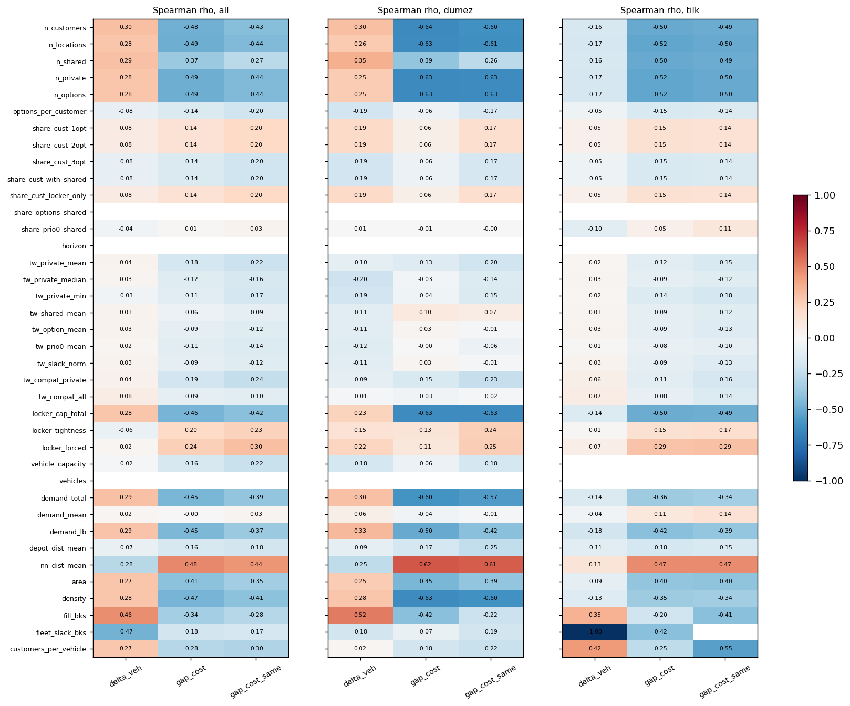
Figure 2. Spearman rho of every feature (rows) against the three degradation metrics (columns), pooled and per benchmark.

4. Experiment 3B: case studies
For every selected instance the final solution is dissected. The three lightest routes are tested: for each of their stops, whether another route has spare capacity for it, whether a feasible insertion exists keeping its delivery option (what the relocation move sees) or with any of its options (what the flip move sees), and whether a greedy one-at-a-time elimination (cheapest feasible insertion, any option, routes updated as it goes) can empty the route. The selection: all 14 fleet failures, the three worst same-fleet cost gaps per benchmark, and one control per class with a fleet failure (the instance of that class that reaches the BKS fleet with the best gap).
instance | selected as | LS veh. | BKS veh. | gap % | min fill | spare cap. | stops tested | fit by cap. | feasible slot | greedy placed | routes emptied
V_100_9 | fleet failure | 11 | 10 | -3.8 | 0.41 | 154 | 19 | 19 | 19 | 16 | 0
V_400_4 | fleet failure | 41 | 40 | -7.1 | 0.88 | 191 | 27 | 19 | 19 | 15 | 0
U_400_4 | fleet failure | 41 | 40 | -8.0 | 0.52 | 170 | 24 | 19 | 19 | 9 | 0
V_100_2 | fleet failure | 11 | 10 | -9.5 | 0.45 | 152 | 22 | 22 | 22 | 15 | 0
V_100_3 | fleet failure | 11 | 10 | -11.3 | 0.35 | 151 | 22 | 22 | 22 | 19 | 0
V_400_3 | fleet failure | 41 | 40 | -12.0 | 0.65 | 160 | 24 | 18 | 18 | 8 | 0
U_400_7 | fleet failure | 42 | 41 | -12.5 | 0.53 | 176 | 21 | 19 | 19 | 12 | 0
U_400_2 | fleet failure | 42 | 41 | -13.0 | 0.35 | 197 | 20 | 17 | 17 | 12 | 0
U_400_9 | fleet failure | 41 | 40 | -14.2 | 0.27 | 167 | 22 | 19 | 19 | 14 | 0
V_400_7 | fleet failure | 42 | 41 | -15.2 | 0.71 | 165 | 24 | 24 | 24 | 12 | 0
V_200_2 | fleet failure | 21 | 20 | -15.8 | 0.54 | 162 | 23 | 23 | 23 | 16 | 0
V_200_8 | fleet failure | 21 | 20 | -18.9 | 0.42 | 164 | 20 | 20 | 20 | 14 | 0
UBC_400_3 | fleet failure | 16 | 15 | -23.3 | 0.49 | 413 | 56 | 56 | 56 | 49 | 0
U_200_9 | fleet failure | 21 | 20 | -27.2 | 0.61 | 160 | 23 | 21 | 21 | 14 | 0
UBC_200_10 | worst cost gap (dumez) | 8 | 8 | 8.6 | 0.83 | 142 | 70 | 70 | 70 | 18 | 0
V_100_5 | worst cost gap (dumez) | 10 | 10 | 3.4 | 0.99 | 6 | 29 | 0 | 0 | 0 | 0
U_100_4 | worst cost gap (dumez) | 10 | 10 | 3.0 | 0.90 | 23 | 29 | 12 | 12 | 2 | 0
U_50small_4 | worst cost gap (tilk) | 6 | 6 | 1.2 | 0.51 | 116 | 21 | 21 | 21 | 12 | 0
V_50medium_3 | worst cost gap (tilk) | 5 | 5 | 0.7 | 0.91 | 16 | 30 | 10 | 10 | 2 | 0
V_25large_4 | worst cost gap (tilk) | 3 | 3 | 0.1 | 0.53 | 81 | 25 | 20 | 20 | 9 | 0
V_100_10 | control for V_100 | 10 | 10 | -0.9 | 0.93 | 30 | 29 | 1 | 1 | 1 | 0
V_200_4 | control for V_200 | 21 | 21 | -7.4 | 0.95 | 37 | 27 | 0 | 0 | 0 | 0
U_400_3 | control for U_400 | 41 | 41 | -13.0 | 0.77 | 151 | 25 | 23 | 23 | 11 | 0
V_400_6 | control for V_400 | 40 | 40 | -13.6 | 0.97 | 46 | 28 | 0 | 0 | 0 | 0
U_200_10 | control for U_200 | 20 | 20 | -19.4 | 0.96 | 15 | 29 | 0 | 0 | 0 | 0
UBC_400_10 | control for UBC_400 | 15 | 15 | -25.1 | 0.99 | 16 | 79 | 0 | 0 | 0 | 0
Table 7. Case studies. Min fill = load/capacity of the lightest route; spare cap. = spare capacity of the whole fleet; the last five columns count the stops of the three lightest routes.
The fleet failures share one pattern (orange rows). The lightest route carries 27 to 88 percent of a load and the fleet has 150 to 410 units of spare capacity, i.e. one to three vehicles' worth spread over the other routes. Almost every stop of the lightest routes fits elsewhere by capacity and has a feasible time-window slot, and the relocation and flip neighbourhoods see exactly those slots. Yet the greedy elimination places only 8 to 19 of 20 to 24 stops (49 of 56 on UBC_400_3) and never empties a route: after the first few placements the remaining routes are full, and the stops that are left have no slot anymore. The missing vehicle is a packing problem that needs several routes to be rebuilt at once, which is what the set-partitioning reassembly of the matheuristic does and a sequence of single moves cannot.
The controls (green rows) are at the BKS fleet with 15 to 46 units of spare capacity in total, so no route can be emptied and none of their stops has a slot; they show what a solved tight instance looks like. U_400_3 is the exception: it reaches the BKS fleet with 151 spare units and still cannot empty its lightest route, which confirms that the pattern is about reassembly, not about free capacity. The trace adds one more observation: on U_200_10, a control, only 1 of the 15 restarts reaches the BKS fleet of 20 and the other 14 end at 21, so on instances at the bound the fleet is decided by the restart that happens to pack well.
The worst cost gaps are of a different kind. V_100_5 (gap 3.4 percent) is at the bound with 6 spare units: the solution is locked and the matheuristic found a cheaper packing. U_100_4 and UBC_200_10 have slack and their routes could be rebuilt, which points at the search rather than at the instance.

4.1 U_400_4
U_400_4 is typical: 400 customers, demand 5980, capacity 150, bound 40 vehicles, BKS 40, local search 41 (fill 99.7 percent at 40 vehicles). The load profile shows 38 routes at or near the capacity and three light ones, and every restart stalls at 41 from iteration 5,500 to 9,000 on and never leaves.
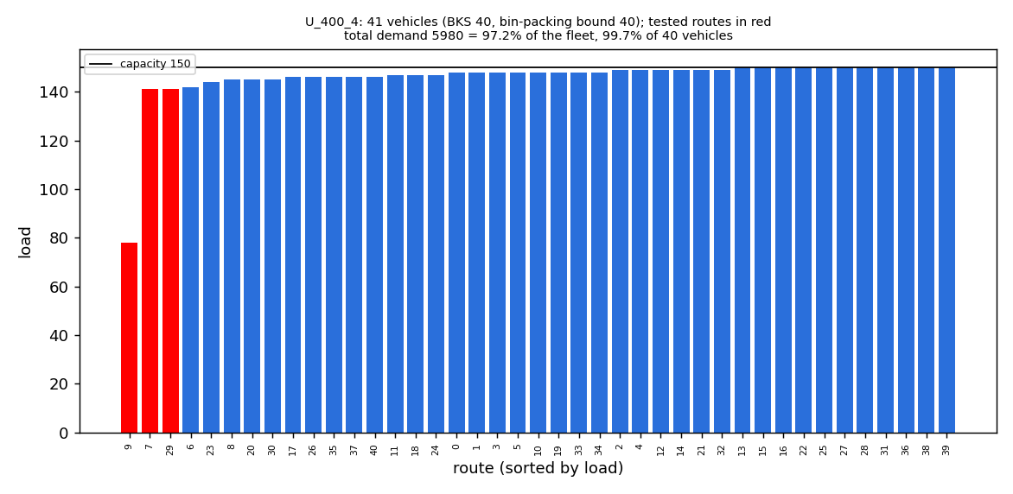
Figure 3. U_400_4: load per route, sorted; the three tested routes in red; capacity 150.
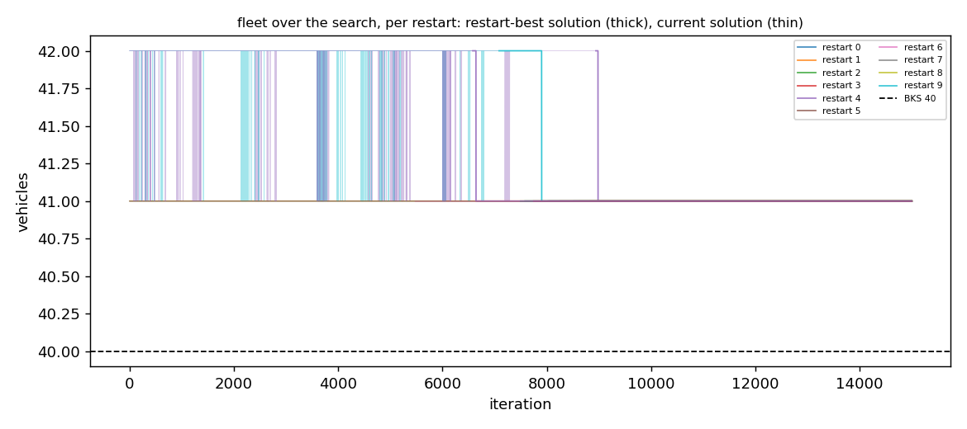
Figure 4. U_400_4: vehicles of the restart-best (thick) and current (thin) solution per iteration, 10 of the 15 restarts shown; dashed line = BKS.
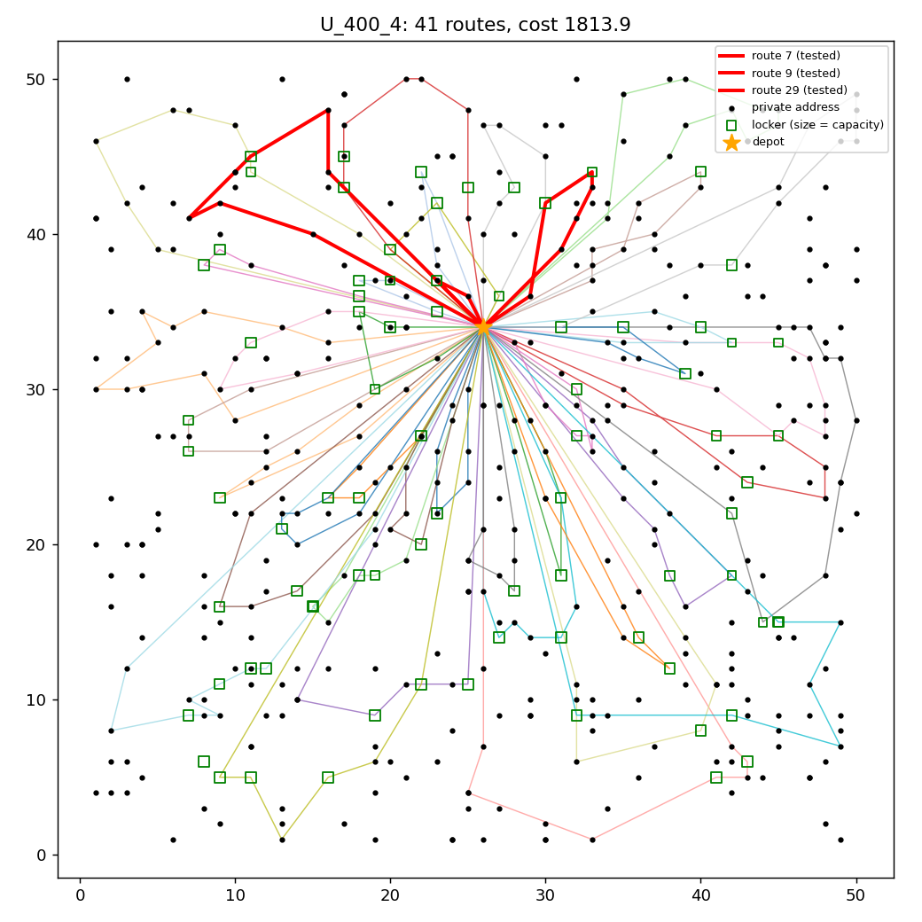
Figure 5. U_400_4: the 41 routes; lockers as squares scaled by capacity; the three tested routes thick.

5. Where the local search stops sufficing
The boundary the referee asks for has two parts, both computable from the instance data before any run.
- Fleet. Compute the bin-packing bound ceil(total demand / vehicle capacity) and the fill it implies. If the fill is at or below 0.99, the local search reaches the minimum fleet on every benchmark instance (89 of 89). If it is above 0.99, the minimum fleet is a packing problem: the local search ends one vehicle above it on about half of the instances (14 of 27), and the case studies show that this vehicle cannot be removed by single relocations or flips, only by rebuilding several routes at once. A practitioner whose fleet is that tight should expect one extra vehicle or pair the local search with a route-reassembly step.
- Distance. At a given fleet, the local search beats the matheuristic reference from about 200 customers on (44 of 49 same-fleet cases, 5 to 7 percent cheaper) and ties or beats the exact reference on the 25 and 50-customer instances of Tilk et al. (99 of 102). On the 50 and 100-customer Dumez et al. instances it is worse on 22 of 56 cases, by 0.2 to 3.4 percent at most (mean gap -0.2 and +0.1 percent). The width of the time windows, the locker capacity and the number of delivery options per customer do not change this picture.
Hence the method is appropriate when the fleet is not at the packing bound or when a vehicle more is acceptable, and its advantage grows with the instance size. Its weak spot is not constraint tightness in the routing sense but demand tightness, and the remedy would be a reassembly component rather than a different neighbourhood.

Appendix: files
Branch exp3-failure-cases, folder experiments/exp3-failure-cases/. Features: instance_features.py / .csv (one row per instance); results: paper_results.csv (BKS side) and runs.csv of the run; 3A: analyze_exp3a.py --runs, outputs in results/exp3_2026-11-02_1645_all/exp3a/ (summary.md, claim_check, correlations, groups, tightness, merged, plots); 3B: run_case_studies.py, outputs in results/exp3_2026-11-02_1645_all/case_studies/ (case_studies.md and one case.md with four plots per instance). The run itself was made with run-exp3.ps1 -All on the VM.

