Experiment 5: diminishing returns of the multi-restart scheme
Answer to the referee's comment on the restarts. Results from the full benchmark run of 2 November 2026.

1. The referee's comment and the design
The referee writes: “The multi-restart scheme invests computation without analysis of diminishing returns. The paper tunes restarts (Section 5.3.1) but does not report how solution quality evolves across restarts. Does the algorithm find 90% of its improvement in the first 3 restarts, or does it continue finding improvements late? For the 400-customer instances (which take ~3 hours), a practitioner needs to know whether halving the budget would sacrifice 2% or 20% of the solution quality.”
The question is answered by per-restart telemetry over the whole benchmark: for every instance, the incumbent (best solution so far) after each of the 15 restarts, the cost gap of that incumbent to the final solution, the fleet of that incumbent, and the restart index r* at which the final fleet and the final solution were first found. The deliverables are the convergence curves (gap against restart index), a trade-off table at 1, 3, 5, 10 and 15 restarts, and per-class tables of the cumulative share of instances whose final solution is already in hand after r restarts.
The restarts of the algorithm are independent: restart r builds its starting solution with a random generator seeded with r and runs the same number of local search iterations, and the incumbent is the best over the restarts completed so far (fewer vehicles first, then distance). The incumbent after the first r restarts of a 15-restart run is therefore exactly the solution a run with the budget set to r restarts returns. The experiment thus needs no additional solves: it reads the per-restart results out of the full run of the benchmark and rebuilds the incumbent after each restart with the solver's own rule.
Because the order of the restarts is arbitrary (the seeds), the tables also give the expectation of each quantity over all possible orders of the 15 restarts, computed exactly from the order statistics of the restart results. The expected values are the smoother estimate of what a budget of r restarts yields; the actual-order values are what this particular run would have returned.
The budget is expressed as a share of the full run (r/15), since every restart costs the same number of iterations and the wall-clock times of the paper no longer apply to the revised algorithm.

1.1 The run
The data are those of the full benchmark run of 2 November 2026 (experiment 3): all 240 instances (120 of Tilk et al., 120 of Dumez et al.), revised solver with the exchange move, 15 restarts x 15,000 iterations, integer metric for Tilk et al. and double metric for Dumez et al. The per-iteration trace of that run records the best solution of the restart after each iteration, so the result of every restart is the last row of the restart in the trace. For future runs the solver now has a setting (logRestarts) that writes a one-line-per-restart log with the measured restart times, which makes the trace unnecessary for this experiment.
The rebuilt incumbent after 15 restarts equals the result of the run (same fleet, same cost) on all 240 instances, which checks that the reconstruction applies the solver's rule exactly.
Definitions. Cost gap (%) of the incumbent after r restarts: (incumbent cost - final cost) / final cost, reported only when the incumbent already has the final fleet, since a distance comparison across different fleets is meaningless; the fleet is reported separately as the share of instances at the final fleet. 'Final solution found': the incumbent equals the final solution (same fleet, cost within 0.001). A restart can end without any solution meeting the two service-level constraints (this happened in 56 of the 3,600 restarts, 1.6%, all on 50- and 100-customer instances); until the first restart that meets them an instance has no incumbent.

2. Where the final result comes from
The fleet is settled early and the distance keeps improving, by small amounts, until the end. On the Dumez et al. instances the final fleet is already reached by the first restart on 104 of 120 instances (87%), by the fifth on 114, and by the ninth on all; no restart after the ninth ever removed a vehicle. The final solution itself is found by the first restart on 22 instances (18%), by the third on 29%, by the fifth on 43% and by the tenth on 70%; the median restart that produced it is 7. On average 4.4 of the 15 restarts improve the incumbent.
The Tilk et al. instances converge almost at once: 63% are at their final solution after one restart and 90% after ten; the final fleet is reached by the first restart on 97% of them and by the sixth on all.
instances | n | final fleet by R1 | by R5 | last R with fleet gain | final solution by R1 | by R3 | by R5 | by R10 | median r* | mean r* | improving restarts
Dumez et al., all | 120 | 87% | 95% | 9 | 18% | 29% | 43% | 70% | 7 | 7.1 | 4.4
Tilk et al., all | 120 | 97% | 99% | 6 | 63% | 75% | 78% | 90% | 1 | 3.3 | 1.6
Dumez et al., 50 | 30 | 90% | 93% | 9 | 40% | 50% | 67% | 83% | 3.5 | 5.0 | 7.0
Dumez et al., 100 | 30 | 93% | 97% | 8 | 23% | 33% | 40% | 70% | 7 | 6.9 | 3.8
Dumez et al., 200 | 30 | 80% | 93% | 9 | 7% | 17% | 40% | 70% | 6.5 | 7.7 | 3.4
Dumez et al., 400 | 30 | 83% | 97% | 9 | 3% | 17% | 27% | 57% | 10 | 8.8 | 3.5
Tilk et al., 25 | 60 | 100% | 100% | 1 | 93% | 95% | 97% | 98% | 1 | 1.4 | 1.1
Tilk et al., 50 | 60 | 93% | 98% | 6 | 33% | 55% | 60% | 82% | 2 | 5.1 | 2.2
Table 1. Restart at which the final fleet and the final solution were first reached (r*), cumulative share of instances, and the mean number of restarts that improved the incumbent.
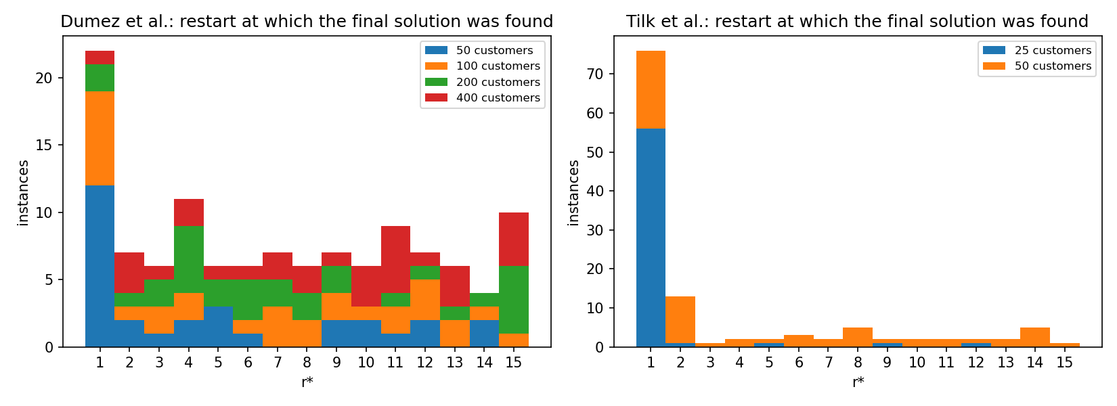
Figure 1. Histogram of r*, the restart that produced the final solution, by instance size.

3. Trade-off: quality after r restarts
Tables 2 and 3 give, per benchmark and per size, the quality of the incumbent after 1, 3, 5, 10 and 15 restarts: the share of instances at the final fleet, the mean, median and maximum cost gap to the final solution among them, the share of instances whose final solution is already found, and the expected gap over all orders of the restarts.
r | budget share | at final fleet | mean gap % | median gap % | max gap % | final found | expected gap % | expected found
1 | 7% | 86.7% | 1.80 | 1.33 | 15.66 | 18.3% | 1.66 | 15.2%
3 | 20% | 91.7% | 0.94 | 0.51 | 13.25 | 29.2% | 0.72 | 29.9%
5 | 33% | 95.0% | 0.54 | 0.13 | 3.67 | 43.3% | 0.45 | 42.6%
10 | 67% | 100.0% | 0.23 | 0.00 | 4.28 | 70.0% | 0.17 | 72.1%
15 | 100% | 100.0% | 0.00 | 0.00 | 0.00 | 100.0% | 0.00 | 100.0%
Table 2. Dumez et al., all 120 instances: quality of the incumbent after r restarts (gaps among the instances at the final fleet).
r | budget share | at final fleet | mean gap % | median gap % | max gap % | final found | expected gap % | expected found
1 | 7% | 96.7% | 0.54 | 0.00 | 5.61 | 63.3% | 0.60 | 60.1%
3 | 20% | 98.3% | 0.24 | 0.00 | 6.91 | 75.0% | 0.25 | 72.3%
5 | 33% | 99.2% | 0.15 | 0.00 | 2.96 | 78.3% | 0.14 | 79.3%
10 | 67% | 100.0% | 0.05 | 0.00 | 1.07 | 90.0% | 0.03 | 91.1%
15 | 100% | 100.0% | 0.00 | 0.00 | 0.00 | 100.0% | 0.00 | 100.0%
Table 3. Tilk et al., all 120 instances.
On Dumez et al. the first restart alone is 1.8% above the final distance on average (median 1.33%, worst 15.7% on UBC_200_2); three restarts bring the mean to 0.94%, five to 0.54% and ten to 0.23%. The first three restarts therefore capture about half of the distance improvement that the 15 restarts bring and the first five about 70%; the last five restarts are worth 0.23 percentage points. On Tilk et al. the whole effect is within 0.5% from the first restart.
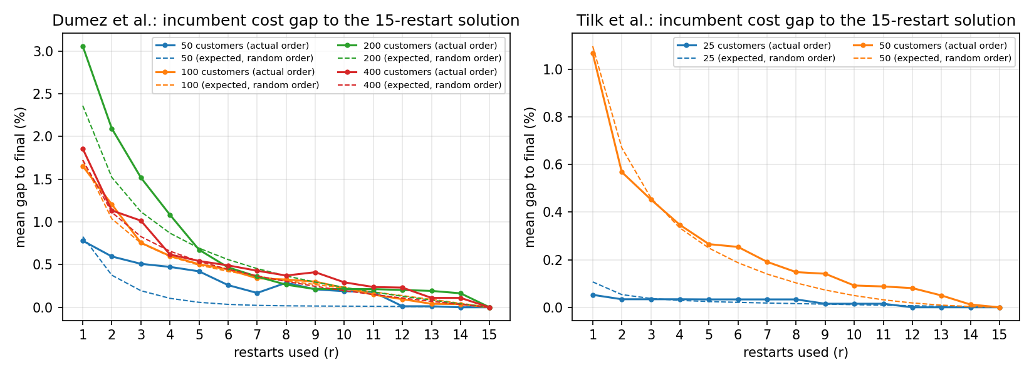
Figure 2. Mean cost gap of the incumbent to the 15-restart solution against the number of restarts, by instance size. Solid: the order the restarts ran in; dashed: expectation over all orders of the restarts.
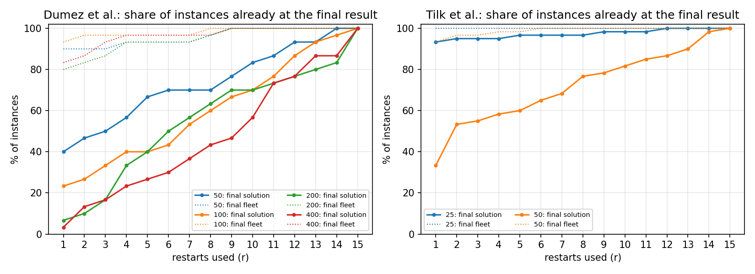
Figure 3. Share of instances whose incumbent already is the final solution (solid) or already has the final fleet (dotted), against the number of restarts.

size | r | at final fleet | mean gap % | median gap % | max gap % | final found | expected gap %
Dumez 50 | 1 | 90.0% | 0.78 | 0.12 | 3.82 | 40.0% | 0.83
 | 3 | 90.0% | 0.51 | 0.00 | 3.26 | 50.0% | 0.19
 | 5 | 93.3% | 0.42 | 0.00 | 3.67 | 66.7% | 0.06
 | 10 | 100.0% | 0.19 | 0.00 | 4.28 | 83.3% | 0.01
 | 15 | 100.0% | 0.00 | 0.00 | 0.00 | 100.0% | 0.00
Dumez 100 | 1 | 93.3% | 1.65 | 1.11 | 4.66 | 23.3% | 1.72
 | 3 | 96.7% | 0.76 | 0.34 | 3.85 | 33.3% | 0.75
 | 5 | 96.7% | 0.50 | 0.24 | 3.25 | 40.0% | 0.49
 | 10 | 100.0% | 0.23 | 0.00 | 1.76 | 70.0% | 0.22
 | 15 | 100.0% | 0.00 | 0.00 | 0.00 | 100.0% | 0.00
Dumez 200 | 1 | 80.0% | 3.06 | 2.58 | 15.66 | 6.7% | 2.36
 | 3 | 86.7% | 1.52 | 0.95 | 13.25 | 16.7% | 1.12
 | 5 | 93.3% | 0.67 | 0.09 | 2.52 | 40.0% | 0.69
 | 10 | 100.0% | 0.21 | 0.00 | 2.52 | 70.0% | 0.23
 | 15 | 100.0% | 0.00 | 0.00 | 0.00 | 100.0% | 0.00
Dumez 400 | 1 | 83.3% | 1.86 | 1.57 | 5.66 | 3.3% | 1.72
 | 3 | 93.3% | 1.01 | 0.89 | 3.93 | 16.7% | 0.83
 | 5 | 96.7% | 0.54 | 0.35 | 1.92 | 26.7% | 0.54
 | 10 | 100.0% | 0.29 | 0.00 | 1.75 | 56.7% | 0.20
 | 15 | 100.0% | 0.00 | 0.00 | 0.00 | 100.0% | 0.00
Tilk 25 | 1 | 100.0% | 0.05 | 0.00 | 1.09 | 93.3% | 0.11
 | 3 | 100.0% | 0.03 | 0.00 | 1.09 | 95.0% | 0.04
 | 5 | 100.0% | 0.03 | 0.00 | 1.09 | 96.7% | 0.02
 | 10 | 100.0% | 0.01 | 0.00 | 0.90 | 98.3% | 0.01
 | 15 | 100.0% | 0.00 | 0.00 | 0.00 | 100.0% | 0.00
Tilk 50 | 1 | 93.3% | 1.07 | 0.38 | 5.61 | 33.3% | 1.10
 | 3 | 96.7% | 0.45 | 0.00 | 6.91 | 55.0% | 0.46
 | 5 | 98.3% | 0.27 | 0.00 | 2.96 | 60.0% | 0.25
 | 10 | 100.0% | 0.09 | 0.00 | 1.07 | 81.7% | 0.05
 | 15 | 100.0% | 0.00 | 0.00 | 0.00 | 100.0% | 0.00
Table 4. The trade-off by instance size (30 instances per Dumez et al. size, 60 per Tilk et al. size).
The pattern is the same at every size: the fleet is at its final value on 80 to 100% of the instances after one restart and on all of them after ten; the distance gap of the first restart grows with the size, from under 1% at 50 customers to 2 to 3% at 200 and 400 customers, and is below 0.6% after five restarts and below 0.3% after ten at every size.

4. Per class: cumulative share of instances at their final result
Table 5 is the cumulative share (%) of the instances of each class whose final solution is already found after r restarts; Table 6 the same for the final fleet; Table 7 the mean cost gap (%) of the incumbent after r restarts (instances at the final fleet). Tilk et al. classes: U/V = the two instance families, small/medium/large = 60/120/240-minute time windows.
class | n | R1 | R2 | R3 | R4 | R5 | R6 | R7 | R8 | R9 | R10 | R11 | R12 | R13 | R14 | R15
U_25small | 10 | 100 | 100 | 100 | 100 | 100 | 100 | 100 | 100 | 100 | 100 | 100 | 100 | 100 | 100 | 100
U_25medium | 10 | 80 | 90 | 90 | 90 | 90 | 90 | 90 | 90 | 100 | 100 | 100 | 100 | 100 | 100 | 100
U_25large | 10 | 100 | 100 | 100 | 100 | 100 | 100 | 100 | 100 | 100 | 100 | 100 | 100 | 100 | 100 | 100
U_50 | 10 | 20 | 20 | 30 | 40 | 60 | 60 | 60 | 60 | 60 | 80 | 90 | 100 | 100 | 100 | 100
U_50small | 10 | 50 | 70 | 70 | 70 | 80 | 80 | 80 | 90 | 90 | 90 | 90 | 90 | 100 | 100 | 100
U_50medium | 10 | 10 | 30 | 30 | 40 | 40 | 50 | 60 | 70 | 70 | 70 | 80 | 80 | 80 | 100 | 100
U_50large | 10 | 20 | 50 | 60 | 60 | 60 | 60 | 70 | 70 | 70 | 80 | 80 | 80 | 80 | 90 | 100
U_100 | 10 | 10 | 10 | 20 | 40 | 40 | 40 | 50 | 60 | 60 | 60 | 60 | 90 | 90 | 90 | 100
U_200 | 10 | 0 | 0 | 10 | 20 | 20 | 40 | 40 | 50 | 60 | 60 | 70 | 70 | 80 | 90 | 100
U_400 | 10 | 0 | 10 | 20 | 20 | 30 | 30 | 40 | 40 | 50 | 60 | 70 | 80 | 100 | 100 | 100
V_25small | 10 | 100 | 100 | 100 | 100 | 100 | 100 | 100 | 100 | 100 | 100 | 100 | 100 | 100 | 100 | 100
V_25medium | 10 | 100 | 100 | 100 | 100 | 100 | 100 | 100 | 100 | 100 | 100 | 100 | 100 | 100 | 100 | 100
V_25large | 10 | 80 | 80 | 80 | 80 | 90 | 90 | 90 | 90 | 90 | 90 | 90 | 100 | 100 | 100 | 100
V_50 | 10 | 30 | 40 | 40 | 40 | 50 | 60 | 60 | 60 | 80 | 80 | 80 | 90 | 90 | 100 | 100
V_50small | 10 | 30 | 60 | 60 | 60 | 60 | 70 | 70 | 90 | 90 | 90 | 100 | 100 | 100 | 100 | 100
V_50medium | 10 | 50 | 60 | 60 | 70 | 70 | 70 | 70 | 70 | 70 | 80 | 80 | 80 | 90 | 100 | 100
V_50large | 10 | 40 | 50 | 50 | 50 | 50 | 60 | 60 | 70 | 80 | 80 | 80 | 90 | 90 | 100 | 100
V_100 | 10 | 30 | 30 | 30 | 30 | 30 | 30 | 40 | 50 | 60 | 70 | 90 | 90 | 90 | 100 | 100
V_200 | 10 | 0 | 10 | 10 | 50 | 60 | 60 | 60 | 70 | 80 | 80 | 80 | 80 | 80 | 80 | 100
V_400 | 10 | 0 | 10 | 10 | 10 | 10 | 20 | 20 | 40 | 40 | 50 | 90 | 90 | 90 | 90 | 100
UBC_50 | 10 | 70 | 80 | 80 | 90 | 90 | 90 | 90 | 90 | 90 | 90 | 90 | 90 | 90 | 100 | 100
UBC_100 | 10 | 30 | 40 | 50 | 50 | 50 | 60 | 70 | 70 | 80 | 80 | 80 | 80 | 100 | 100 | 100
UBC_200 | 10 | 20 | 20 | 30 | 30 | 40 | 50 | 70 | 70 | 70 | 70 | 70 | 80 | 80 | 80 | 100
UBC_400 | 10 | 10 | 20 | 20 | 40 | 40 | 40 | 50 | 50 | 50 | 60 | 60 | 60 | 70 | 70 | 100
Table 5. Share (%) of instances whose final solution is already found after r restarts, per class.
class | n | R1 | R2 | R3 | R4 | R5 | R6 | R7 | R8 | R9 | R10 | R11 | R12 | R13 | R14 | R15
U_25small | 10 | 100 | 100 | 100 | 100 | 100 | 100 | 100 | 100 | 100 | 100 | 100 | 100 | 100 | 100 | 100
U_25medium | 10 | 100 | 100 | 100 | 100 | 100 | 100 | 100 | 100 | 100 | 100 | 100 | 100 | 100 | 100 | 100
U_25large | 10 | 100 | 100 | 100 | 100 | 100 | 100 | 100 | 100 | 100 | 100 | 100 | 100 | 100 | 100 | 100
U_50 | 10 | 90 | 90 | 90 | 90 | 90 | 90 | 90 | 100 | 100 | 100 | 100 | 100 | 100 | 100 | 100
U_50small | 10 | 90 | 100 | 100 | 100 | 100 | 100 | 100 | 100 | 100 | 100 | 100 | 100 | 100 | 100 | 100
U_50medium | 10 | 100 | 100 | 100 | 100 | 100 | 100 | 100 | 100 | 100 | 100 | 100 | 100 | 100 | 100 | 100
U_50large | 10 | 90 | 90 | 90 | 100 | 100 | 100 | 100 | 100 | 100 | 100 | 100 | 100 | 100 | 100 | 100
U_100 | 10 | 90 | 100 | 100 | 100 | 100 | 100 | 100 | 100 | 100 | 100 | 100 | 100 | 100 | 100 | 100
U_200 | 10 | 60 | 60 | 60 | 80 | 80 | 80 | 80 | 90 | 100 | 100 | 100 | 100 | 100 | 100 | 100
U_400 | 10 | 80 | 80 | 90 | 90 | 90 | 90 | 90 | 90 | 100 | 100 | 100 | 100 | 100 | 100 | 100
V_25small | 10 | 100 | 100 | 100 | 100 | 100 | 100 | 100 | 100 | 100 | 100 | 100 | 100 | 100 | 100 | 100
V_25medium | 10 | 100 | 100 | 100 | 100 | 100 | 100 | 100 | 100 | 100 | 100 | 100 | 100 | 100 | 100 | 100
V_25large | 10 | 100 | 100 | 100 | 100 | 100 | 100 | 100 | 100 | 100 | 100 | 100 | 100 | 100 | 100 | 100
V_50 | 10 | 90 | 90 | 90 | 100 | 100 | 100 | 100 | 100 | 100 | 100 | 100 | 100 | 100 | 100 | 100
V_50small | 10 | 90 | 100 | 100 | 100 | 100 | 100 | 100 | 100 | 100 | 100 | 100 | 100 | 100 | 100 | 100
V_50medium | 10 | 100 | 100 | 100 | 100 | 100 | 100 | 100 | 100 | 100 | 100 | 100 | 100 | 100 | 100 | 100
V_50large | 10 | 90 | 90 | 90 | 90 | 90 | 100 | 100 | 100 | 100 | 100 | 100 | 100 | 100 | 100 | 100
V_100 | 10 | 90 | 90 | 90 | 90 | 90 | 90 | 90 | 100 | 100 | 100 | 100 | 100 | 100 | 100 | 100
V_200 | 10 | 80 | 90 | 100 | 100 | 100 | 100 | 100 | 100 | 100 | 100 | 100 | 100 | 100 | 100 | 100
V_400 | 10 | 90 | 100 | 100 | 100 | 100 | 100 | 100 | 100 | 100 | 100 | 100 | 100 | 100 | 100 | 100
UBC_50 | 10 | 90 | 90 | 90 | 90 | 90 | 90 | 90 | 90 | 100 | 100 | 100 | 100 | 100 | 100 | 100
UBC_100 | 10 | 100 | 100 | 100 | 100 | 100 | 100 | 100 | 100 | 100 | 100 | 100 | 100 | 100 | 100 | 100
UBC_200 | 10 | 100 | 100 | 100 | 100 | 100 | 100 | 100 | 100 | 100 | 100 | 100 | 100 | 100 | 100 | 100
UBC_400 | 10 | 80 | 80 | 90 | 100 | 100 | 100 | 100 | 100 | 100 | 100 | 100 | 100 | 100 | 100 | 100
Table 6. Share (%) of instances whose incumbent has the final fleet after r restarts, per class.
class | n | R1 | R2 | R3 | R4 | R5 | R6 | R7 | R8 | R9 | R10 | R11 | R12 | R13 | R14 | R15
U_25small | 10 | 0.00 | 0.00 | 0.00 | 0.00 | 0.00 | 0.00 | 0.00 | 0.00 | 0.00 | 0.00 | 0.00 | 0.00 | 0.00 | 0.00 | 0.00
U_25medium | 10 | 0.19 | 0.11 | 0.11 | 0.11 | 0.11 | 0.11 | 0.11 | 0.11 | 0.00 | 0.00 | 0.00 | 0.00 | 0.00 | 0.00 | 0.00
U_25large | 10 | 0.00 | 0.00 | 0.00 | 0.00 | 0.00 | 0.00 | 0.00 | 0.00 | 0.00 | 0.00 | 0.00 | 0.00 | 0.00 | 0.00 | 0.00
U_50 | 10 | 0.88 | 0.85 | 0.59 | 0.41 | 0.26 | 0.13 | 0.11 | 0.52 | 0.52 | 0.46 | 0.43 | 0.00 | 0.00 | 0.00 | 0.00
U_50small | 10 | 0.32 | 0.82 | 0.75 | 0.29 | 0.10 | 0.10 | 0.10 | 0.08 | 0.08 | 0.08 | 0.08 | 0.08 | 0.00 | 0.00 | 0.00
U_50medium | 10 | 1.79 | 0.43 | 0.33 | 0.16 | 0.16 | 0.16 | 0.13 | 0.05 | 0.05 | 0.05 | 0.04 | 0.03 | 0.03 | 0.00 | 0.00
U_50large | 10 | 1.05 | 0.63 | 0.42 | 0.44 | 0.44 | 0.44 | 0.20 | 0.20 | 0.20 | 0.14 | 0.13 | 0.13 | 0.13 | 0.07 | 0.00
U_100 | 10 | 2.24 | 1.57 | 1.03 | 0.70 | 0.46 | 0.43 | 0.27 | 0.27 | 0.27 | 0.27 | 0.27 | 0.11 | 0.11 | 0.11 | 0.00
U_200 | 10 | 1.46 | 0.88 | 0.76 | 0.87 | 0.87 | 0.31 | 0.31 | 0.15 | 0.13 | 0.13 | 0.13 | 0.13 | 0.10 | 0.02 | 0.00
U_400 | 10 | 1.33 | 0.92 | 0.80 | 0.64 | 0.50 | 0.48 | 0.29 | 0.29 | 0.42 | 0.31 | 0.29 | 0.27 | 0.00 | 0.00 | 0.00
V_25small | 10 | 0.00 | 0.00 | 0.00 | 0.00 | 0.00 | 0.00 | 0.00 | 0.00 | 0.00 | 0.00 | 0.00 | 0.00 | 0.00 | 0.00 | 0.00
V_25medium | 10 | 0.00 | 0.00 | 0.00 | 0.00 | 0.00 | 0.00 | 0.00 | 0.00 | 0.00 | 0.00 | 0.00 | 0.00 | 0.00 | 0.00 | 0.00
V_25large | 10 | 0.12 | 0.09 | 0.09 | 0.09 | 0.09 | 0.09 | 0.09 | 0.09 | 0.09 | 0.09 | 0.09 | 0.00 | 0.00 | 0.00 | 0.00
V_50 | 10 | 1.09 | 0.67 | 0.67 | 0.95 | 0.94 | 0.61 | 0.38 | 0.31 | 0.10 | 0.10 | 0.10 | 0.03 | 0.03 | 0.00 | 0.00
V_50small | 10 | 1.08 | 0.09 | 0.09 | 0.09 | 0.09 | 0.06 | 0.03 | 0.00 | 0.00 | 0.00 | 0.00 | 0.00 | 0.00 | 0.00 | 0.00
V_50medium | 10 | 1.15 | 0.83 | 0.56 | 0.54 | 0.25 | 0.25 | 0.25 | 0.23 | 0.23 | 0.17 | 0.17 | 0.17 | 0.06 | 0.00 | 0.00
V_50large | 10 | 0.93 | 0.63 | 0.58 | 0.58 | 0.58 | 0.52 | 0.44 | 0.33 | 0.29 | 0.11 | 0.11 | 0.08 | 0.08 | 0.00 | 0.00
V_100 | 10 | 0.58 | 0.55 | 0.54 | 0.47 | 0.45 | 0.44 | 0.40 | 0.36 | 0.34 | 0.21 | 0.01 | 0.01 | 0.01 | 0.00 | 0.00
V_200 | 10 | 2.75 | 1.46 | 1.02 | 0.53 | 0.49 | 0.43 | 0.42 | 0.29 | 0.17 | 0.17 | 0.17 | 0.17 | 0.17 | 0.17 | 0.00
V_400 | 10 | 1.39 | 0.85 | 0.62 | 0.58 | 0.52 | 0.46 | 0.46 | 0.30 | 0.30 | 0.24 | 0.10 | 0.10 | 0.10 | 0.10 | 0.00
UBC_50 | 10 | 0.36 | 0.27 | 0.27 | 0.00 | 0.00 | 0.00 | 0.00 | 0.00 | 0.01 | 0.01 | 0.01 | 0.01 | 0.01 | 0.00 | 0.00
UBC_100 | 10 | 2.08 | 1.42 | 0.67 | 0.63 | 0.59 | 0.46 | 0.35 | 0.35 | 0.29 | 0.20 | 0.16 | 0.16 | 0.00 | 0.00 | 0.00
UBC_200 | 10 | 4.26 | 3.39 | 2.47 | 1.81 | 0.70 | 0.62 | 0.34 | 0.34 | 0.34 | 0.34 | 0.34 | 0.31 | 0.31 | 0.31 | 0.00
UBC_400 | 10 | 2.90 | 1.70 | 1.66 | 0.64 | 0.59 | 0.53 | 0.52 | 0.52 | 0.52 | 0.32 | 0.32 | 0.32 | 0.23 | 0.23 | 0.00
Table 7. Mean cost gap (%) of the incumbent after r restarts to the final solution, per class (instances at the final fleet).

5. The 400-customer instances
These are the instances the referee singles out. After one restart 25 of the 30 have their final fleet and the distance is 1.86% above the final one on average (worst 5.7%, UBC_400_8). Halving the budget, i.e. stopping after 7 or 8 restarts, leaves 29 of 30 instances at the final fleet (the exception, U_400_5, loses its last vehicle at restart 9) with a mean distance gap of 0.43% after 7 restarts and 0.37% after 8, at most 1.49%; the expectation over restart orders is 0.37% and 0.30%. Five restarts, a third of the budget, cost 0.54% on average (at most 1.92%), ten restarts 0.29%. The answer to the referee's question is therefore a fraction of a percent, not 2% and not 20%.
instance | vehicles | final cost | r* fleet | r* solution | gap R1 | gap R3 | gap R5 | gap R8 | gap R10
UBC_400_1 | 16 | 997.9 | 1 | 1 | 0.00 | 0.00 | 0.00 | 0.00 | 0.00
U_400_3 | 41 | 2298.6 | 1 | 2 | 1.75 | 0.00 | 0.00 | 0.00 | 0.00
UBC_400_9 | 16 | 1155.4 | 1 | 2 | 2.63 | 0.00 | 0.00 | 0.00 | 0.00
V_400_10 | 40 | 2694.8 | 1 | 2 | 2.10 | 0.00 | 0.00 | 0.00 | 0.00
U_400_6 | 40 | 2056.6 | 3 | 3 | +1 veh. | 0.00 | 0.00 | 0.00 | 0.00
UBC_400_7 | 15 | 996.0 | 1 | 4 | 4.27 | 3.93 | 0.00 | 0.00 | 0.00
UBC_400_10 | 15 | 1148.9 | 3 | 4 | +1 veh. | 2.45 | 0.00 | 0.00 | 0.00
U_400_1 | 41 | 1943.9 | 1 | 5 | 1.20 | 1.20 | 0.00 | 0.00 | 0.00
V_400_1 | 41 | 2544.1 | 1 | 6 | 0.84 | 0.84 | 0.57 | 0.00 | 0.00
U_400_9 | 41 | 2624.6 | 1 | 7 | 2.16 | 1.76 | 1.67 | 0.00 | 0.00
UBC_400_6 | 15 | 1286.3 | 4 | 7 | +1 veh. | +1 veh. | 0.14 | 0.00 | 0.00
V_400_3 | 41 | 1864.1 | 1 | 8 | 1.02 | 0.93 | 0.74 | 0.00 | 0.00
V_400_4 | 41 | 1924.5 | 1 | 8 | 2.63 | 1.46 | 0.95 | 0.00 | 0.00
U_400_7 | 42 | 2544.0 | 1 | 9 | 0.78 | 0.78 | 0.14 | 0.14 | 0.00
U_400_4 | 41 | 1813.9 | 1 | 10 | 1.07 | 1.07 | 1.07 | 0.86 | 0.00
UBC_400_3 | 16 | 1099.0 | 1 | 10 | 3.72 | 2.19 | 1.44 | 1.44 | 0.00
V_400_6 | 40 | 2835.8 | 2 | 10 | +1 veh. | 0.57 | 0.57 | 0.57 | 0.00
U_400_8 | 41 | 2009.5 | 1 | 11 | 0.38 | 0.38 | 0.25 | 0.25 | 0.25
V_400_2 | 41 | 2752.5 | 1 | 11 | 1.57 | 0.56 | 0.56 | 0.56 | 0.56
V_400_5 | 41 | 1806.6 | 1 | 11 | 0.18 | 0.18 | 0.18 | 0.18 | 0.18
V_400_8 | 41 | 1969.2 | 1 | 11 | 1.36 | 0.53 | 0.53 | 0.53 | 0.53
V_400_9 | 40 | 2345.2 | 1 | 11 | 0.36 | 0.13 | 0.13 | 0.13 | 0.13
U_400_2 | 42 | 3145.5 | 1 | 12 | 2.00 | 0.75 | 0.27 | 0.27 | 0.20
U_400_5 | 40 | 2266.7 | 9 | 13 | +1 veh. | +1 veh. | +1 veh. | +1 veh. | 1.75
U_400_10 | 41 | 2237.3 | 1 | 13 | 1.30 | 1.30 | 1.13 | 1.13 | 0.95
UBC_400_8 | 16 | 1202.6 | 1 | 13 | 5.66 | 1.47 | 0.99 | 0.78 | 0.78
UBC_400_2 | 16 | 1158.6 | 1 | 15 | 1.45 | 1.45 | 0.35 | 0.35 | 0.35
UBC_400_4 | 16 | 1156.6 | 1 | 15 | 2.90 | 2.37 | 1.92 | 1.49 | 0.97
UBC_400_5 | 16 | 1018.3 | 1 | 15 | 2.57 | 1.10 | 1.10 | 1.10 | 1.10
V_400_7 | 42 | 2028.3 | 1 | 15 | 2.49 | 1.02 | 1.02 | 1.02 | 1.02
Table 8. The 30 instances with 400 customers: the restart at which the final fleet and the final solution were reached, and the cost gap (%) of the incumbent after 1, 3, 5, 8 and 10 restarts ('+1 veh.': the incumbent still has one vehicle more than the final solution).
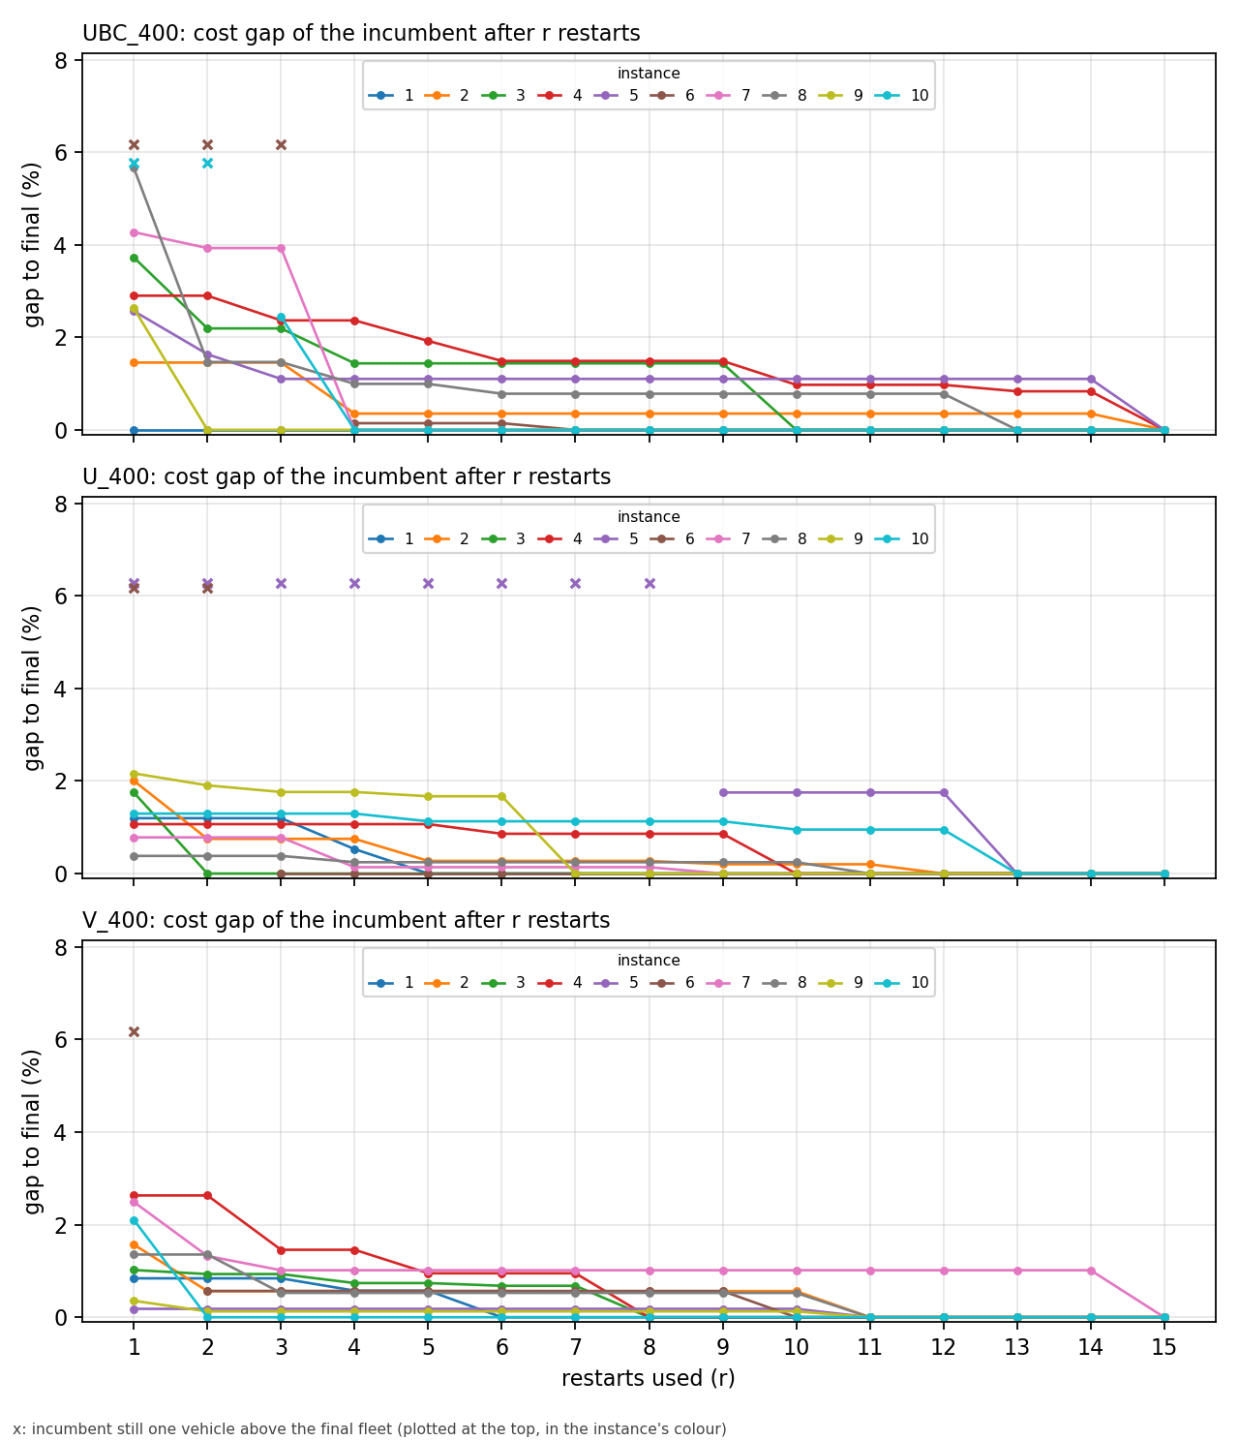
Figure 4. The 400-customer instances one by one, per set: cost gap of the incumbent after r restarts. A cross at the top marks a restart after which the incumbent still has one vehicle more than the final fleet.
Improvements do arrive late on these instances: the median restart that produced the final solution is 10, and 13 of the 30 found it after restart 10 (four at restart 15 itself). But what the late restarts bring is small: the instances that improved after restart 10 did so by 0.67% on average. The restarts are a distance refinement with diminishing returns, not a search for the fleet.

6. Statement for the response letter
- The fleet is decided early. The final fleet is reached by the first restart on 87% of the Dumez et al. instances and 97% of the Tilk et al. ones, by five restarts on 95% and 99%, and by ten on all 240. No restart after the ninth ever removed a vehicle.
- The distance converges with diminishing returns. On Dumez et al. the incumbent is 1.8% above the final distance after one restart, 0.94% after three, 0.54% after five and 0.23% after ten; the first three restarts capture about half of the improvement and the first five about 70%. On Tilk et al. the first restart is already within 0.5% and 63% of the instances are final.
- Improvements continue late but are small: the median restart producing the final solution is 7 on Dumez et al., 48 of the 240 instances found it after restart 10, and the gain of those late restarts is a few tenths of a percent.
- Halving the budget on the 400-customer instances sacrifices 0.37% of distance on average and at most 1.49%, with the final fleet on 29 of 30 instances; a third of the budget sacrifices 0.54%. A practitioner with a tight budget can stop at 5 restarts and lose under 1% in distance; the full 15 restarts are a refinement of the last few tenths of a percent.
- The 15 restarts of the paper are kept because they are cheap relative to the exact and matheuristic references and because the late improvements, although small, are real on the largest instances; the trade-off table lets a practitioner choose.

Appendix: files
results/exp3_2026-11-02_1645_all/exp5/: summary.md (all numbers), per_restart.csv (one row per instance and restart: restart best, incumbent, gap, fleet excess, expected values over orders), r_star.csv (per instance r* and times), tradeoff.csv (Tables 2 to 4), class_found.csv, class_fleet.csv, class_gap.csv (Tables 5 to 7), plots/. Scripts: experiments/exp5-restart-returns/analyze_exp5.py (the analysis, runs on any results folder with runs.csv and restarts/ or traces/), run-exp5.ps1 (a VM run with the per-restart log on, for measured restart times), README.md. Solver: settings.logRestarts, IO/RestartWriter.cs.

