
Professional experience:
 | 2018/Current | Danieli Systec Engineering, Niš, Serbia - PLC/ Scada SW development and commissioning in steel industry - Automation Supervisor
 | 2018/2018 | Faculty of Electronic Engineering, Niš, Serbia - Student Internship - PCB board design
 | 2018/2018 | Danieli Systec d.o.o. Osijek, Croatia - Student Internship - PLC/ Scada SW development
 | 2016/2016 | DMV d.o.o. , Niš, Serbia - Student Internship - PCB design

Achievements:
 | 2025 | PROJECT NAME: BISCO DRP - Direct reduction plant  CUSTOMER: IRAN, BUTIA IRANIAN STEEL CO.  WORK DESCRIPTION: Software development  PLC AREA: Process Gas Heater PLC, Safety PLC  PLATFORM: Simatic Step7 PCS7 v10, HMI WinCC 8  POSITIONS: Team leader & Software developer
 | 2024 | PROJECT NAME: Salcos DRP - Direct reduction plant  CUSTOMER: Salzgitter, Energiron  WORK DESCRIPTION: Software development  PLC AREA: WTP PLC  PLATFORM: Simatic Step7 PCS7, HMI WinCC 7,5  POSITIONS: Software developer
 | 2024 | PROJECT NAME: Standardization DRP - Direct reduction plant  CUSTOMER: Tenova  WORK DESCRIPTION: Software development  PLC AREA: Core Area PLC, Process Gas Heater PLC  PLATFORM: Simatic Step7 PCS7, HMI WinCC 7,5  POSITIONS: Software developer
 | 2023 | PROJECT NAME: Rolling Mill - Pipe mill  CUSTOMER: OMK Vyksa steel works,  PLACE: Vyksa, Russia  WORK DESCRIPTION: Commissioning on site  PLC AREA: Pipe finishing line area- LD81C1(Cooling bad entry and exit area), LD81C2(Removal and Cutting line 1), LD81C3(Auxiliary and Cutting line 2), D15BAD(Blowing station line 1), G15BAD(Blowing station line 2)  PLATFORM: TiaPortal15.1, HMI WinCC 7.5, Zenon 7.5
 | 2022 | PROJECT NAME: DRP - Direct reduction plant  CUSTOMER: Ezz Steel  PLACE: Suez, Egypt  WORK DESCRIPTION: Education about new technology  PLC AREA: Material handling PLC, Reactor Solids PLC, Reformer PLC, Gas treatment PLC, WTP PLC, Safety PLC  PLATFORM: Simatic Step7 PCS7, HMI WinCC  POSITIONS: Seminar participant
 | 2022 | PROJECT NAME: GSP - Gas cleaning plant  CUSTOMER: Arcelomittal  PLACE: Kryvy Rih, Ukraine  WORK DESCRIPTION: Software development  PLC AREA: Pump House - Common PLC  PLATFORM: Simatic Step7 Multi-project S7-400H, HMI WinCC 7.5 Sp 1, KEP Server EX  POSITIONS: Software developer
 | 2021 | PROJECT NAME: Blast Furnace No.3 - Steel making  CUSTOMER: Metalloinvest Ural Steel  PLACE: Novotroick, Russia  WORK DESCRIPTION: Commissioning on site - Revamping  PLC AREA: Top Charging, Stock House, Pump House, Furnace Cooling, Natural Gas, Above burden probe  PLATFORM: Simatic Step7 Multi-project S7-400H, HMI WinCC 7.4 Server-Client, Process Historian  POSITIONS: Automation coordinator/ Automation Supervisor/ Software developer
 | 2020 | PROJECT NAME: Blast Furnace No.2 - Steel making  CUSTOMER: Metalloinvest Ural Steel  PLACE: Novotroick, Russia  WORK DESCRIPTION: Commissioning on site - Revamping  PLC AREA: Pump House, Furnace Cooling, Natural Gas, Above burden probe  PLATFORM: Simatic Step7 Multi-project S7-400H, HMI WinCC 7.4 Server-Client, Process Historian  POSITIONS: Automation Supervisor/ Software developer
 | 2019 | PROJECT NAME: Rolling Mill - Pipe mill  CUSTOMER: OMK Vyksa steel works,  PLACE: Vyksa, Russia  WORK DESCRIPTION: Commissioning on site  PLC AREA: Pipe finishing line area  PLATFORM: Simatic Step7 S7-300, HMI WinCC 7.3
 | 2019 | PROJECT NAME: Rolling Mill - Pipe mill  CUSTOMER: OMK Vyksa steel works,  PLACE: Vyksa, Russia  WORK DESCRIPTION: Commissioning on site  PLC AREA: Heat treatment line  PLATFORM: Simatic Step7 S7-300, HMI WinCC 7.3

Education:
 | 2020 | Faculty of Electronic Engineering, University of Niš, Serbia: Master Degree Master Engineer of Electrical Engineering and Computing, Control Systems
 | 2017 | Faculty of Electronic Engineering, University of Niš, Serbia: Bachelor Degree Control Systems (UPS)

Certifications, Licences and Training:
 | 2020 | SQL Bootcamp with MySQL, PHP & Python
 | 2020 | Learning Python

Strengths:
- Ambitious, Precise, Persistent
- Full of working spirit

Areas of Development:
- Leadership, Team work, Productivity, Creativity
Personal Interests:
- Automation, Technology, Electrical and Robotic

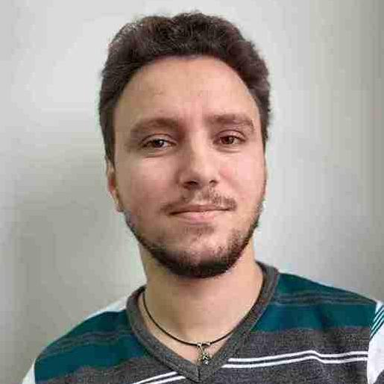
Name, Surname:
VLADIMIR, SIMOVIC
Nationality:
Serbian
Current Position:
Automation Supervisor
Danieli Seniority:
7 YEARS, 2 MONTHS
Seniority in Metal Industry:
7 YEARS, 3 MONTHS
Languages:
English : Proficient
Serbian : Proficient
French : Beginner
Russian : Beginner
Techs:
Simatic Manager (Step7/Tia) : Proficient
WinCC : Proficient
Microsoft Office (Word, Excel, Power Point, Visio) : Proficient
InTouch : Moderate
Profinet, Profibus and Ethernet Networks : Proficient
Contacts:
Home Mobile : /-/
E-Mail: v.simovic@systec.danieli.com

