Finding the Prescribers a Spend Ranking Cannot See
An Analysis of Colorado Medicare Part D Prescribing Patterns, 2024
Caleb Edwards, M.D.
Data Analytics Bootcamp Capstone · Front Range Community College / Upright Education
August 2026
Summary
Medicare Part D cost $2.74 billion in prescription drug coverage across 19,390 prescribers. A population health team can review a few hundred or a couple thousand of them, at maximum. This analysis shows that the review list most organizations build — a statewide spend or unit-cost ranking — misses roughly half of the prescribers who are genuinely unusual for their own specialty, and that comparing each prescriber to their own peer group instead yields a tractable, defensible cohort of 507 clinicians holding $317.6 million in above-peer spend.
1. The business question
Medicare Part D is the outpatient prescription drug benefit for people on Medicare, delivered through private plans approved by the Center for Medicare and Medicaid Services (CMS). Every year, CMS publishes a public record of what each prescriber in the country prescribed and what those prescriptions cost. The 2024 Colorado extract covers $2.74 billion in drug costs across 19,390 prescribers and 1,177 generic drugs. It contains no patient identifiers and no protected health information.
A population health team inside a health system or a plan has a handful of pharmacists and perhaps one medical director. It cannot be expected to review nineteen thousand prescribers in any effective manner. Therefore, this project aims to support the following decision:
Which prescriber segments should a health system prioritize for outreach, education, or further review — and on what evidence?
There are two ways to build that review list, and the choice between them is the analytical heart of this project.
Option A — rank everyone statewide. Sort all 19,390 prescribers by total spend, or by cost per prescription, and take the top of the list. It's simple, it's fast, and it's what most programs do. The problem is that an oncologist and a dentist end up on the same ranking. Cancer drugs cost thousands of dollars per prescription because they are cancer drugs. A statewide ranking largely measures what kind of medicine a clinician practices, not how they practice it.
Option B — compare each prescriber to their own specialty. Rank each prescriber only against peers in the same specialty, then flag the ones sitting above their own peer group. It requires the full file and more work to build, but case mix is held roughly constant: family practice is compared to family practice, oncology to oncology.
My working hypothesis was that the harder list is worth building. This report tests that hypothesis and, having confirmed it, converts it into a specific cohort a team could begin reviewing on Monday morning. The application is direct: peer-comparison outreach is an established tool in pharmacy utilization management, and the constraint it always runs into is reviewer capacity. Getting the targeting right is what determines whether the program pays for itself.
2. Data collection and preparation
Source. CMS Medicare Part D Prescribers by Provider and Drug, 2024, Colorado extract, downloaded from data.cms.gov. The file has 390,473 rows and 22 columns. Each row is one prescriber, one brand name, one generic name, for the calendar year. It carries total claims, 30-day fills, day supply, drug cost, and beneficiary counts, plus a 65-and-older subgroup breakout. It is a public use file with no PHI.
I read the raw CSV exactly once for the entire project and cached a single cleaned copy that every later stage reads. Preparation was deliberately conservative. Ten of the columns are numeric by definition but load as text, so I coerced them to numbers; not one non-blank value failed to parse, and the sum of drug cost was identical before and after coercion at $2,737,455,388.61. I checked for duplicate rows across all 22 columns and on the file's grain key of NPI plus brand plus generic, and found none. I checked whether any NPI mapped to more than one specialty or more than one city, and none did — which means specialty and city can be carried from row level to prescriber level without loss.
The judgment call worth naming is that I did not fill in blanks. In this file a blank is not an omission — CMS suppresses any cell that would identify a small number of patients. Filling those with zero would have invented data. Every blank was left blank, and no row was filtered, dropped, or reweighted at any step. 390,473 rows in, 390,473 rows out.
Measure | Raw CSV | Cleaned file | Delta
Rows | 390,473 | 390,473 | 0
Columns | 22 | 24 (22 source + 2 derived) | +2
SUM(Tot_Drug_Cst) | $2,737,455,388.61 | $2,737,455,388.61 | $0.00
SUM(Tot_Clms) | 16,573,710 | 16,573,710 | 0
Distinct prescribers (NPI) | 19,390 | 19,390 | 0
Distinct specialties | 97 | 97 | 0
Distinct generic drugs | 1,177 | 1,177 | 0

Reconciliation between the raw extract and the cached clean file. The step-by-step record, with a row count before and after each of ten steps, is in CLEANING.md.
The choice of unit metric
One preparation decision shaped everything downstream, so it gets its own section. The measure a clinician would naturally reach for is cost per patient - which unfortunately could not be computed. The total beneficiary column is blank on 58.9% of rows under CMS privacy suppression, and the 65-and-older beneficiary column is blank on 86.3%. A denominator that's missing more than half the time isn't a denominator, so no per-patient rate appears anywhere in this analysis.
What is complete is claims and dollars — both have no blanks. The unit metric throughout is therefore cost per claim, computed as total drug cost divided by total claims, with cost per 30-day fill as a companion measure. Both denominators are guarded against zero.
That distribution is severely right-skewed: the median cost per claim is $31.09 against a mean of $193.65. That much skew rules out leading with a test that assumes a normal distribution, which is why Section 3 leads with a rank-based one.
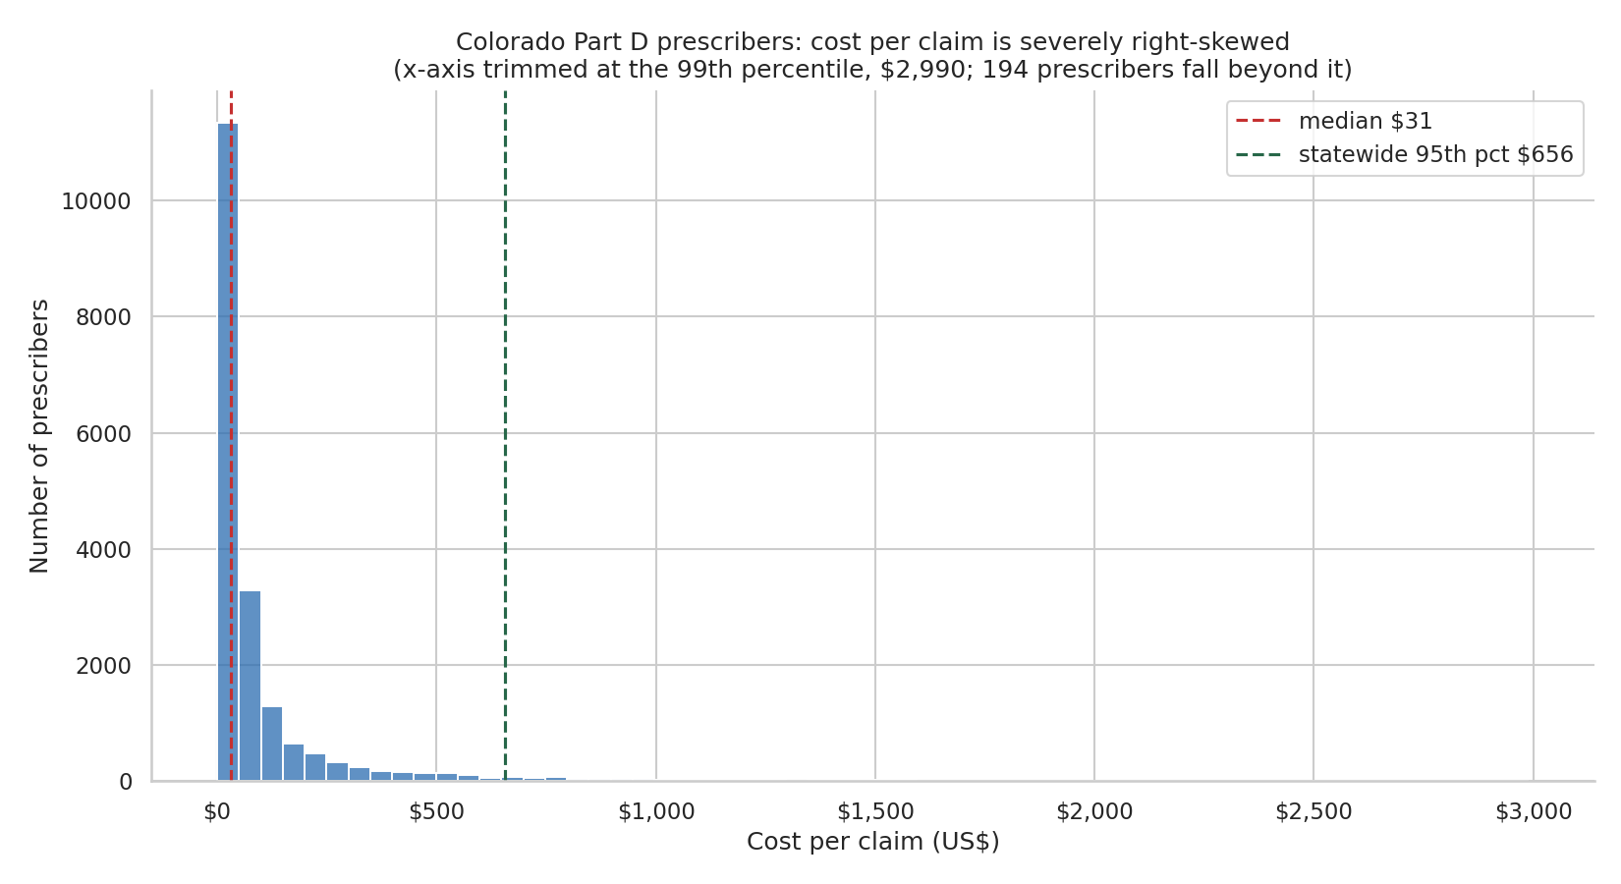
Figure 1 — Distribution of cost per claim. The long right tail is what drives the choice of a rank-based test. Source: capstone_analysis.ipynb, chart stage3_01.
3. Methodology
The pipeline is four tools in sequence, each layer checking the one before it. This structure follows the proposal, and I kept to it.
1. Excel: Aggregate tables built straight off the raw extract — the fast first pass across prescriber, specialty, and drug cuts, and the tie-out that every later number is checked against. All sheets reconcile to $2,737,455,388.61.
2. SQL: The full 390,473-row file loaded to SQLite as the system of record. Percentile window functions — NTILE() partitioned by specialty — build the peer bands and identify outliers inside each specialty. Every query carries a plain-language comment stating what it does and why.
3. Python: pandas and seaborn. This layer tests which dimension actually explains cost, ranks each prescriber inside their own specialty, and produces the seven charts. The notebook runs clean-kernel end to end: 23 code cells, zero errors.
4. Tableau: The executive layer — the prioritized segments in a form a population health director can act on — paired with a one-page recommendation memo.
Peer groups and the outlier rule
A peer group is a prescriber specialty. To keep the comparison honest I restricted within-specialty work to specialties with at least 30 prescribers; a specialty with four members produces a median nobody should trust. That rule qualifies 46 of 97 specialties, covering 18,940 of 19,390 prescribers. The 51 excluded specialties account for 2.3% of prescribers and 3.0% of spend, and I claim nothing about them.
A prescriber is flagged as a within-specialty outlier when their cost per claim exceeds the 95th percentile of their own specialty. The parallel statewide rule, used only for comparison, flags the top 5% of all prescribers on cost per claim regardless of specialty. The SQL layer builds the same construct with NTILE(20) band 20; the two rules agree closely but not exactly, and where both are quoted the notebook rule governs.
A substitution I want to state plainly
My proposal called for regression to identify which dimensions drive cost. Regression beyond a fitted line was never covered in this curriculum — no coefficient tables, no R², no statsmodels or scikit-learn. Rather than import a method I couldn't defend line by line, I answered the same question with techniques that were taught or that I knew previous: one-way ANOVA and the Kruskal–Wallis test to compare cost per claim across specialty and across city, and within-specialty percentile ranking using groupby, quantile, and merge to locate individual prescribers against their peers. Two smaller substitutions follow the same principle: a Pareto cumulative-percent line was replaced by a bar chart with the concentration figure stated in the title, and log-scale axes were replaced by 99th-percentile trims declared on the chart rather than hidden.
ANOVA and Kruskal–Wallis tell you whether a grouping explains variation; the percentile ranking tells you which individuals sit outside their group. Together, that's the entire business question, and I can defend every line of it.
4. Key findings
Finding 1 — Specialty drives cost. Geography barely matters.
I tested two ways of grouping prescribers, specialty and city, to see which explains cost per claim. Both came back statistically significant, and that isn't a result by itself — with roughly 19,000 prescribers almost anything rejects the null. The size of the effect is the finding.
Dimension | Qualifying groups | Kruskal–Wallis H | ANOVA F | Span of group medians | p75 / p25 fold
Specialty | 46 of 97 | 8,608.94 | 51.83 | $3.89 → $2,272.07 (584×) | 11.23×
City | 60 of 226 | 254.96 | 3.17 | $4.38 → $79.71 (18×) | 1.81×

Both p-values fall below 0.001; specialty's is below 1e-300. Kruskal–Wallis is the test relied on because cost per claim is severely right-skewed; ANOVA is reported alongside it and points the same way. Source: FINDINGS.md F1.
The middle half of specialties differ eleven-fold on median cost per claim. The middle half of cities differ 1.8-fold, which is close to noise. Across the full range, the cheapest qualifying specialty sits at $3.89 per claim and the most expensive at $2,272.07 — a 584-fold spread that is case mix, not behavior.
The practical consequence is the one that matters: cost-per-claim comparisons must be made inside a specialty. Comparing an oncologist to a dentist measures case mix. Comparing a Denver prescriber to a Pueblo prescriber measures almost nothing. City-level geography is off the table as a targeting dimension, with two qualifications: this tests the 60 city strings as CMS published them, without normalizing the 28 spelling variants logged as Q1 in QUESTIONS.md, and it tests cities rather than a rural/urban or regional grouping, which Q3 leaves open.
Finding 2 — Spending a lot and charging a lot are unrelated.
I checked whether the prescribers who spend the most are also the ones whose individual prescriptions are most expensive. The Pearson correlation between cost per claim and total claims is −0.011. That is zero.
Prescriber-level pair | Pearson r
Total cost vs total claims | 0.380
Cost per claim vs total claims | −0.011
Cost per claim vs total cost | 0.337

Correlations computed at prescriber level on the qualifying population. Source: FINDINGS.md F4, chart stage3_07.
Read plainly: knowing a prescriber spent two million dollars tells you nothing about whether their prescriptions are expensive. High spend usually means high volume — a busy clinic seeing a lot of patients. This is the analytic justification for the whole project. If the two measures moved together a spend ranking would be an acceptable shortcut; because they do not, a high-spend review list and a high-unit-cost review list are lists of different people.
Finding 3 — Half the prescribers who stand out among peers are invisible statewide.
This is the direct test of the fork described in Section 1. I built both lists and compared them.
Flagged by | Prescribers | Reading
Statewide top 5% only | 431 | High unit cost, but normal for their specialty — explained by case mix
Both methods | 498 | High unit cost and unusual against their own peers
Within-specialty top 5% only | 467 | Unusual against their own peers, invisible on a statewide list

Flag rule: cost per claim above the prescriber's own specialty 95th percentile, versus above the statewide 95th percentile. Source: FINDINGS.md F2, chart stage3_06.
Of the 965 prescribers sitting above their own specialty's 95th percentile, 467 — 48% — never appear on a statewide top-5% list at all. Conversely, 431 of the 929 statewide flags are fully accounted for by specialty. A statewide ranking is roughly half noise for this purpose, and it misses about half the real signal.
Those 965 prescribers are 5.1% of the state and carry 22.1% of qualifying spend. Their median total drug cost is $144,422 against $4,924 for everyone else — a 29-fold gap on the median, significant at H = 658.63, p = 3.0e-145. I deliberately ran that test on total cost rather than on cost per claim, because cost per claim was the variable used to build the flag and re-testing it would have been circular.

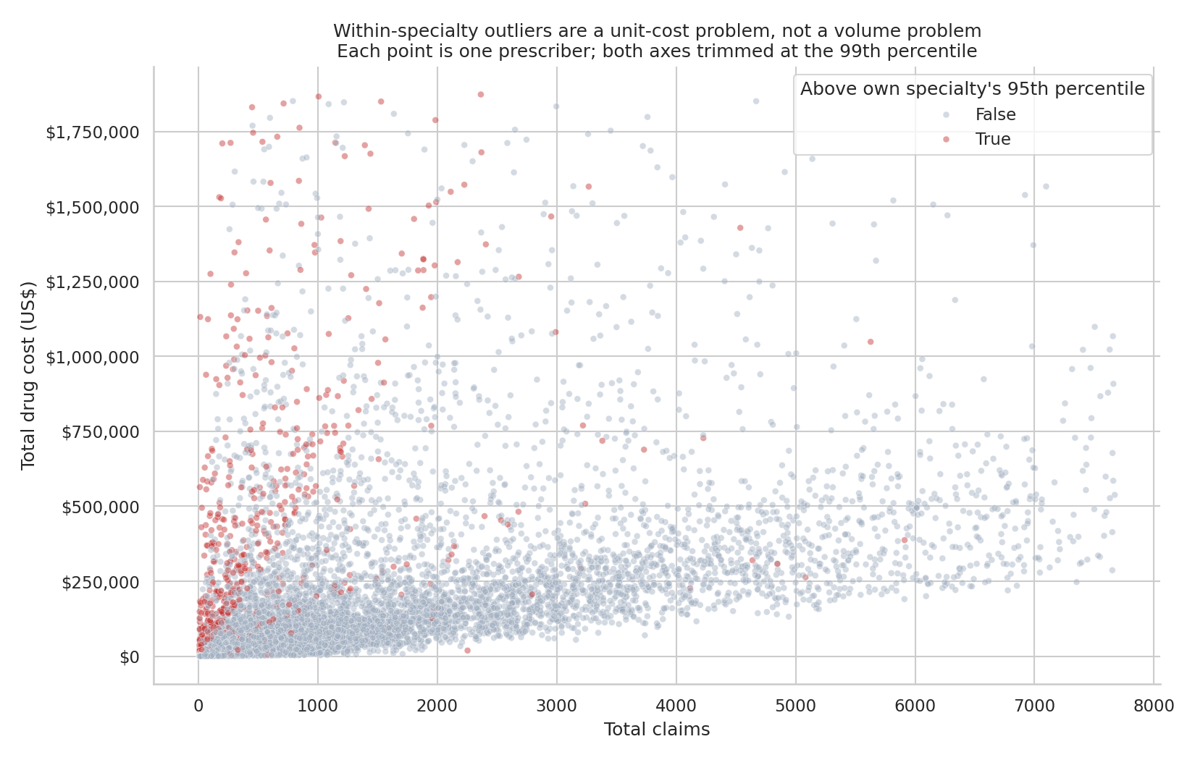
Figure 2 — Prescribers by claim volume and total cost, with within-specialty outliers highlighted. Flagged prescribers sit high on total cost at low claim counts. Source: chart stage3_06.
Finding 4 — The money is concentrated, which is what makes a targeted program viable.
Cut | Share of the $2.74B
Top 10 of 1,177 generic drugs | 33.5% ($917.8M)
Top 20 generic drugs | 45.5% ($1.25B)
Top 100 generic drugs | 79.0%
Top 100 of 19,390 prescribers | 18.5%
Top 1,000 prescribers | 56.1%
Top 10% of prescribers (1,939) | 71.9% ($1.97B)

Concentration on the drug axis and the prescriber axis. Source: FINDINGS.md F5, chart stage3_04.
Twenty drugs — 1.7% of the drug list — carry 45.5% of Colorado Part D spend, and the top decile of prescribers carries 71.9%. This is a feasibility finding rather than a fairness one: because the money is concentrated rather than spread evenly, a formulary or utilization review scoped to twenty drugs touches nearly half the state's spend.
5. Recommendations and next steps
The table below ranks specialties by spend flagged — the total drug cost held by prescribers above that specialty's own 95th percentile — the money a peer-based review would actually be looking at. It is the notebook's output sorted, not a judgment layered on top of it.
# | Specialty | Outliers / Prescribers | Flagged Spend | % of specialty spend | Cost per claim (weighted)
1 | Nurse Practitioner | 176 / 3,509 | $109,343,136 | 27.8% | $137
2 | Physician Assistant | 151 / 3,010 | $106,670,500 | 41.6% | $147
3 | Internal Medicine | 65 / 1,292 | $60,293,209 | 19.1% | $98
4 | Family Practice | 115 / 2,288 | $41,334,113 | 11.7% | $73
5 | Hematology-Oncology | 6 / 115 | $33,045,826 | 14.5% | $2,652
6 | Urology | 9 / 178 | $26,685,838 | 53.0% | $320
7 | Pulmonary Disease | 8 / 154 | $25,642,076 | 24.8% | $907
8 | Cardiology | 11 / 205 | $24,133,908 | 17.9% | $272

Priority segments ranked by spend flagged — the total drug cost held by prescribers above their own specialty’s 95th percentile. Cost per claim in this table is specialty-weighted (total specialty cost divided by total specialty claims), which is why it runs higher than the prescriber-level medians quoted in Finding 1. Rows 1–4 are the recommended first cohort. Source: FINDINGS.md, “Recommended priority segments”.
Primary recommendation — review the top four segments first, as a single cohort of 507 clinicians
Nurse Practitioner, Physician Assistant, Internal Medicine and Family Practice are the four cheapest segments on this list, at $73 to $147 per claim, and yet their within-specialty outliers hold $317.6 million — 54% of all outlier dollars in Colorado. That combination is the entire argument for using a within-specialty rule.
These 507 prescribers are invisible to any statewide unit-cost screen: a $600 claim looks unremarkable next to oncology and extraordinary next to a family practice peer group whose median is $73. 507 people is a tractable review list — a project a small team can finish, not a program it has to staff.
Second tier — Urology, on concentration rather than size
Nine prescribers hold 53.0% of the specialty's entire spend. No other segment on the list is close to that concentration. Nine charts is roughly a day of work, and the potential return per reviewer hour is the highest on the table.
Deprioritize the expensive specialties relative to their dollar rank
Hematology-Oncology, Pulmonary Disease and Cardiology appear high in the table because their drugs are genuinely expensive — $2,652, $907 and $272 per claim. Finding 1 establishes that specialty explains most of that. The residual within-specialty signal is real but small, and the clinical justification for high-cost oncology and pulmonary agents is correspondingly stronger. Reviewer hours are better spent where the peer gap is not already explained by pharmacology.
Next steps
1. Run the 507-clinician cohort as a pilot. Peer-comparison letters and pharmacist outreach, then measure in the next data year whether the peer gap narrowed. That's a measurable intervention, not a report that sits on a shelf.
2. Scope a formulary review to the top twenty drugs. Those twenty carry 45.5% of state spend, which makes them the cheapest structural lever available.
3. Rebuild the flag with clinical context. Diagnoses and panel composition would turn a statistical outlier into an actionable one. That data lives inside a health system, not in a public file.
4. Repeat the analysis on the 2023 file. One year cannot separate a persistent pattern from a single unusual year. Two can.

6. Limitations
This is data about real clinicians, so I want to be precise about what it doesn't say.
No clinical context. The file carries no diagnoses, no severity, and no patient panel composition. A prescriber above their peer group is a statistical outlier — a reason to look at a chart. It's not a finding of waste, and it's not an accusation.
Cost is gross, not net. Tot_Drug_Cst is the point-of-sale cost of the prescription — ingredient cost, dispensing fee, sales tax and any vaccine administration fee — summed across every payer: the Part D plan, the beneficiary, government subsidies and any third party. It is not net of manufacturer rebates, so cross-drug comparisons overstate the spread on heavily rebated brands.
No cost per beneficiary. Beneficiary counts are suppressed on 58.9% of rows, so no per-patient rate is computed anywhere in this analysis. Cost per claim and cost per 30-day fill are the only unit metrics used.
CMS suppression sets a floor on the file. Every published row has at least 11 claims. A prescriber's totals here are therefore sums over only the rows CMS chose to report, which understates the true total for anyone whose volume is spread thinly across many drugs.
Specialty labels are not uniformly sourced. Prscrbr_Type is derived from claims for 88.2% of rows and from the NPPES registry for the rest, so a peer group built on this column mixes two derivations.
The 65-and-over split was built but is not reported. Queries 9 and 10 in capstone_segmentation.sql split cost by age group, but the 65-and-over cost columns are suppressed on 42.1% of rows. Reporting an age difference on a 71%-complete subset needs an imputation decision, logged as Q9 in QUESTIONS.md and left undecided rather than defaulted.
Scope, and what remains open. 2024 Colorado only — no trend and no national benchmark. The ≥30-prescriber rule excludes 51 of 97 specialties, covering 2.3% of prescribers and 3.0% of spend. Fifteen open data questions remain logged in QUESTIONS.md — none large enough to move the figures in this report, and none silently fixed.

Appendix — Artifacts
Every file in the outputs folder and what it demonstrates. Items marked “working file” document the process and were not written as graded prose.
Deliverables
File | What it demonstrates
Edwards_Caleb_Capstone_Report.docx | This report — business question, data collection and preparation, methodology, findings, recommendations, limitations, and this appendix.
Edwards_Caleb_Capstone_Deck.pptx | Fifteen slides with full speaker notes, written for an audience with no prior knowledge of Medicare Part D.
RECOMMENDATION_MEMO.docx | One-page memo to a population health leadership team. All 34 figures in it were checked programmatically against FINDINGS.md with zero mismatches.
CO Medicare Part D Dashboard.twbx | Tableau executive dashboard, rebuilt in Tableau Desktop — flagged spend by segment, cost per claim by segment, and a volume-versus-unit-cost scatter across the top 8 priority segments.
tableau_prescriber_segments.csv | The prescriber-level extract feeding the dashboard; reconciles exactly to the priority table in Section 5.

Analysis and code
File | What it demonstrates
capstone_analysis.ipynb | The Python analysis. 23 cells, clean-kernel run, zero errors — ANOVA, Kruskal–Wallis, within-specialty percentile ranking, correlations, and all seven charts. Every cell carries a plain-language comment.
capstone_segmentation.sql | SQL segmentation using CTEs and NTILE() window functions to build peer bands and identify outliers inside each specialty. Commented query by query.
part_d_profiling.sql | Profiling SQL — 35 queries establishing the shape, completeness, and distribution of the raw file.
CAPSTONE_EXCEL_AGGREGATES.xlsx | Excel aggregate tables built from the raw extract, tying to $2,737,455,388.61 — the reference every later number is checked against.
charts/ (7 PNG files) | The complete chart set: cost-per-claim distribution, cost by specialty (box and bar), top generic drugs by spend, group-median dispersion by dimension, within-specialty outlier scatter, and the measure correlation heatmap.
part_d_co_clean.csv | The single cached clean file. The raw CSV is read once; every later stage reads this instead.
part_d.sqlite | The full 390,473-row file as a SQLite database — the SQL system of record.
Build scripts (load_part_d.py, build_excel_aggregates.py, build_nb.py, make_charts.py, run_segmentation_sql.py, build_tableau_extract.py, build_recommendation_memo.py, build_report.py) | Every deliverable in this folder is reproducible from the raw CSV by running these in order.

Documentation
File | What it demonstrates
CLEANING.md | The data cleaning log — ten steps, each with a row count before and after, plus a full data-limitations section. This is the preparation audit trail.
FINDINGS.md | The findings of record. Every figure in this report, the deck, the memo and the dashboard traces to a numbered finding here.
QUESTIONS.md | Fifteen open data questions raised and deliberately left undecided — ambiguities logged rather than silently resolved.
SQL_RESULTS.md, STATS_OUTPUT.md, PY_RESULTS.md | Raw query and statistical output, retained so any number in this report can be traced back to the run that produced it.
PROGRESS.md | Stage-by-stage run log, including decisions made without supervision and residual risks (working file).
CALIBRATION.md, REQUIREMENTS.md, VERIFICATION.md | Scope and technique controls — what the curriculum taught, what the rubric requires, and what was verified (working files).
CHART_FLAGS.md, SQL_FLAGS.md, PY_FLAGS.md, RUN_LOG.md, PREGAME_RESEARCH.md | Earlier exploratory work, retained for completeness (working files).
charts/superseded/ (5 PNG files) | Five earlier figures built with techniques outside the curriculum. Moved rather than deleted, and excluded from the deliverable set.
CAPSTONE_AGGREGATES.xlsx, CAPSTONE_PROFILE.xlsx, CITY_REFERENCE.xlsx, outliers.csv, part_d_analysis.ipynb, regression_output.csv | Prior exploratory work from before the pipeline was rebuilt on taught techniques. Superseded by the files above and retained, not deleted, so the path from first pass to final analysis stays visible (working files).

Reproducibility: every number in this report can be regenerated from Medicare_Part_D_Prescribers_by_Provider_and_Drug_2024.csv by reading it with encoding='utf-8-sig' and running the build scripts listed above in order.

