**Project1_group08**

**Name: Real Estate Analysis**

* The impacts of Pandemic on Real Estate
* Finding cities with better investment value
* Seasonal effects on the home sale prices

Our focus is Real Estate analysis of Sales and Trends of the 5 hottest selling cities between "2015 - 2022."

- Tampa, Phoenix, Austin, Seattle, San Jose

Motivation

* Real estate is an important aspect of everybody’s life as we all need a place to stay. We have been hearing about the housing bubble over the last few years and burst that is looming. We want to use our data to see whether this is true or not.
* During the year of 2015, homes had a more reasonable price to be purchased. When pandemic hits in 2020, a world crisis affected globally the economy and interest rates on homes dropped. A few homeowners were able to finance their homes, a few weren’t. After two years, an inflation developed, and homes became more expensive to a lot of people. Either it was too expensive to buy or keep.
* Cash flow is important due to the inflation developed. Real-estate is a passive   
  income; we are wondering which states are the best places to consider investing in near future. Rising property values, better rent rate etc. are the key metrics we will consider.

Data Source

<https://www.zillow.com/research/data/>

Team Members

* Chandrani Ghosh
* Francis Rivera
* Simpel Osman
* Wei Chen

Tools/Modules to use.

* Python
* Pandas
* Matplotlib
* NumPy
* SciPy
* PowerPoint

Analysis

**Seasonal changes and Effects**

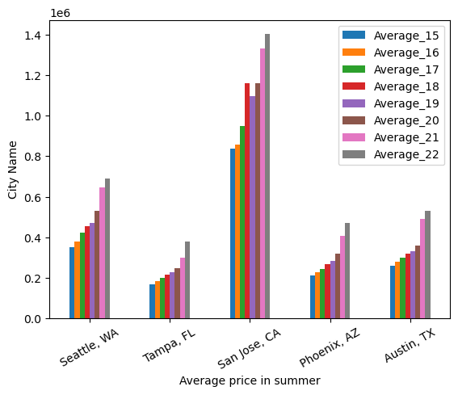

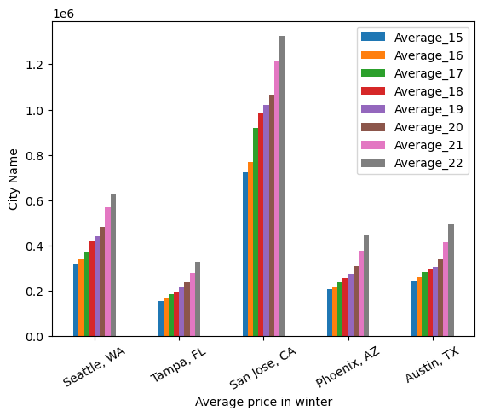

We looked into whether the seasons have any effect on the sale prices of the houses across these 5 cities. We made comparisons between summer and winter sales prices and conducted paired t-test.

Our Null and alternate hypotheses were

* H₀ = The seasons have no effect on the sale prices of the houses
* H₁ = The seasons effect the sale prices of the houses

Our p value was 2.02297199090102e-08. The results from the analysis indicate that there was statically significant (p = <0.05) difference in the sale prices of the homes between winter and summer months

In 2015 to 2019 homes within these cities had a more reasonable price and more homes were being bought out. 2016 held the lowest annual mortgage rate and was priced at 3.65 percent. That’s $553 a month lower than average for long term.

In 2018 mortgage rates went to 4.54% , assuming that 2019 will top out to 5% but instead it went down to 3.95% that year.

After 2019 a world crisis pandemic affected the market for housing. Interest rates for homes dropped down to 3%. Some homeowners were able to finance their homes, and a few weren’t.

Show in the bar graph,

Two years after the pandemic, homes spiked and became more expensive to afford. The average rate went from 2.96% to 5.34% due to an inflation in the US these cities were the most affected. So in that case It was either way too expensive to buy a home or homeowners weren’t meeting the income to provide payments for their homes and ended having to give it up.

PRE-PANDEMIC POST PANDEMIC

Investment in real-estate is a popular passive income option; Cash flow is especially important during pandemic due to the inflation developed. We analyze the trend of median house sale price and gross rental rate in the five cities chosen with the hottest housing market. Rising property values, better rental revenue etc. are the key metrics we are considering.

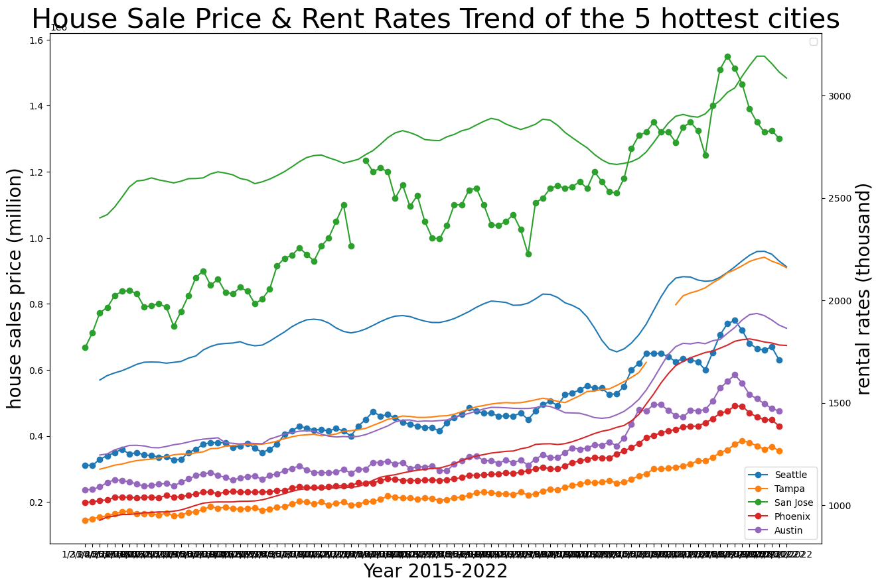

At the same time, we also do the regression analysis of Seattle housing data set from Y 2015 and Y 2022. We observe the obvious linear relationship between house price and rental rate. In addition, in certain period, the house price will increase in a comparatively higher rate.

The r-squared is: 0.6702528782529232

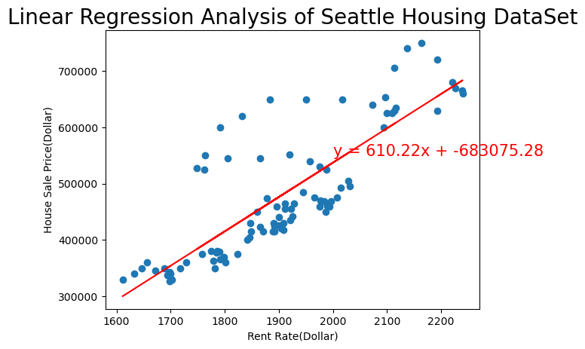

Conclusion

* The Pandemic in the real estate market caused the listing prices of homes especially in certain areas to rise from previous years.
* The seasons do affect the sale prices of the houses.
* We have seen more increase in 5 hottest cities because of people moving more to certain areas and pay less taxes however many companies have moved to Austin Texas and made a big increase in the price.