**Pandas-Challenge Report Summary**

We have a dataset with 15 schools and a total of 39,170 students. The total budget for the school district is $24,649,428.

The average math score across the 15 schools was 78.98 and the reading score was 81.88. The percentage of students who passed math and reading respectively were 74.98 and 85.81. The percentage of students who passed both was 65.17. We can see that the average analysis reading score is higher than the average math score. Also, the percentage of students who score above 70 is higher in reading compared to math.

The total number of students in each school ranges from 427 Holden High School to 4976 Bailey High School. We have two different categories of schools that represent our dataset, one is District and the other Charter schools. We can see from the dataset that the District Schools have a greater number of students enrolled than Charter Schools.

The total school budget for each of the schools ranged from $248,087 Holden High School to $3124,928 Bailey High School, while the per capita budget ranged from $581 Holden High School to $655 Huang High School. In conclusion of budget, we can see that the district schools have more budget available than the charter schools.

The average math score ranged from 76.63 Huang High school to 83.84 Pena High school. The average reading score ranged from 80.74 Rodriguez High school to 84.04 Pena High school. Pena High schools had the highest average math and reading scores. The average data tells us that the reading score is higher across all schools compared to the average math score.

The percentage of students passing math was highest for Pena High school 94.59% however, the school with the lowest percentage of student passing in math was Huang High school 65.68%. Thomas High school had the highest percentage of students passing in reading 97.31% compared to Ford High school 79.3% with the lowest percentage. The school with the highest overall passing percentage was Cabrera High School 91.33%. While Rodriguez High school 52.3% has the lowest overall passing percentage.

Additionally, the top 5 performing schools are below listed in the table.

Table1

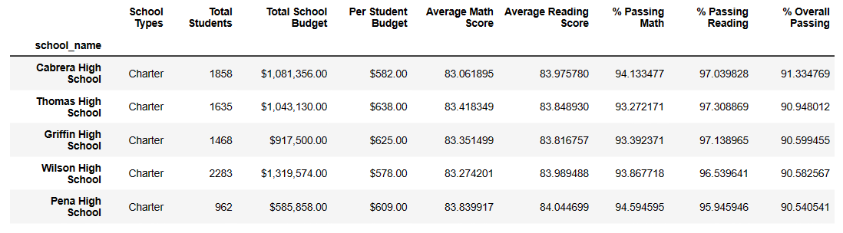

As conclusion, spending per student have negative correlation to test scores and passing percentages. Smaller sized schools are doing better at tests compared to larger schools. The charter schools are doing better in both math and reading tests and passing percentages compared to the district schools.