[](http://www.comsol.com/)

Transport and adsorption

Report date

Jun 29, 2020 4:19:39 PM

Contents

1. Global Definitions

1.1. Parameters

2. Component 1

2.1. Definitions

2.2. Geometry 1

2.3. Transport of Diluted Species

2.4. General Form Boundary PDE

2.5. Mesh 1

3. Study 1

3.1. Time Dependent

4. Results

4.1. Data Sets

4.2. Plot Groups

1. Global Definitions

|  |  |
| --- | --- |
| Date | Jun 25, 2020 7:13:49 PM |

Global settings

|  |  |
| --- | --- |
| Name | Transport and adsorption.mph |
| Path | E:\Charitidis\Dragatogiannis\Transport_and _adsorption.mph |
| Version | COMSOL Multiphysics 5.4 (Build: 295) |

Used products

|  |
| --- |
| COMSOL Multiphysics |

* 1. Parameters

Parameters 1

| **Name** | **Expression** | **Value** | **Description** |
| --- | --- | --- | --- |
| c0 | 1000[mol/m^3] | 1000 mol/m³ |  |
| k_ads | 1e-6[m^3/(mol*s)] | 1E−6 m³/(s·mol) |  |
| k_des | 1e-9[1/s] | 1E−9 1/s |  |
| Gamma_s | 1000[mol/m^2] | 1000 mol/m² |  |
| Ds | 1e-11[m^2/s] | 1E−11 m²/s |  |
| D | 1e-9[m^2/s] | 1E−9 m²/s |  |
| v_max | 1[mm/s] | 0.001 m/s |  |
| delta | 0.1[mm] | 1E−4 m |  |

1. Component 1
   1. Definitions
      1. Variables

#### Variables 1

Selection

|  |  |
| --- | --- |
| Geometric entity level | Boundary |
| Selection | Boundary 5 |

| **Name** | **Expression** | **Unit** | **Description** |
| --- | --- | --- | --- |
| R | k_ads*c*(Gamma_s - cs) - k_des*cs | mol/(m²·s) | Surface reaction rate |

#### Variables 2

Selection

|  |  |
| --- | --- |
| Geometric entity level | Domain |
| Selection | Domain 1 |

| **Name** | **Expression** | **Unit** | **Description** |
| --- | --- | --- | --- |
| v_lam | v_max*(1 - ((x - 0.5*delta)/(0.5*delta))^2) | m/s | Inlet velocity profile |

* + 1. Coordinate Systems

#### Boundary System 1

|  |  |
| --- | --- |
| Coordinate system type | Boundary system |
| Tag | sys1 |

Coordinate names

| **First** | **Second** | **Third** |
| --- | --- | --- |
| t1 | n | to |

* 1. Geometry 1

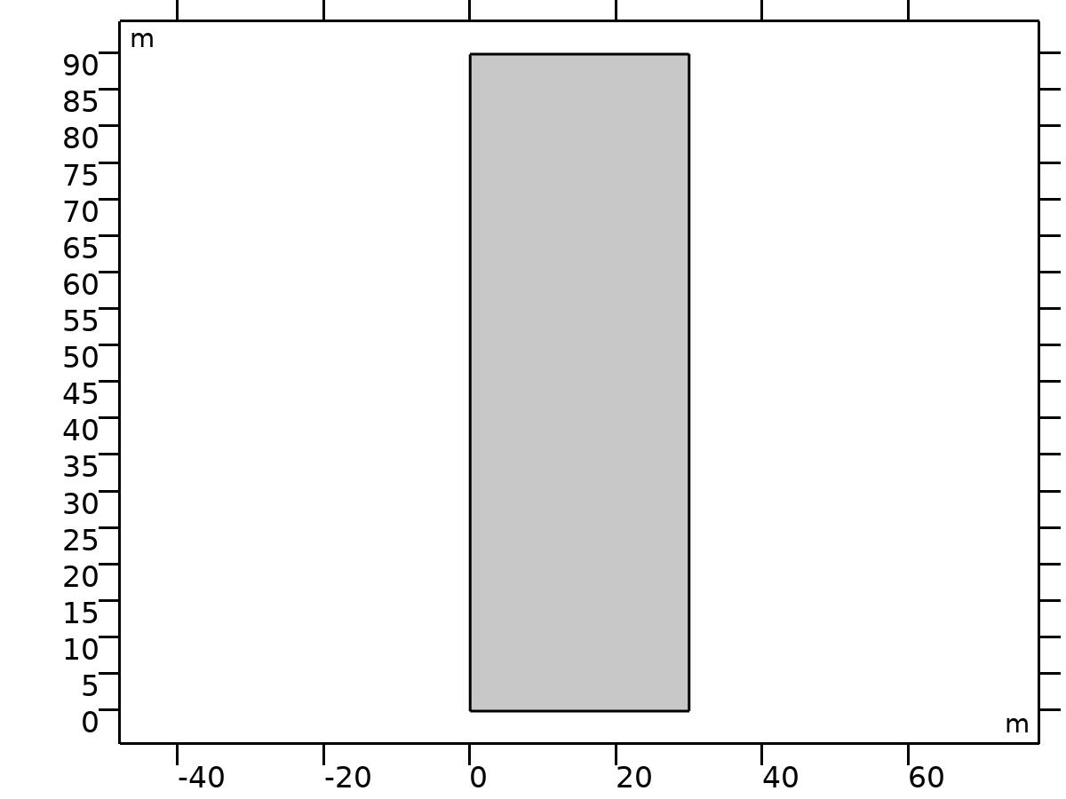

Geometry 1

Units

|  |  |
| --- | --- |
| Length unit | m |
| Angular unit | deg |

* 1. Transport of Diluted Species

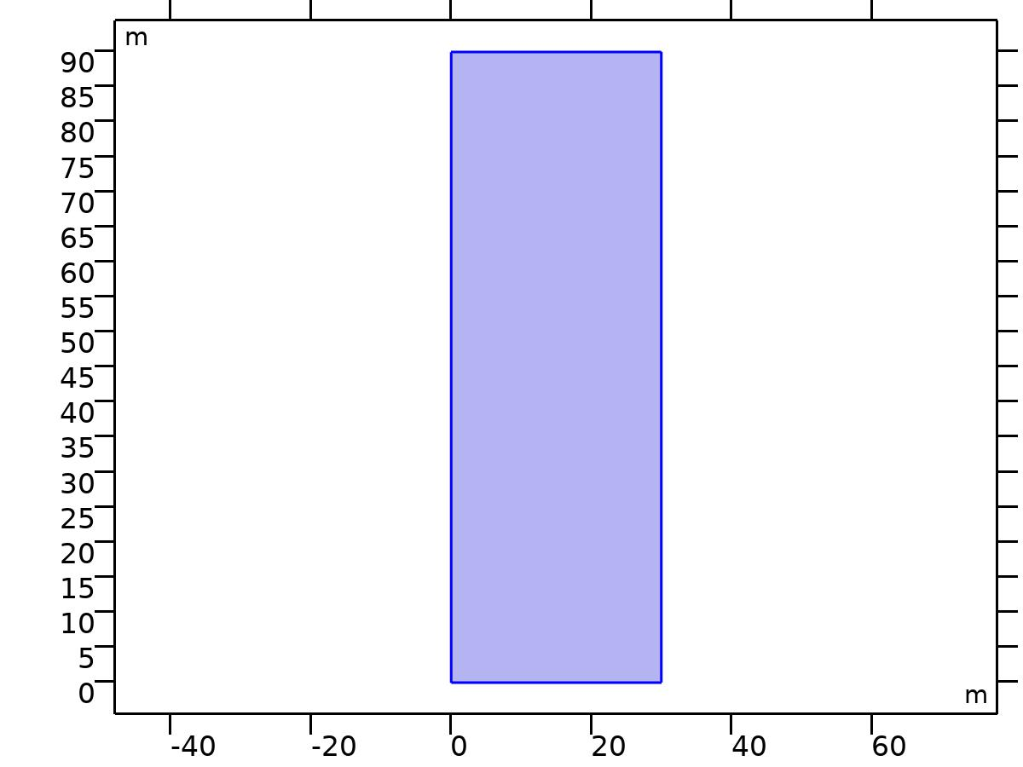

Transport of Diluted Species

Equations

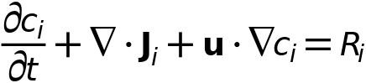



Features

|  |
| --- |
| Transport Properties 1 |
| No Flux 1 |
| Initial Values 1 |
| Concentration 1 |
| Flux 1 |
| Outflow 1 |
| Symmetry 1 |

* + 1. Transport Properties 1

Equations

* + 1. No Flux 1

Equations

* + 1. Concentration 1

Equations

* + 1. Flux 1

Equations

* + 1. Outflow 1

Equations

* + 1. Symmetry 1

Equations

* 1. General Form Boundary PDE

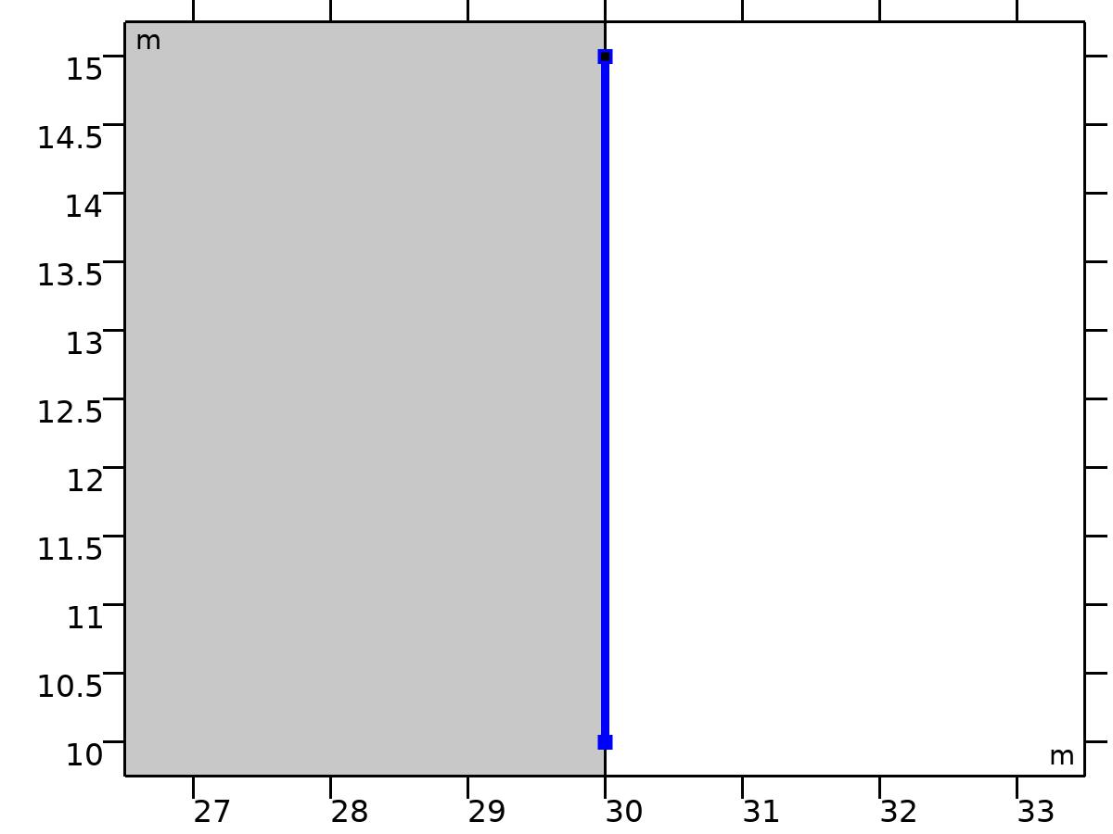

General Form Boundary PDE

Features

|  |
| --- |
| General Form PDE 1 |
| Initial Values 1 |

* + 1. General Form PDE 1

Equations

* 1. Mesh 1

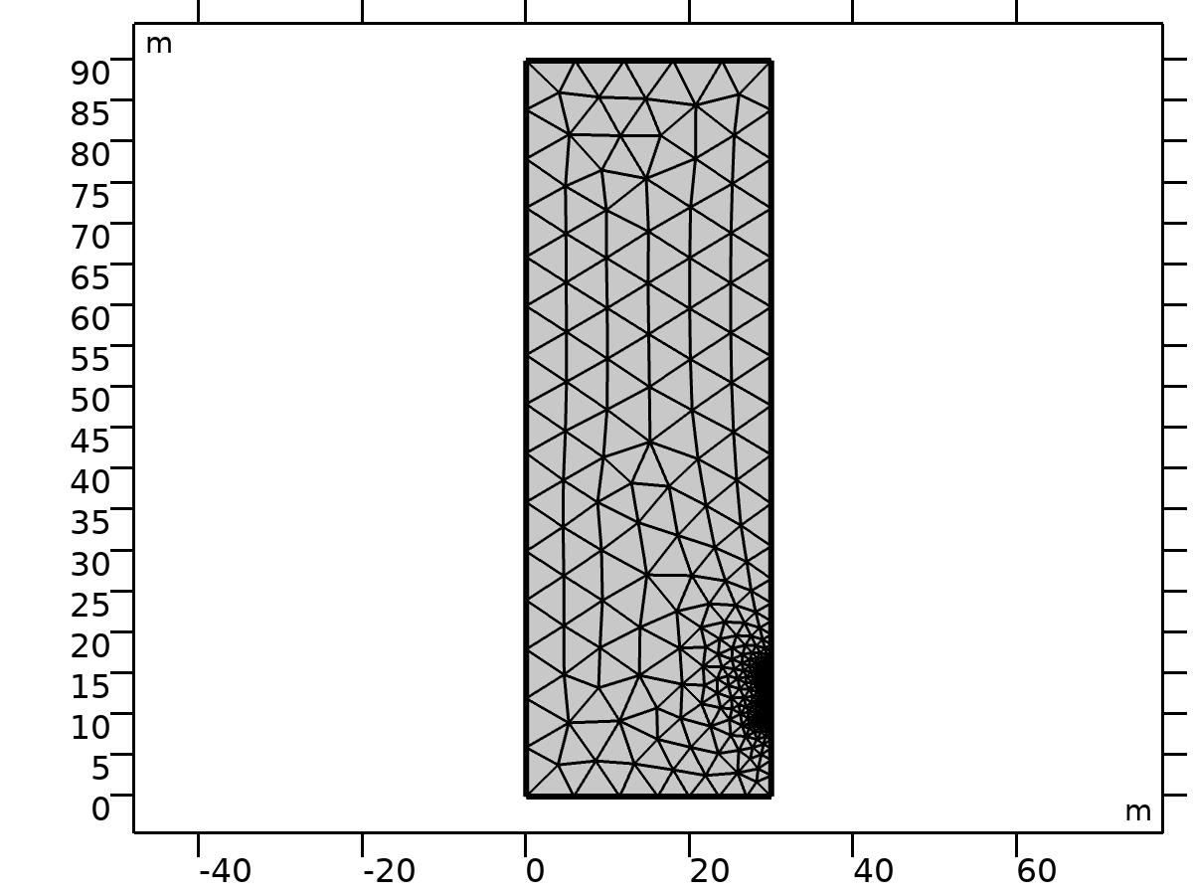

Mesh 1

1. Study 1

Computation information

|  |  |
| --- | --- |
| Computation time | 9 s |
| CPU | Intel(R) Core(TM) i7-4930K CPU @ 3.40GHz, 6 cores |
| Operating system | Windows 7 |

* 1. Time Dependent

| **Times** | **Unit** |
| --- | --- |
| range(0,0.05,2) | s |

Study settings

| **Description** | **Value** |
| --- | --- |
| Include geometric nonlinearity | Off |

Mesh selection

| **Geometry** | **Mesh** |
| --- | --- |
| mesh1 | mesh1 |

Physics and variables selection

| **Physics interface** | **Discretization** |
| --- | --- |
| Transport of Diluted Species (tds) | physics |
| General Form Boundary PDE (gb) | physics |

Mesh selection

| **Geometry** | **Mesh** |
| --- | --- |
| Geometry 1 (geom1) | mesh1 |

1. Results
   1. Data Sets
      1. Study 1/Solution 1

Solution

| **Description** | **Value** |
| --- | --- |
| Solution | Solution 1 |
| Component | Save Point Geometry 1 |

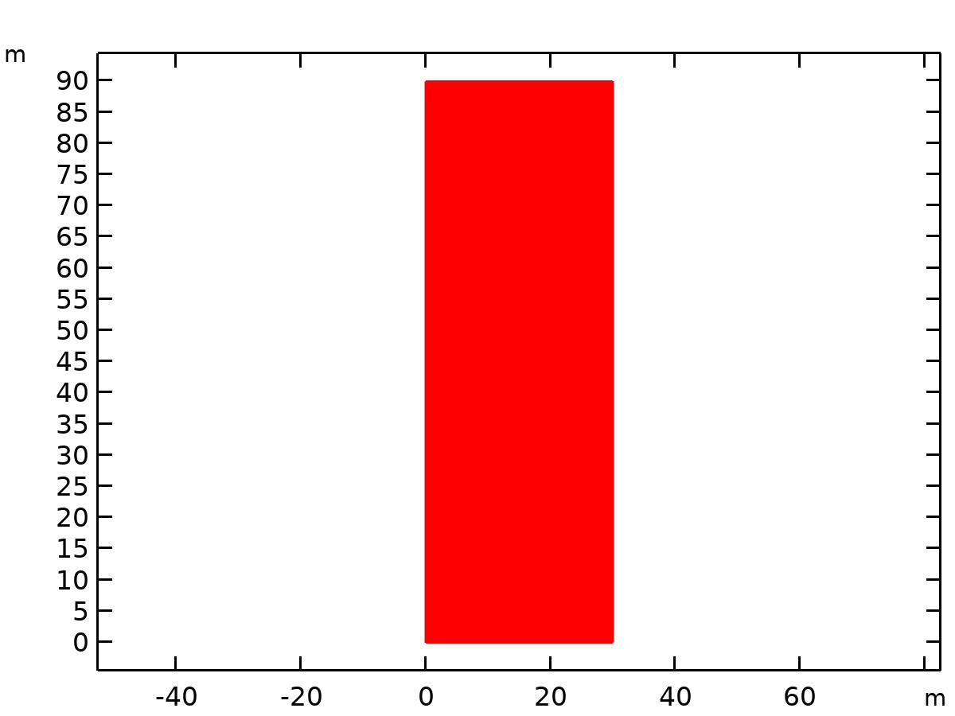

Data set: Study 1/Solution 1

* 1. Plot Groups
     1. Concentration (tds)

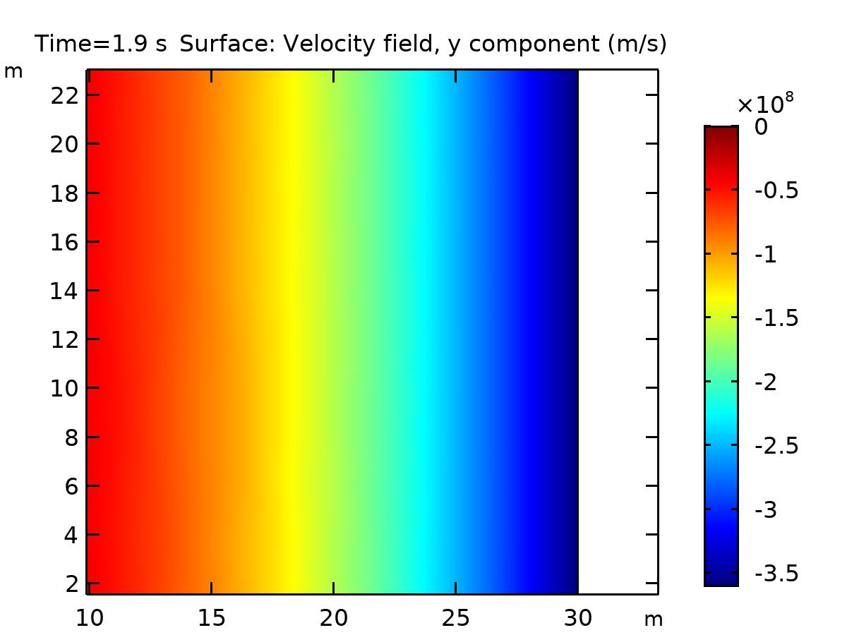

Surface: Velocity field, y component (m/s)

* + 1. Concentration species in reactor

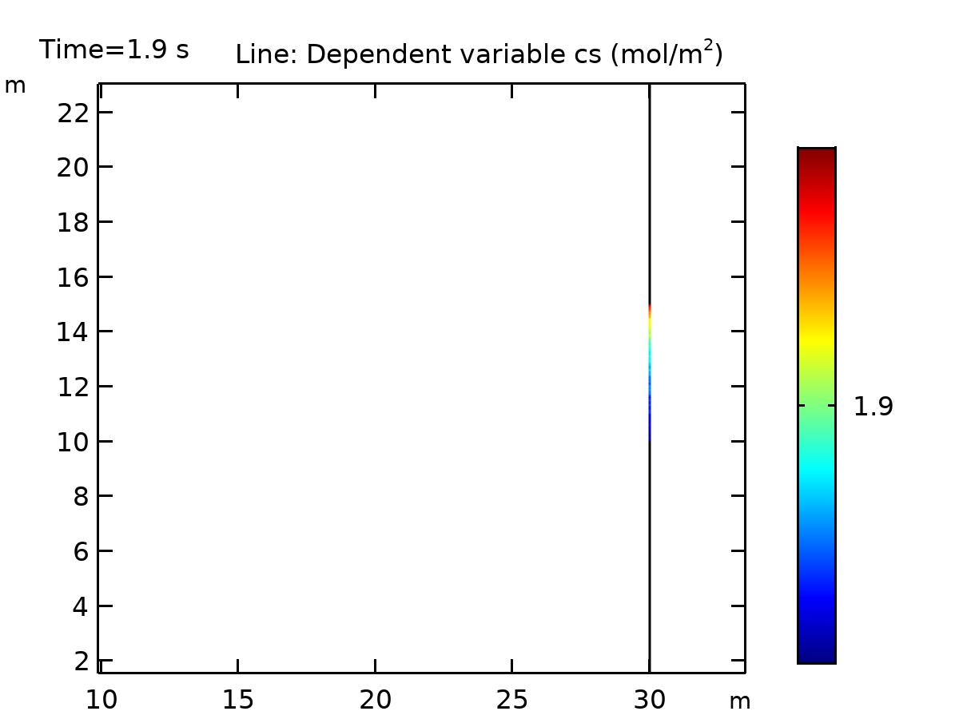

Line: Dependent variable cs (mol/m2)

* + 1. Concentration reacting species along active surface

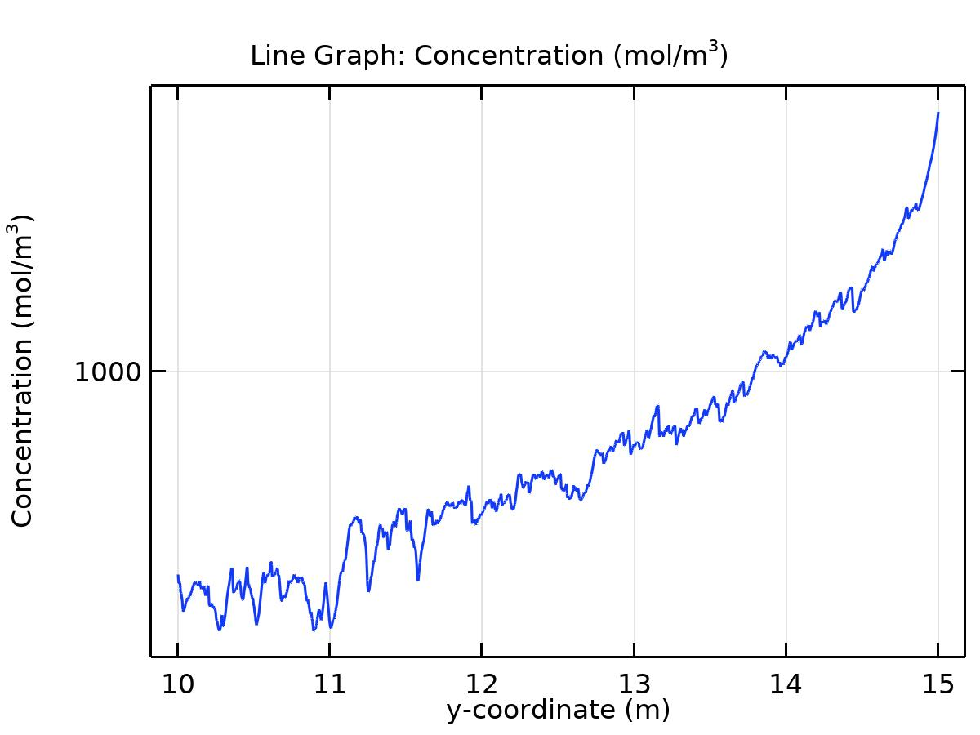

Line Graph: Concentration (mol/m3)