Problem-Sheet 4
My Solution
Michael Single
08-917-445
msingle@students.unibe.ch

Task 1:

a)
Given: Undirected Graph G = (E,V).
Unforutnaltely, I did not know how to generate optimization problems in latex. Hence I decided to write these froms by hand and just take a picture.
From the following given primal LP

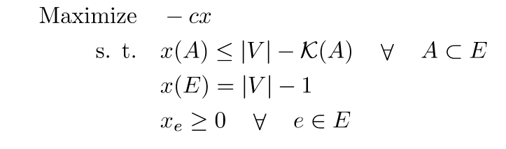
Fig: Given initial primal LP

We want to find the corresponding dual LP.
As a first step I slightly reformulate the given Probem:
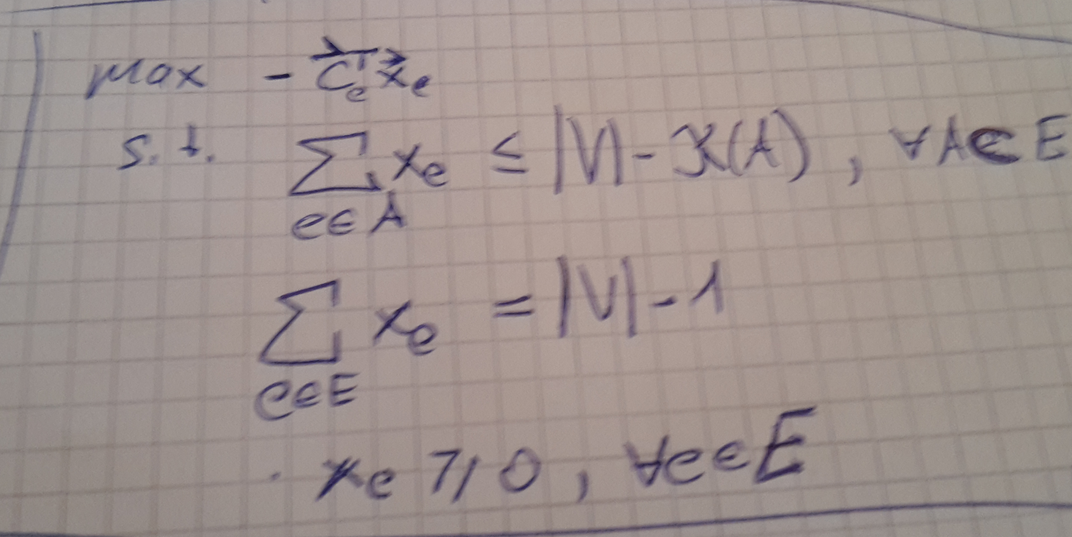
Fig: Reformulated primal LP

Note that I simply used the definition of x(A) which is equal to X(A) = sum e in A x_e for any subset A of E.

The respective dual LP is then:
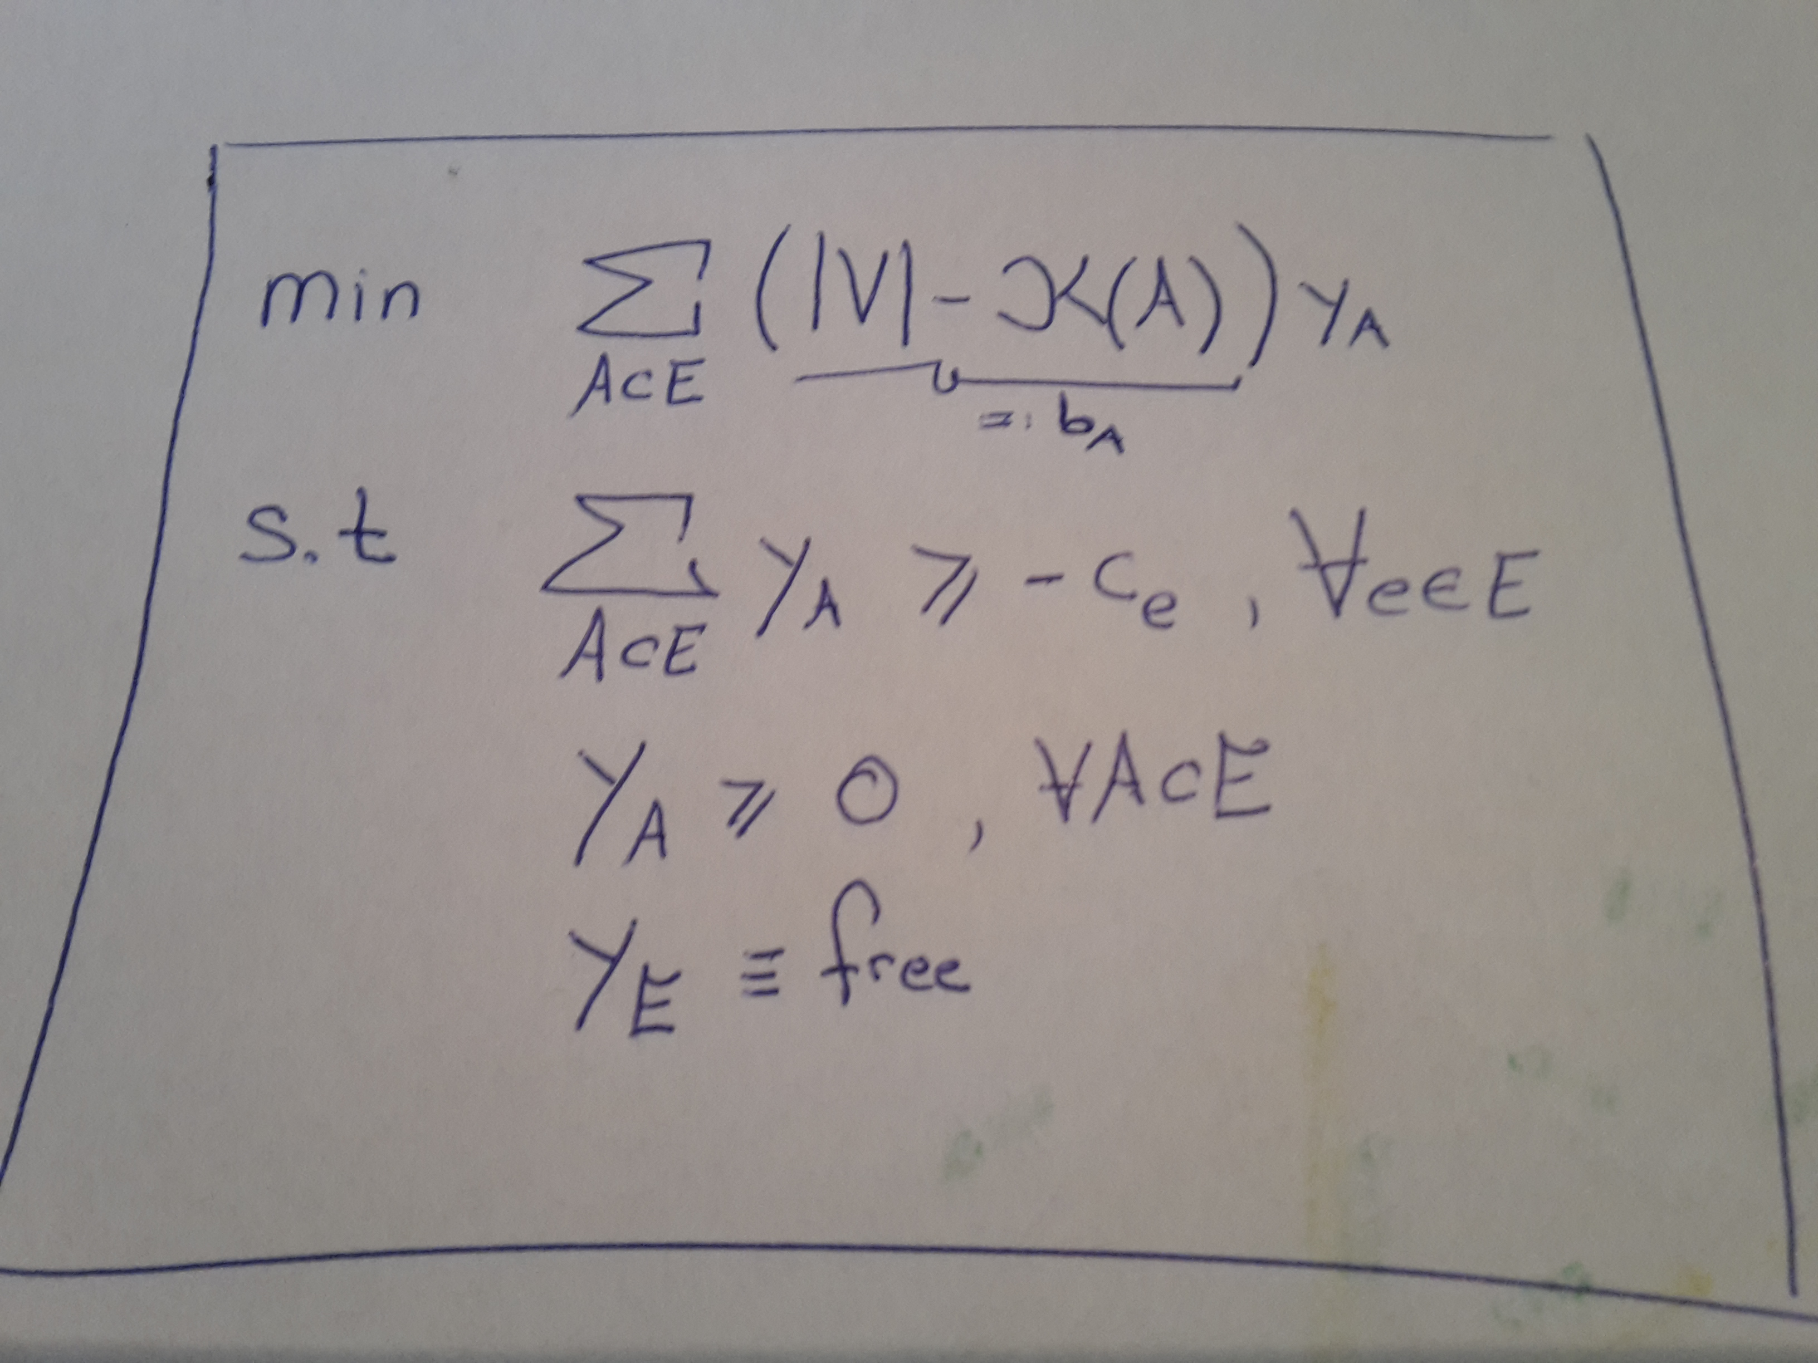
Fig: Dual version

b)
Given an undirected Graph G = (E, V) as shown in figure 1. E denotes the set of its edges, V denotes the set of its vertices.
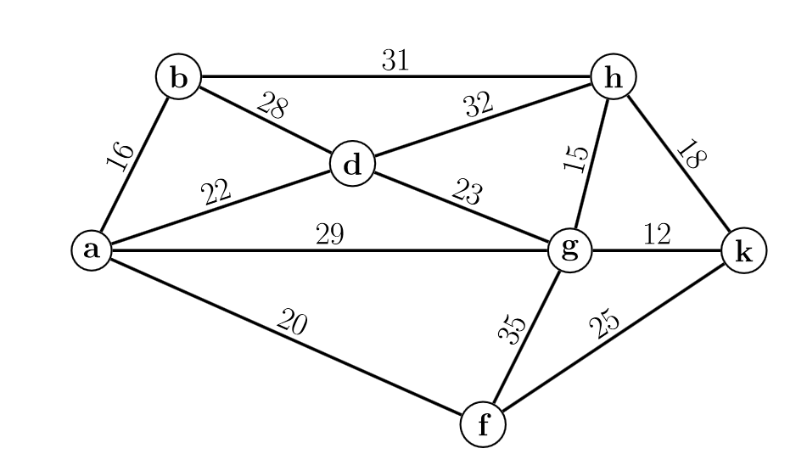
Figure 1: Given Graph G = (E, V) to solve.

Using the Kruskal Algorithm I get the following MSP from the graph in figure 1:
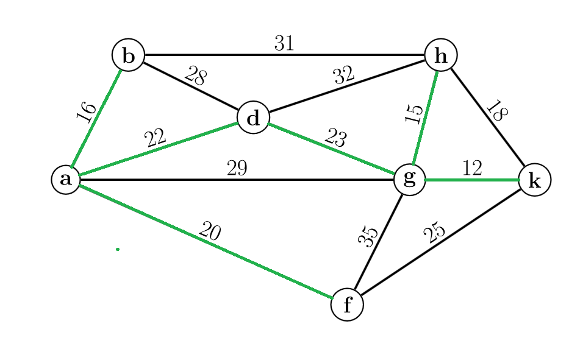
Figure 2: Minimal Spanning Tree of given graph (in green)

Next let us sort all the edges in the set E of the given graph G in an ascending order according to their edge weights. The follwoing table lists all the sorted edges. Note that the first row contains the edge with the lowest weight, whereas the last edge contains the edge with the heighest weight:

Edge e | Weight e_c | Edge e taken x_e
gk | 12 | 1
gh | 15 | 1
ab | 16 | 1
hk | 18 | 0
af | 20 | 1
ad | 22 | 1
dg | 23 | 1
fk | 25 | 0
bd | 28 | 0
ag | 29 | 0
bh | 31 | 0
dh | 32 | 0
fg | 35 | 0

In addition there is a 3rd row telling us whether we have taken this edge for our MST (equal 1) or we have not taken it (equal zero). Note that I use the following notation: an edge ab denotes an edge that connects the vertex a with the vertex b.
The total cost of this MST from figure 2 is then equal to the dot product of the vector e_c and x_e,
i.e. dot(e_c, x_e) = 108

this product is the optimal solution for the primal LP – using the vectors
- the vector e_c which corresponds to c in the primal LP.
- The vector x_e which corresponds to x⁰ in the primal LP.

Some important facts:
- Note that E is the set of all edges in G, ordered ascending according to the edge weights and
- R_i denotes the subset of E which is equal to R_i = (e1, ..., e_i) for all i=1,...,m.
- We use the dual LP (linear program) from task a)

In the following a table which contains the solution vectors of the dual problem LP:
Index I | R_I | K(A) | b = |V|-K(A) | y⁰_{A}
1 | R_1 | 6 | 1 | 3
2 | R_2 | 5 | 2 | 1
3 | R_3 | 4 | 3 | 2
4 | R_4 | 4 | 3 | 2
5 | R_5 | 3 | 4 | 2
6 | R_6 | 2 | 5 | 1
7 | R_7 | 1 | 6 | 2
8 | R_8 | 1 | 6 | 3
9 | R_9 | 1 | 6 | 1
10 | R_10 | 1 | 6 | 2
11 | R_11 | 1 | 6 | 1
12 | R_12 | 1 | 6 | 3
13 | R_13 | 1 | 6 | -35

According to the given definition:
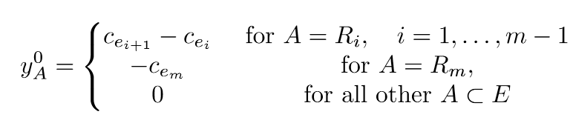
Eq 1: Equation in order to compute y⁰_{A}

I computed the values of y⁰_{A} by using Eq.1 and applying it to all R_i sets:
In practice I ordered all edge-costs ascending:
D |  | 3 |  | 1 |  | 2 |  | 2 |  | 2 |  | 1 |  | 2 |  | 3 |  | 1 |  | 2 |  | 1 |  | 3
C | 12 |  | 15 |  | 16 |  | 18 |  | 20 |  | 22 |  | 23 |  | 25 |  | 28 |  | 29 |  | 31 |  | 32 |  | 35
I | 1 |  | 2 |  | 3 |  | 4 |  | 5 |  | 6 |  | 7 |  | 8 |  | 9 |  | 10 |  | 11 |  | 12 |  | 13

Here the row C denotes all the sorted costs
I denotes the index of the i-th element in in the sorted edge-costs collection.
Row D denotes the differences between the (i+1)-th cost and the (i-th) cost.
This gives us m-1, i.e. 12 values for y⁰_{A} the last value is -35 since for A = R_m y⁰_{A} is equal to -c_e_m. This is the explenation how I computed the vector y⁰_{A} in the table from above.
Thus, the solution to the dual LP is equal to the dot product between the vectors y⁰_{A} and b (from above's table) times (-1) – please see the dual LP from task a). This is written out equal to
dot(y⁰_{A ,}b) = 108.

Last let us perfrom some sanity check – how reliable are our found solutions:

Def(Strong Duality Theorem): IF there exists a primal and a dual feasible solution, then there exists a primal feasible solution x and a dual feasible solution y such that cx = yb. The solutions x and y are then optimal.

Thus, we simple can check whether cx = yb holds true for our case:
since dot(y⁰_{A ,}b) = 108 = dot(e_c, x_e)
Our solutions to the primal and dual LP are optimal.
c)
Check the complementary slackness condition for two positive primal and two dual variables.
Def( complementary slackness condition): A primal feasible solution x and a dual feasible soution y are optimal, if and only if (i) and (ii) hold true:
- y_i > 0 and y_i non-neg variable => sum_j=1^n a_ij*x_j = b_i
- x_j > 0 and x_j non-neg. Variable => sum_i=1^m a_ij y_i = c_j

Unfortunatelly I was not able to find an easy exmaple using this graph.

d)
for the primal LP: we are looking for an vector x and c (take edge k and cost of edge k for the k-th element of these vectors).

For the dual LP :we are looking for an vector b and y.
The primal LP has many inequalties but just some unknowns whereat the dual LP has many parameter but just the number of edges constraints.

e)
Primal LP
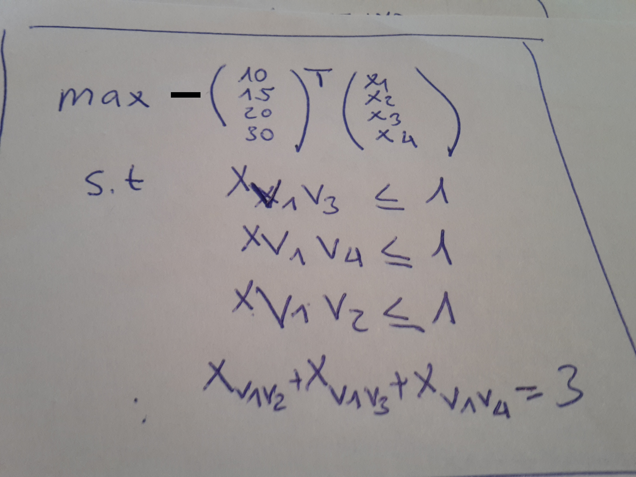
Figure Primal explicit form:
Note that I used the following variable mapping:
x1 := x_v1v4; x2 := x_v1v3; x3 := x_v3v4; x4 := x_v1v2

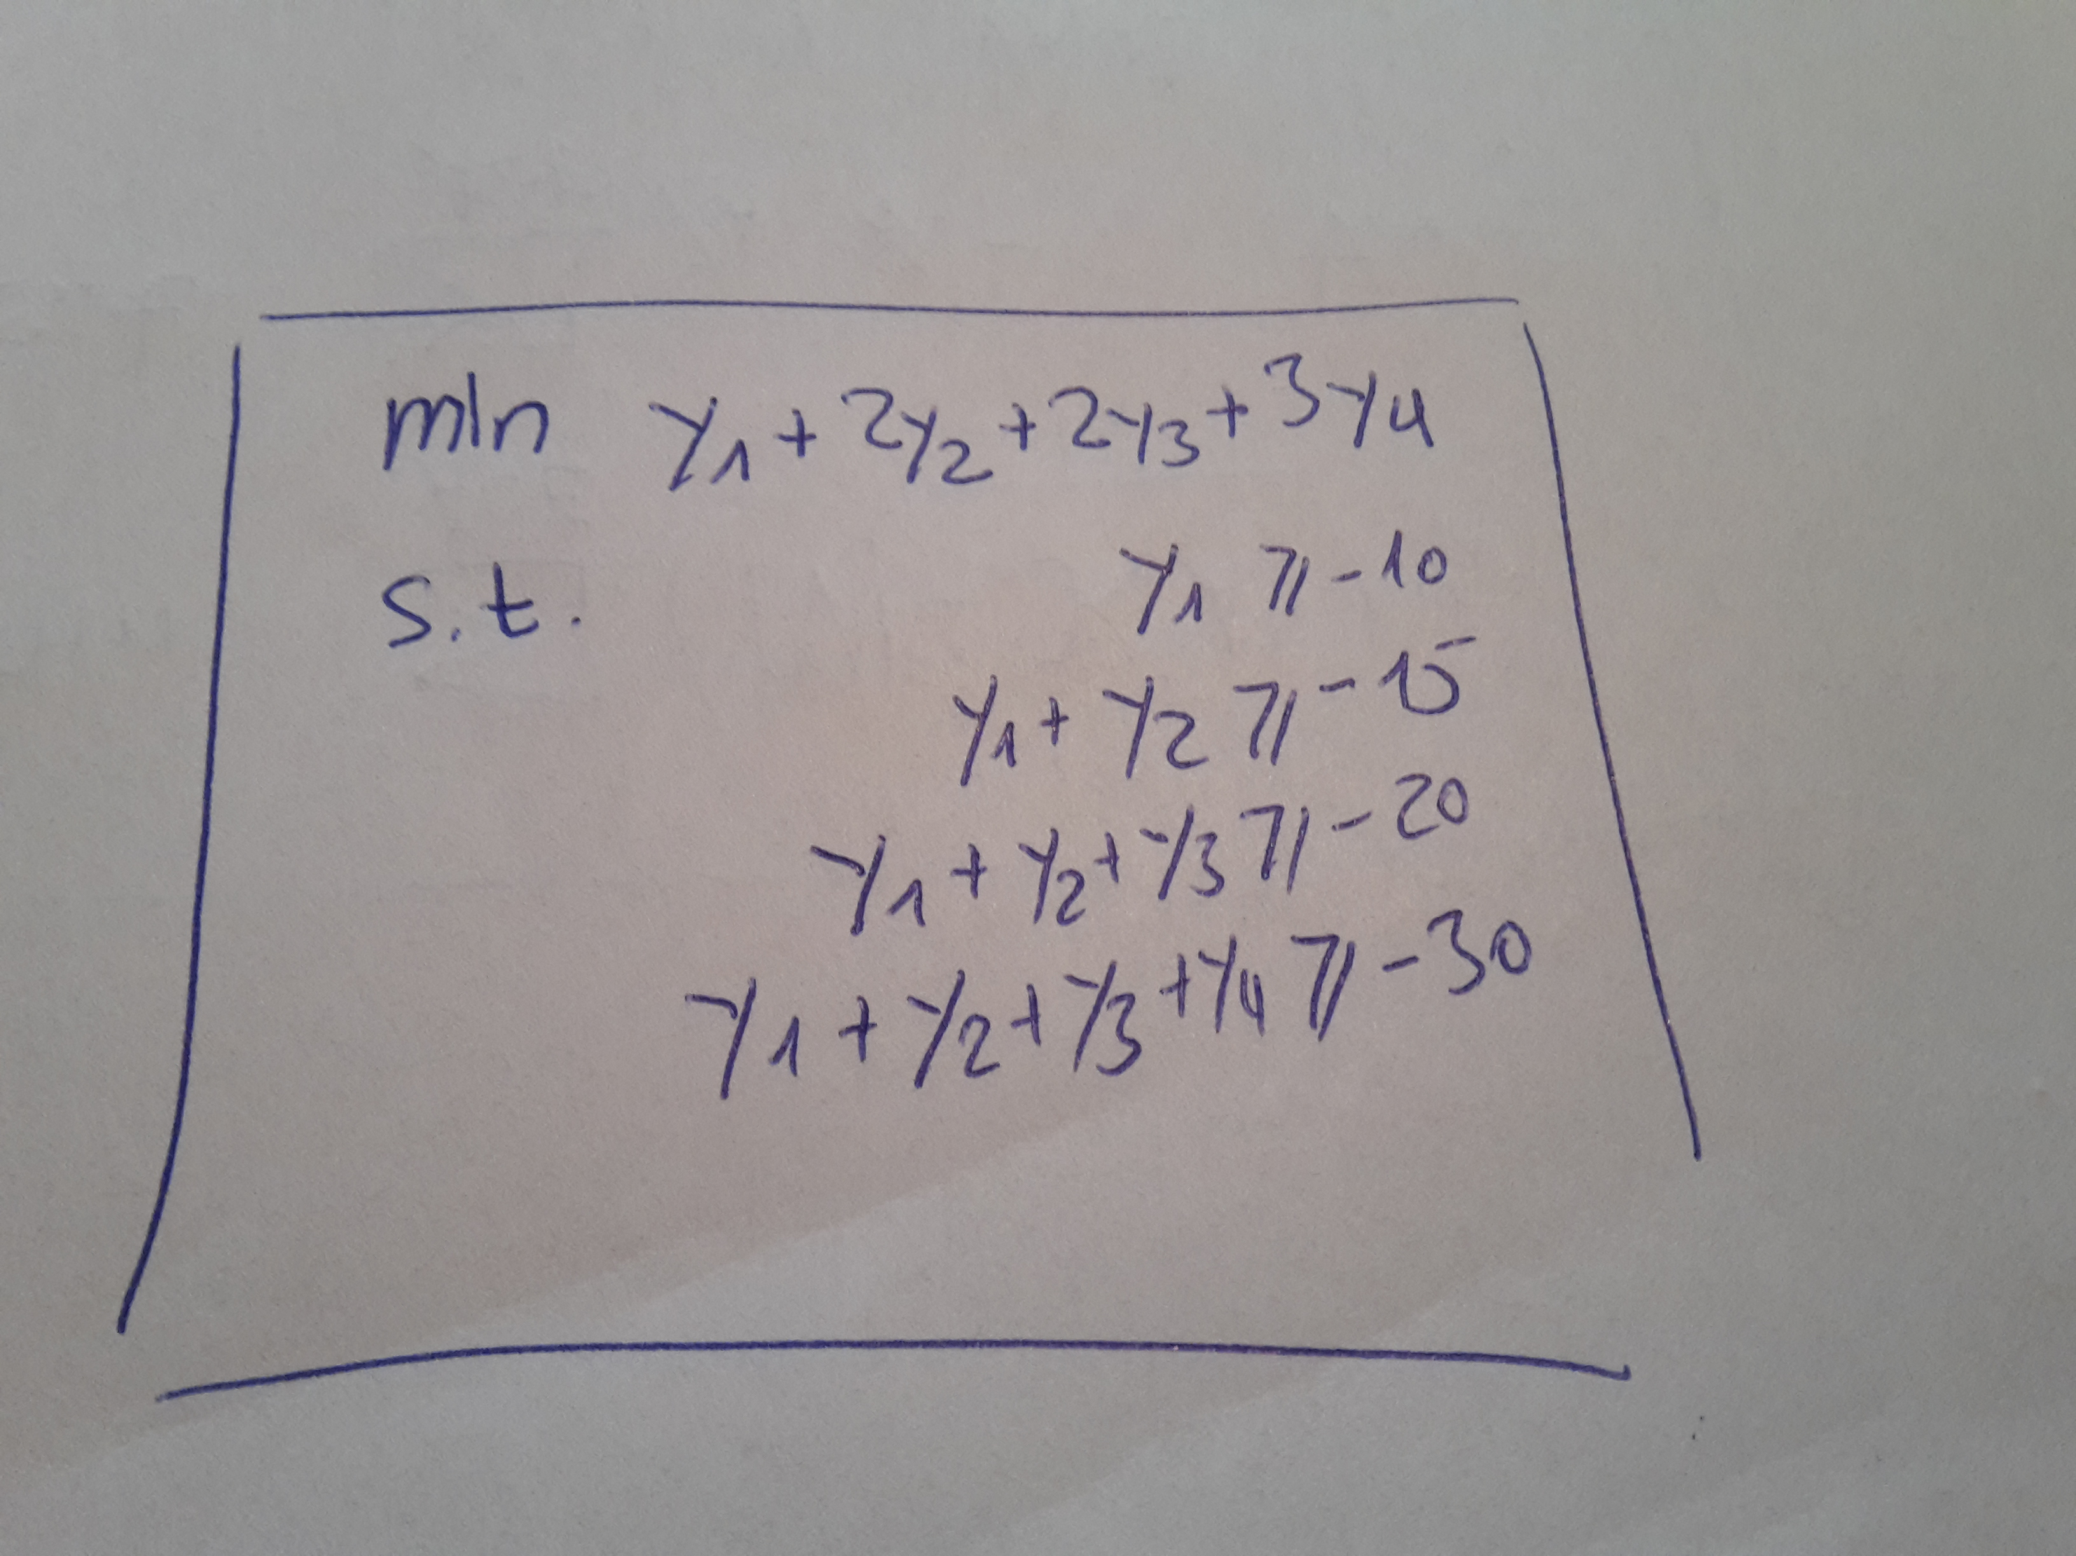

f)
Given: undirected graph G = (V,E)
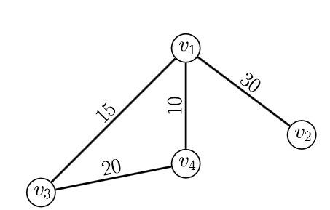

Which has the following mst:
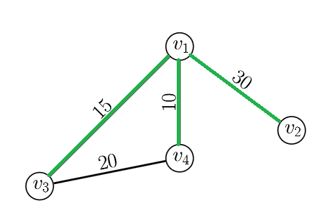

by applying the same approach I used in the previouse part, i find the vectors x and c for the primal LP and y and b for the dual LP. I gain use the formula from Eq. 1 in order to compute y:
Sorted edges according to their weights (in ascending order):

c_e =: c | e | x_e =: x
10 | v1v4 | 1
15 | v1v3 | 1
20 | v3v4 | 0
30 | v1v2 | 1

c_e denotes the cost of edge e
e is an edge, where v1v2 is the edge connecting vertex v1 with vertex v2.
x_e tells us whether we take this edge into our mst

_b = |V|-K(A) | K(A) | I | y
1 | 3 | 1 | 5
2 | 2 | 2 | 5
2 | 2 | 3 | 10
3 | 1 | 4 | -30

We can check the validity of our solution by again using the Strong duality theorem.
If cx = yb holds true, then, our solution is indeed optimal.
Since cx = 55 = yb we have shown that we have found an optimal solution.

