Problem-Sheet 6
My Solution
Michael Single
08-917-445
msingle@students.unibe.ch

Task1:
Given the undirected Graph G =(E, V) as shown in Figure 1
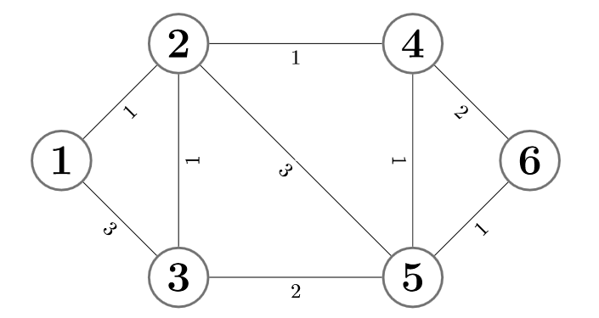
Figure 1.1: Exercise Graph G

a)
Give a linear Program that solves the problem of finding a shortest path from Vertex 1 to Vertex 6.

The general formulation of such a linear program for finding the shortest path from a given starting vertex s to a certain target vertex t is shown in figure 1.2.
Note that the variables
- y_{k} denotes the length of the shortest path from the source vertex s to the vertex k in the Graph G.
- w_ij denotes the weight of the edge ij – i.e. The edge from vertex i to vertex j.
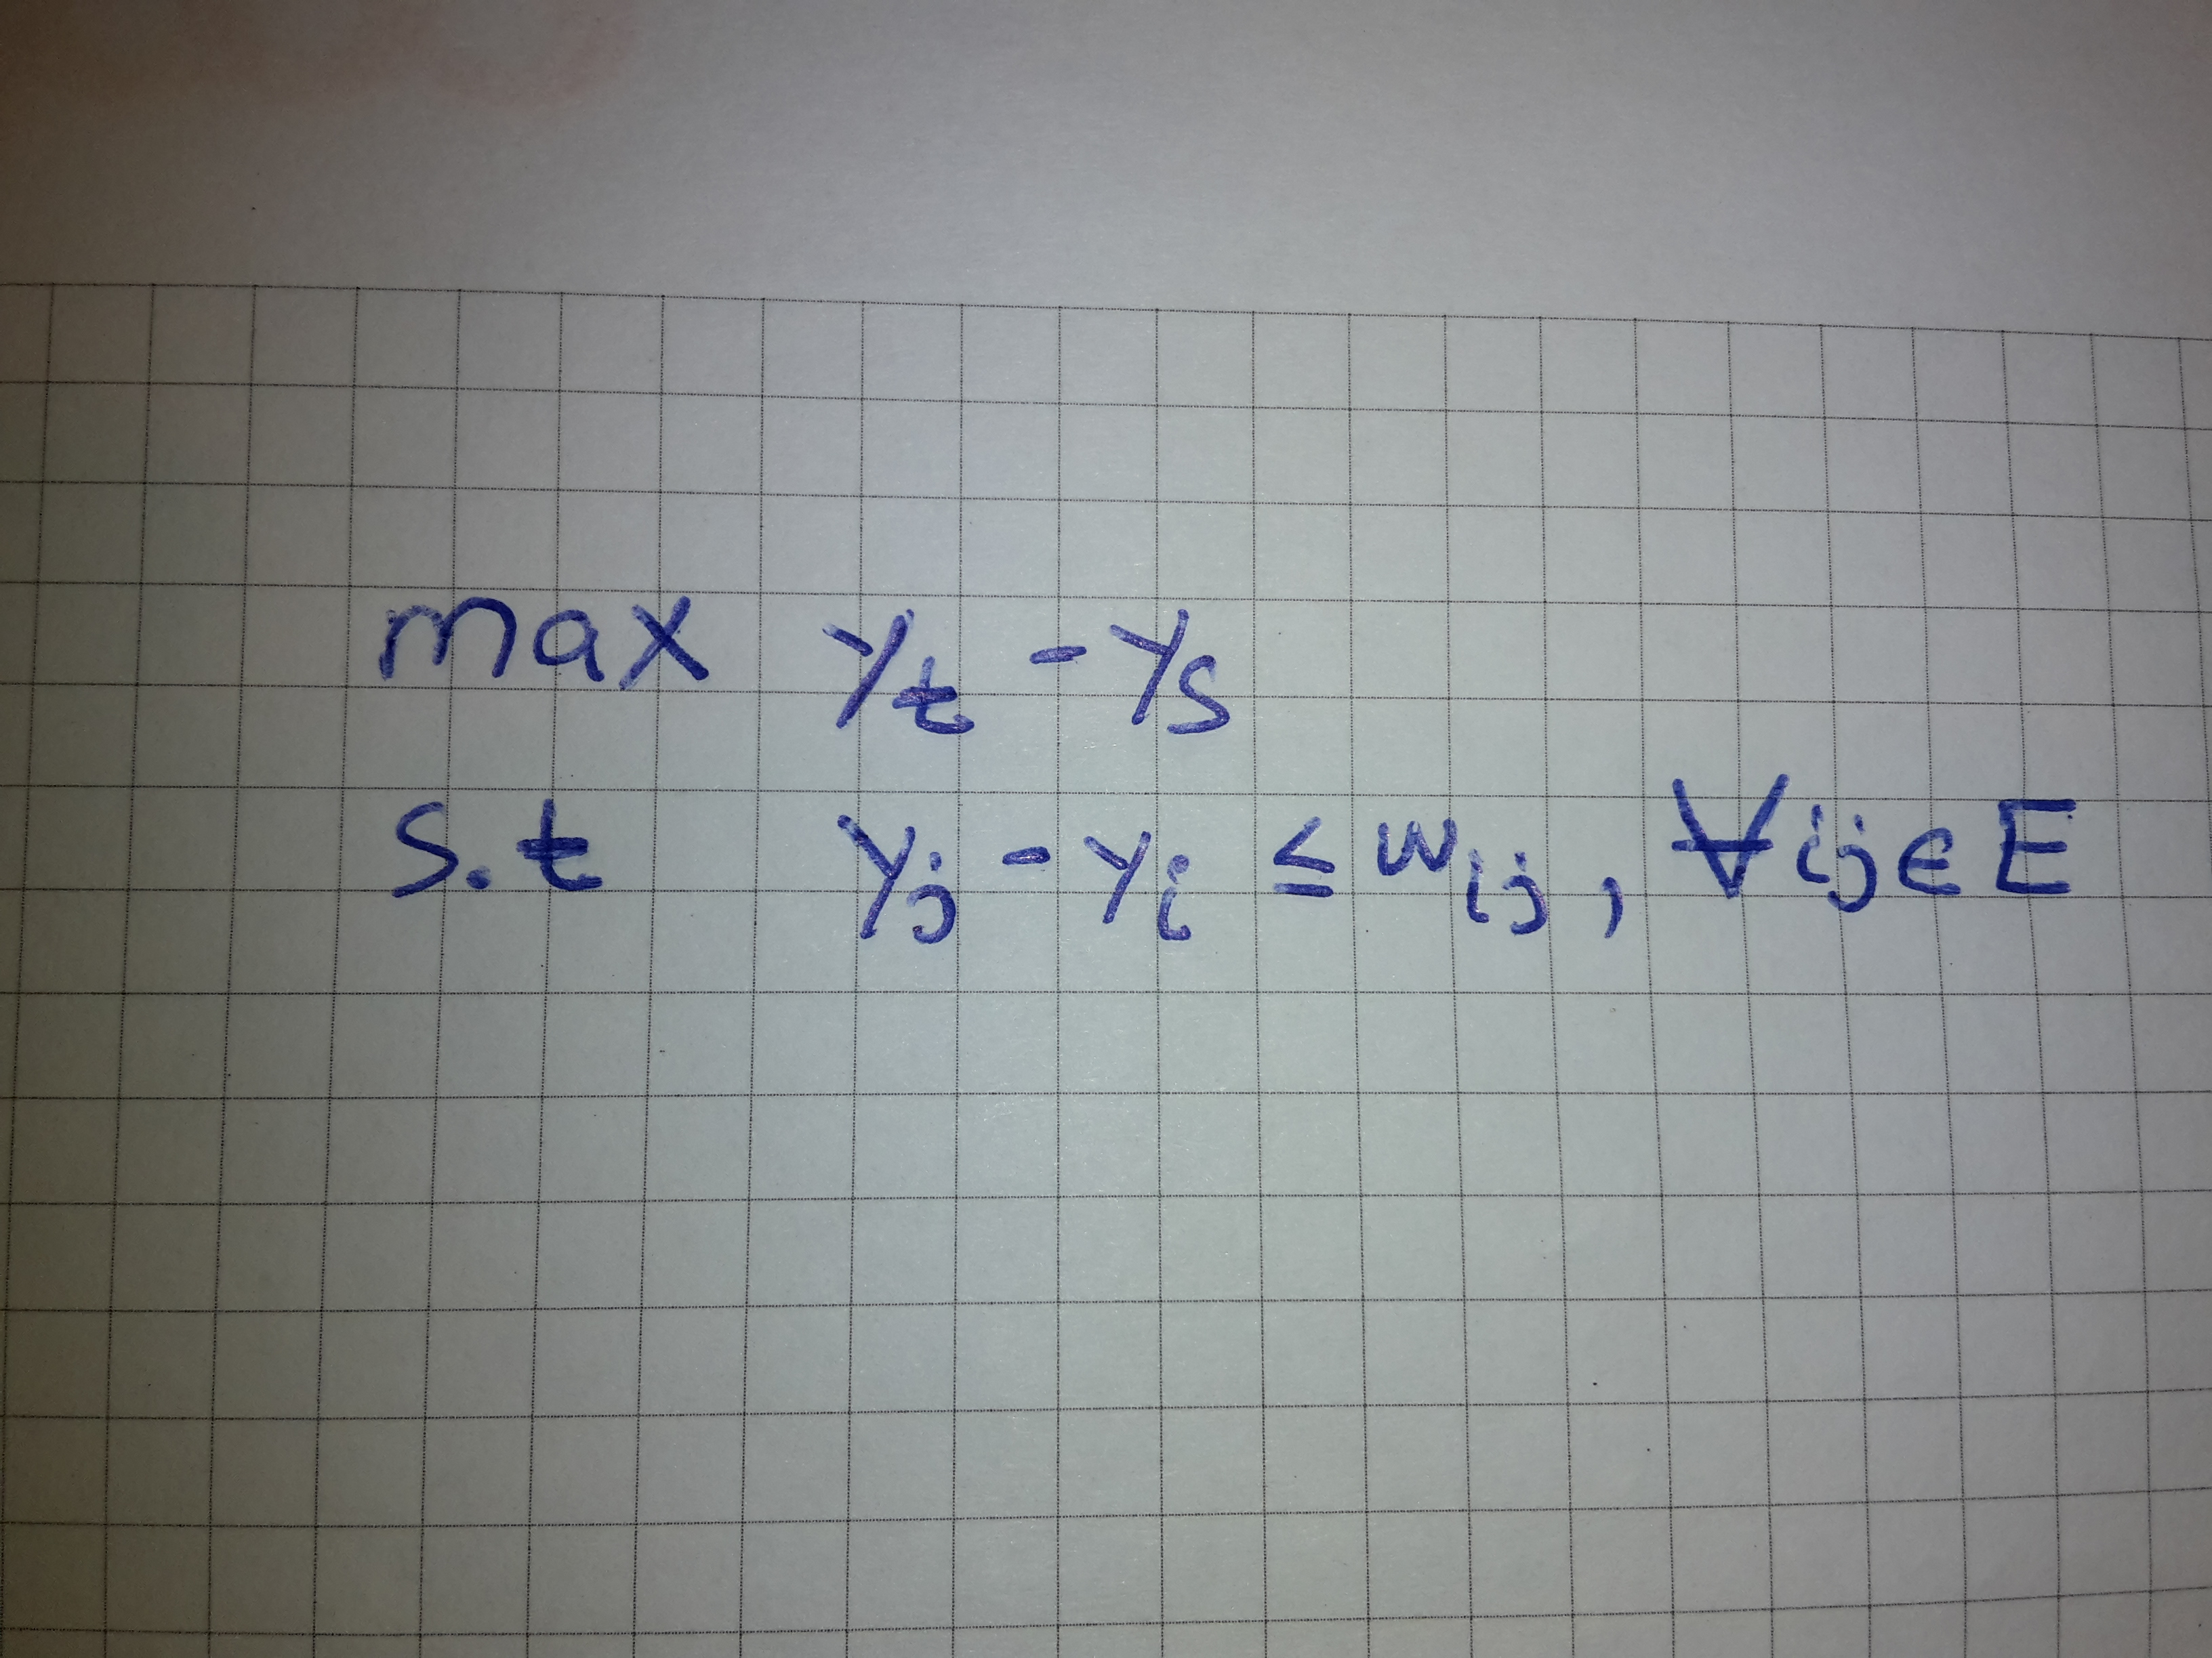
Figure 1.2:General LP for finding the Shortest Path

For the graph in figure 1.1, it has the following weight vector
w= [w_12, w_13, w_21, w_23, w_24, w_25, w_31,
w_32, w_35, w_42, w_45, w_46, w_52, w_53, w_54, w_56, w_64, w_65]
= [1,3,1,1,1,3,3,1,2,1,1,2,3,2,1,1,2,1]

Applying this LP to our given example graph G from figure 1.1 gives us the LP as shown in figure 1.3 below:

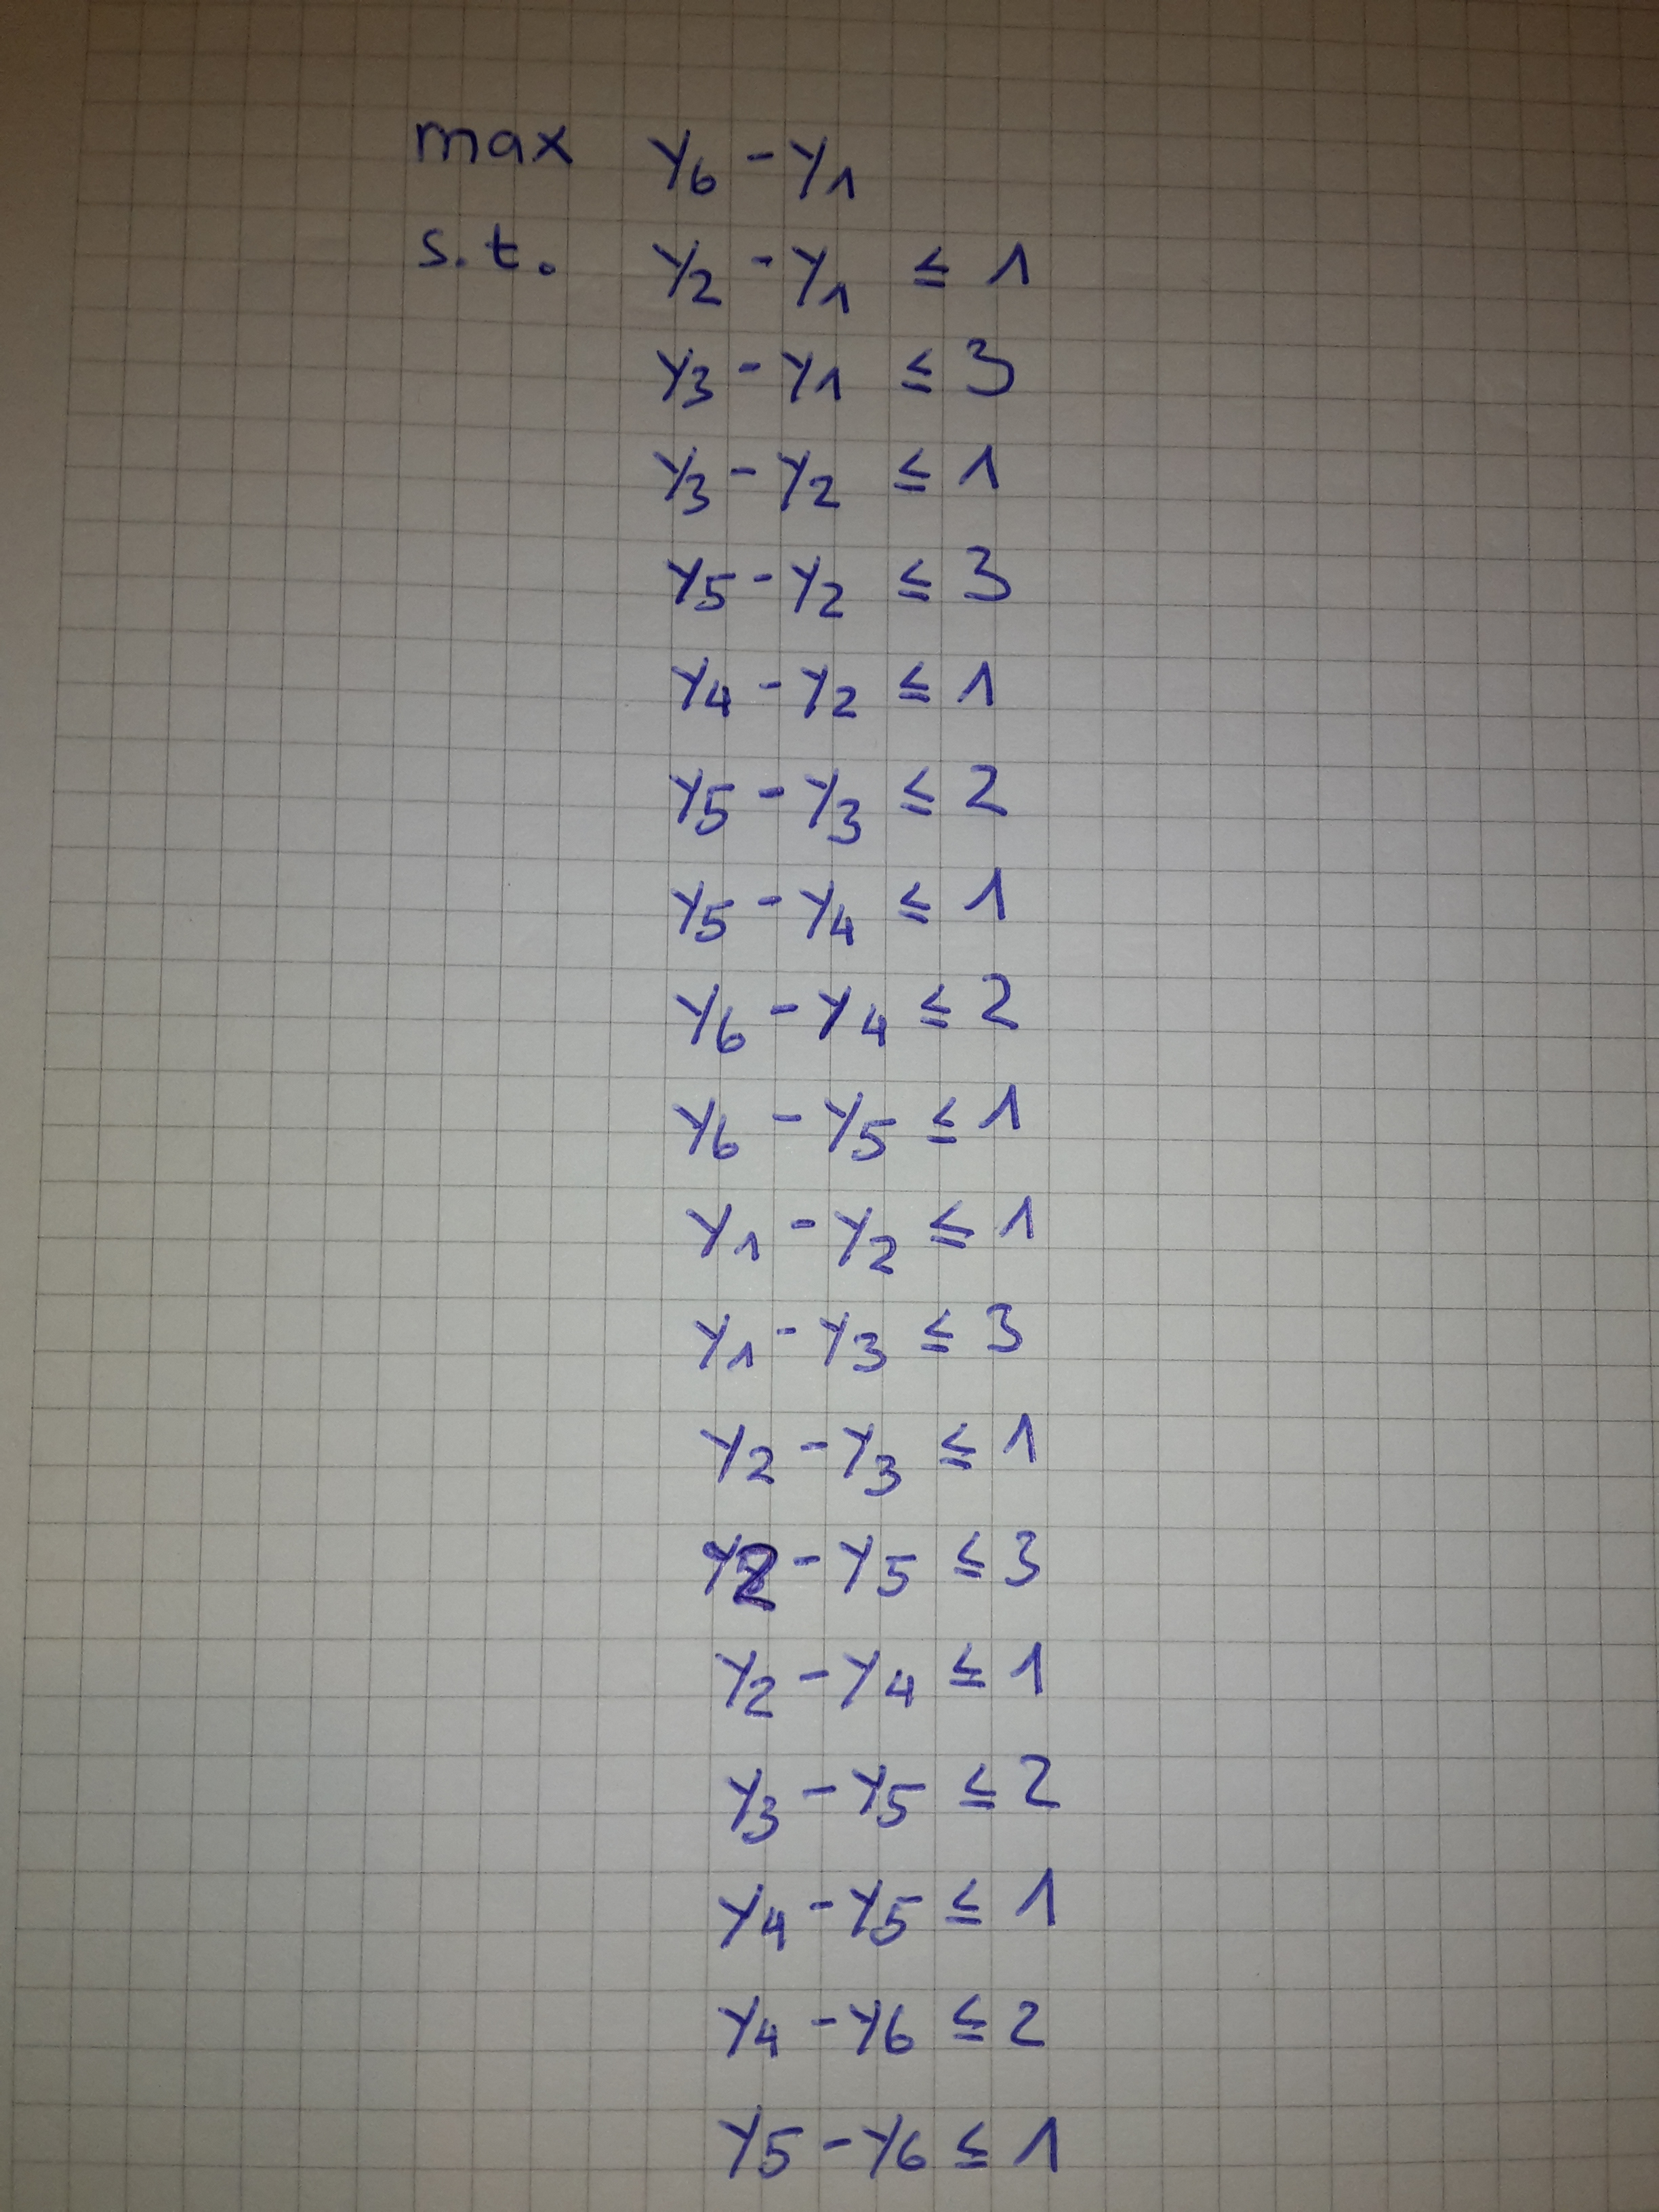
Figure 1.3: LP from figure 1.2 applied to the example graph from figure 1.1

b) Solve the linear program
Solving the LP from a) we get y = [y1, y6] = [0, 4]
thus, the solution (for the maximum) is then: y_6 – y_1 = 4 – 0 = 4.

c) Derive the dual problem and explain it.

The general formulation of the dual problem of a) for finding the shortest path from a given starting vertex s to a certain target vertex t is shown in figure 1.4.

- x_ij is an indicator variable telling us whether an edge ij in E is part of the shortest path. If ij is in the shortest path, then x_ij is equal 1 otherwise it is equal 0.
- Note that since our graph G is undirected we have to consider both, x_ij AND x_ji
  - Corresponds to the same as we would have a directed graph having an edge from Vertex i to Vertex j and one edge from j to i.
- Here: x = [x_12, x_13, x_21, x_23, x_24, x_25, x_31,
x_32, x_35, x_42, x_45, x_46, x_52, x_53, x_54, x_56, x_64, x_65]

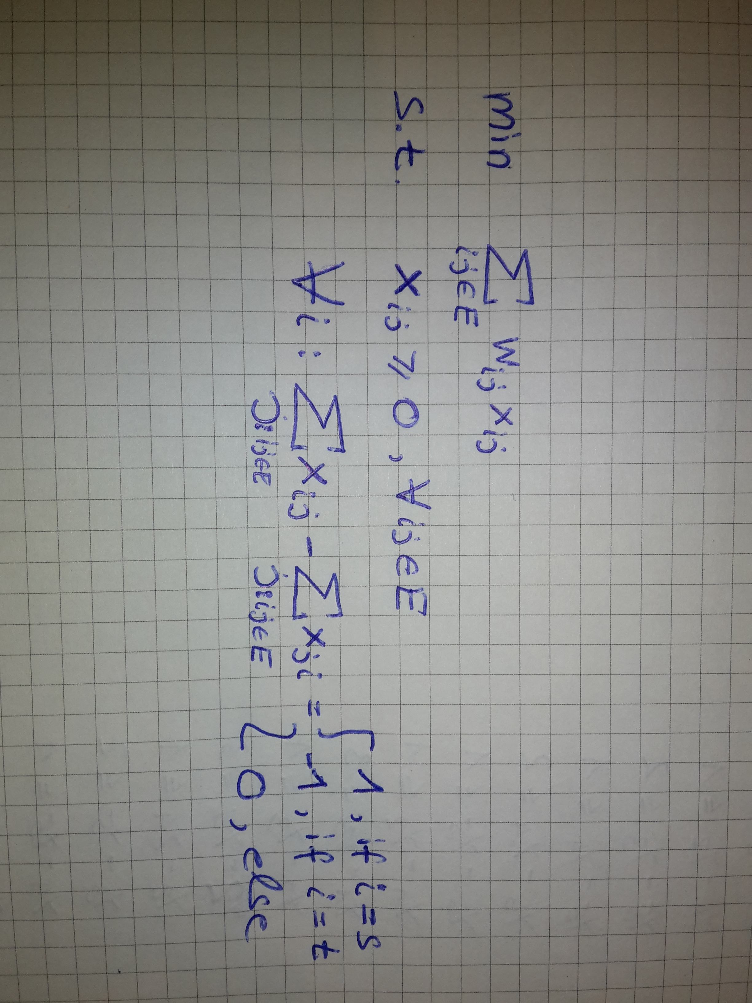
Figure 1.4: General Dual Problem from c)

Applying this dual Problem to our given example graph G from figure 1.1 gives us the LP as shown in figure 1.5 below:
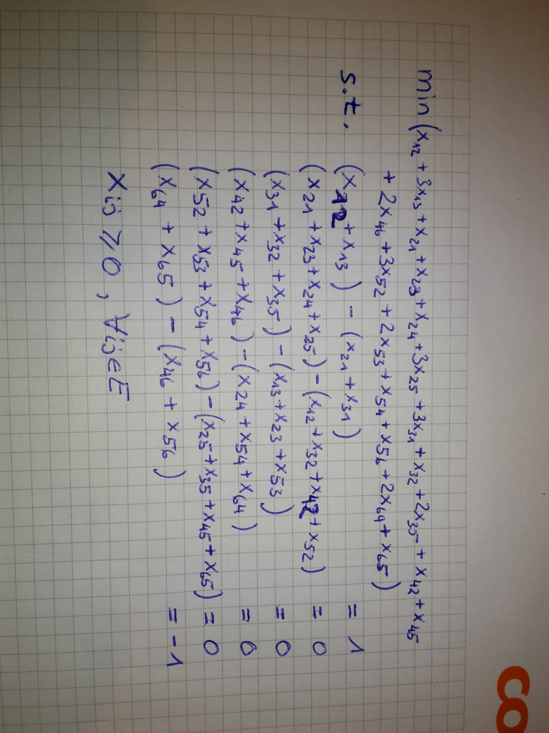
Figure 1.5: dual problem from figure 1.4 applied to the example graph from figure 1.1.

d) Solve the linear program
Given our dual problem, we are looking for the entries of the vector
x = [x_12, x_13, x_21, x_23, x_24, x_25, x_31,
x_32, x_35, x_42, x_45, x_46, x_52, x_53, x_54, x_56, x_64, x_65]

There exists actually two possible solutions:
- solution#1: x_12 = 1, x_24 = 1 and x_46 = 1 and every other x_ij of x is zero
- solution#2: x_12 = 1, x_24 = 1, x_45 = 1 and x_56 = 1 and every other x_ij in x is zero

Using the solution#1, we get the following minimum: x_21+x_24+x_46 = 1 + 1 + 2*1 = 4
Using the solution#2, we get the following minimum: x_21+x_24+x_45+x_56 = 1 + 1 + 1 + 1 = 4

Since the solution for the Primal and dual Problem give us both 4 – for every case – we have found the correct solution.

Note that there are two possible shortest path:
- From v1=>v2=>v4=>v6
- From v1=>v2=>v4=>v5=>v6
Both having a cost of 4.

Task2:
A directed graph G is given by the table from figure 2.1.
Figure 2.1: Adjacency matrix of example graph for task 2.

Implment the algorithm of Floyd and Warshall in a programming language of your chouce and test it on the graph from figure 2.1. Give the shortest paths and their lengths for all pairs of noces.

I have implemented the „ Floyd and Warshall“ Algoirthm in Ruby. You can find my source-code on github: https://github.com/simplay/combo
Please read the READMEmd + the WIKI on the Repository.
Usage: simply run: ruby combo -t 2 in your console for solving for the shortest paths for the graph shown in figure 2.1.
Running my code I get the following output:
directed Graph G=(V,E,w)
6 vertices V with their label values l:
1 l: -1
2 l: -1
3 l: -1
4 l: -1
5 l: -1
6 l: -1
14 edges E with their weight w:
1->2 w: 2.0
1->5 w: 9.0
2->1 w: 2.0
2->6 w: 6.0
3->1 w: 15.0
3->2 w: 2.0
3->4 w: 3.0
3->5 w: 3.0
3->6 w: 9.0
4->6 w: 1.0
5->3 w: 10.0
5->4 w: 9.0
6->4 w: 4.0
6->5 w: 3.0
All shortest paths for each vertex pair (i,j):
Distance from vertex i=1 to vertex j=1: 0.0 path: does not exist
Distance from vertex i=1 to vertex j=2: 2.0 path: [1,2]
Distance from vertex i=1 to vertex j=3: 19.0 path: [1,5,3]
Distance from vertex i=1 to vertex j=4: 12.0 path: [1,2,6,4]
Distance from vertex i=1 to vertex j=5: 9.0 path: [1,5]
Distance from vertex i=1 to vertex j=6: 8.0 path: [1,2,6]
Distance from vertex i=2 to vertex j=1: 2.0 path: [2,1]
Distance from vertex i=2 to vertex j=2: 0.0 path: does not exist
Distance from vertex i=2 to vertex j=3: 19.0 path: [2,6,5,3]
Distance from vertex i=2 to vertex j=4: 10.0 path: [2,6,4]
Distance from vertex i=2 to vertex j=5: 9.0 path: [2,6,5]
Distance from vertex i=2 to vertex j=6: 6.0 path: [2,6]
Distance from vertex i=3 to vertex j=1: 4.0 path: [3,2,1]
Distance from vertex i=3 to vertex j=2: 2.0 path: [3,2]
Distance from vertex i=3 to vertex j=3: 0.0 path: does not exist
Distance from vertex i=3 to vertex j=4: 3.0 path: [3,4]
Distance from vertex i=3 to vertex j=5: 3.0 path: [3,5]
Distance from vertex i=3 to vertex j=6: 4.0 path: [3,4,6]
Distance from vertex i=4 to vertex j=1: 18.0 path: [4,6,5,3,2,1]
Distance from vertex i=4 to vertex j=2: 16.0 path: [4,6,5,3,2]
Distance from vertex i=4 to vertex j=3: 14.0 path: [4,6,5,3]
Distance from vertex i=4 to vertex j=4: 0.0 path: does not exist
Distance from vertex i=4 to vertex j=5: 4.0 path: [4,6,5]
Distance from vertex i=4 to vertex j=6: 1.0 path: [4,6]
Distance from vertex i=5 to vertex j=1: 14.0 path: [5,3,2,1]
Distance from vertex i=5 to vertex j=2: 12.0 path: [5,3,2]
Distance from vertex i=5 to vertex j=3: 10.0 path: [5,3]
Distance from vertex i=5 to vertex j=4: 9.0 path: [5,4]
Distance from vertex i=5 to vertex j=5: 0.0 path: does not exist
Distance from vertex i=5 to vertex j=6: 10.0 path: [5,4,6]
Distance from vertex i=6 to vertex j=1: 17.0 path: [6,5,3,2,1]
Distance from vertex i=6 to vertex j=2: 15.0 path: [6,5,3,2]
Distance from vertex i=6 to vertex j=3: 13.0 path: [6,5,3]
Distance from vertex i=6 to vertex j=4: 4.0 path: [6,4]
Distance from vertex i=6 to vertex j=5: 3.0 path: [6,5]
Distance from vertex i=6 to vertex j=6: 0.0 path: does not exist
The most important code is in the file „src/adj_matrix.rb“

class AdjMatrix

attr_accessor :schema

ALMOST_INF = (1 << (1.size * 8 - 2) - 1)

def initialize(graph)
@vertices = graph.vertices
@v_count = @vertices.count

@schema = []
@next = []

# init adj. mat
@v_count.times do
a_row = []
a_next_row = []
@v_count.times do
a_row << ALMOST_INF
a_next_row << nil
end
@schema << a_row
@next << a_next_row
end

#foreach edge label
graph.edges.each do |edge|
@schema[edge.u][edge.v] = edge.weight
@next[edge.u][edge.v] = edge.to
end

graph.vertices.each do |vertex|
v_idx = vertex.idx
@schema[v_idx][v_idx] = 0.0
end

end

# Floyd–Warshall algorithm
def shortes_paths
distances = copied_schema

@v_count.times do |k|
@v_count.times do |i|
@v_count.times do |j|
relax(distances, i, j, k)
end
end
end
distances
end

# get path from a given vertex to a given vertex
# convention: report 'path does not exist'
# in case we query for path from Vertex v to Vertex v.
# @param from Vertex start
# @param to Vertex destination
def shortest_path(from, to)
u = from; v = to
return "does not exist" if @next[u.idx][v.idx].nil?

path = ("["+u.to_s + ",")

until(u.eql?(v))
u = @next[u.idx][v.idx]
path += (u.to_s + ",")
end
path = path[0..path.size-2]
path += "]"
path
end

def to_s
@schema.each do |row|
row.each do |element|
value = element.eql?(ALMOST_INF) ? "inf" : element.to_s
print value + " "
end
puts
end
end

private

# update (i,j)-th element of given container
# if it can be relaxed
def relax(container, i, j, k)
if(container[i][j] > container[i][k] + container[k][j])
container[i][j] = container[i][k] + container[k][j]
@next[i][j] = @next[i][k]
end
end

# copy each value in the :schema into
# a new instantiated 2d array.
def copied_schema
c = []
@v_count.times do |i|
c_row = []
@v_count.times do |j|
c_row << @schema[i][j]
end
c << c_row
end
c
end

end

