Problem-Sheet 7
My Solution
Michael Single
08-917-445
msingle@students.unibe.ch

Task1a:
The flow that goes in, that has to go again out – except for the source and sink nodes.

(1) not feasible, since x_ra = 4 contradicts the capacity constraint x_ra <= c_ra = 3
(3) not feasible, since x_cb = 2 contradicts the capacity constraint x_cb <= c_cb = 1

(2) is feasible, since for each node the total incoming flow is equal its total
outgoing flow into any node (except the sink and and source)

proof
In the following a list incoming and outgoing flow for each node (in = receives, out = sends).
node c
receives
1 from r
1 from d

sends
1 to b
1 to d

node a
receives
2 from r
1 from b
sends
2 to b
1 to d

node b
receives
2 from a
1 from c
sends
2 to s
1 to a

node d
receives
1 from c
1 from a
sends
1 to s
1 to c

the flow from the source to the sink is equal to 2 + 1 = 3
2 from r to a, 1 from a to b (not two, since one goes directly back to a from b) (b gets another one from c), b send 2 to s
similarly from r to c (1 flow), then c sends to d and d to c, i.e. cancels out.
a aslo sends one to d, d sends another one to s, thus one contribution to s.

Task1b:
(1) no, since from there is still a possible flow path from r to s
via r-c-d-s

(2) yes, this is a r-s cut,
since there is no possible flow from r to s
first, r does not connect c anymore and a does not connect d, therefore
there is no possible flow from below, neither from c to b is flow, nor from d to s
since also a to b is cut (last remaining path, there is no flow possible
cap: 4 + 5 = 9

(3) yes, it is a cut:
either, s receives flow from b or d.
since bs is cut, it cannot get flow from b.
since the connection cd and ad are cut, d cannot reiceive any flow
therefore, there is no flow from r to s
cap: 4 + 2 + 5 = 11

(4) yes, it is a cut:
since ra is removed, no cotribution from r to a directly
since cb is also cut, there cannot be any flow from b to s.
since the only connection to d from below is also cut, there is no flow from r to s.

cap: 3 + 1 + 2 = 6

Task1c:
Figure 1 shows a feasible r-s flow with value equal to the best (r-s) cut found in b) which was equal to 6 – see example b) (4).
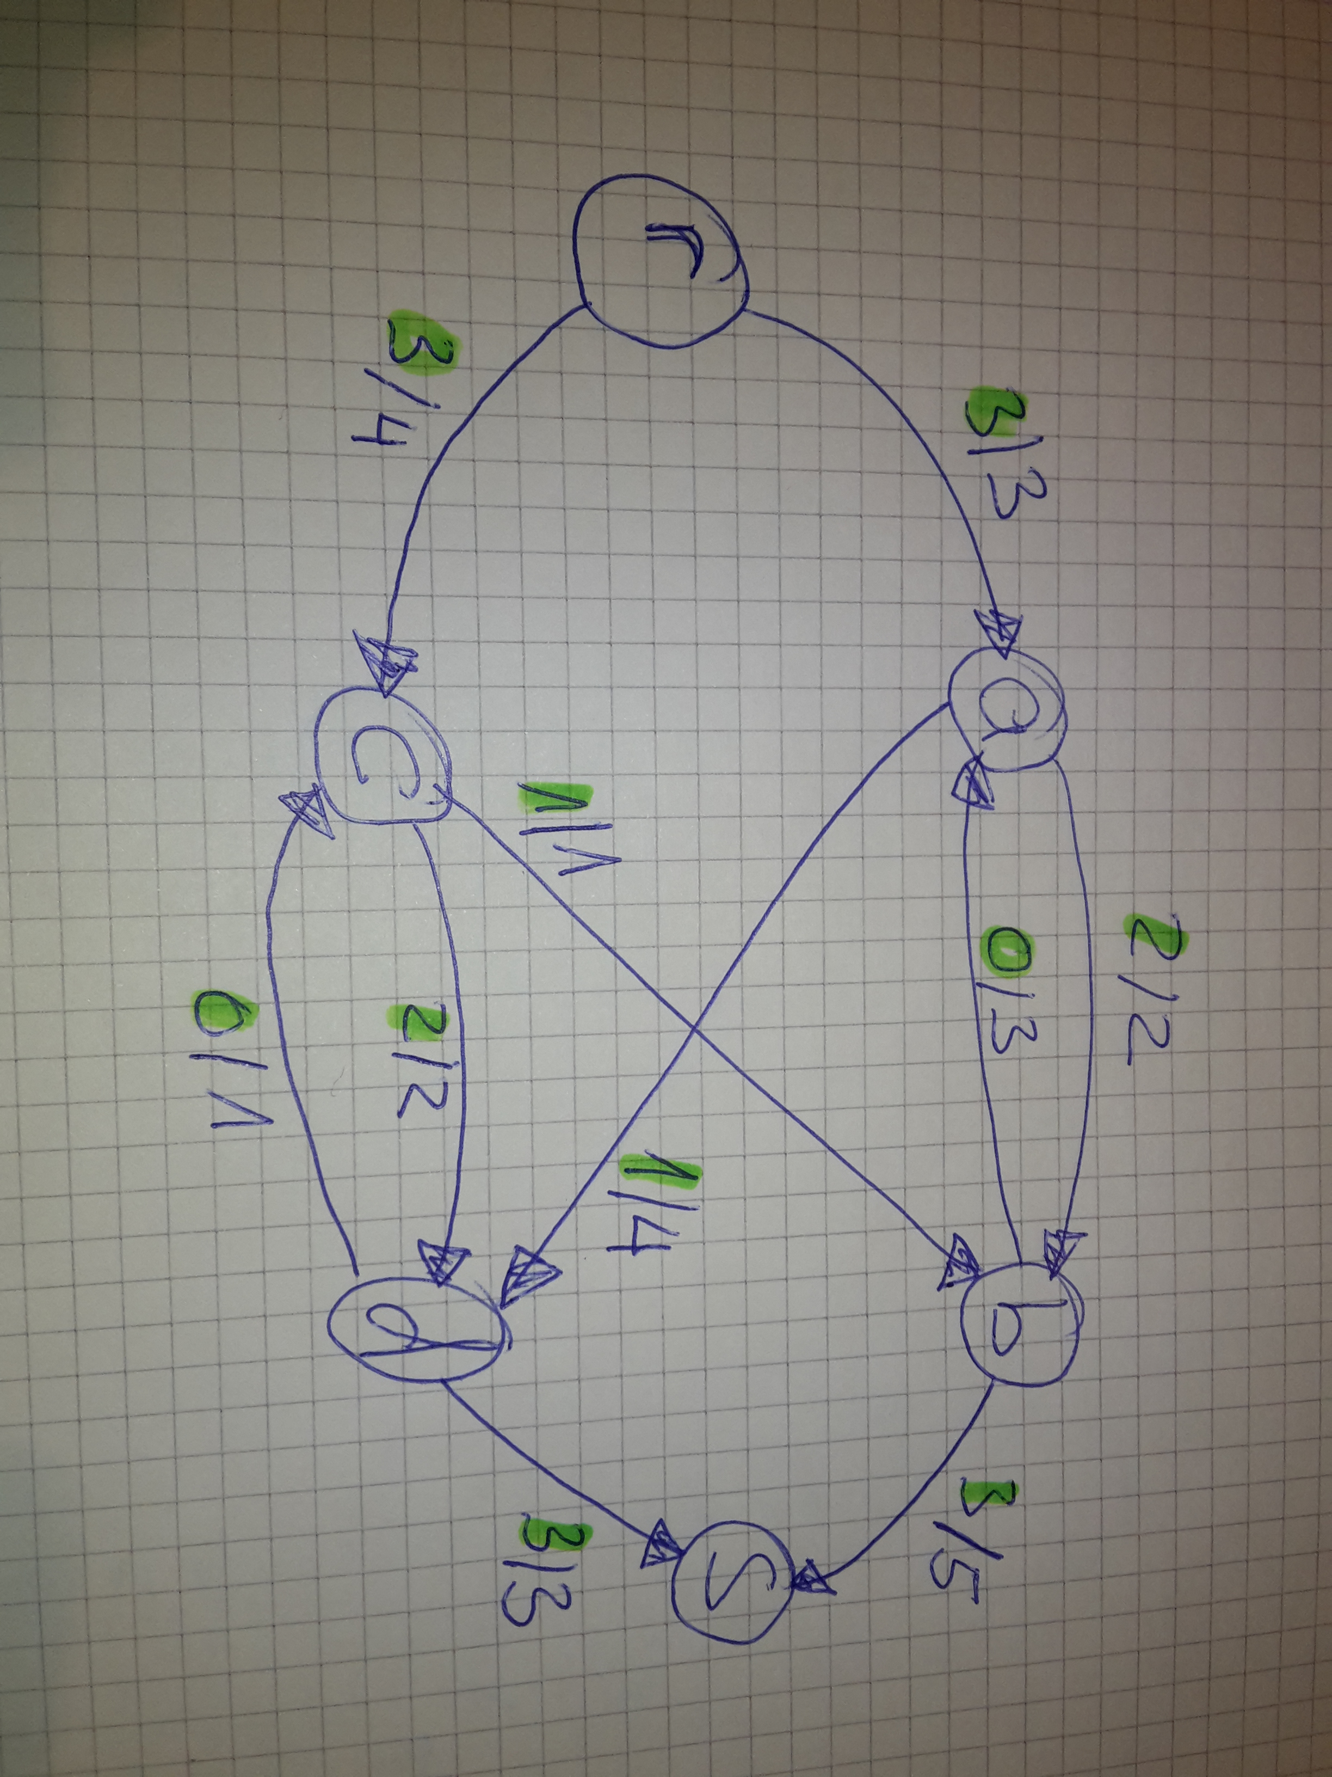
Figure Feasible r-s flow: Remember min cpa in b) was equal 6

Reasoning: From source r we have to send a total flow equal to 6. since the summed capacity of all paths from the source is equal 7, 3 from ra and 4 from rc, there are two possible combinations: either x_ra = 2 and x_rc = 4 OR x_rc = 3 and x_ra = 3. Since the receiver c cannot send more than a total flow of 3 (= cap cb + cab cd = 3), the value for x_rc must be 3. Hence, x_rc must be 3.
since c receives a flow of 3 and has to send therefore a flow of 3 and the outgoing caps from c to its directed neighbors is also equal 3, we also know that x_cb = 1 and x_cd = 2.
next let us consider the node a. It has received a flow of 3 from r. It has a connection to b with cab euqal two and to the node d, with cap 4.
therefore, the following combinations exist:
x_ab = 0 AND x_ad =3
x_ab = 1 AND x_ad = 2
x_ab = 2 AND x_ad = 1

the first two possiblities cannot happen, since then d would either receive a flow of 3 or a flow of 2. since d only can send a flow of max. 3 but already recieves a flow of 2 from c it cannot receive a flow higher than 1. this implies, that only x_ab = 2 AND x_ad = 1 is a viable assignment.

This concludes the reasoning, since now d sends 3 to s
and b sends also 3 flows to s, since b receives a flow of 2 from b and a flow of 1 from c.

Task2:

My solution for the (r,s) max flow can be seen in figure 2. I computed my solution by applying the ford fulkerson algorithm by hand as described in this pdf:
http://wwwdh.cs.fau.de/IMMD8/Lectures/SS03/algo2/AlgII.FAU.SS03.Kap17_1.pdf

My Assumption: There has to go no flow out from the sink node s.
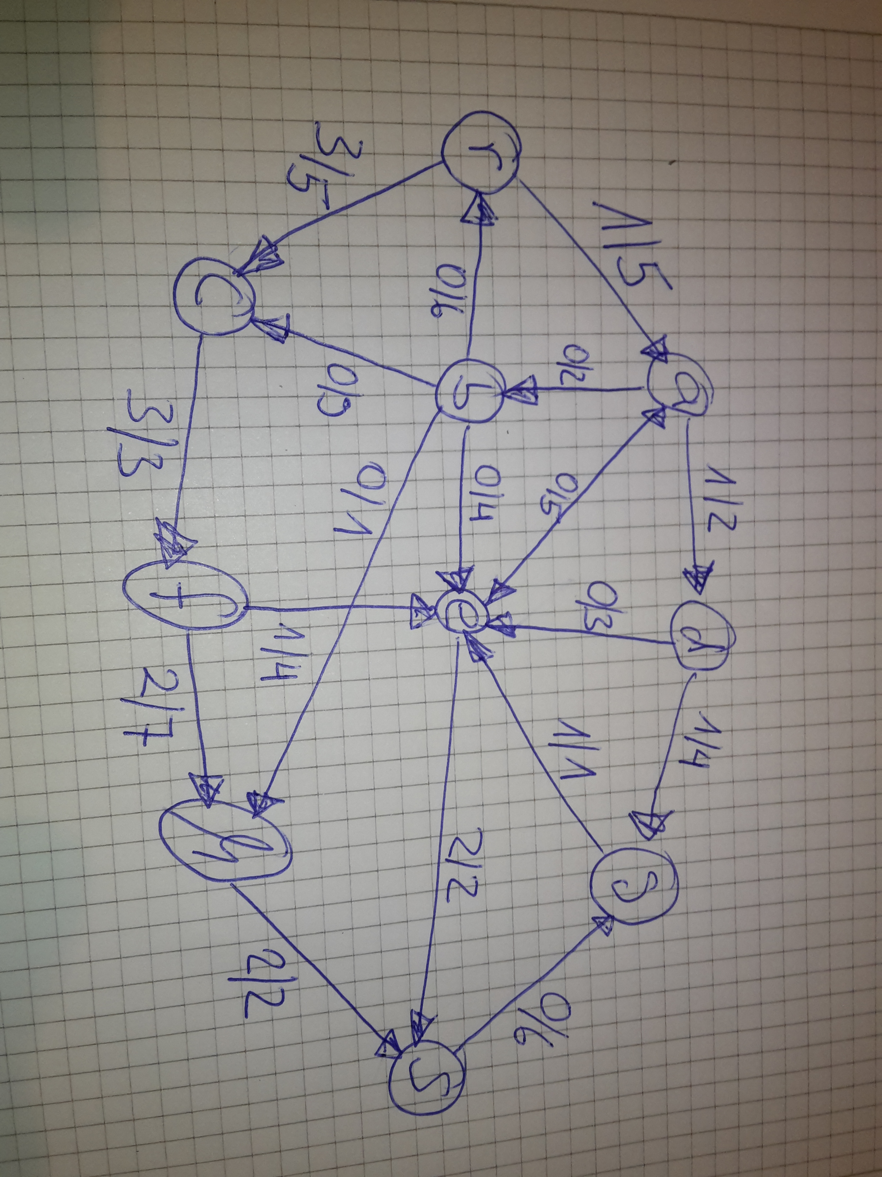
Figure 2: Max (r,s) flow results for the given network graph from task 2 from the assignment.

The corresponding min cut is when we remove the edges es and hs.
Their cab also gives us 2 + 2 = cab_hs + cab_es = 4. The same value as we got for the max flow.
Intermediate results can be seen in figure 3.

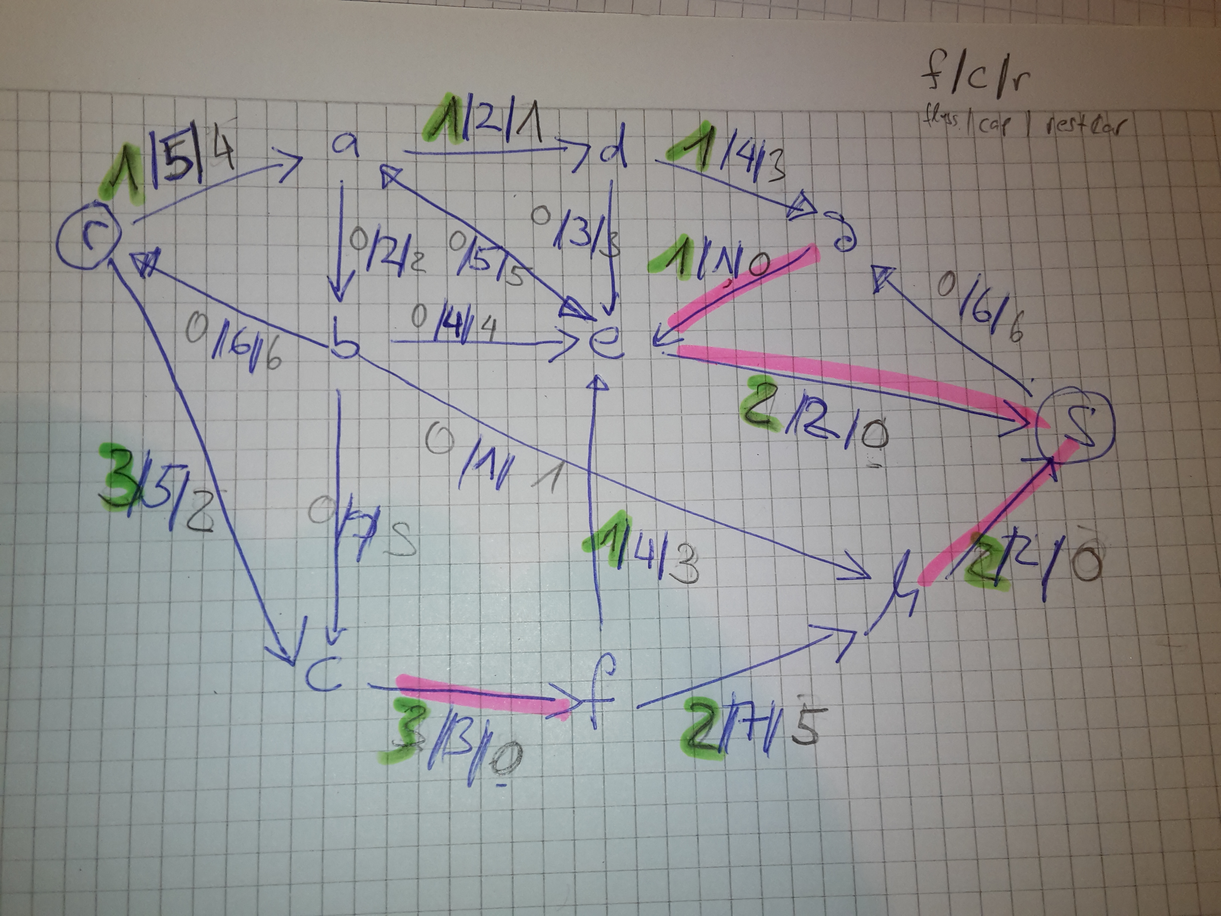
Figure 3: Intermediate Results

Approach how to solve this problem:

- Relable the edges. Initially, there is only a upper bound (the cab) given.
I introduce 3 number f/c/r for each edge in the graph.
. f is the flow, c is the given capacity, and r is the remaining capacity
- Init this labels: r = c, f = 0 for each edge initally.
- Find a path from r to s in the network that has remaining capacity > 0 (i.e r>0) along its path. Then for edge edge along such a path, take the min of r of all these edges, call it r_min.
- Update all edges according to this r_min: for each edge e do:
  - e.f = e.f + r_min and e.r = e.r – r_min.
- As long as there exists a path in the graph that from r to s having nodes with r value all bigger > 0, repeat from step 3 on till 5.
- Otherwise you have found a max (r,s) flow.

Value of flow is sum of all incident edges' flow. Here 4.

I used the following paths:
a) r-c-f-h-s
b) r-c-f-e-s
c) r-a-d-g-e-s
and then I found the solution. Since there was no other path from r to s left.

