Problem-Sheet 8
My Solution
Michael Single
08-917-445
msingle@students.unibe.ch

Task1
Given five persons Herakles, Aeson, Kerberos, Menelaos and Apollo (supposed to be friends)
and five islands Crete, Euboea, Lesbos, Rhodes, Chios.
We want to assign the five biggest Greek islands among five given friends. Each person has individual intentions about island he wants to possess:

Person | Wants to possess
Herakles | Crete and Rhodes
Aeson | Lesbos, Rhodes or Chios
Kerberos | Crete and Chios
Menelaos | Euboea or Chios
Apollo | Euboea and Lesbos

Assumption: Each Island can have exactly ONE owner
When considering the „wants to possess“ list for each person we observe that some want to possess a set of Islands having a AND relationship, and some a OR-relationship. Thus, in order to solve this task we have to define a fairness term, which tells us how we are going to solve this problem.
So the question is: Is it better to give each person just ONE island or is it better to some persons more than one island (which implies that some will not get any island then)?
I am mentioning this, since some are happy to have either „this island OR that island“ whereas some other want to possess „island1, island2 AND island3“.
In the following I am going to assume that it is best to statisfy all person to give everyone at least one island. Since there are as many islands as there are persons, this implies every person gets exactly one particular island.
Thus we are going to formulate this problem as a maximum flow problem where each person should get exactly one island fulfilling as much as possible their wishes (from their „wants to posses“ wishlist).

Solution:

- step: Formulate the person-wants-to-possess relationship graph (as a bipartit graph)
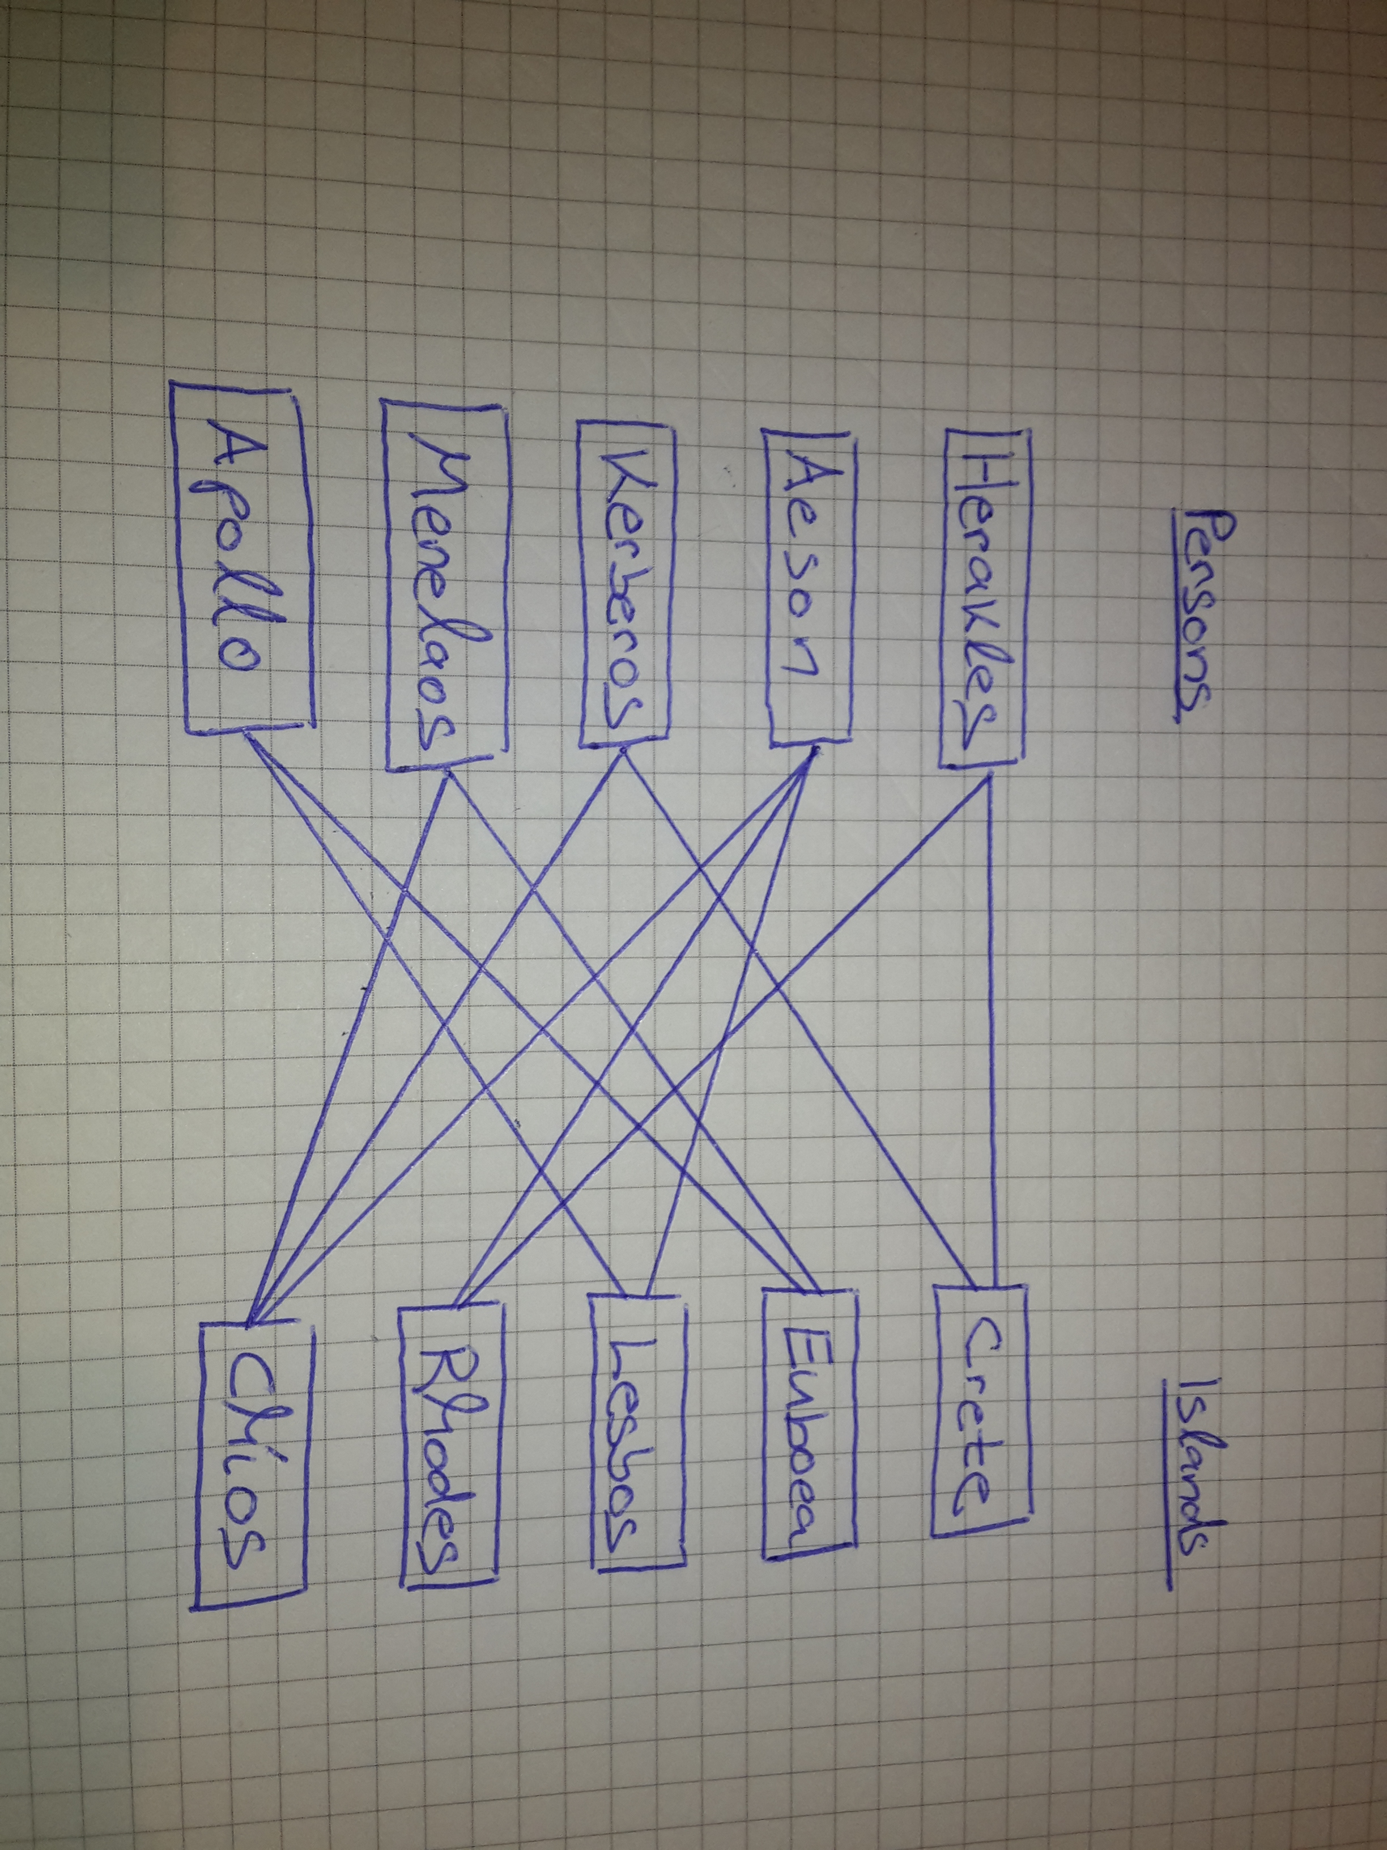
Figure 1.1: Bipartit Graph showing relationship between person and their interests.

- translate this graph into a flow graph
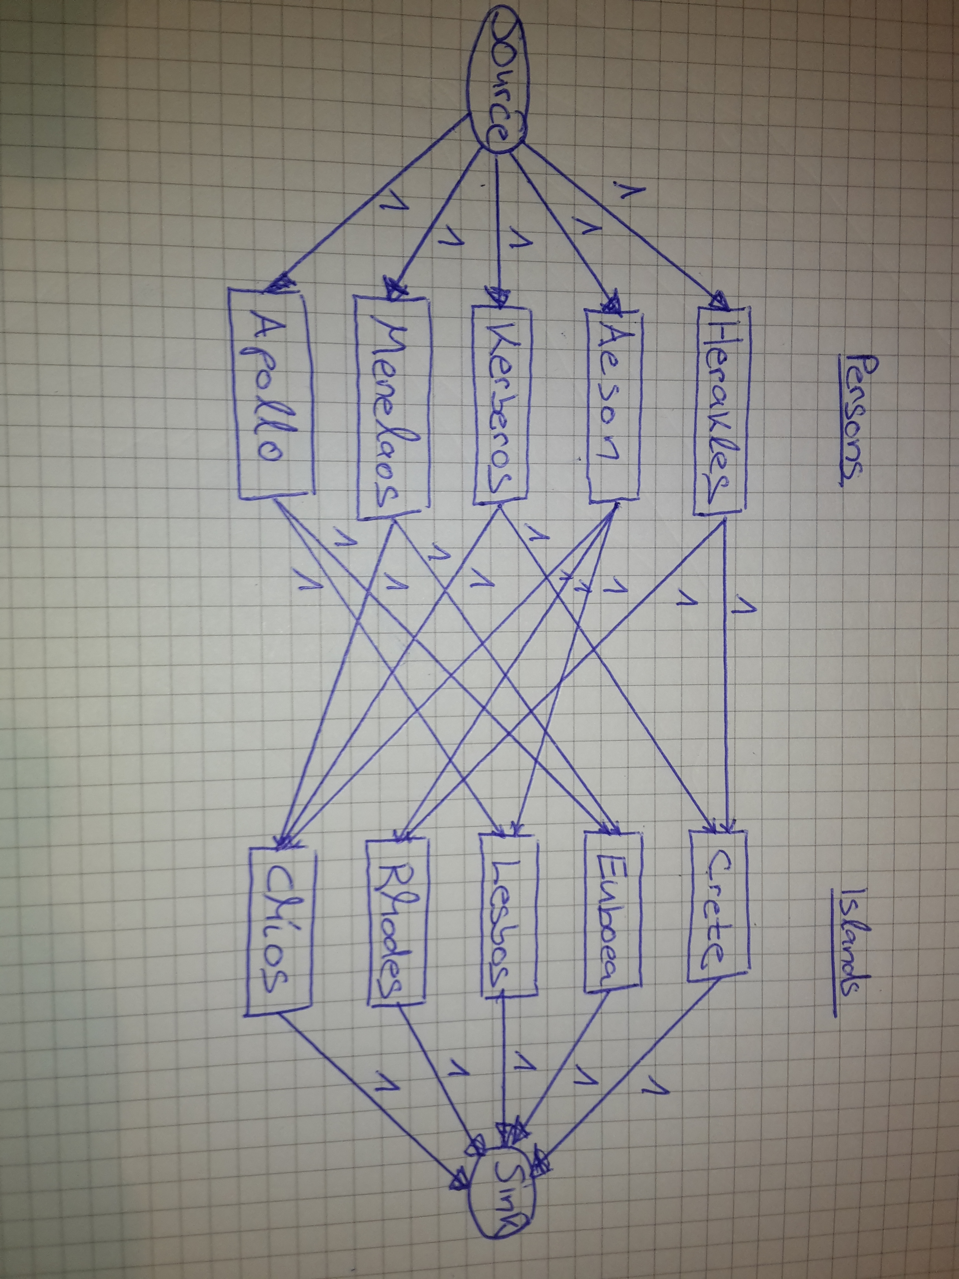
Figure 1.2: Translated version of graph from figure 1.1 into a flow network graph.

- find a maximum flow: Paths will tell us who gets which island.
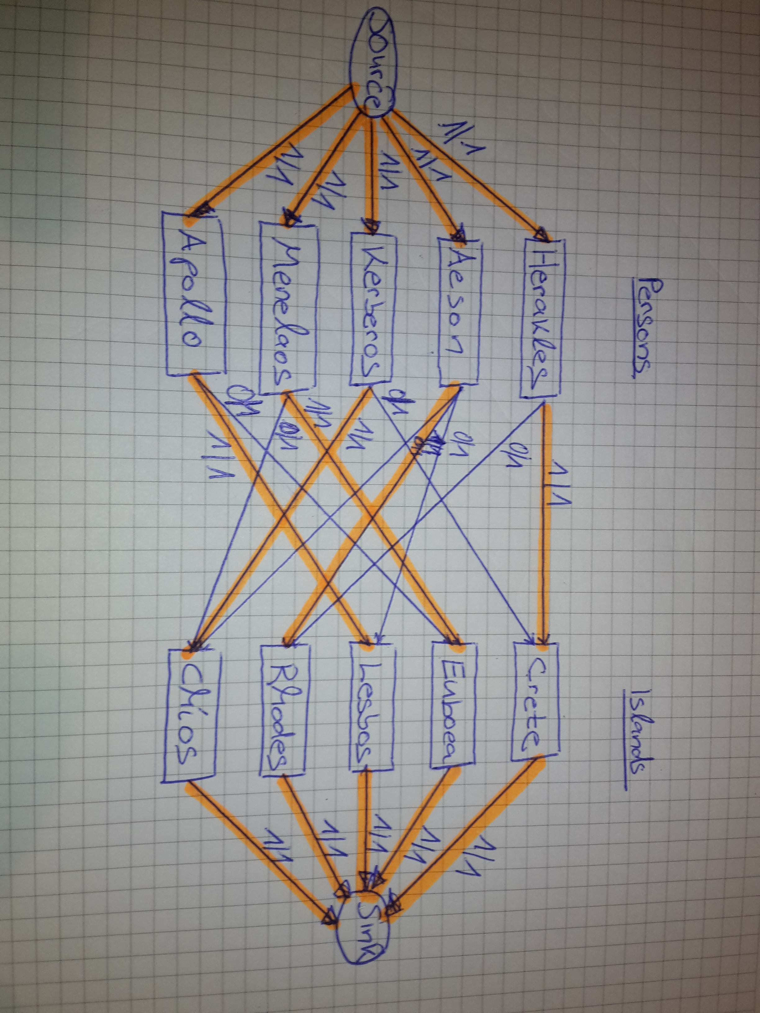
Figure 1.3: A Maximum flow solution of the graph from figure 1.2 found by using ford-fulkerson.

The notation 1/1 indicates there is a flow of 1 given the capacity of 1. 0/1 tells us there is a flow of zero, given the capacity of 1 along a given arc.
For better visibility I indicated existing flows in orange color (see figure 1.3).
By the end of the day, this flow is modelling a binary decision probem: Does person p_r receive island I_k? If yes, there is flow, otherwise there is no flow. Note that an arc is modelling the interest of a particular person (all islands a person is connected to belong this his whish-list (wants to posses)).
Hence, one Solution using the result from step 3 for this Problem is the following:
Person | Receives Island
Herakles | Crete
Aeson | Rhodes
Kerberos | Chios
Menalaos | Euboea
Apollo | Lesbos

Task2
Given a flow graph. The capacity on each edge (edge = highway) denotes the number of lanes in a highway from node u to node v (u and v are supposed to denote cities – source and destionation).
Criminals are transporting contraband from A to F. The police has to assign as many police officers to a highway as there are lanes on a highway in order to check for contraband along this considered highway. What is the minimum number of police officers needed for the following graph in figure 2.1?

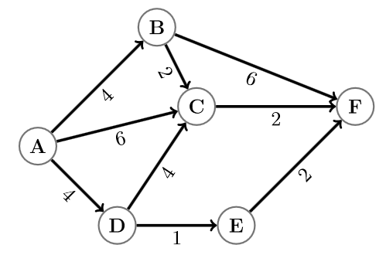
Figure 2.1: Given Road network

Solution: Find the max flow in this graph. The number of the minimum cut corresponds to the max flow (according to the max flow min cut theorem). The minumum cut corresponds to the minumum number of police officers needed.
When solving for the max-flow (using the ford-fulkerson algorithm) we get:
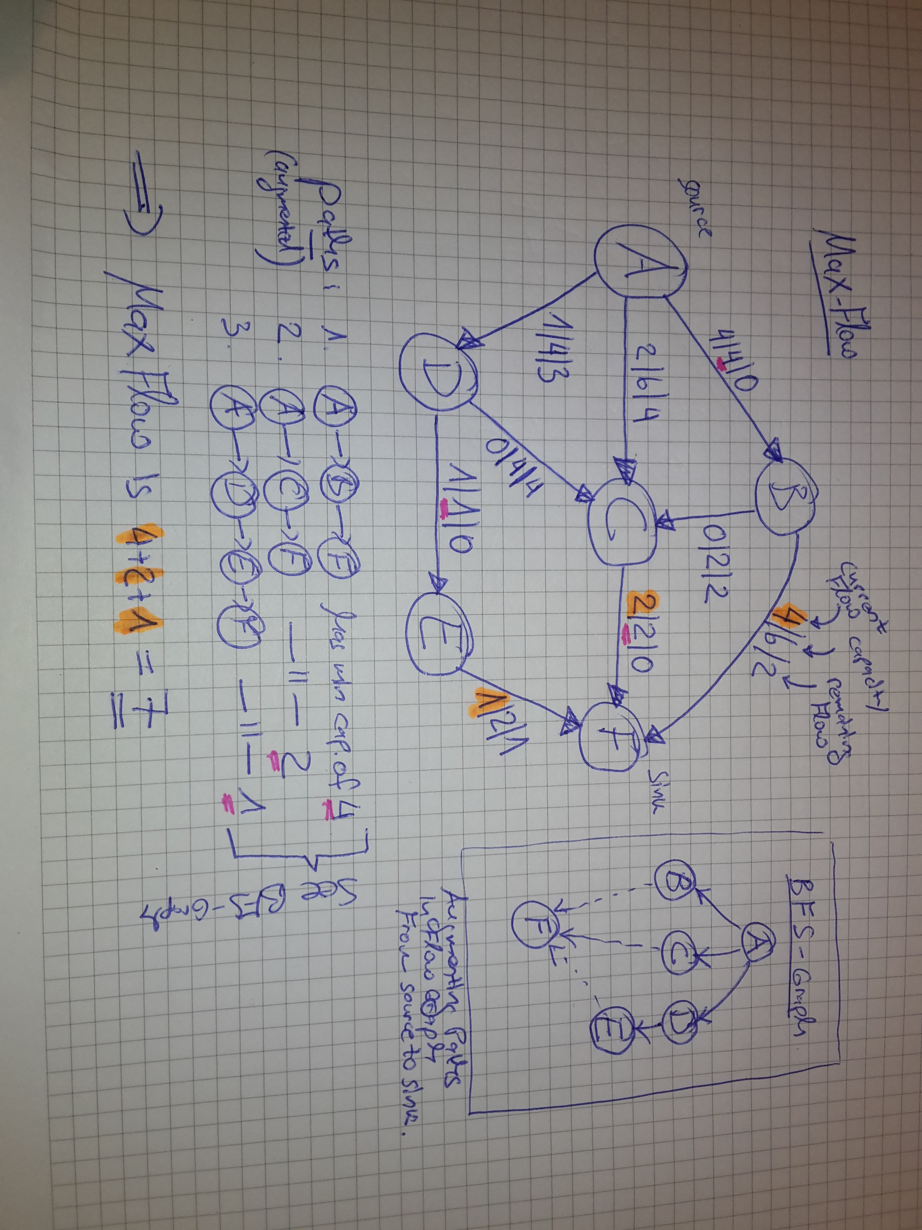
Figure 2.2: Maximum Flow Solution of the Roead Network from figure 2.1

In figure 2.2, we see taht the maximum flow is equal to 7. Therefore, the minumum cut is also equal to seven. Thus, there are at least 7 police officers needed.

Note that for finding augmented paths I used the BFS algorithm to find paths from source to sink. See figure 2.2. The pink marking is indicating the minimum capacity within a particular augmenting path. Orange is marking the flow through a augmented path according to the minumum cap. The sum of all flows to the sink is the max flow.
Remark: one particular MIN CUT in the graph from figure 2.1 is the following: AB, CF, DE (i.e. Police has to control those highway routes) (their capacity sum is also 7, this is hereby a min cut).

