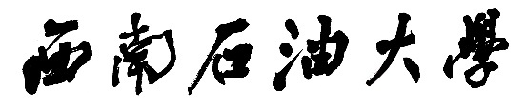

**本科毕业设计（论文）**



|  |  |  |  |  |
| --- | --- | --- | --- | --- |
| **题目：** | | |  | | --- | | **基于VUE+Springboot 教考分离的考试** | | |
|  | | **系统的设计与实现** | |

|  |  |  |  |
| --- | --- | --- | --- |
| **学生姓名** | **汪思朋** | **学　号** | 201831082129 |
| **教学院系** | **计算机科学学院** | | |
| **专业年级** | **计算机科学与技术2018级** | | |
| **指导教师** | **谯英** | **职　称** | **副教授** |
| **单　　位** | **计算机科学学院** | | |
| **完成日期** | **2022-05-20** | | |