Southwest Petroleum University

Graduation Thesis

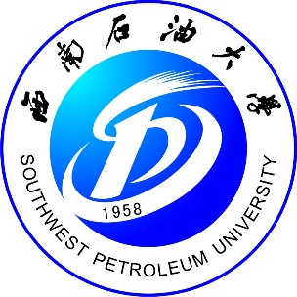

**Based on VUE+Springboot teaching test separation test system Design and Implementation**

**Grade: 2018**

**Name: Wang Sipeng**

**Speciality: Computer Science and Technology**

**Instructor: Qiao Ying**

**School of Computer Science**

**2022-5**