**What is Agile ?**

* Approach to managing and working on projects.
* A simple approach to managing complexity

**Characteristics of Agile Projects**

**Incremental –** plan , development and release increments

**Iterative –** continuously improve the product and the process of building product

**Focus on Value –** agile mind set focuses on value

**An empowered team –** a distributed brain where each member continuously helps make decision.

(**Customer’s prospective)**

* This is best suitable when there are so much uncertainty in the project.
* Ensures that better quality and improved version of product is delivered after each and every iterations
* Agile team constantly matching the customer’s need so that they can deliver desirable product with high quality.
* After each and every increments the errors should be resolved in the next step

(**For the team)**

* Higher job satisfaction
* creates better innovations
* has lower costs than traditional project
* has lower risks
* deliveries could be predicted

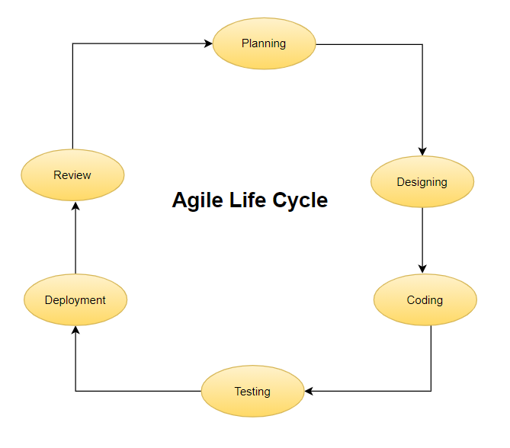

**These are the scientific methods in Agile approach:-**

a)- Create a hypothesis

b)- Build an Experiment

c)- Observe/Learn from the results

d)-Repeat/Iterate

**JIRA**

**Jira**  is a project management tool used for issue and bug tracking system. It is widely used as an issue tracking tools for system.

* It is developed by Atlassian inc.
* It can be used with any OS.

**Application Level**

**JIRA 🡪** A collection of Projects

**Project Level**

**Project 🡪** Collection of Issues

**Issues Level**

**Issues 🡪** A work item

**Why should we use JIRA?**

* JIRA contains everything as per our need
* Countless add-ons for our further needs.

**Instances of JIRA?**

There are two type of Instances

1. **Cloud Instances 2- Server Instance**

Having Fast Startup Here you have to create,

Reduced costs install and run JIRA on your

No need to upgrade system iteself

Security

**Let’s create a JIRA Cloud Account**

Go to <https://www.atlassian.com/software/jira/free> and try building your free account.

It requires no credit cards easy to create account.

Then you are required to add your team mates

Create a scrum Project lets name it **Project A.**

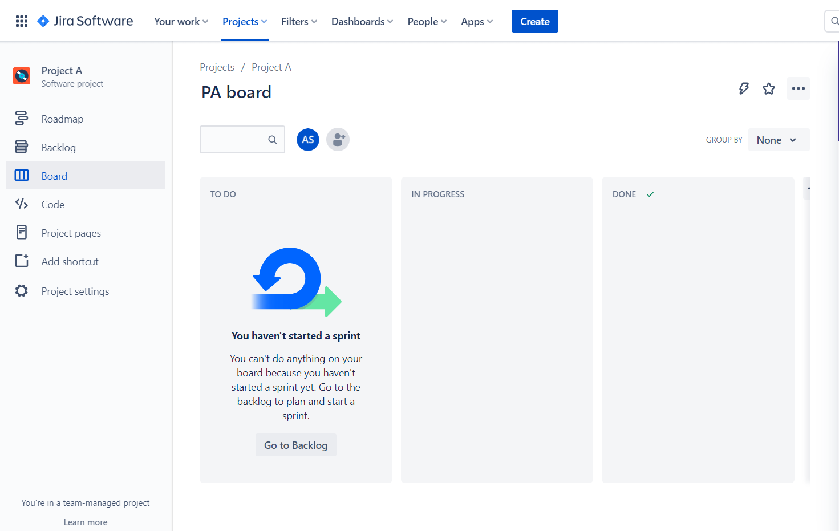

**Visualizing Work: To Do List**

* Reminds us
* Focuses us
* Track Progress
* A principle of agile project is to **visualize work**
* A ***board*** is an agile tool used to visualize and manage works
* **Board**  Allows everyone to see the current status of work

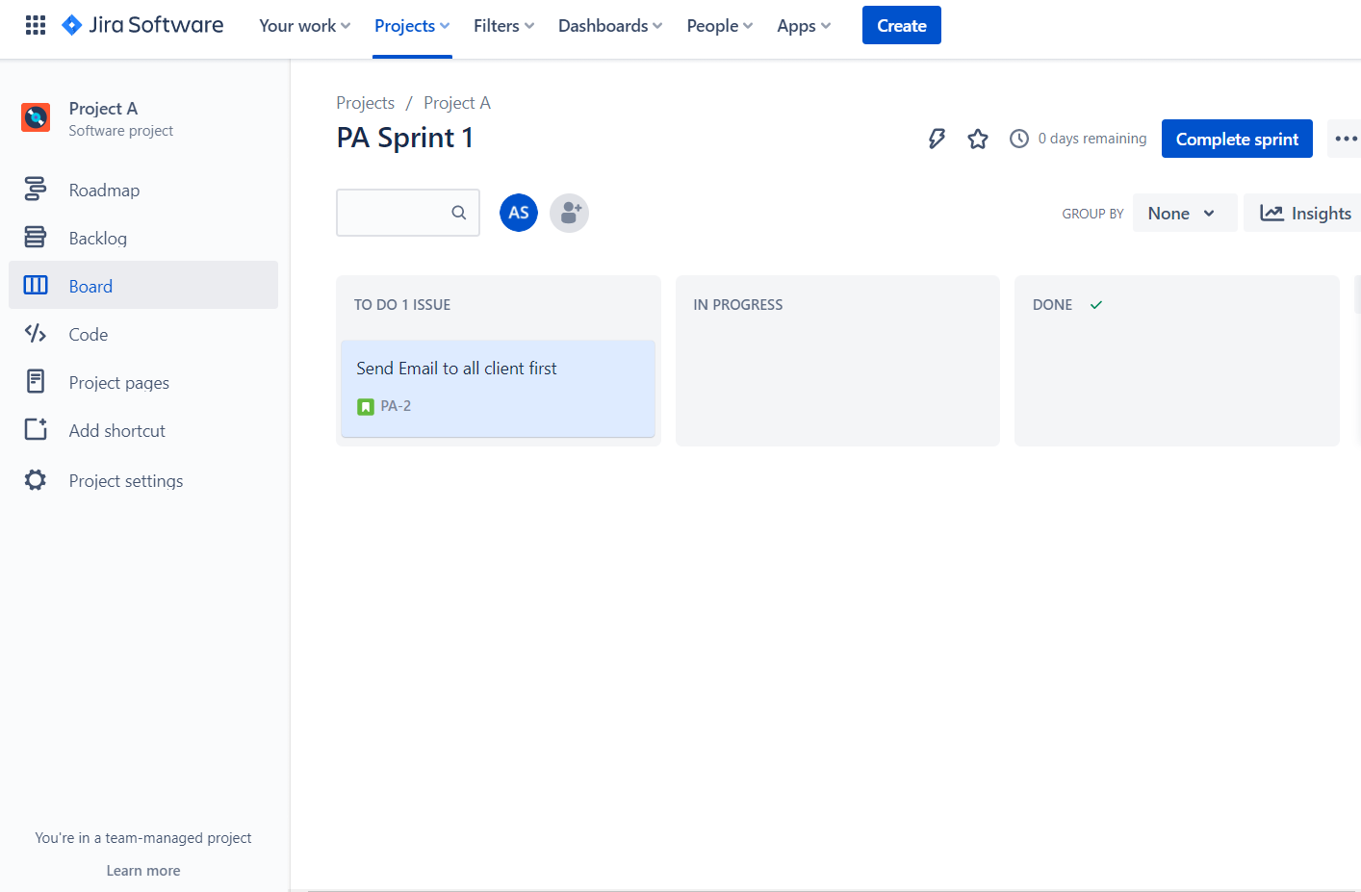

**Let’s take a scenario and understand JIRA**

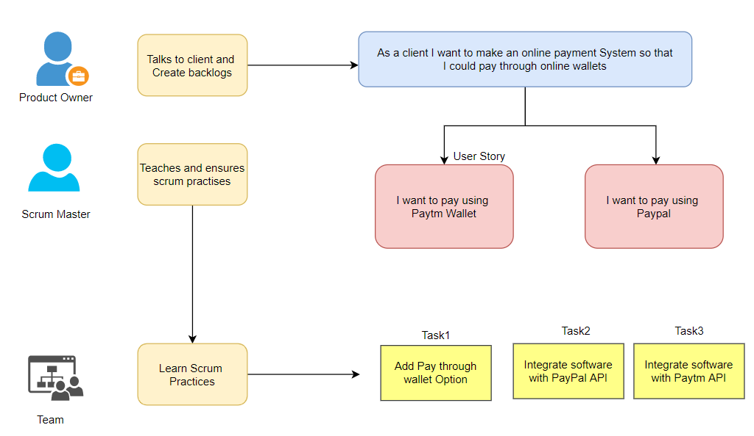

**Sam**  is a product owner who after talking to client come to know that client wants an online payment system for their orders so that they can pay through online wallets.

Then the problem was discussed with Scrum Master and team members. Team Members listened his story and broken down his stories into useful tasks.

so below we have created an epic named as **online_payment** which contains two user stories.

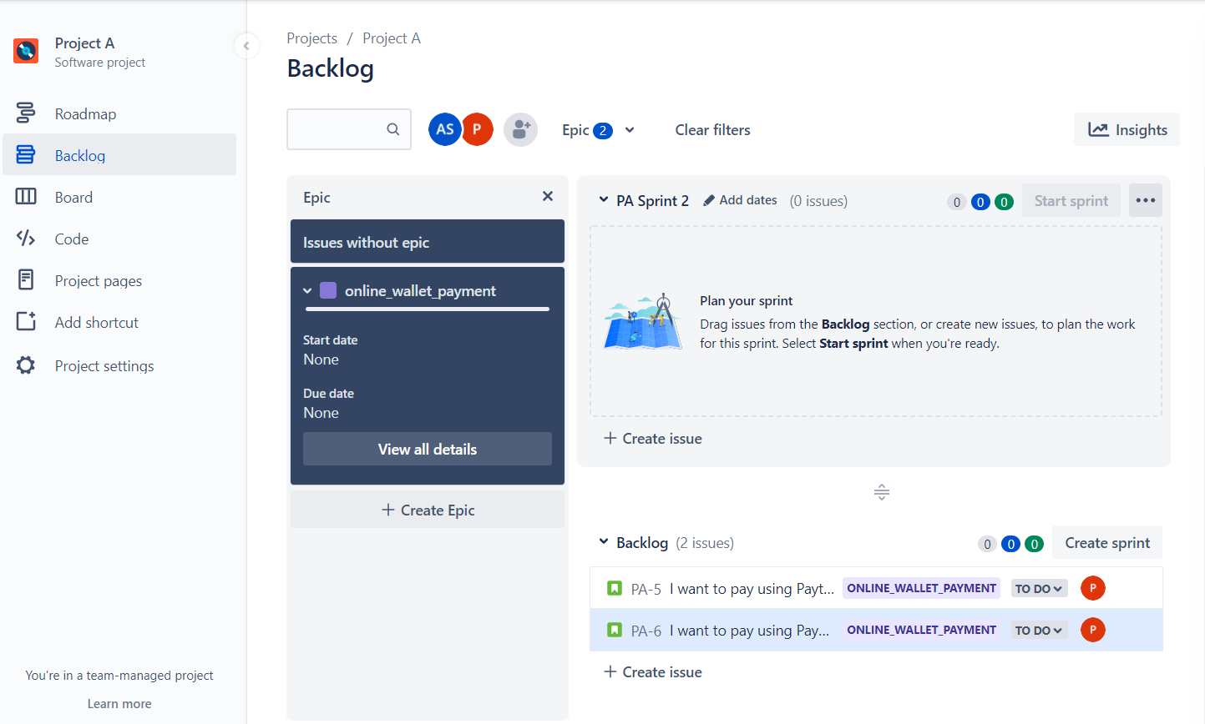

Now next step is to assign these user stories to a sprint so **drag and drop these stories** to sprint and start the sprint, now you will see task has been started and added to **Board .**

