**Virtualization in Cloud Computing**

**Virtualization** is the “creation of a virtual (rather than actual) version of something, such as a server, a desktop, a storage device, an operating system or network resources.

It does by assigning a logical name to a physical storage and providing a pointer to that physical resource when demanded.

Virtualization uses software that stimulates hardware functionality to create a virtual system. This allows IT organizations to operate multiple operating systems, more than one virtual system and various application on single server.

Network

ROM

RAM

Processor

S

E

R

V

E

R

VM (Client)

VM (Client)

VM (Client)

VM (Client)

VM(Client)

VM(Client)

Networking Devices

Physical

Processor

Physical 50TB

Physical 50TB

Virtual

Machines

Virtual

Machines

Virtual

Machines

Virtual

Machines

SERVER (Logical Structuring)

Independent and isolated They only share physical storage not data they are completely isolated

from other VM’scfc

**Forms of Virtualization**

There are many forms of Virtualization.

1. **Server Virtualization**

When the virtual machine software is directly installed on the server system is known as Server Virtualization

It is used to balance load by dividing instances of server

1. **Storage Virtualization**

Storage Virtualization is the process of grouping various storage devices from different network storage devices so that it looks like single storage device

**Hypervisor**

A Hypervisor or Virtual Machine Monitor (VMM) is computer software, firmware, hardware that creates and runs virtual machines.

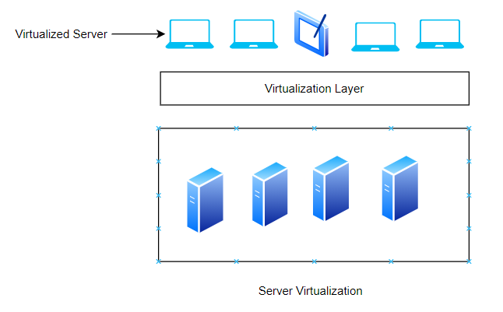

**What are Virtual Machines?**

A Virtual Machine is a compute resource which uses software instead of physical computer to run application. It has encapsulated OS

Operating System could be any OS . They don’t know about virtualization and physical server. They know that they have full access to the hardware . They don’t know about sharing environment.

Virtual Machines are not hardware independent they could be run on any system.

VMs are called **Guest** and Physical Server is called **Host**

**so we have**

1. Virtual CPU **2-** Virtual Memory **3-** Virtual Disk **4-** Virtual Network

**What is overcommitment in Virtualization?**

Overcommitment is hypervisor feature which allows guest to use more than available physical memory at host side. For ex. Server has 2 GB memory and it has been divided into 4 VMs with 1GB each.

**Damnnnn How is it possible?**

**Yes** Its possible  a guest machine with 1 GB of physical memory allocated to it might only need 300-400 MB, leaving 600-700 MB of allocated space unused. If all four example machines use 300 MB, the physical server will have 800 MB of its original 2 GB left over.

**TYPE – 1 Hypervisor vs. TYPE – 2 Hypervisor**

Type 2 Hypervisor

* Loaded in an OS running on hardware
* Examples:
* Worksatation/Fusion
* Oracle VM
* Parallels

Type 1 Hypervisor

* Loaded directly on the hardware
* Examples:
* Hyper V
* ESXi
* KVM

**Virtualization and Cloud**

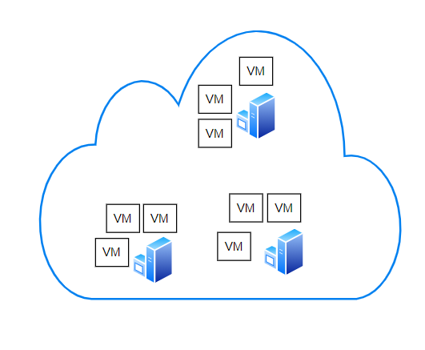

Cloud is not possible without virtualization Cloud contains many VMs which can be hired

**Why do we need Virtualization?**

By analysing these two pics u can imagine the benefit of virtualization.

saves memory CPU costs

saves admin powerhead

saves cooling infra

saves cabling and space

save number of ITprofessional

more flexibility

improves availability

suppose physical server failed then we can run VM on different machine

No OS dependency

Greater business agility

Ability to “ do more with less”

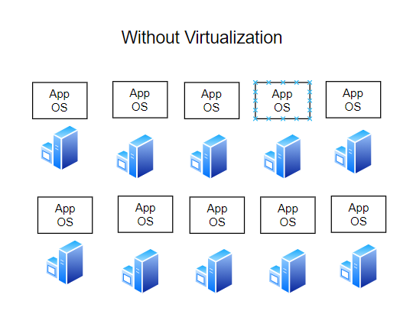 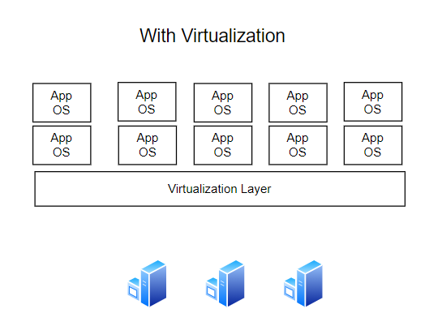

How Virtualization improves Data Protection ?

All cloud providers do server virtualization in which they setup backup data center at offsite locations so if center is destroyed then VM could be shifted to other location

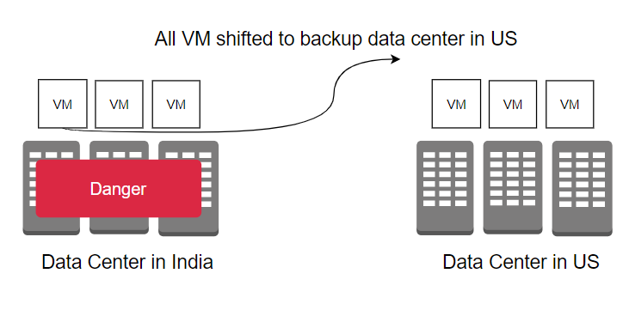 Complexities introduced by Virtualization ?

Sometimes resource contention problem may arise. since so many applications , machines are there so complexity increases that’s why sometimes troubleshooting becomes difficult.