User Manual

Content
Introduction 2
1, Quick begins. 3
1.1 Add players 3
1.2 Add ball 5
1.3 Remove players and ball 5
1.4 Reset field 6
1.5 control a scene 6
2, Save and load scenes 8
3, Settings 9
3.1 Set colors 9
3.2 Choose team to be added 9
3.3 set showing stuffs 9
4, Get help 10
5, Contact information 10

Introduction
This software is to help coaches explain basic principles of soccer game to young players. By using the software, users are able to save, load and create new scenes and show them to the players. Because the whole simulation can be played dynamically on the screen, it makes the explanation more attractive and impressive. Players can understand the coach much faster than by traditional way.

The following is the user interface of the software.

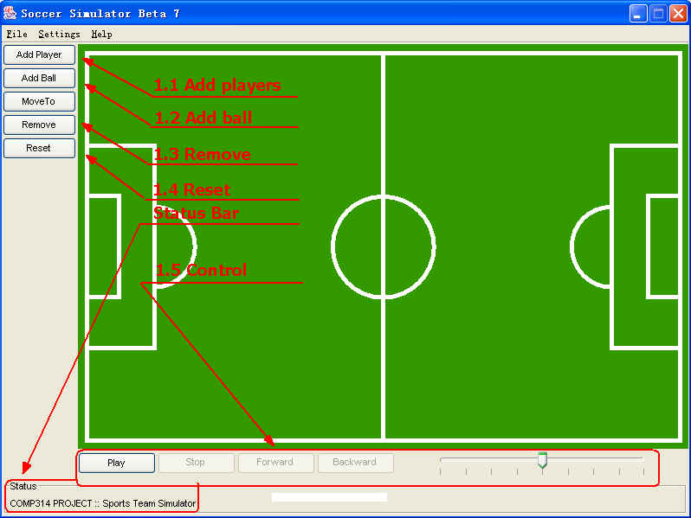

Note: ► At any stage, there will be a short description down the status bar, telling you what you are doing now or what you are suppose to do next.
► Also, if you move the mouse over any buttons for a second, there will be a short message popup to indicate the functionality of the button.

1, Quick begins.

1.1 Add players
Step 1, click ‘add player’ button at the top left corner.
Step 2, choose a starting point at the playing ground by clicking the left button of the mouse.
Step 3, type in a number to distinguish the player in the popup window.
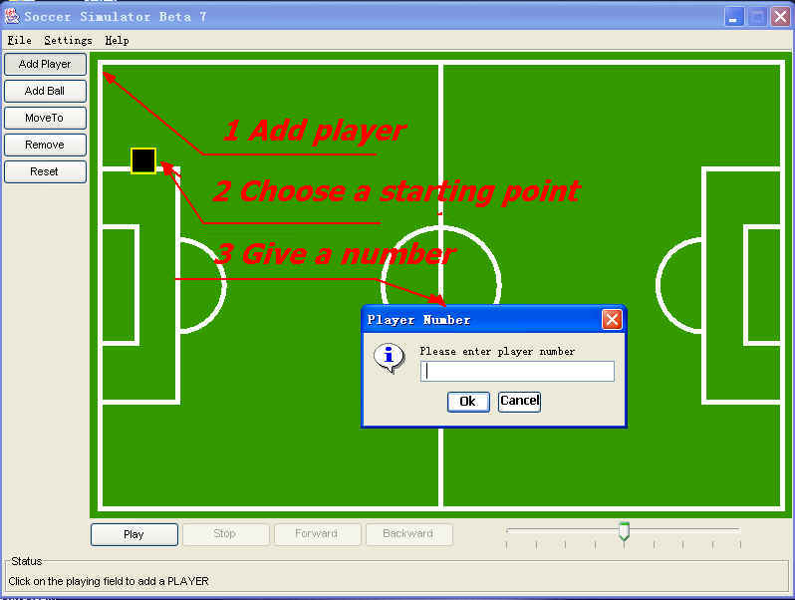
Add players step 1.1.1~1.1.3

Note:
► If you don’t want to choose a number for the player, just press cancel
► If you feel any points you’ve set is not ideal, you can simply right click the mouse anywhere on the playing ground, left click the point you want to move, and drag it to wherever you want.

Step 4, press ‘Move to’, then click on the playing ground to choose an ending point.
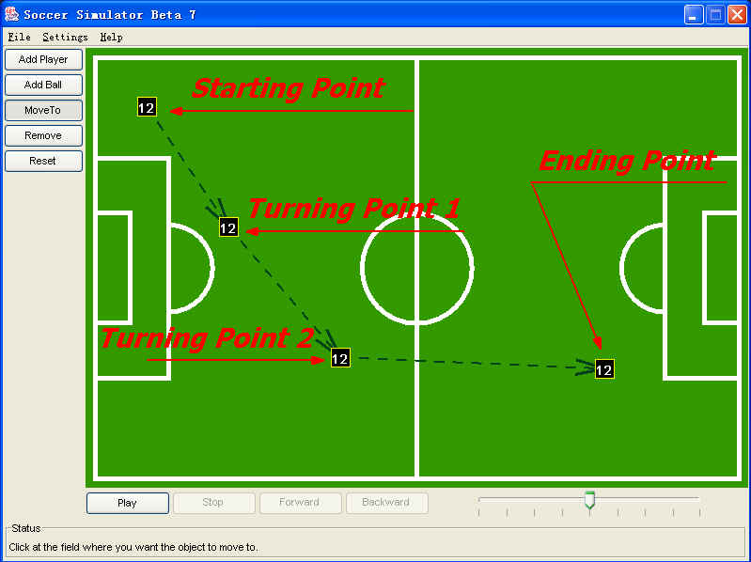
Add players step 1.1.4

Note:
► If you want to give the player some ‘turning points’ in order to let him run in a poly-line, just give him more ending points. There is no need for you to click the ‘Move to’ button again and again.
► Our software is pretty smart, you only need to click ‘Move to’ once, and you can add ending points/turning points as many as you want. The player will run along the path you show him. Once you finish choosing the first ending point, there will be an arrow pointing from the previous point to show the direction of running.
► In step 4, you can add any number of player as you want.
► if you want to add to teams on the playing ground, each of them is represented by different color, see ‘settings’

1.2 Add ball
Adding ball is pretty similar to adding players, the only difference is only one ball can be added, as the software is simulating the soccer game. If you want to make animation for more sport games, please contact us. See last page for more contact details.

1.3 Remove players and ball
Click ‘remove’ button, then choose a point you want to delete. By ‘remove’ button, you can delete any points you set up before, including starting point, turning points and ending point for both players and ball. The arrow will point from the point before the deleted point to the point after it.
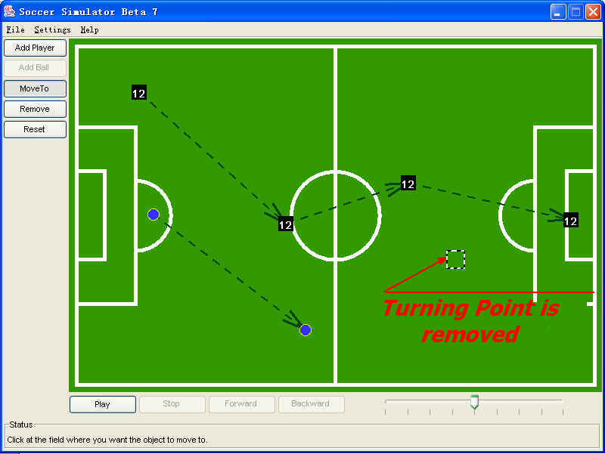.

1.4 Reset field
When you press on this button, the software will be reset. All scenes that haven’t been saved will lose. In case of pressing this button by accident, there will be a confirming window pops up asking the user for confirmation.
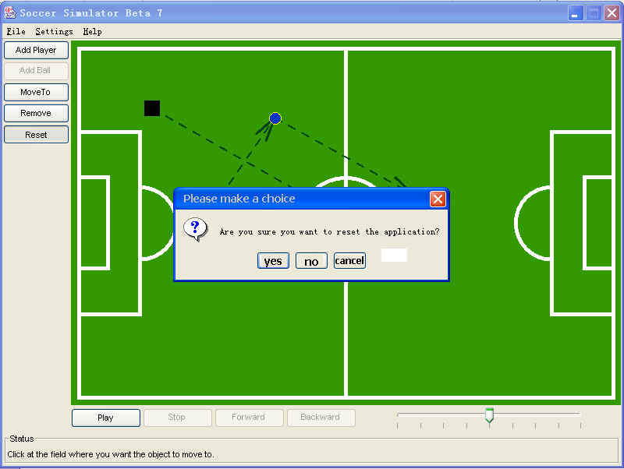

1.5 control a scene

1.5.1 Play, pause and stop
Once the new scene has been set up or loaded properly, you can show it to the audiences dynamically by using play, pause and stop buttons.
The ‘play’ button will automatically change to ‘pause’ button in order to make the layout look nice.
When the animation finished, all the objects on the screen will not go back to their starting positions until the user presses ‘stop’. (The reason is that some of user machines might be very fast. When the animation finishes, the audiences might not see their ending positions very clearly. In another hand, the coach might have something to explain with last positions to the young players. If the animation goes back automatically, the coach wouldn’t have enough time to do it.)

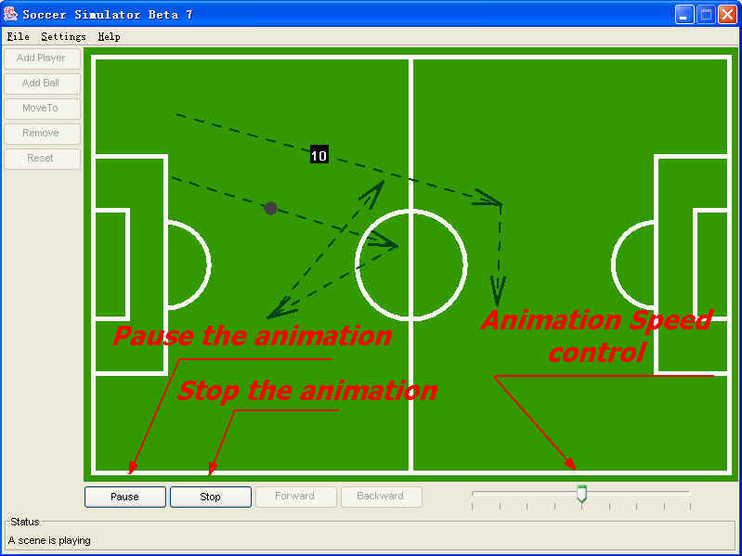

1.5.2 Forward and backward
When you press to pause the animation, the ‘forward’ and ‘backward’ buttons will be available. You can keep pressing them to play the scene manually.

1.5.3 Adjust the animation speed
You can change the animation speed at anytime by dragging the speed bar down the bottom right corner. The animation speed will change automatically according to the position of the speed bar.

2, Save and load scenes
Save and Load functions are available down the ‘file’ menu. You can save your personal scenes on the hard disk for the future usage. Also, you can load other people’s creations to show to your audiences.

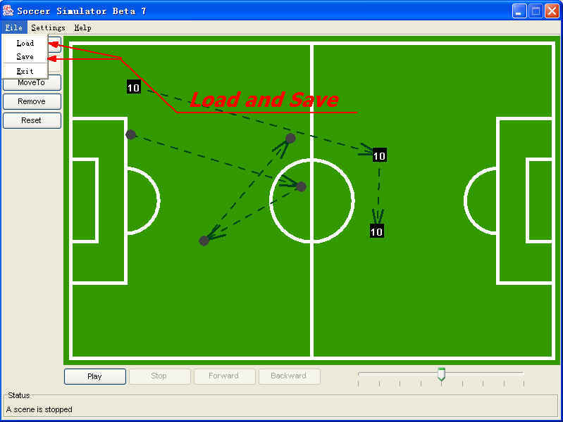

3, Settings

3.1 Set colors
You can change background color, ball’s color and the two teams’ colors here.

3.2 Choose team to be added
If you want to add two teams choose here.

3.3 set showing stuffs
If you want to show the lines of the playing ground, moving paths or player’s number, they can be set here.

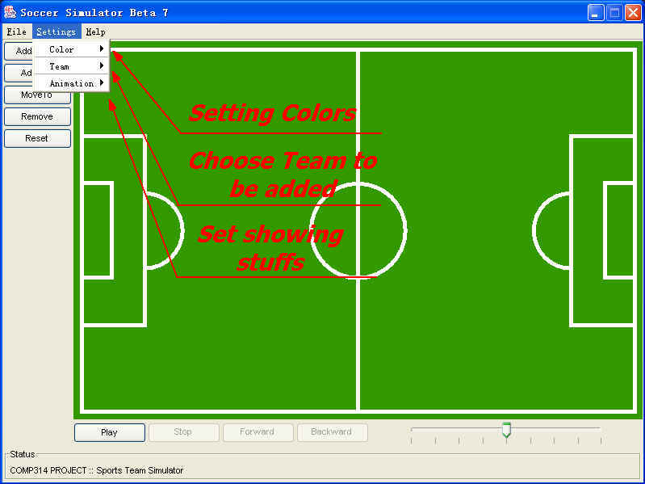

4, Get help

5, Contact information
Sport games simulator team
Phone: 07-8591234
Fax: 07-8594321
Post address: PO box 1234
Waikato University
Hamilton
New Zealand.

