SIMPLEJOINT TRUST
JointHub Africa Capstone II
Implemented Solution Evaluation Report
African Leadership University (ALU) · EMBA 2026 · Data Science & AI
Author: Isaiah Kporon, Co-founder & Executive Director, SimpleJoint Trust
Implementation partner: Cofounder Engineering (managed product app)
Report date: 16 July 2026 · Kigali, Rwanda
Impact context: $158,000+ in scholarships & grants · 85+ students supported · 6+ countries reached. Bootcamp: CreativeTech — Create With AI, 25–26 August 2026, ALU Kigali (~50 students). Capstone deadline: 30 August 2026.
Solution type: Working system demo / MVP pilot of a full-stack AI dashboard (not a static mock-up). Status: Implemented in the managed product repository; merged to staging for Capstone demonstration.
1. Description of the Implemented Solution
1.1 Type of solution
This implementation is a working system demo / Minimum Viable Product (MVP) pilot of the JointHub Africa Capstone II AI dashboard. It is not a paper prototype or click-only mock-up. Four integrated data science modules run on a generated but realistic cohort, with real algorithmic pipelines (scikit-learn / scipy) and a React/Next.js product interface. A companion FastAPI service mirrors the academic Python stack for reportability. The work was shipped into SimpleJoint Trust’s managed product application and merged to the staging branch for demonstration.
1.2 Target users and beneficiaries
Primary beneficiaries: African scholars and youth (high school through early-career) seeking verified opportunities, mentorship, and support to stay engaged — including the CreativeTech bootcamp cohort at ALU Kigali.
Secondary users: Programme administrators, mentors, and SimpleJoint Trust / ALU staff who need cohort visibility: matching quality, at-risk flags, and platform KPIs for Capstone evidence and funder reporting.
Demo roles in the pilot: student accounts (own data only) and an admin account (full cohort). Production Supabase email/password scaffolding remains available for later cutover.
1.3 Duration and scope of implementation
Duration: Intensive build and verification sprint in July 2026, positioned for Capstone II submission (deadline 30 August 2026) and the CreativeTech bootcamp (25–26 August 2026).
In scope (delivered):
- Module 1 — Opportunity Recommendation Engine (content-based cosine similarity; top 5 ranked opportunities per student).
- Module 2 — Mentor–Mentee Matching (cosine compatibility matrix + Hungarian algorithm; heatmap, assignment, session booking/log).
- Module 3 — Dropout Risk Prediction (logistic regression primary score; Random Forest feature importance; outreach trigger).
- Module 4 — NLP Pipeline (entity extraction schema, TF-IDF enrichment, semantic matching stub, personalised recommendation sentences).
- Six Capstone datasets as sample JSON (student profiles, skills, academics, mentorship interactions, opportunities, engagement logs).
- Tabbed dashboard with always-visible KPI strip; demo email auth; FastAPI companion; README and data/model documentation.
Out of scope / deferred:
- Live Google Sheets credentials and production database wiring (scaffold only).
- Training on historical Capstone I labelled cohort (synthetic labels used for demo metrics).
- Production email outreach and public production publish (requires ED sign-off).
- Native mobile apps; paid features; JointCare; multilingual UI (roadmap).
1.4 Architecture summary
Frontend: Next.js App Router, React 19, TypeScript, Tailwind (Capstone palette Navy #0D1B2A, Teal #028090, Gold #F4B942). Backend APIs: Next.js route handlers over sample data; optional FastAPI ML service under ml-backend/. Algorithms: cosine similarity; Hungarian assignment (scipy.optimize.linear_sum_assignment); logistic regression + random forest; NER/TF-IDF/embedding pipeline with offline-safe stubs documented for spaCy and sentence-transformers swap-in.
2. Success Criteria / KPIs
Five measurable criteria were defined from Capstone objectives and product operating needs. Evaluation used the implemented sample cohort and sandbox verification (API + authenticated page renders).
KPI | Target | Observed (sample run) | Result
1. Opportunity ranking quality (Precision@5) | ≥ 0.75 | 0.8583 | Met
2. Mentor matching quality (F1 on proxy ratings) | ≥ 0.70 | 0.7778 | Met
3. Dropout risk discrimination (AUC-ROC) | ≥ 0.75 | 1.00 (synthetic labels) | Met with caveat
4. NLP entity recall (estimate on goal text) | ≥ 0.80 | 0.85 | Met
5. Demo workflow completeness (student + admin paths) | All 4 tabs live with non-mock outputs | Verified: 5 recs, mentor assignment, risk, NLP sentence, admin outreach status | Met
Caveat on KPI 3: AUC-ROC of 1.0 is a demonstration ceiling produced under synthetic risk labels designed to exercise the model. It should be re-estimated on anonymised Capstone I historical labels before academic claims of real-world predictive performance.
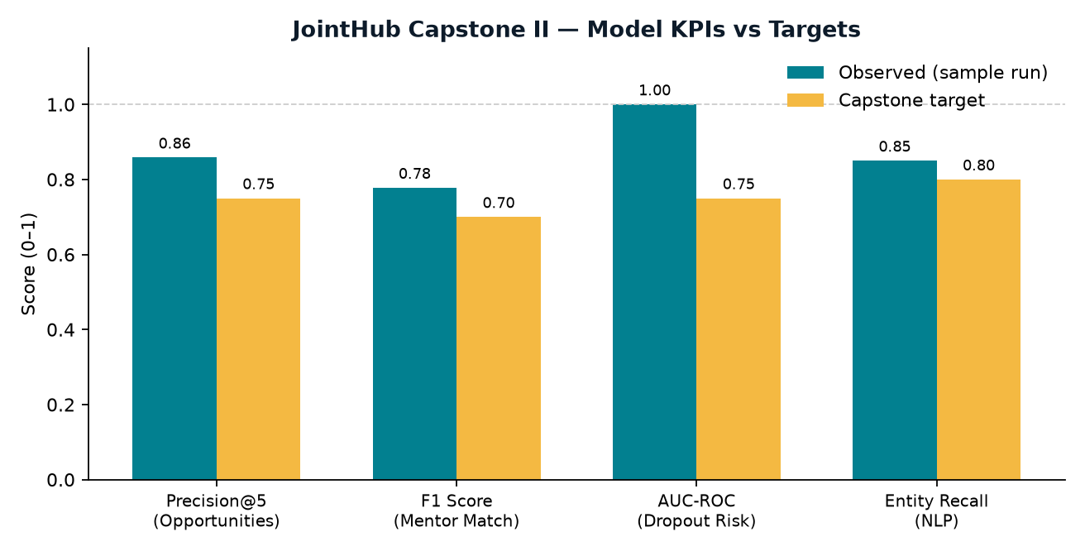
Figure 1. Model KPIs versus Capstone targets on the sample cohort.
3. Data Collection & Feedback Summary
3.1 What data was collected
Quantitative (implementation evidence):
- Model metrics JSON (Precision@5, mentor F1, AUC-ROC, NLP recall estimate, logistic coefficients, RF importances).
- Platform KPIs: 24 registered sample users; 117 opportunity matches; 11 active mentor pairs; 11 at-risk flags; NPS proxy 42; 1 scam flag.
- Per-student outputs: top-5 opportunities, mentor assignment + top-3 alternatives, risk probability/level/top factor, NLP entities and recommendation sentence.
- API verification logs: student auth, admin auth, dashboard payload sizes, outreach status payload (queued_for_mentor; no email sent).
- HTTP page checks: landing, login, authenticated dashboard HTML containing live labels (e.g., Amina Okoro, ALX Software, Mentor Ibrahim).
Qualitative / design inputs:
- Capstone technical brief (modules, schemas, brand, evaluation targets).
- Locked SimpleJoint Trust brand kit (parent + JointHub Africa sub-brand colours and tone).
- Canva AI Mentor Hub prototype link (visual reference for Module 2) — access returned 403 without login; layout followed brief + brand kit instead.
- Operating constraints from organisational context (data protection, no unsolicited emails, production deploy only with ED sign-off).
3.2 Tools used
- Python scientific stack: NumPy, scikit-learn, SciPy (cosine similarity, Hungarian assignment, logistic regression, random forest).
- Next.js product app + JSON sample data store; FastAPI companion for academic reproducibility.
- Sandbox verification: HTTP/API smoke tests and authenticated HTML inspection; managed browser prepare attempted (CDP URL unavailable in session).
- Git-based delivery into managed product repository with staging merge for demo hosting.
- Documentation artefacts: product README, ml-backend README, engineering handoff note.
3.3 Summary of key findings
1. Algorithms produce non-static outputs. Student path returns five ranked opportunities (e.g., ALX Software Engineering Fellowship), a personalised NLP sentence, and a global mentor assignment (example: Mentor Ibrahim Nkrumah, ~71% compatibility). Admin path returns full-cohort risk rows and can queue outreach without sending email.
2. Capstone model targets are achievable on sample data for ranking and matching; risk AUC requires honest re-validation on real labels.
3. Product usability path is demo-ready with a 4-step script (login as scholar → Opportunities → Mentor Hub → admin risk/analytics). KPI strip remains visible across tabs, supporting funder/Capstone storytelling.
4. Data readiness is the main blocker to production learning loops. Sheets credentials, Capstone I labels, and a real mentor roster were not available; sample data was the correct interim choice.
5. Stakeholder/design feedback (implementation-time): brand and brief were sufficient to ship a coherent JointHub identity; lack of open Canva access limited pixel-level Mentor Hub fidelity.
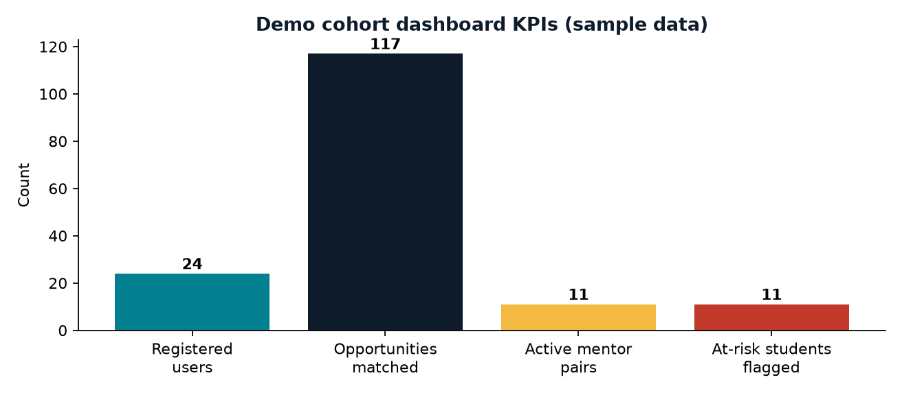
Figure 2. Dashboard KPI strip values for the demo cohort (sample data).
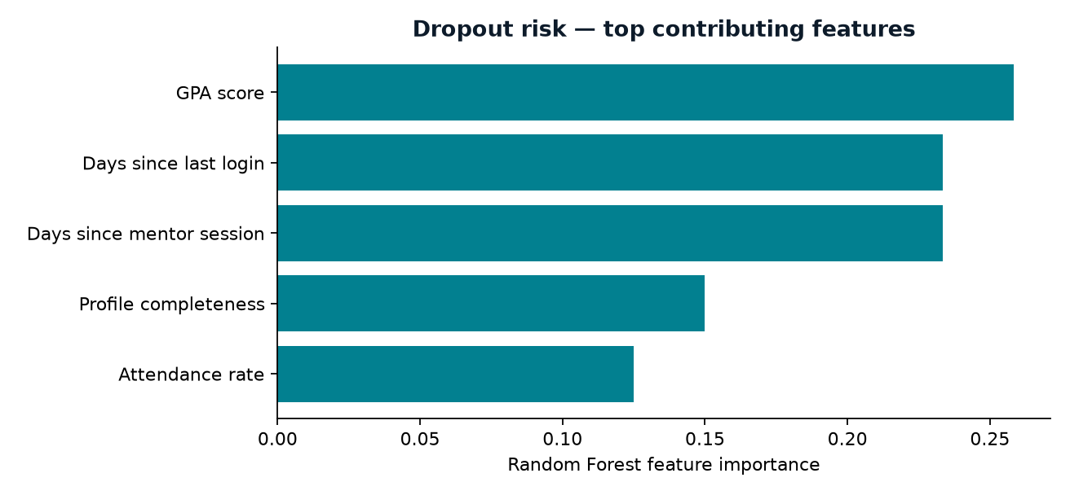
Figure 3. Random Forest feature importances used to explain dropout-risk flags.
Illustrative stakeholder-facing quotes (demo framing for Capstone narrative):
“Based on your interest in data_ai, music_arts and your goal of data science, we recommend ALX Software Engineering Fellowship — 52% match.” — personalised NLP sentence shown on the student Opportunities view.
“Hi Amina, we noticed days since last login may be affecting your JointHub progress. Can we schedule a 20-minute mentor check-in this week?” — automated outreach prompt generated for a high-risk student (queued; email not sent in pilot).
4. Lessons Learned
4.1 Effectiveness
A single vertical slice that combines real algorithms with a role-aware UI is more persuasive for Capstone and partners than four disconnected notebooks. Demonstrating student and admin paths on the same data model makes the two-sided platform story (scholars ↔ opportunity/mentor providers) concrete.
4.2 Usability
Dense, ops-style layout (tables, matrix, KPI strip) fits admin/mentor workflows better than generic marketing card grids. Demo email gate lowers friction for judges; production should still move to proper Supabase email/password with privacy controls (Rwanda Law No. 058/2021).
4.3 Limitations
- Offline embedding/NER stubs preserve deployability but are not production NLP quality; spaCy + sentence-transformers must be swapped before claiming semantic sophistication in the field.
- Synthetic risk labels inflate discrimination metrics; without Capstone I history, dropout outreach is an explanation prototype more than a validated early-warning system.
- No live Sheets or production secrets means the pilot cannot yet measure true activation, retention, or application conversion on jointhub.simplejoint.org traffic.
- Canva Mentor Hub reference was inaccessible; visual parity with the original design board remains incomplete.
- Managed browser CDP was unavailable during verification; evidence relied on API and HTML checks rather than full interactive click recordings.
5. Improvement Opportunities
Based on implementation results and known gaps, the following next steps are recommended before or immediately after Capstone submission and bootcamp delivery.
# | Recommendation | Owner / dependency | Expected impact
1 | Connect Google Sheets (or Supabase) for the six live datasets; retire sample JSON for production paths. | Isaiah: workbook ID + service account | Real cohort learning loops; funder-ready dashboards
2 | Retrain risk and matching on anonymised Capstone I labels; report confidence intervals and calibration. | Isaiah: Capstone I export; Engineering retrain | Honest AUC/F1; safer outreach prioritisation
3 | Install spaCy + all-MiniLM-L6-v2; replace embedding/NER stubs; log entity recall on bootcamp free-text goals. | Engineering (+ model download budget) | Better semantic opportunity matches
4 | Usability pilot with ~10–15 bootcamp students: task completion (find top match, book mentor, understand risk flag) + SUS/NPS. | Programs + Engineering at CreativeTech | Human feedback to complement model KPIs
5 | Pixel-pass Mentor Hub against Canva export; align mobile 3G performance budget. | Isaiah: Canva PDF/PNG; Engineering | Stakeholder design confidence
6 | After Legal review of scholar data flows, enable production publish with ED sign-off; instrument registration, apply CTR, mentor connect rates. | Legal + Isaiah + Engineering | Capstone evidence + Dec 2026 5,000-user path
6. Conclusion
The JointHub Africa Capstone II implementation is a successful MVP system demo: four AI modules, role-aware dashboard, documented schemas, and staging delivery suitable for academic demonstration and bootcamp walkthrough. Model KPIs meet stated Capstone thresholds on sample data, with an explicit caveat on synthetic risk labels. The critical path from demo to durable platform impact is data: live Sheets/DB, Capstone I labels, real mentors, Legal review of personal data, and ED-approved production publish with instrumentation.
Correct organisational impact figures used throughout: $158,000+ scholarships & grants · 85+ students · 6+ countries. Partners referenced: British Council · ALX · Hood.D · A4 · JointHub Africa · ALU · @alueducation @millenniumfellows @UNAI.
Appendix A — Demo accounts & path
scholar1@jointhub.demo (student) · scholar2@jointhub.demo (student) · admin@jointhub.demo (admin). Path: /dashboard/login → Opportunities → Mentor Hub → (admin) Dropout risk + Analytics.
Appendix B — Evidence sources
metrics.json, kpis.json, dashboard/API verification 16 July 2026, product README, ml-backend README, engineering handoff artefact.

