**Mithila DeSilva**

simplemithi@gmail.com

Android Developer

**Mobile App Proposal**

2421 Erin Centre Blvd

Mississauga, Ontario

L5M5B3, Canada

Phone: (416)-829-1557

**Executive summary:**

This app will allow any student or anyone in the education department to get an idea of how much money has been given as loans to the students in Canada from the year 2004 till 2013.

**Why Mobile App?**

Mobile app is the best choice for this product because in the current generation everything is shifting to the mobile industry. It makes life so much easier for people who are busy and almost all the time away from a personal computer but almost all the time has a phone in hand. Especially with the smart phone era we are living in right now you can pretty much do everything that was done in a personal computer on the palm of your hand.

**List of basic app features:**

* Get information about the Province
* Display a picture of the province capital in the ListView
* Select a Province and a Year for the grant value to be displayed
* Short click and long hold features
* Help menu
* About menu

**Expected users/market for this app:**

This app is targeted at anyone in the education industry from a student who is taking a course to the education minister. Also this will be very useful for the accountants in the education department.

**Most common use cases:**

This app will be most used at times when trying to look back into the history of loan allowance in Canada by the Province. Also this will provide an idea of how much money has been granted by the government for the education of the country to be a success.

**Mock-ups of the App:**

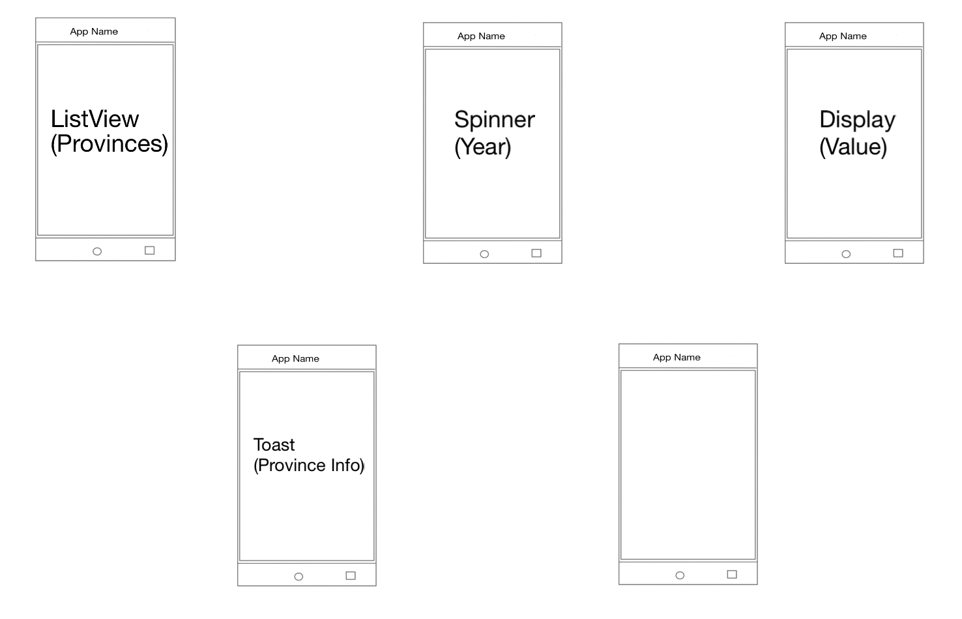

Screen1: Displays the list of Provinces in a ListView

Screen2: Display the years from 2003-2013 in a Spinner

Screen3: Displays the Loan Value of the year for the selected province

Screen4: On Long click displays some information about the selected province

Screen5: Two Menus: Help and About menu

**Timeline for implementation:**

|  |  |  |
| --- | --- | --- |
| **Task** | **Due Date** | **Status** |
| Pick an idea t | July 30th | Done |
| Create the proposal | July 30th | Done |
| Test app features | August 4th | - |
| Upload the app | August 10th | - |
| Market the app | - | - |