Query Designer

Rob Tucker
03/27/2019
Query Designer
Contents
Project Layout 3
Application Configuration 3
appconfig.json 3
document-groups.json 4
orms.json 5
Creating a Query Document 5
Login 5
Select Starting Model 5
Select Desired Model Columns 6
Column Setting 7
Define Filter 8
View Generated SQL 9
Running the Query 10
Saving the Query 11
Loading and Deleting Existing Query Documents 12

The Query Designer is a React web application designed to work in concert with Simple Node ORM installations. The query designer allows users to create query documents that can return JSON result sets or JSON object graphs. Once created, the query documents can be accssed and run via REST calls to retrieve JSON data or as the foundation for reports built by the Report Designer..

Project Layout

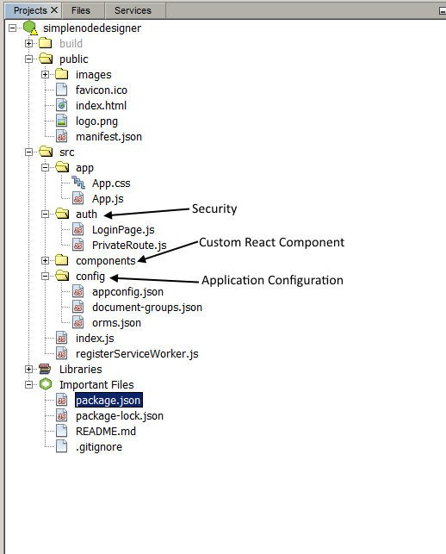

The project is available on github at:

https://rbtucker@github.com/rbtucker/simplenodedesigner.git

Application Configuration
Application configuration is handled in 3 files:

appconfig.json
{
"textmsg": {
"logintitletext": "Simple Node ORM", "modelselectdefault": "Select starting model...", "adddocument": "Add Document",
"setupmenuname": "Setup", "filemenuname": "File", "newmenuname": "New", "newdocument": "New",
"preferencesmenuname": "Preferences",
"selectdata": "Select Data",
"formatselections": "Column Settings",
"definefilter": "Define Filter",
"designreport": "Design Report",
"runquery": "SQL/Results",
"aggfunctionlabel": "Function:",
"sortposlabel": "Sort Pos:",
"ascdesclabel": "Desc:",
"customcolinputlabel": "Custom:",
"columnlabel": "Label:",
"value": "Value:",
"paramentrytitle": "Search Parameters", "savedocumenttitle": "Save Document", "authenticatorlabel": "Authenticator:", "resultformatlabel": "Result Format:", "validitycheckonly": "Validity Check Only", "distinct": "Distinct", "documentnamelabel": "Document Name:"
},
“demoMode”:true,
"defaultDesignAuthenticator": "DefaultAuthorizer"
}

name | description
textmsg | Configurable display text
demoMode | If true, it is assumed that we are running in demo mode with query designer in same docker container as orm
defaultDesignAuthenticator | This is the authorizer to use for designer login authentication. The DefaultAuthorizer expect a basic auth string but does not validate the contents so access will be granted to everyone.

document-groups.json
This is the document group hierarchy used for loading/saving query documents that displays as a tree in the left pane of the main page. The “key” entry must be unique. When a document is saved it will be associated with the selected group. Document storage location is set in the ORM configuration. Documents will be stored in folders by group under this path.

{
"title": "Queries",
"key" : "grp0", "isLeaf": false, "children": [
{
"title": "General",
"key" : "grp1", "isLeaf": false
},
{
"title": "Financial", "key" : "grp2", "isLeaf": false, "children": [
{
"title": "Accounting", "key" : "grp3", "isLeaf": false
},
{
"title": "Purchasing", "key" : "grp4", "isLeaf": false
}
]

},
{
"title": "Personnel", "key" : "grp5", "isLeaf": false
}

]
}

orms.json
Query Designer supports multiple ORM installations. An example configuration for available ORMs is shown below. defaultUsername and defaultPassword are optional, if they exists they will auto-populate the associated login dialog fields.

[
{
"name" : "simple",
"url" : "http://localhost:8888/orm"
},
{
"name" : "kfs",
"url" : "http://localhost:8888/kfsorm", "defaultUsername" : "user", "defaultPassword" : "pass"
}
]

Creating a Query Document

Login
Pull up the application in the browser, select the desired ORM, enter Username and Password if required and click Login.

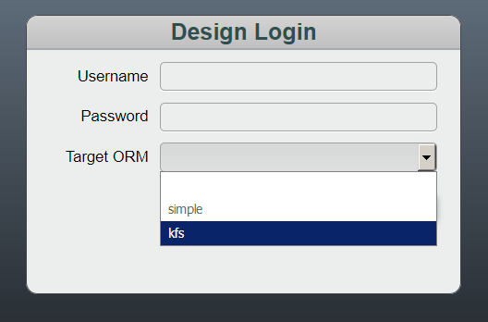

Select Starting Model
Click the menu button to display a list of available models:

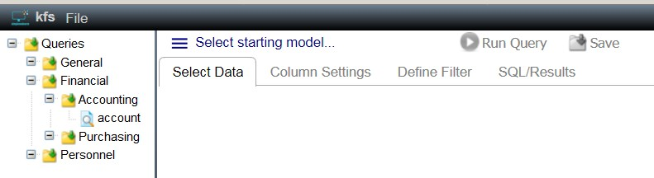

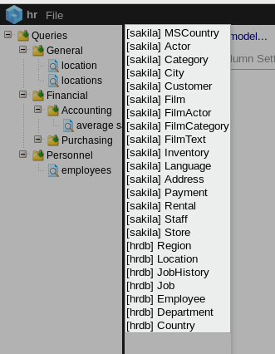

Select Desired Model Columns
After the starting model is selected a model hierarchy will be displayed – check the desired columns. Starred columns indicate primary keys
.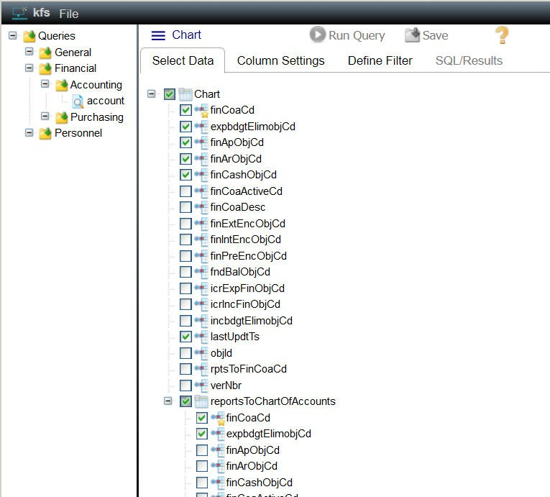

Column Setting
Customize the selected column settings on the Column Settings tab. The Label field is used in the SQL select for the “as” column setting. Aggregate functions can be applied via the Function dropdown. If an aggregate function is applied the appropriate “group by” clause will be generated. The Custom field allows the designer the flexibility to add database specific select logic. If custom is populated it will be placed in the select statement as is. Entering a “?” in the custom entry will insert the current column name into that position .
The green arrows allow you to change the select column order. If a result set is returned the columns will be in the order specified.

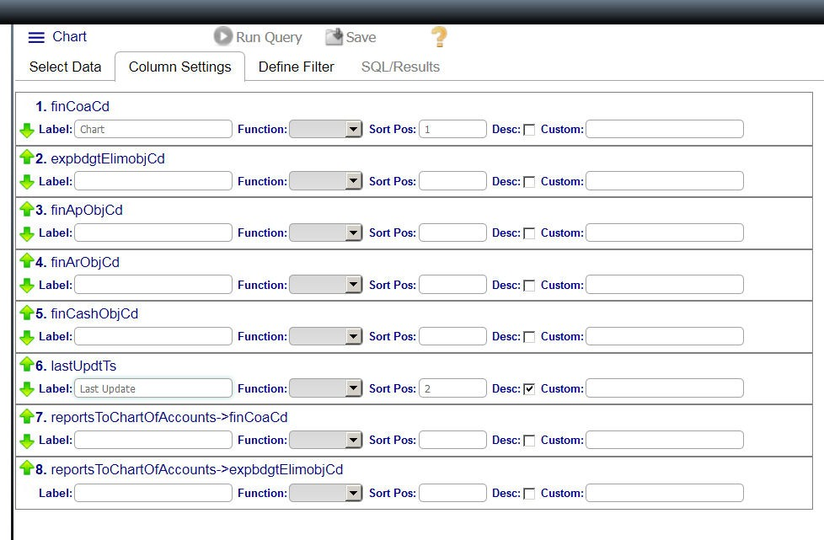

Define Filter
A where clause is required for all query documents. The Define Filter tab is to build the where clause. Where column entries are selected from the available column selections so ensure that desired filter columns are selected in the column selection tree. To add a filter entry, select the desired column and click the add button:

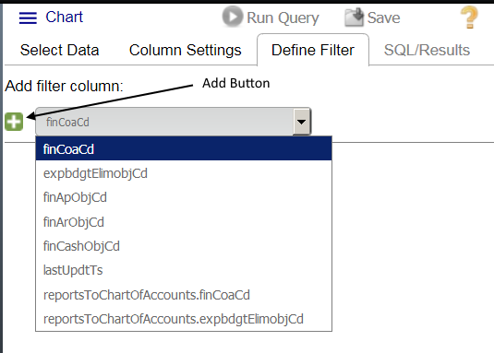

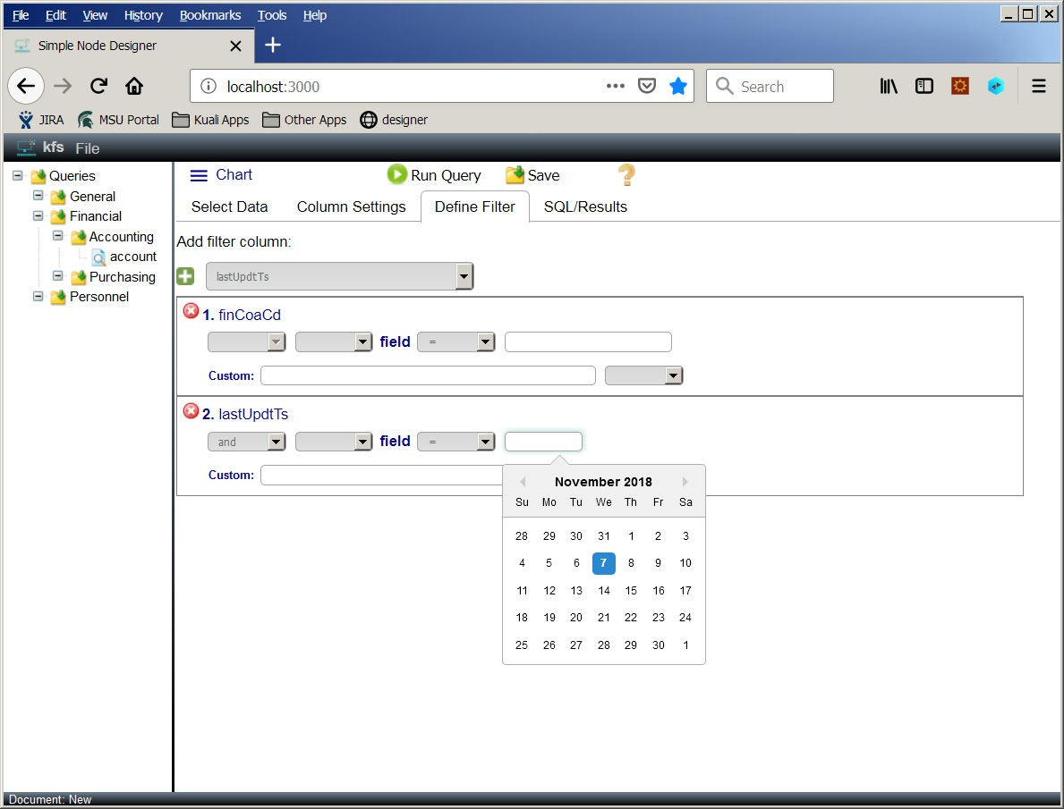

Each filter line allows for selection (where appropriate) of:
- Logical operator (and/or)
- Open parenthesis - (, ((, (((o ((((
- Comparison operator (=, >, <, <=, >=, in, like, is null, is not null)
- Comparison value entry
- Close parenthesis - ), )), ))) or ))))
If a comparison value field is left empty it is assumed that the field will be populated by a bind parameter when the document is run.
The Custom field allows for freeform entry of any where value. If this field is populated it is added to the where clause as is. Entering a “?” in the custom entry will insert the current column name into that position .

View Generated SQL
Once a filter has been defined the user can see the generated SQL in the SQL/Results tab:

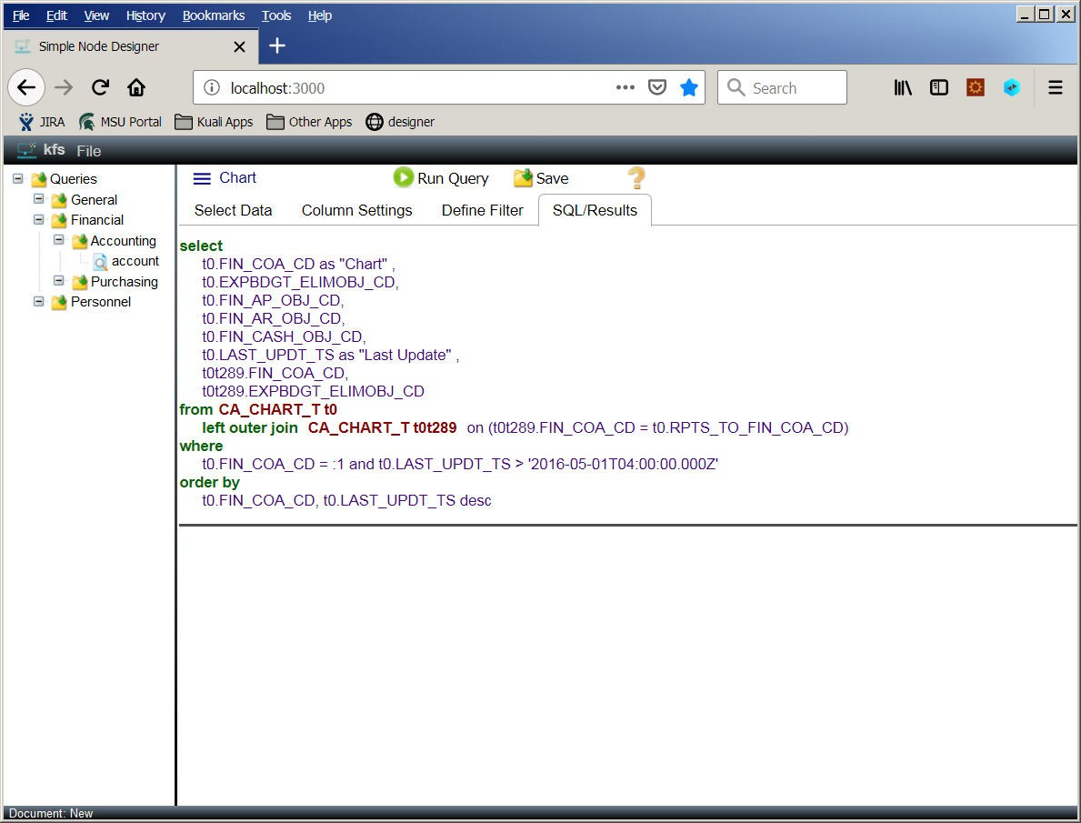

Running the Query
To run a query, click the Run Query button:


When Run Query is clicked, a parameter entry dialog will display. If any bind parameters are required they can be entered here:

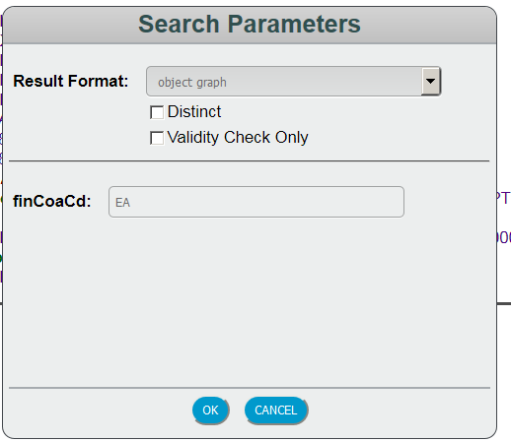

The parameter entry dialog also allows the user to enter other options:
- Result Format – object graph or result set
- Distinct – check to run distinct query
- Validity Check Only – if checked, no results are generated and the validity of the generated sql is displayed in the results panel.
Once the required entries are made, clicking Ok will run the query and results will display in bottom panel of split pane:

Object Graph Result:

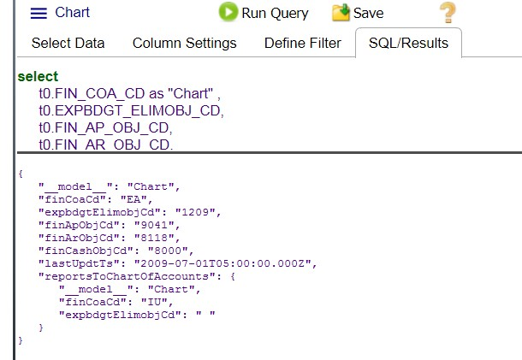

Result Set Result:

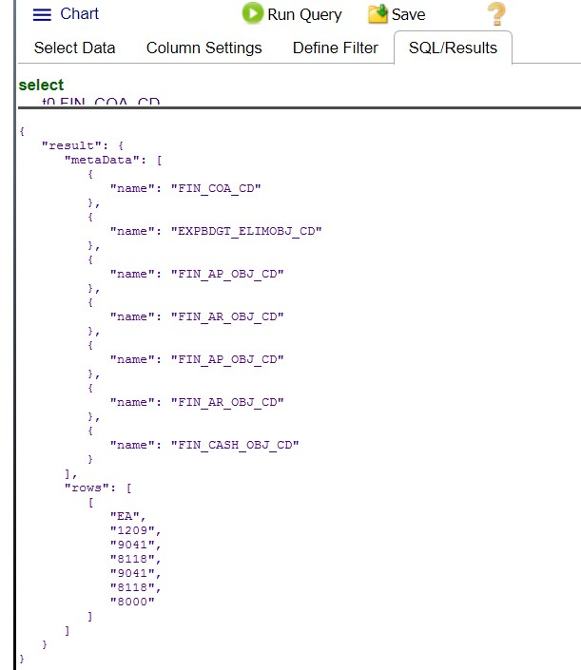

Saving the Query
Click the save button to the Query Document

When clicked, the Save button will display the Save dialog:

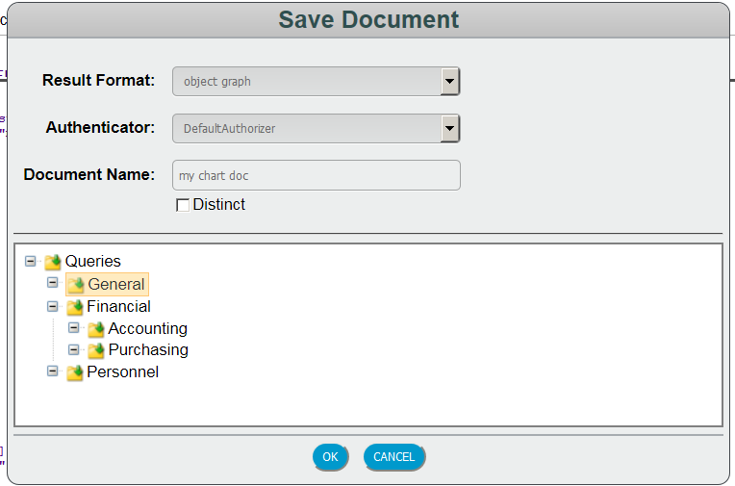

Complete the required entries and select the document group, then click Ok to save the document. You should see the saved document show up in the document tree in the left pane:

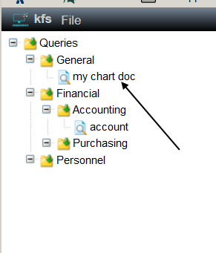

Loading and Deleting Existing Query Documents
To load or delete an existing query document, right click on the desired document and select the desired menu option:

