Contents
Getting Started 2
Login 2
Setting Default Preferences 3
New Report 4
Common Report Object Opertions 5
Select an Object 5
Resize an Object 5
Moving and Object 6
Editing an Object 6
Text Align Multiple Objects 6
Align Multiple Objects 6
The Report Design Panel 7
Application Toolbar 8
Page Sections 8
Page Design Scroll 8
Adding Report Objects 9
Current Date 9
DB Data 11
Image 14
Graph 15
Label 15
Link 16
Email 17
Page Number 17
Shape 19
Running the Report 20
Saving a Report 22
Load an Existing Report 22

Getting Started

Login
Pull up the application in the browser, select the desired ORM, enter Username and Password if required and click Login.

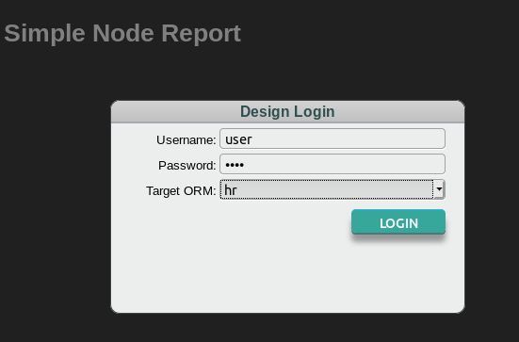

Once logged in you should see a screen similar to this:

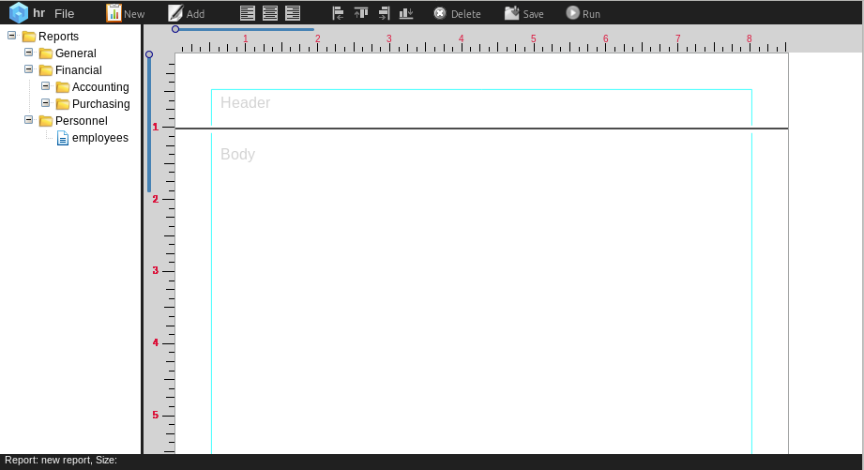

The left pane contains the document tree. The right pane contains the document design panel. Previously created report documents will display in the left pane -
“employees” is an example.

Setting Default Preferences
Click the File menu item on the application toolbar the click Preferences from the dropdown menu to show the Default Settings panel.

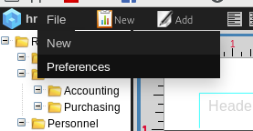

Set your desired default settings. These are what will pre-populate the report settings when you create a new report.

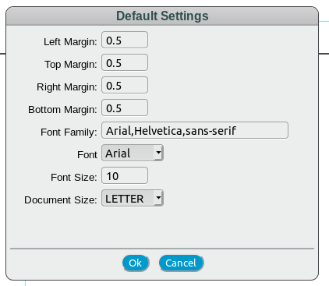

New Report
From the application toolbar click the New report icon
to display the Add Report panel:
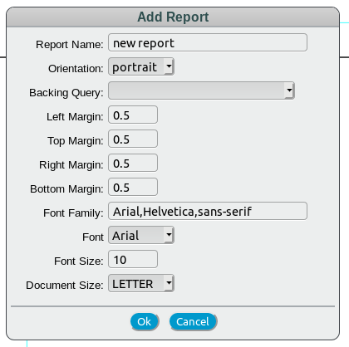

Enter an appropriate report name and select a backing query.

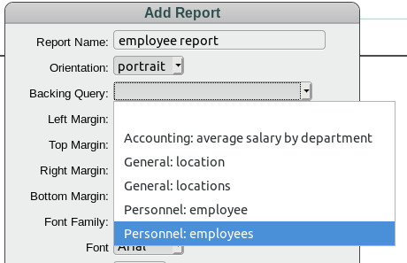

Make any other desired modifications to the report format and click Ok to start designing a new report.

Common Report Object Opertions
When designing a report there a some common operations that select, move, resize and edit report objects. For this discussion we will use the “example label” in the header section shown below. Note that this label has the defined label border. This border is for development purposes only to identify labels and will not display in active report.
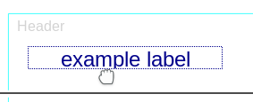

Select an Object
To select a report object press the CTRL key and left click the object with the mouse. The object will display the selected (defaults to red) border. To deselect the object CTRL click again. T deselect all selected objects hit the ESC key.
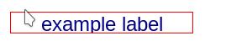

Resize an Object
Report objects can be resized in 2 ways:
- Hover the mouse over a border and when the resize cursor displays, drag the border

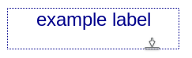

- Selected objects can be resized by holding down shift key and pressing the arrow keys. Resizing will be applied to all selected objects.
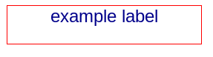

Moving and Object
To move a report object the user can drag it with the mouse of select an object and use the arrow keys

Editing an Object
To edit or delete an existing report object, right click on the object and select the desired option from the popup menu.

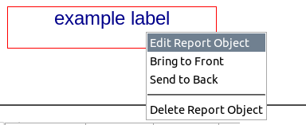

Text Align Multiple Objects
To set the text alignment on multiple objects, select the target objects:
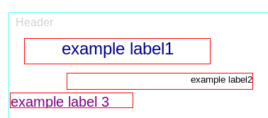

then click the desired alignment icon on the tool bar.
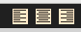

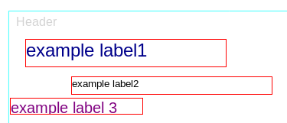

Align Multiple Objects
To align multiple objects, select the desired target objects. The selected objects will align to the associated border of the first selected object. Click the desired object align icon:

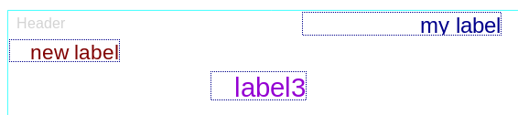

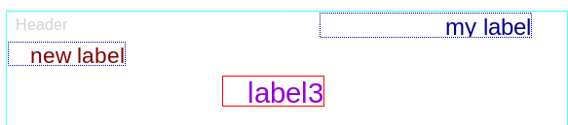

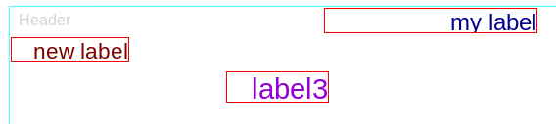

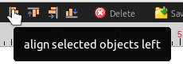

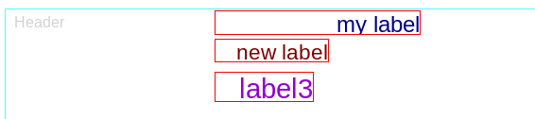

The Report Design Panel
After completing the steps listed in the previous section your are presented with an enabled report design panel formatted based on your selections. Key design panel components are desribed below.

Application Toolbar
The application toolbar provides the following functionality:

- Add new report
- Add report objects
- Text align on selected report objects
- Report object align
- Delete selected report objects
- Save report
- Run report
delete selected objects
add report object
run report
new report

text align selected objects
align selected objects
save report

Page Sections
The design panel is broken into 3 page sections – header, body and footer. These sections are resizable by moving the section separtor.
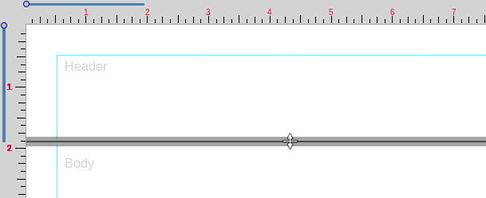

Page Design Scroll
Use the vertical and horizontal design scroll controls to scroll the report design:

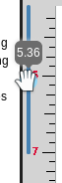

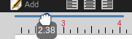

The mouse wheel can also be used fro vertical scrolling.

Adding Report Objects
To add a report click the add report object icon
and select the desired object type from
the displayed list:

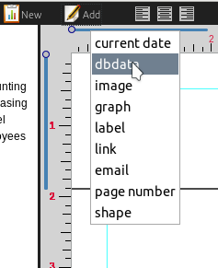

Current Date
To add a current date object to the report select current date from the add object dropdown.

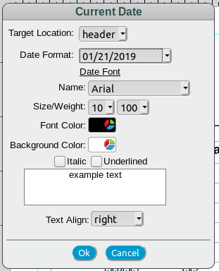
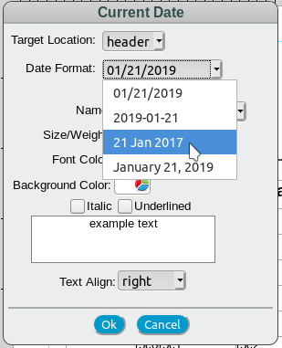

Select the report section, date format and set the font as desired ten click Ok to add to the report.

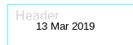

The current report run date will be inserted into this object.

DB Data
The dbdata report object is the report link to the backing query result data. An example of the object setup panel is shown below:

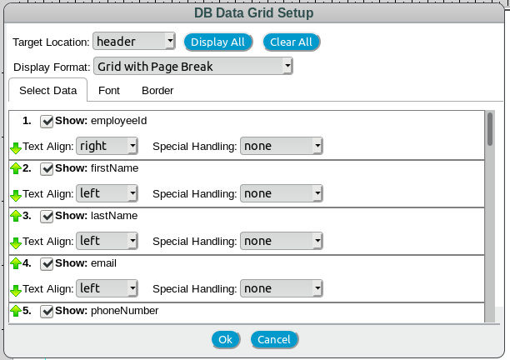

The Select Data panel above allows the user to select, order and format result set data for the report object. By default, all available columns in the backing query are selected. The user can click the Display All and Clear All buttons to change all the column selections. Individual columns can be selected and deselected by clicking the Show checkbox. Column names are shown next to Show checkbox. The format will show the path to the column so more complex data from child objects are shown as an arrow delimited string – for example:

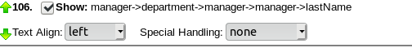

Selected column order can be adjusted by clicking the green arrows. Display Format allows the user to select how the data will be displayed on the report and how to control page breaks.

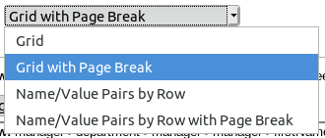

The selections are descibed below:
- Grid – displays a standard column/row table with the selected result set data. Column and rows are resizable via mouse.
- Grid with Page Break – displays column/row table and forces a page break when the report object display area is full. Column and rows are resizable via mouse.
- Name/Value Pairs by Row – displays a vertical Name Value list of row data, each Name and value is an invidual object which can be moved and resized as desired.
- Name/Value Pairs by Row with Page Break - displays a vertical Name Value list of row data and forces a page break after each row.

Below are examples of the Grid an Name/Value objects:
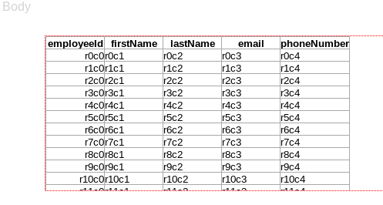

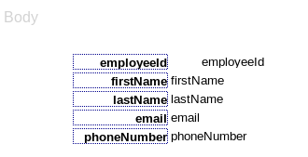

Special Handling can be applied to report columns. For numeric fields the following options are available:

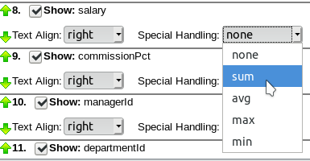

If selected, the numeric options will display on a Grid object in a totals line at the added at the end of the grid. The option will not be applied to the Name/Value pairs display type.

For text column types the following options are available:

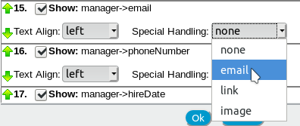

If selected, the text-based options will apply to the displayed data. For email and link options the text will used for an html anchor tag. For the image option, it will be assumed that the text is an image url and an html image tag will be created.

The Font and Border tabs allow the user to set header and data font and border properties and the displayed results:

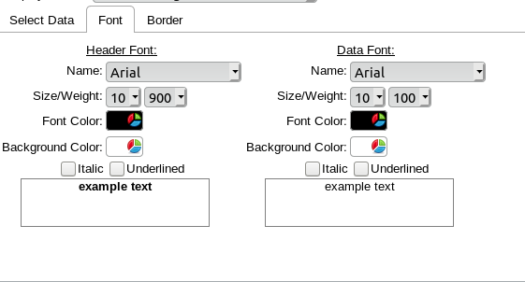

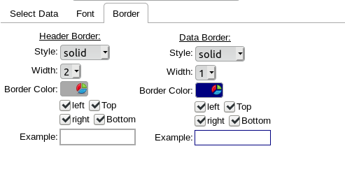

Image
Select image from the report object popup menu to add an image to the report.

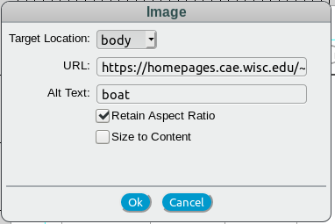

Select target page location, enter image URL and Alt text and click Ok to place image object on the report. The checkboxes support the following:

- Retain Aspect Ratio – if checked the image will retain the original aspect ratio and fit the report object rectangle based on the max/min sizes required.
- Size to Content – if checked the image will be placed in the report at it’s original size. If the report object size is smaller than the image size then only a portion of the image will be visible. If not checked the image will be sized to the report object size.

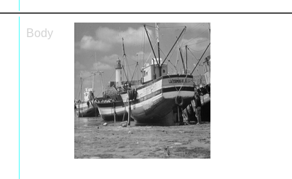

Graph
This functionality is currently under construction and will be in a future release.

Label
To create a label object select label from the report object dropdown menu:
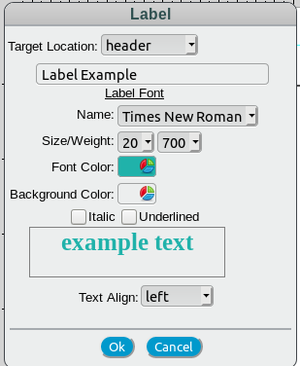

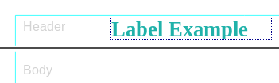

Link
To create a link select link from the report object dropdown:

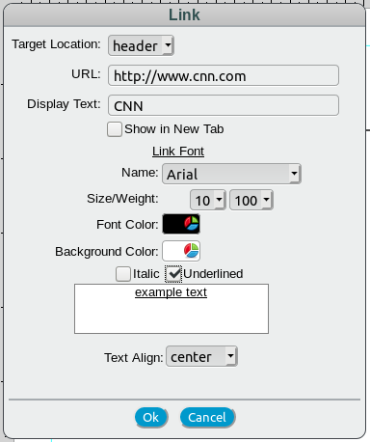

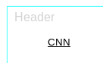
Select target location and desired font format. If you would like the contents of the URL to display in new tab when clicked, check the Show in New Tab checkbox.

Email
Email is very similar to the link example above. Select email from the report object dropdown and choose your desired setting.

Page Number
To add a page number to report select page number from the report object dropdown:

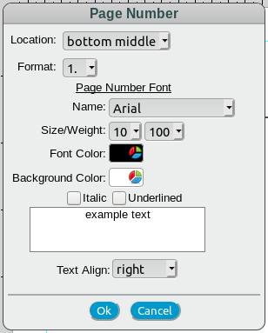

Select the page number location, format and desired font format then click Ok to add to the report. Available locations and formats are shown below.:

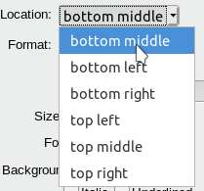
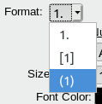

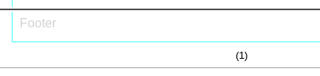
When the report is run the current page number will be placed in the object.

Shape
To add a shape to the report select shape from the report object dropdown:

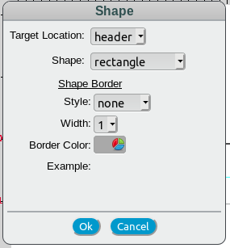

Selecet target location, desired shape and font format then click Ok to add to report.

The available shapes are shown below:
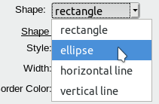
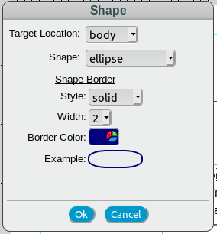
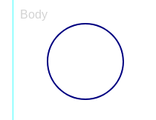

Running the Report
For test purposes the desgned report can be run from the designer by clicking the run icon on the toolbar. So if we design a report something like this:

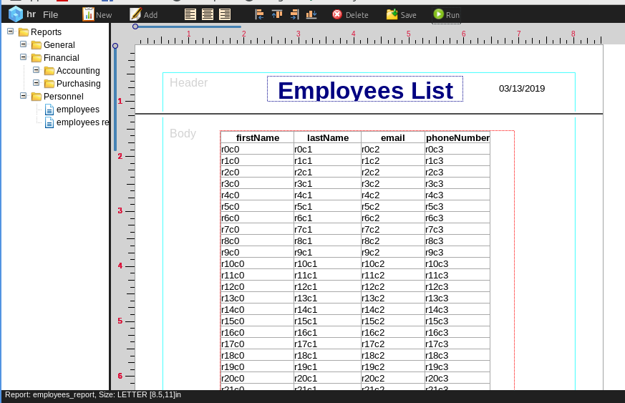
and click the run button we will get something like this:

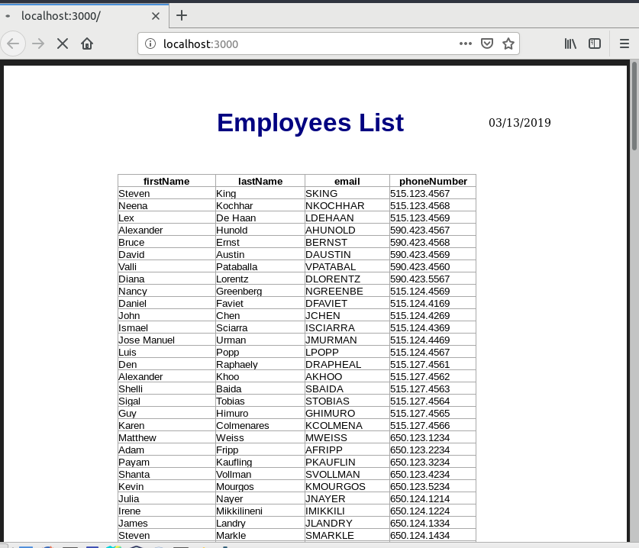
If input data is required an input panel will display:
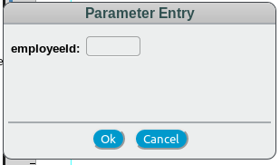

To run reports standalone you would call a url similar to the following:

http://<reportserver>/runreport/<ormid>.<groupname>.<reportname>

for example:

http://localhost/runreport/hr.grp5.employees

User login and/or parameter entry panels will display if required.

Saving a Report
To save a report click the save icon to display the Save Document panel:
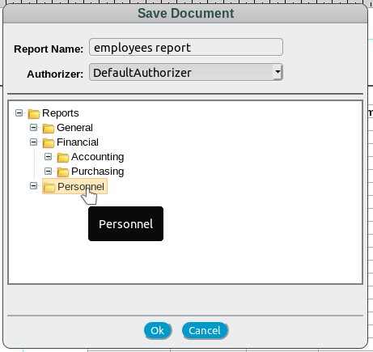

Update report name and authorizer if desired then select group for the report and click Ok to save.

Load an Existing Report
To load an existing report left click the desired report in the report tree and select Load Report from the popup menu:
