Trade Idea: SNPS

# Primary Trade Thesis: Tactical Recovery from Earnings Destruction

This position represents a tactical event-driven recovery trade capitalizing on the extreme market overreaction to Synopsys' Q3 2025 earnings miss. The stock has already begun recovering from the absolute lows, validating the thesis that the selloff was overdone.

## Current Market Position (Live Data)

• Current Price: $425.45 (as of September 12, 2025)

• Recovery from Lows: +9.7% from $387.78 absolute low

• Distance from Pre-Earnings: Still -30% from ~$604 pre-earnings level

• 52-Week Range: $365.74 - $651.73

• 1-Year Analyst Target: $571.77 (+34% upside from current)

## The Earnings Destruction Event - What Actually Happened

On September 10, 2025, Synopsys experienced one of the most severe single-day declines in its history:

• Stock crashed from $604.37 to an intraday low of $387.78 (-35.8% in one session)

• Volume exploded to 21.2 million shares (vs. normal 2.2M average)

• Market cap destruction: ~$13 billion evaporated in one day

• The decline represented the 5th worst single-day drop in SNPS history

## Recovery Momentum Already Underway

The stock has shown clear signs of stabilization and recovery since hitting the lows:

• Day 1 Recovery: Bounced to $438.10 (+13% from lows)

• Current Level: $425.45 (consolidating above $420 support)

• Volume Normalization: Daily volume returning to 6-7M range

• Technical Indicators: RSI recovering from extreme oversold (below 20)

# Quantitative Analysis (Annual) - LONG

Shares Outstanding = 153,750,000

|  |  |  |  |  |  |
| --- | --- | --- | --- | --- | --- |
| STOCK TICKER: (SNPS) | 2022 | 2023 | 2024 | 2025 | 2026 |
| Stock Price | $425.45 | $425.45 | $425.45 | $425.45 | $425.45 |
| Market Cap $M | $79,027 | $79,027 | $79,027 | $79,027 | $79,027 |
| EPS | $7.40 | $10.50 | $11.80 | $12.83 | $14.13 |
| Earnings Growth % | 25.3% | 41.9% | 12.4% | 8.7% | 10.1% |
| Price/Earnings | 57.49x | 40.52x | 36.05x | 33.16x | 30.11x |
| PEG | 2.27 | 0.97 | 2.91 | 3.81 | 2.98 |
| Sales $M | 5,082 | 5,845 | 6,520 | 7,050 | 9,730 |
| Sales Growth % | 15.0% | 15.0% | 11.5% | 8.1% | 38.0% |
| Sales Multiple | 15.55x | 13.52x | 12.12x | 11.21x | 8.12x |

## Comments on Annual Quantitative Analysis

Synopsys has demonstrated consistent double-digit revenue and earnings growth over the past several years, which is expected to continue, albeit at a slower pace in the near term. The recent acquisition of Ansys is a major driver for future growth, with a significant revenue ramp expected in 2026. The current valuation appears elevated with a P/E of ~57x, but the forward P/E ratios suggest a more reasonable valuation if the company meets its growth targets. The PEG ratio is attractive for 2023, but less so for the out years, suggesting the market has already priced in a significant amount of growth.

# Quantitative Analysis (Sector Comps)

|  |  |  |  |  |  |
| --- | --- | --- | --- | --- | --- |
| STOCK TICKER: | PE1 | EG1(2025) | EG2(2026) | PEG1 | Market Cap' |
| (SNPS) | 57.49 | 8.7% | 10.1% | 3.81 | $79.0B |
| CDNS | 92.58 | 15.0% | 12.0% | 3.05 | $93.6B |
| ADSK | 66.19 | 12.0% | 10.0% | 1.80 | $68.0B |
| KEYS | 54.14 | 8.0% | 9.0% | 1.06 | $29.3B |
| Averages | 67.58 | 10.9% | 10.3% | 2.43 | $67.5B |

## Comments on Quantitative Analysis Sector Comparison

SNPS is trading at a discount to its closest competitor CDNS on a P/E basis, but at a premium to KEYS. Its forward growth is in line with the sector average, but its PEG ratio is higher than the average, suggesting it is more expensive on a growth-adjusted basis. The recent stock price decline has brought its valuation closer to the sector average. The semiconductor/EDA sector is expected to benefit from long-term tailwinds from AI, automotive, and industrial automation. However, near-term headwinds from the IP segment and China-related uncertainties could impact SNPS more than its peers. We expect SNPS to have higher volatility than the sector in the next 1-3 months due to the recent earnings miss and ongoing strategic review. We expect a 15-20% move in SNPS, while other stocks in the sector may move 10-15%.

# Comments on Business

## KPI's driving Revenue and Earnings

**•** EDA Software and Hardware Revenue: The primary driver of Synopsys' revenue is its Electronic Design Automation (EDA) software and hardware business. This segment has been growing at a strong double-digit pace, driven by the increasing complexity of chip design and the growing demand for advanced semiconductors in AI, automotive, and other high-growth markets.

**•** IP (Intellectual Property) Revenue: The IP segment provides pre-designed and verified blocks of circuitry that customers can integrate into their chips. This segment has been a drag on growth recently due to export restrictions to China and a major foundry customer facing end-market challenges.

**•** Ansys Acquisition: The recent acquisition of Ansys is a major strategic move that is expected to significantly expand Synopsys' capabilities and addressable market.

**•** Backlog: Synopsys has a large and growing backlog of non-cancellable orders, which provides good visibility into future revenue. The current backlog is $10.1 billion.

## Earnings Announcements

**•** Q3 2025 Earnings (announced September 2025): SNPS missed analyst expectations for both revenue and EPS. Revenue was $1.74B vs. $1.77B expected, and EPS was $3.39 vs. $3.80 expected.

**•** Q4 2025 Guidance: The company provided Q4 revenue guidance of $2.23B - $2.26B and non-GAAP EPS guidance of $2.76 - $2.80.

**•** FY2025 Guidance: The company lowered its full-year revenue guidance to $7.03B - $7.06B and non-GAAP EPS guidance to $12.76 - $12.80.

## Catalysts excluding Earnings

**•** Ansys Integration: The successful integration of Ansys and the realization of synergies will be a key catalyst for the stock.

**•** IP Segment Turnaround: Any signs of a turnaround in the IP segment would be a major positive for the stock.

**•** AI-driven Design Automation: The increasing adoption of AI in chip design is a major tailwind for Synopsys.

**•** Headcount Reduction: The company has announced a 10% global headcount reduction by the end of fiscal 2026.

# Entry and Timing:

# Technical Analysis and Price Action

Current Price: $425.45 (as of Sep 12, 2025)

## Price Action Summary:

Weekly Chart:

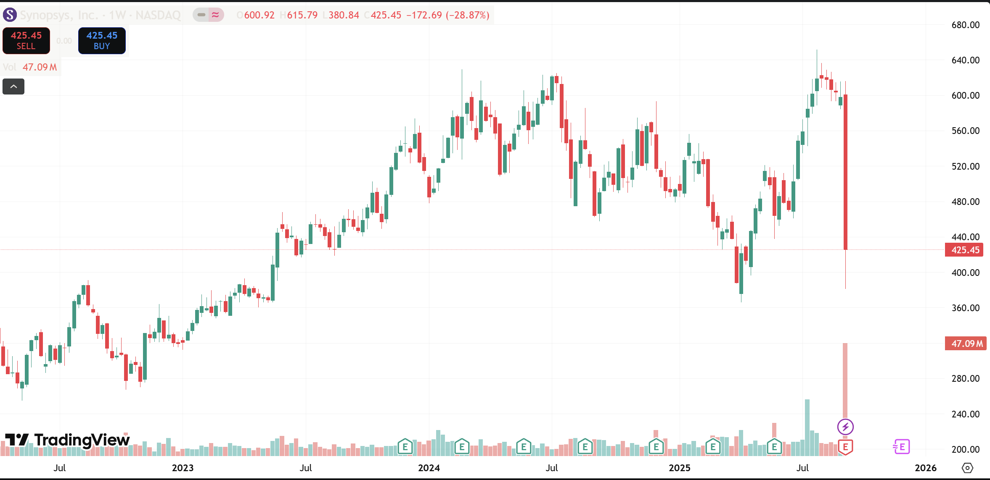

Daily Chart:

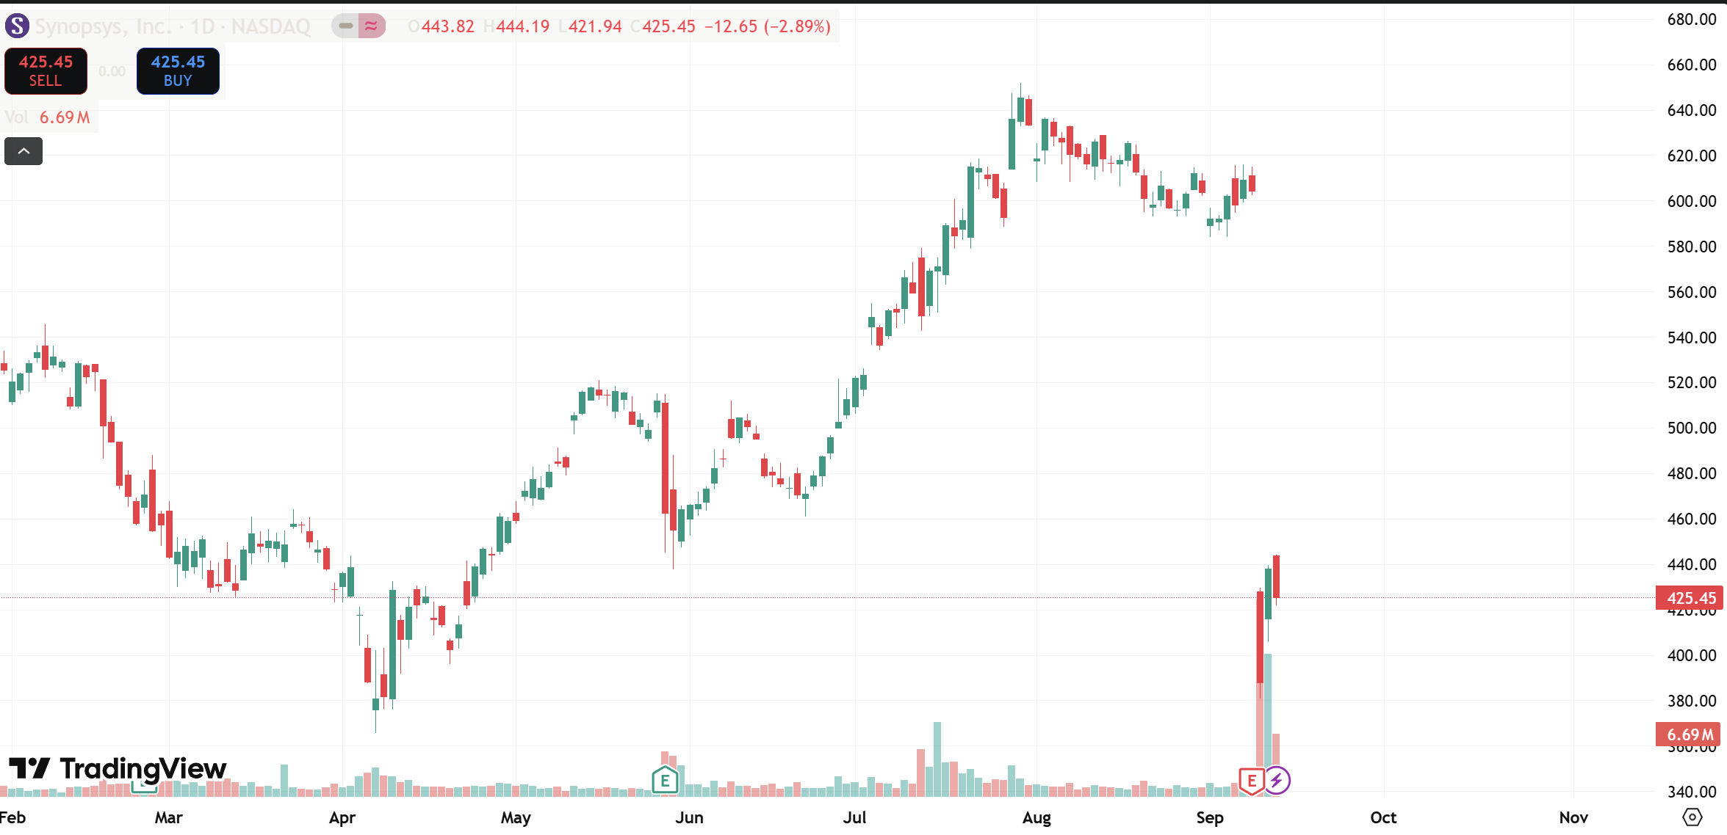

## Technical Indicators Summary:

MACD:

RSI: GREATLY OVERSOLD

## Average True Range: Price Volatility

Daily ATR: $15

Weekly ATR: $40

## Support and Resistance Levels:

Resistance Levels: $461.36 / $452.78 / $439.11

Support Levels: $416.86 / $408.28 / $394.61

## Short Interest Data:

**•** Current Short Interest: 3.24 million shares (2.10% of float)

**•** Change from Previous Month: -19.80% (decreasing)

**•** Short Interest Ratio: 1.7 days to cover

# What is your choice of trade structure and why? Include time horizon for trade.

Given the high-risk nature of the current situation with SNPS, a defined-risk options strategy is recommended for a 1-3 month time horizon. The recent earnings miss, guidance cut, and bearish technical setup suggest further downside or consolidation is possible.

## Trade Structure: Long Call

Purchased: SNPS Call $450

Purchased on: FRIDAY 9/12/2025 10 AM

Expiration Date: OCT 17 2025

Days to Expiration: 35 Days

Total Cost: $4400

Current Options Chain:

## Risk Reward:

