

NCDC
Lab No. 30
Synthesis
Digital Design Verification

Submitted by Hamza Mateen
to instructor Hira Sohail

Dated: ___/___/___

Objective
The aim of this lab is to synthesize your Verilog HDL code by using cadence tool genus to generate netlist, timing report and output report.
After completing this lab, you will be able to:
• Get hands on experience with Cadence tool for front-end design.
• Generate the script file and constraint .sdc file.
• Learn the complete procedure to synthesize your Verilog code and to generate their netlist using tool.

Lab Task:

- Write RTL code of a 4-bit counter. [done]
- Verify its functionality using Xcelium.
- Follow the above steps to perform synthesis of the counter design without DFT and then with DFT.
- Perform post-synthesis simulation with and without timing annotation and compare results.
- Make a proper report by adding all the screenshots at each step.
- Understand script.tcl and constraint.sdc file and explain what you understood.
- Read all the reports and output files generated after synthesis and write a paragraph on each file.
- What do you understand and what results do you conclude.
- Explanation of each file contains marks.
- Report carries 80% weightage.
Project Description:
In this project or lab, we aim to write frontend RTL code in Verilog for a 4 bit counter. The design is supposed to be simulated using Cadence Xcelium before synthesis. This simulation is a functional verification of this system.
Next, we perform the synthesis of this system. It produces a generic netlist (in terms of logical constructs like OR, MUX etc) which is portable across different technology systems i.e 28nm, 65nm process etc or different vendors like Intel, TSMC. This synthesis step assumes ideal hardware with no operation constraints but only functional correctness. It is akin to conversion of high level source code to intermediate representation (e.g that of MLIR in LLVM) during a compilation step, capable of targeting different architectures like x86, amd64 or RV32I etc.
Since the chips are fabricated at fabs, they have different kind of technologies to offer. These technologies come with different trade-offs, operating conditions and, costs. The foundary in questiosn provides the designers with a PDK (process design kit) that contains libraries and files that define the technology specific constraints. The designers then need to design their systems with respect to those constraints. One such file(s) is .lib that contains information about fabricable cells called standard cells.
So in the next step of design synthesis, the generalized netlist is expressed in terms of these standard cells. This process is called mapping. The mapping step uses real-life hardware, so it comes with physical limitations. These limitations are what is covered in .lib file and taken care of by the synthesizer tool such as Genus etc. It reads this file and then translates the generalized netlist in terms of these cells and implements the corresponding hardware circuitry. We can relate it to translation of IR to architecture-dependent assembly code in the final step of a compilation.
In the final step, we implement Design For Testability hardware. Design for testability is a hardware verification step at fabrication level after which the design is moved into tapeout stage. In DFT, we inject scan registers with multiplexed input for function and scan mode, into the design that capture the internal state and provide it as output. In this way, a black box system can be analyzed for manufacturing faults such as stuck-at faults etc. It works on the principle of Automatic Test Pattern Generation.
The 4 bit counter DFT hardware is subjected to scanner mode to scan for internal state once in a while and its output is compared. If the output doesn't match the generated vector for a given input, the fabrication is deemed flawed. The bit location which causes the bit flip is predicted to be the culprit in the chip. The chip should either be fixed somehow or discarded altogether if the damage is permanent or perhaps the affected area be avoided during mapping stage.
What is Synthesis?
Synthesis is a stage in digital design flow in which the HDL code is translated into the final intended circuit.
Verilog is an HDL used to explain the hardware of circuit, which would implement our logic. At the end of the synthesis, we get “gate level netlist” mapped onto standard cells provided by the foundary.
To perform synthesis of a design using Cadence Genus, we typically need the following files:
- constraints file .i.e <module_name>.sdc
- script file specified in TCL .i.e <script_name>.tcl
- HDL file .i.e <module_name>.v (verilog)
- Library files provided in PDF by foundary. .i.e (.lib)

A short explanation follows for each of these files in context of this lab:
1. Constraints file (Synopsys Design Constraints)
.sdc file format is a industry standard format that imposes design limitations on the tool (.i.e Genus) during synthesis or PnR within a digital flow. These include timing, wire load models, and systems interface models constraints.

Salient parameters include:
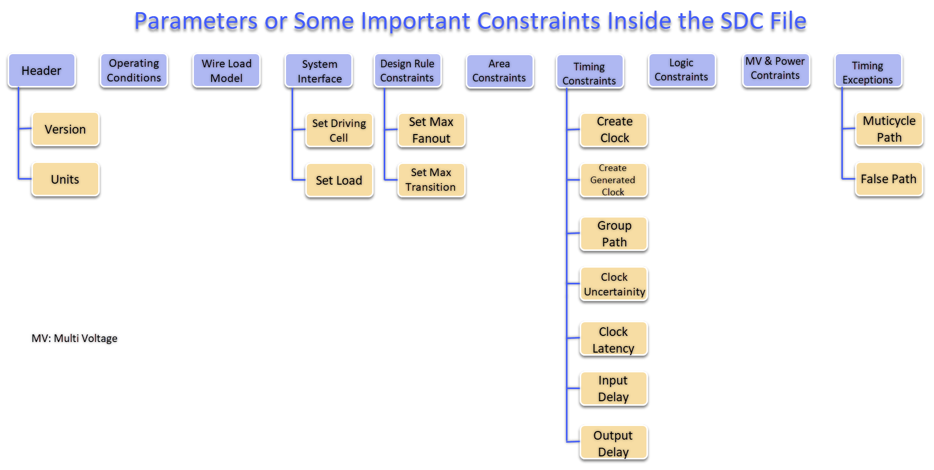 Possible constraints or parameters - https://yogish.com/blog/vlsi-blog/sdc-file-in-the-logic-synthesis-flow-of-vlsi-design
In our case, the counter.sdc file which follows TCL syntax, comprises constraints for the following parameters:
1. clock definition
Clock is the prime timing orchestrator that controls when the designated operations should take place, and after how long a duration. Here, a cycle is 10ns long with 50% duty.

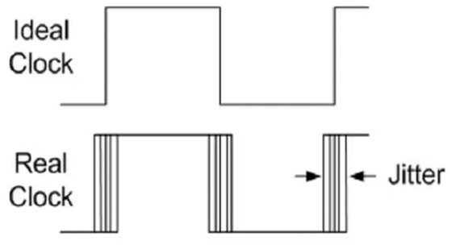
2. Jitter/Skew
Jitter is the difference between clock arrival time of two consecutive edges, resulting in non-ideal variating clocks. In Phase Locked Loop (PLL) based clocking systems, Jitter can be high due to high volatility and difficulty of maintaining phase cohesion among clocks, resulting in dictation of different sampling times for each edge. Jitter relates to clock precision

Skew is similar but it is actually the difference between the clock arrival times between data launching and data capture flip flops.
data lauch FF
data capture FF
clock

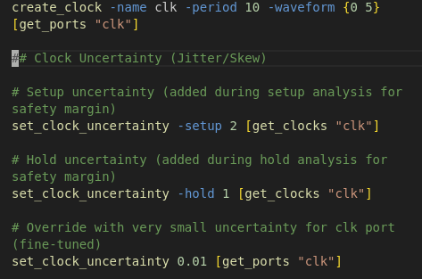
here, the clock edge arrives at first FF earlier than the data capture because of clock wire delays etc. This delay is beneficial for setup time because it gives extra time for data to settle before the next clock edge is received.

3. Slew.
Real life hardware has physical limitations, and clock is piece of hardware too. So, it is not ideal either. A clock in a system exhibits non-ideal transitions from one magnitude level to another.
This time, which it takes to go rise from lower magnitude (say 10% of Mmax) to higher one (90% of Mmax) is called clock slew.
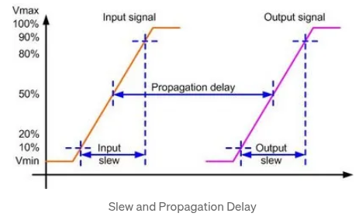

Slew can affect the pulse width because if it takes longer to transition then the design gets lower than intended pulse time to process its data path traversal, which could lead to inaccurate calculations and hence compromise data integrity in a datapath.
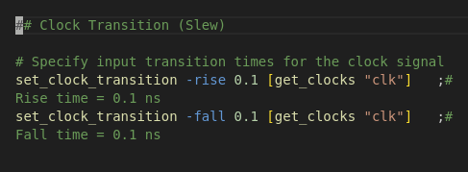

in .sdc file, we allow a relaxation of 0.1ns out of 10ns for rise and fall clock transitions. The data must be held for at least 0.1ns after the clock edge to ensure it is properly read. The original hold time specification still comes from .lib file, which we design our system around but this input specification helps the tool accurately calculate the design parameters such as pulse width, transition time and other stuff.
4. Input & output constraints
set_input_delay and set_output_delay basically guide the synthesis tool to generate a netlist optimized so that the clock to input pin delay margin is 1.0ns after a clock edge since the external environment delivers it with this much delay. And then the produced output is supposed to be available 1.0ns before the next clock edge.
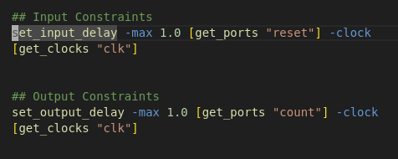

this has been the gist of .sdc design constraints file for our design.
Next, 4bit counter design synthesis in Genus...
We synthesize the counter.v file into standard cells based netlist using Genus by running the script.tcl script. Most EDA tools come with TCL support for infrastructure automation.
The script reads the verilog RTL code RTL/counter.v, the constraints/counter.sdc constraints file and the standard cells library file 65_lp_libs/tcbn65lptc.lib generating the mapped netlist counter_map.v along with the following files:
• counter_gates.rpt
• counter_area.rpt
• counter_timing.rpt
• counter_qor.rpt
• counter_power.rpt
• counter_map.sdc (in “out” subdirectory)
• counter_map.sdf (in “out” subdirectory)

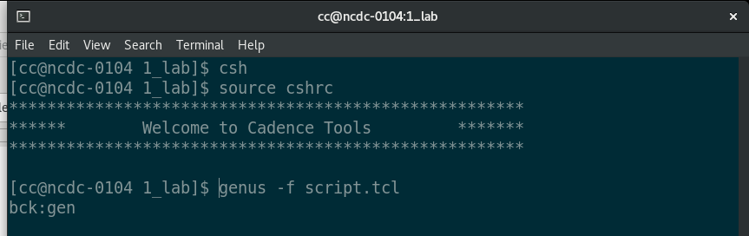 running the script

Gate-level Schematic
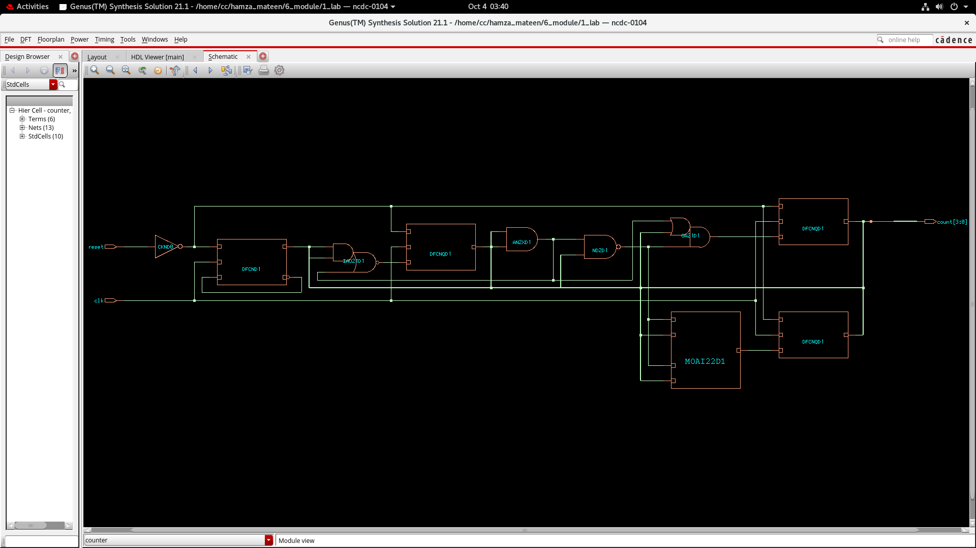

Let's analyze the files that got generated:
1. counter_map.sdc is the file that shall be used down the digital design flow by PnR tools such as Innovus to perform the layout of gates and wiring with respect to the constraints specified by this file.
2. counter_map.sdf file contains the technology-dependent delay timing information of standard cells and related components comprising the netlist. This information is derived by Genus from foundry provided files, while wiring and routing related information is extracted during synthesis step with help of wiring models such as Elmore model and wire parasitics etc.
The sdf file is used to back-annotate the simulation data and help run timing-accurate simulations.

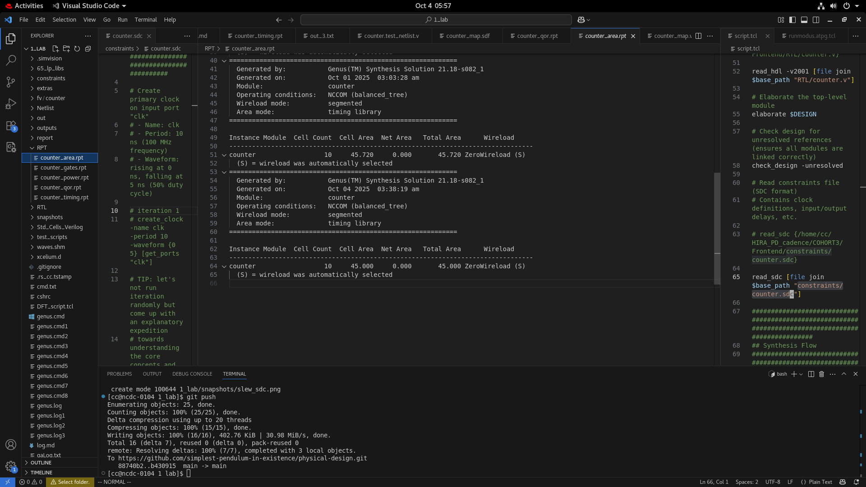
3. counter_area.rpt

generated by *report_area* command. The file shows the module's name (counter), Cell count (10) and total area occupied which happens to be 45 microns or square micrometers (10^-6). This file helps in PPA, standing for Power-Performance-Analysis.
PPA refers to balancing of design's area and power requirements for a given chip.
4. counter_gates.rpt
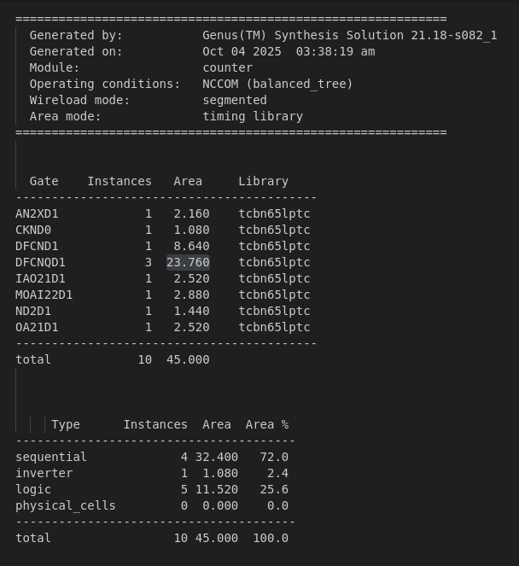

This file documents the standard cells picked from the tcbn65lptc library to implement the design. Most of the area is occupied by 3 DFCNQD1 (flip flop) cells amounting to 23.760 microns and the rest by other 7 components.
72% of the area is covered by sequential/memory elements while 25% is dedicated to combinatiosn logic implementing the counter logic (datapath).
5. counter_power.rpt
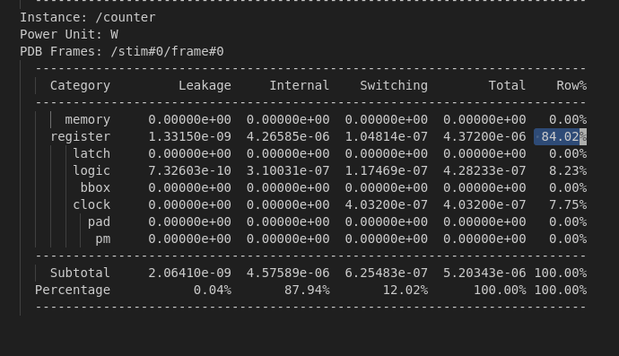

total power consumed is around ~5microWatts, most of which is spent by registers in the design, 84%. The static and dynamic powers are in negligible amounts, indicating that clock switching (dynamic) and the power consumed when the components are off (static) don't have much impact on the power consumption.
Flip flops have internal power and they are clocked every cycle.
7% of power is consumed when powering the clock network in the design, while 8% of consumption is contributed by the combinational logic.
6. Counter timing
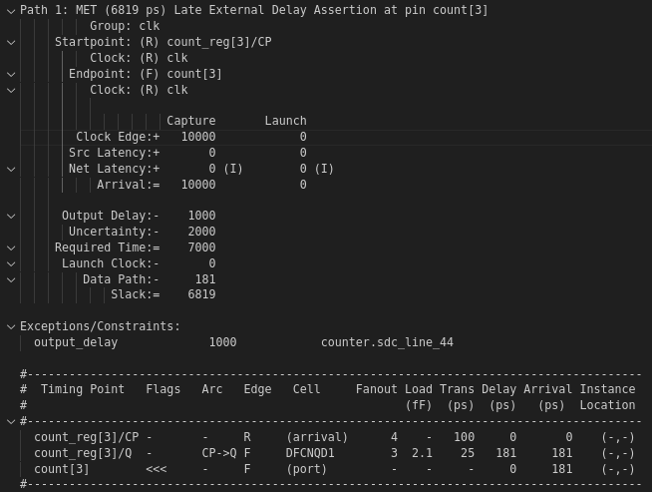

The timing report appears to have consulted the .sdc file because in the datapath, 1000ps or 1ns is reserved for output delay as we specified and 2000ps or 2ns account for uncertainty (Jitter/Skew). This leaves us with 7ns for datapath traversal.
The timing report states that datapath essentially only takes 181ps or 1.81ns to increment the counter on a 65nm low power technology node, therefore leading towards 6819ps or 6.82ns +ve slack.
A counter is a very simple circuit so the required time for datapath traversal is very short. We can improve our design to a good extent, or more precisely, make it fast at the cost of something else.

