M.SANGEETHA

NM ID : **65D1CCDD148143F872C4187BA96036D2**

BLOCK CHAIN

ASSIGNMENT

SRI RAAJA RAAJAN COLLEGE OF ENGINEERING AND TECHNOLOGY

1. Go to the chrome and open remix platform

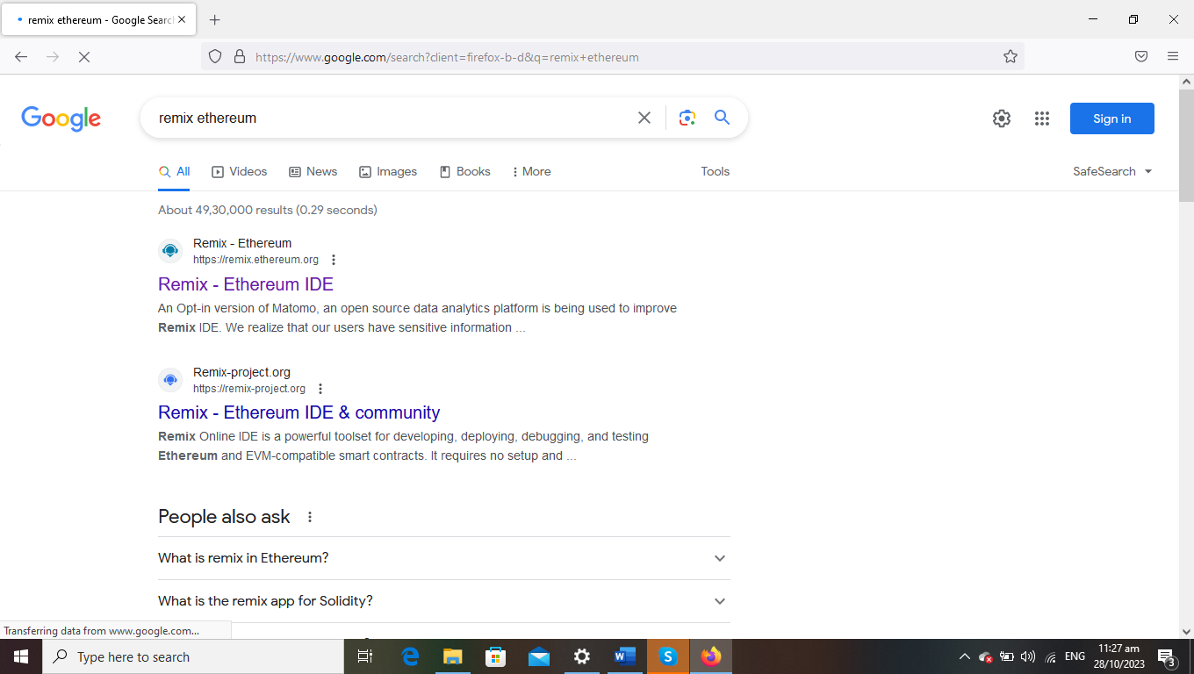

2.Open the remix page and create a new FILE

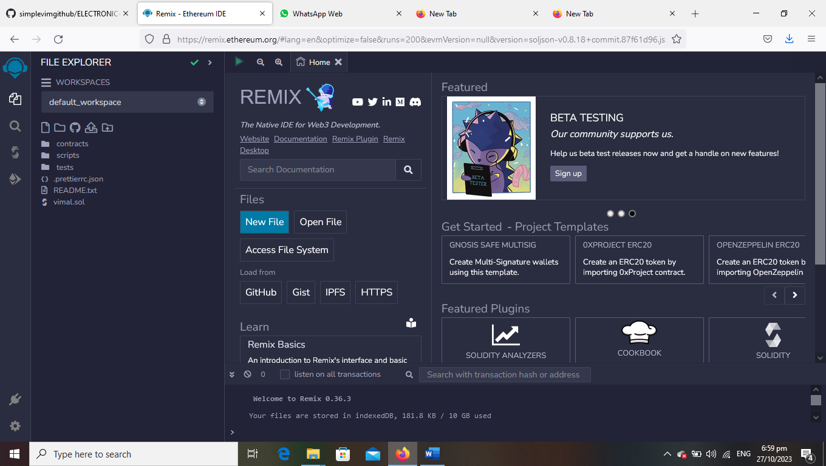

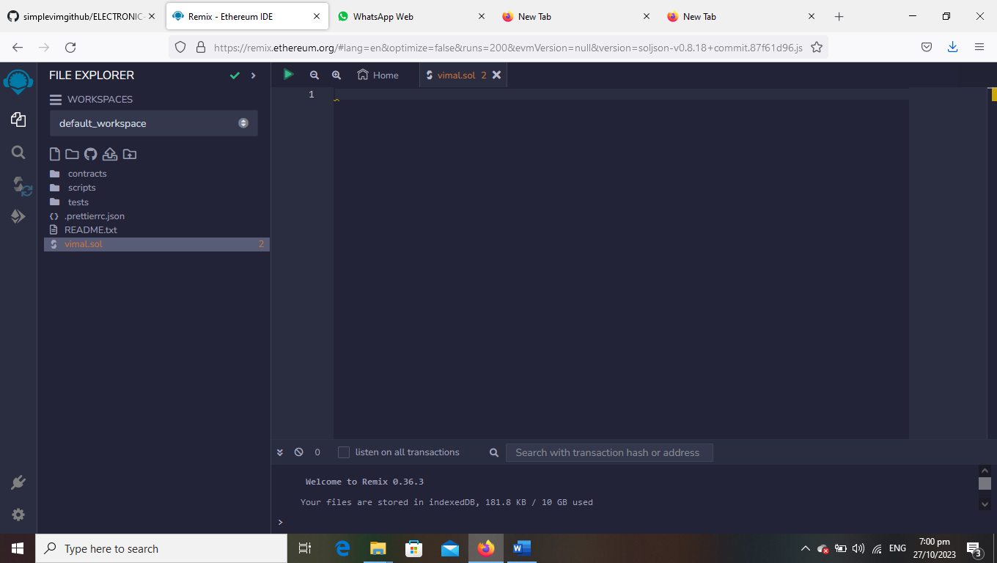

3.create a program to return your string ”ZONE NAME”

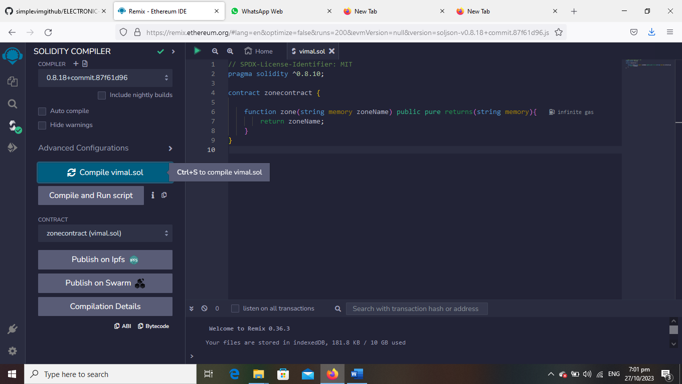

4.compile it det ABI code and BYTECODE

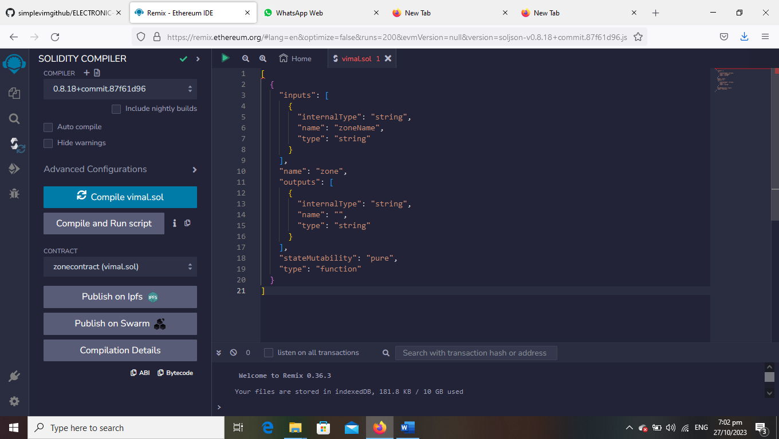

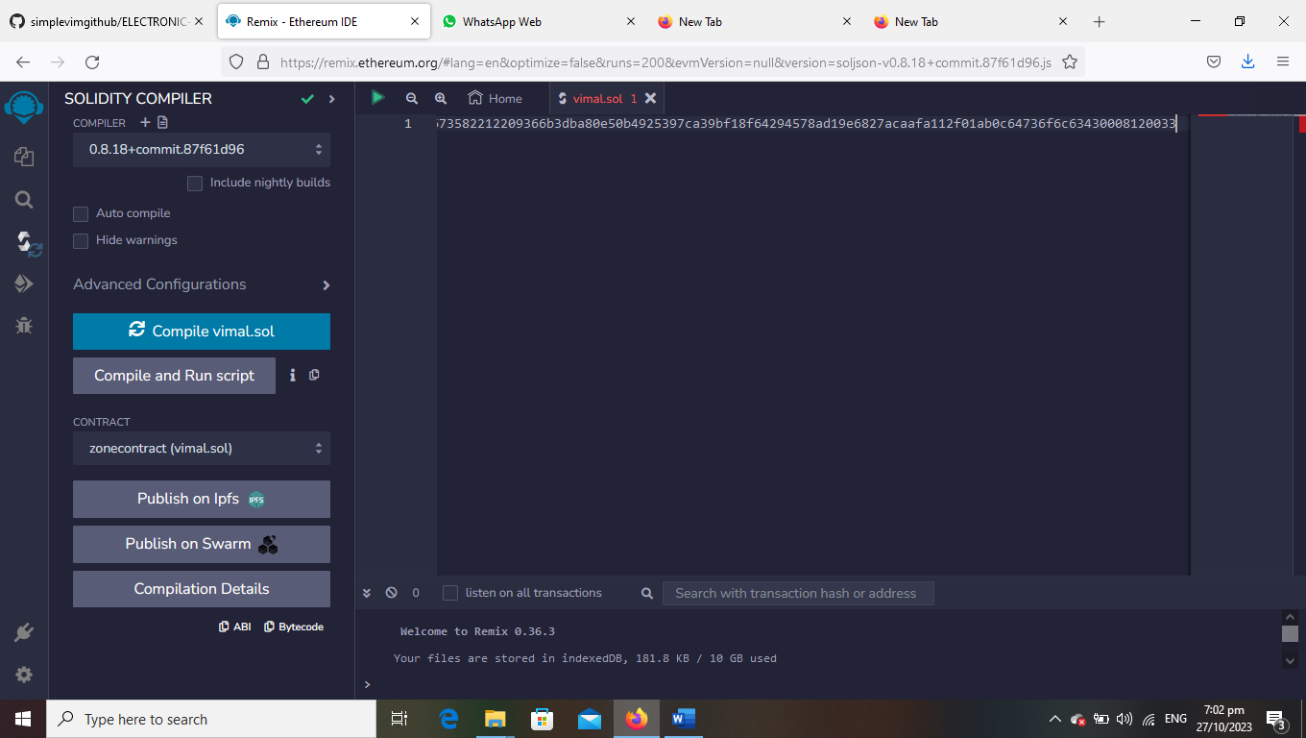

5.Deploy it to display the out put

