BLOCK CHAIN(ZONE 14)

ASSIGNMENT

M.SANGEETHA

NM ID : **65D1CCDD148143F872C4187BA96036D2**

FINALYEAR CSE

SRI RAAJA RAAJAN COLLEGE OF ENGINEERING AND TECHNOLOGY

TEAM MEMBER

PROBLEM

create a program to return your string "ZONE NAME"

PROGRAM

// SPDX-License-Identifier: MIT

pragma solidity ^0.8.10;

contract zonecontract {

function zone(string memory zoneName) public pure returns(string memory){

return zoneName;

}

}

1. Go to the chrome and open remix platform

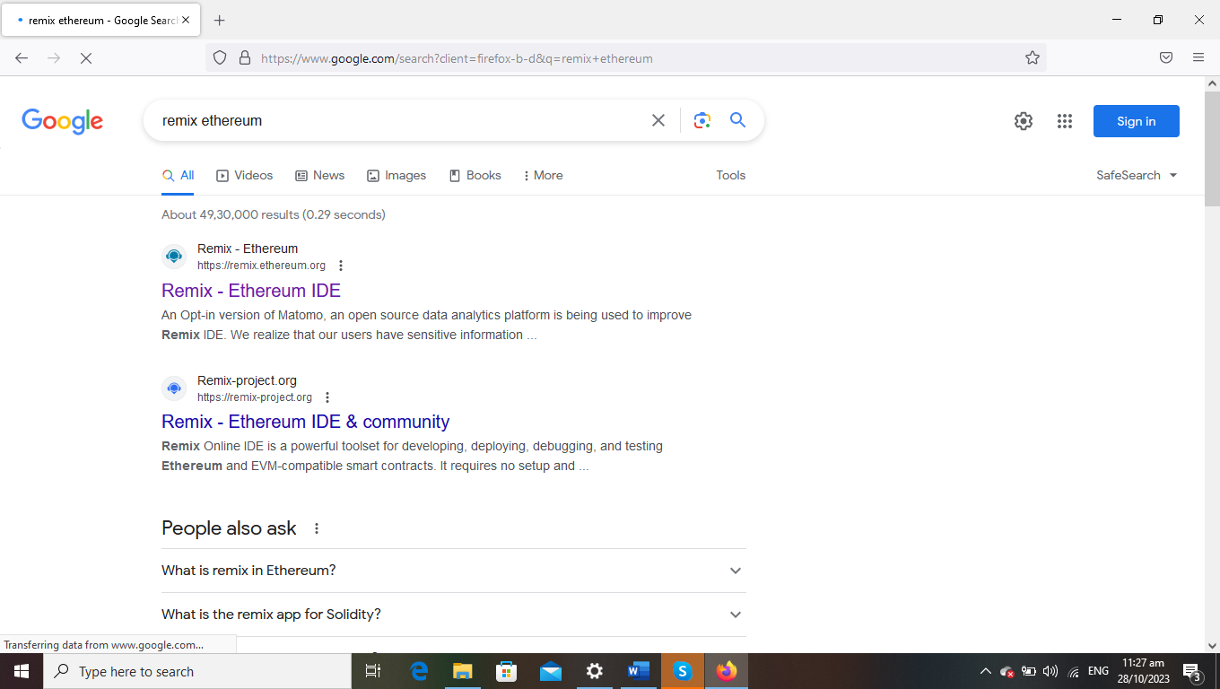

2.Open the remix page and create a new FILE

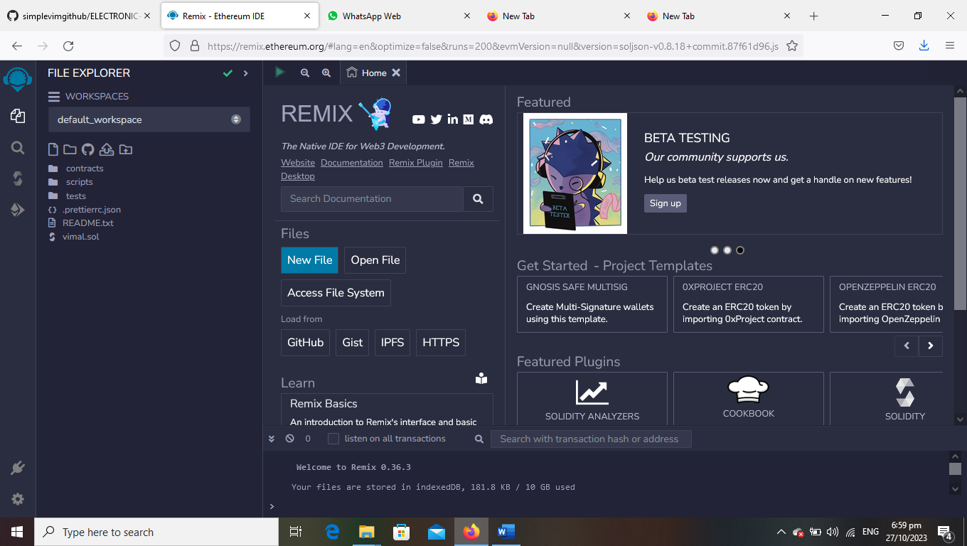

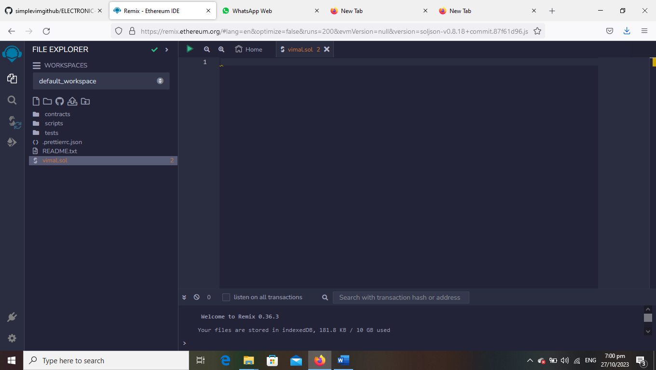

3.create a program to return your string ”ZONE NAME”

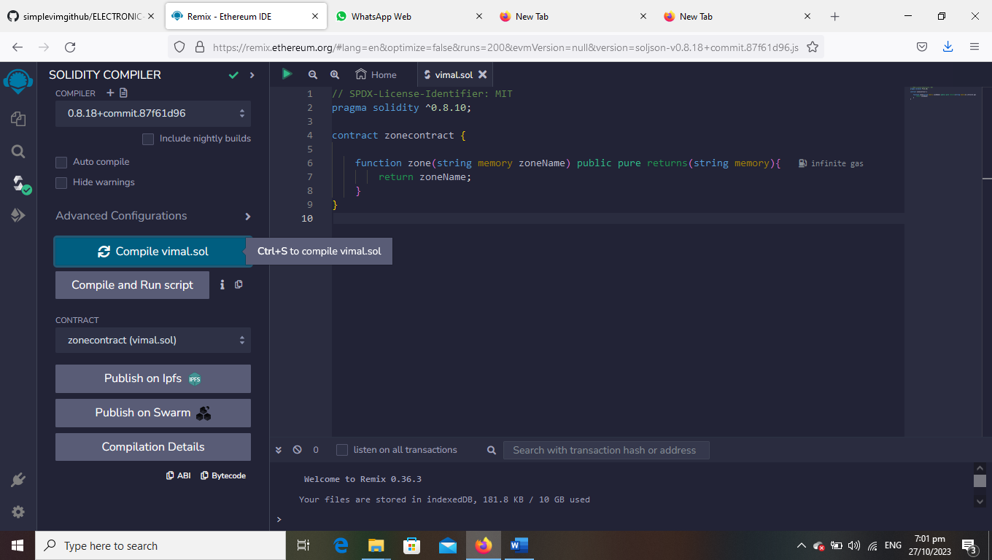

4.compile it det ABI code and BYTECODE

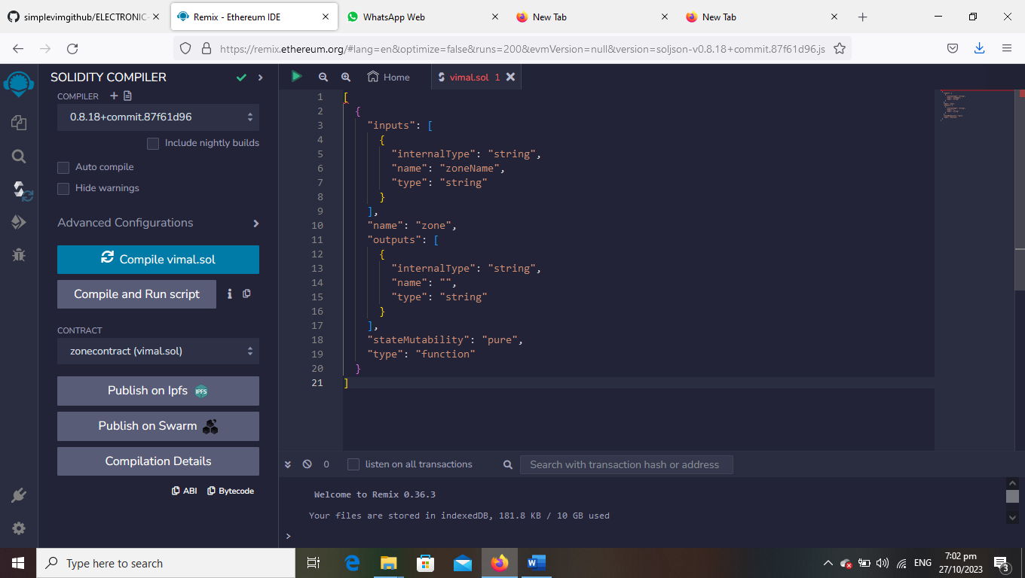

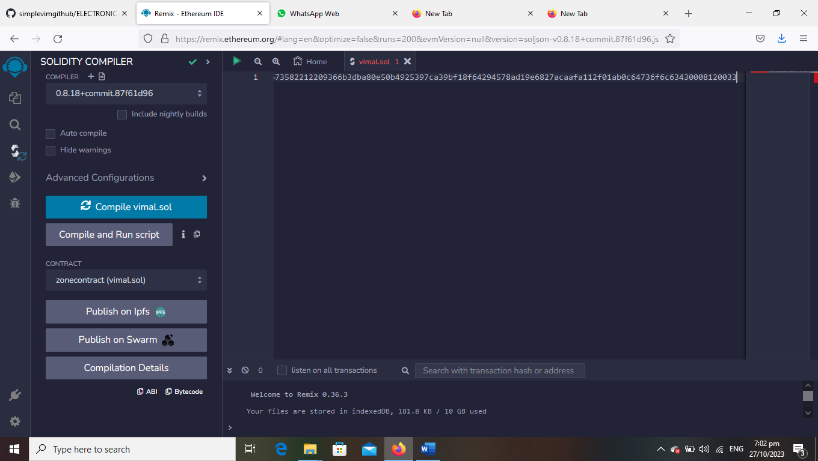

5.Deploy it to display the out put

