

Synago is a hybrid mobile/web application that enables Christian-based organizations and volunteers to connect digitally and is a proposed solution for the GoForth Singapore National Conference for 2018/2021. The word is derived from Greek “ἐπισυναγωγὴν” (episynagōgēn), which carries the meaning of “assembling together”. The word originates from the Bible in Hebrews 10:24,25 (NIV) – “And let us consider how we may spur one another on toward love and good deeds, not giving up meeting together, as some are in the habit of doing, but encouraging one another — and all the more as you see the Day approaching.”



Prototype: <http://bit.do/synago>

***Objectives***

Synago aims to:

* Create a digital ecosystem for churches, independent organizations, communities and independents who are committed to the Great Commission. This platform also serves to showcase their work, seek support for projects financially and spiritually and foster partnerships; especially for those who do not yet have a digital presence.
* Provide a conference networking platform to match participants, donors / investors and volunteers to churches, organizations, communities and independents, based on common interests and strategies. Specifically targeting national-level conferences, i.e., GoForth, Love Singapore
* Engage tech-savvy millennials to engage in the Great Commission works

Additionally, the following value-added features are planned for future upgrades:

* Optional service subscriptions for churches, organization, communities and independents, which includes transaction services for funding, providing digital analysis on visits to their profiles and maximising the returns on their digital presence.

***Features***

* Profiling of church, organizations, communities and individuals

 

* Directory listing, publishing and search function

 

* Web Login via password and mobile authentication

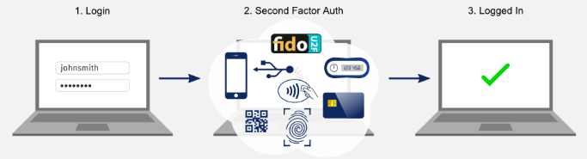

* Responsive design that can be used across multiple devices



* Applying Google’s Firebase provides additional value-added services, including real-time databases, data analytics and Google Cloud services for future development

***Technology & Architecture***

Synago will leverage on the following technology stack:

* Firebase
* React
* HTML5 / CSS3
* Google Cloud Services

   

We also plan to leverage on existing solutions from **Oikos** (<http://oikos.com>), which has an established conference digital package and track record of hosting systems for global Christian conferences.

***Funding***

With the intention to contribute to and support the Christian community, Synago will seek funding from independent private donors. Service hosting will be on Firebase with the Blaze plan (pay-as-you-go) (< 100 concurrent users and peaked at 1,000 users during conference day) at around US $370 and US $120 for peak and non-peak respectively. Refer to Appendix A and B for the estimates.

- - - - - - - - - - - - - - - - - - - - - - - - - - - - - - - - - - - - - - - - - -

For more details, contact Mervyn at [mervyn.lee@99plus1.sg](mailto:mervyn.lee@99plus1.sg).

Appendix A - Non-Peak Firebase Plan

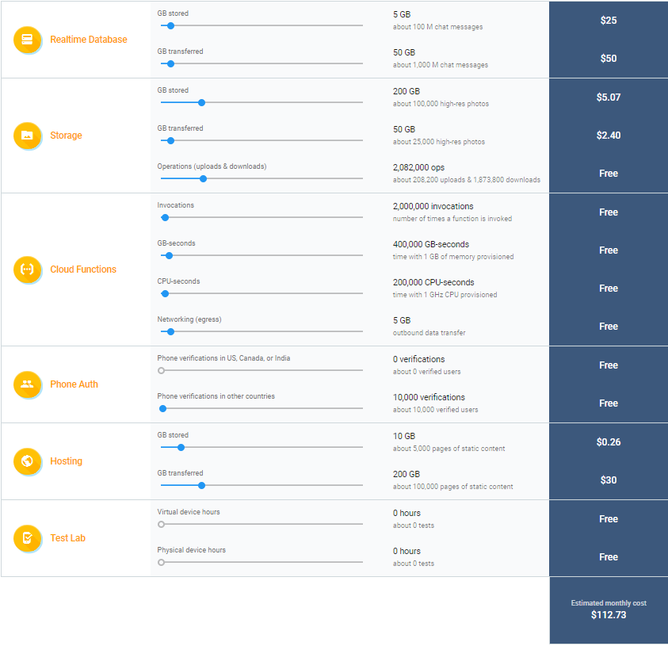

*Source: Google Firebase*

Note: Price is in US $ above. Prices are estimates and upgrade/downgrade of the plan if possible any time. No lock in period.

Appendix B - Non-Peak Firebase Plan

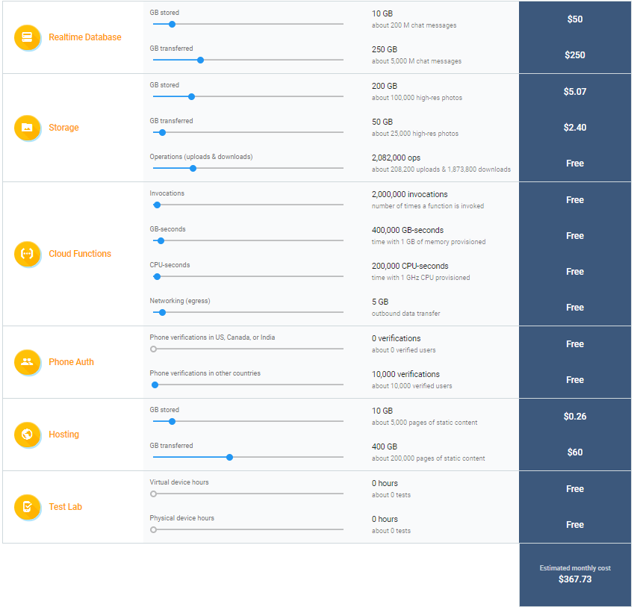

*Source: Google Firebase*

|  |
| --- |
| Limitation: Phone Authentication is significantly expensive due to the use of telecommunication infrastructure. An alternative is to develop integration with social messaging applications like Messenger, Whatsapp, Line and WeChat. These solutions come with its own limitations as well – user will require to adopt the dependent application. Another alternative is to develop an independent app to act as a soft-token for phone authentication.    *Above: An increase in phone verification by just one unit of 5,000 verifications increases the overall cost by USD $300.* |