## **Indian Institute of Information Technology Surat**



# **Lab Report on**

# **Software Engineering (CS 501) Practical**

**Submitted by**

### **[Ashmit Gupta] (UI21CS12)**

**Course Faculty**

### **Dr. Ritesh Kumar**

## **Department of Computer Science and Engineering**

## **Indian Institute of Information Technology Surat**

## **Gujarat-394190, India**

## **August 2023**

**Table of Contents**

| **Exp. No** | **Name of the Experiments** | **Page no** | **Date of Experiment** | **Date of Submission** |
| --- | --- | --- | --- | --- |
| **1** |  |  |  |  |
| **2** |  |  |  |  |
| **3** |  |  |  |  |
| **4** | Draw use case diagram and DFD (Level -2) for Blood Bank Management System. | **4-5** | **16-08-2023** | **16-08-2023** |
| **5** |  |  |  |  |
| **6** |  |  |  |  |
| **7** |  |  |  |  |
| **8** |  |  |  |  |
| **9** |  |  |  |  |
| **10** |  |  |  |  |
| **11** |  |  |  |  |
|  |  |  |  |  |
|  |  |  |  |  |
|  |  |  |  |  |
|  |  |  |  |  |
|  |  |  |  |  |
|  |  |  |  |  |

**Lab-4**

**Aim:** Draw use case diagram and DFD (Level -2) for Blood Bank Management System.

1. Blood bank management system (DFD)

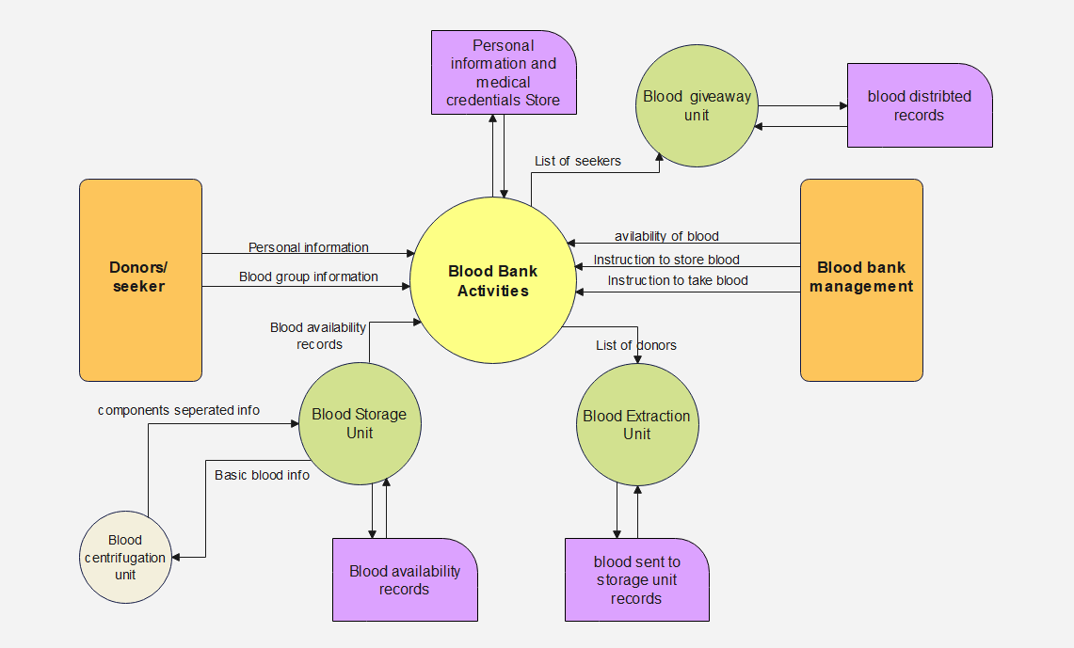

1. Blood bank management system (Use-case-diagram)

