Multiple Regression Homework Assignment

Cade Muntz

**Overview**

For this project, we have been asked to generate estimated demand for contracts for a regional car rental agency using a variety of different variables. These predictor variables are used to see whether or not they would be able to accurately predict what makes someone sign a rental contract. Because of the outcome variables given to us being quantitative in nature, the best method for this will be to run a multiple regression model. In terms of rental contracts we will specifically be looking at Economy Contracts and using predictor variables to see what might influence those.

**Initial Insights**

To start off our research into this data, we looked into a factor that intuitively seems like it may predict demand for rental cars, being seasonality. Specifically, we looked into whether or not there were any differences in demand for economy rental cars between the four different seasons. To pull this off, we simply ran an ANOVA to demonstrate significant differences between the different seasons (p<0.001). We then calculated the average demand of Economy Contracts per season to get this chart.

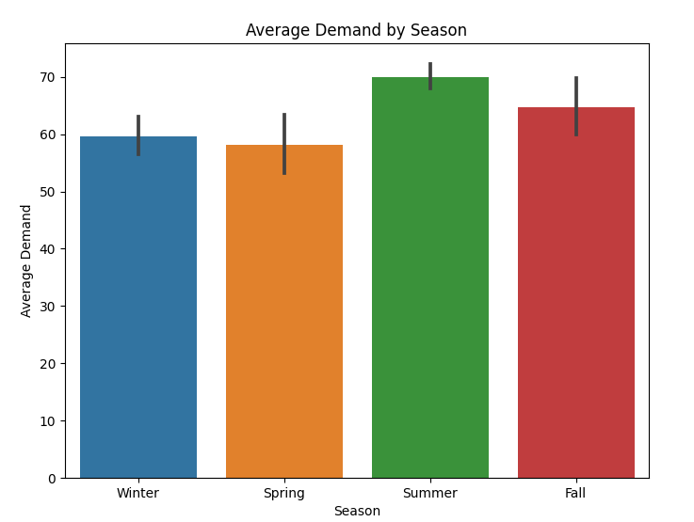

From this we can see that Summer has the highest demand of 69.7 contracts and spring has the lowest demand of 58.2 contracts. Winter comes close to the bottom with a demand of 59.6 contracts with fall having the 2nd highest demand of 64.7 contracts. This means that there is essentially a 10 contract gap between spring and summer. The table below shows the demands for readability:

|  |  |
| --- | --- |
| Season | Demand for Economy Cars |
| Fall | 64.7 |
| Spring | 58.2 |
| Summer | 69.7 |
| Winter | 59.6 |

**Predictive Insights**

We then decided to look into other various predictor variables which could potentially be used to estimate the demand for rental car demand, specifically economy cars.

*Initial Model:* We first looked into the demand for the economy rental cars (EconContracts) as a variable that could potentially have many predictor variables. We first looked at essentially all of the predictor variables being - Competitors price, Flights, Gas Prices, the rental agencies prices,whether or not school was in session, and the seasonality and the total advertising spending.

Upon running this model we were able to immediately notice that seasonality and session did not have a very significant predictive value, therefore they were taken out of future models.

*Model Fit:* Based on the set of predictors used for the model upon taking out session and seasonality, the model was able to predict nearly 40% of the variance within weekly economy car rental contracts (R^2 = .367) Our R^2 coefficient had a +/- of .166 making the average about .308 or 30% of variance within weekly economy car rental contracts. Digging deeper, this model allows us to predict demand for economy rental cars with a margin of error of about +/- 10 cars. With our absolute error being 6.928 + / - 2.540.

*Significant Predictors:* Using this model, it can be noted that the demand of economy car rentals had 4 significant predictors. These predictors are flights with a standard coefficient of 0.427 and p < .001, the car rental agencies own price having a standard coefficient of -0.277 and p = 0.01, the competitors economy price having a standard coefficient of 0.223 and p = 0.010, and gas prices were also relatively significant at predicting economy contract demand as it ended up with a coefficient of -0.167 and a p value of 0.047. While gas price has a relatively high p value it is still less than 0.05 therefore, it seems to be relatively significant when looking into all of these variables. These findings will be able to help the agency predict how variation between flights and pricing on economy cars can influence the demand of economy car rentals.

*Nonsignificant predictors:*Using this model it can be noted that seasonality, whether or not class was in session, and total advertising spending did not help to significantly predict demand of economy car rentals. This is an interesting find as when running the ANOVA the demand for cars varied greatly by season. However, this can likely be explained by the fact that more flights are likely to come in the summer and fall as that is when more people are traveling. Therefore, seasonality and flights are tied pretty closely together which makes flights take up more of the p value leaving seasonality to be relatively insignificant. It can also be noted the very skewed relationship between advertising spending and demand. With advertising spending only having a coefficient of .001 which will be explained more in the upcoming section.

**Interpretations of Predictors:**

In terms of actually interpreting the predictors and how they might possibly predict demand there is quite a bit of information to be gathered. First off we will start with the predictors that did exceptionally well in our model being flights, the rental companies price, gas price and their competitors price.

* As can be seen in our model, we see that flights have a coefficient of 1.46, this essentially means that the weekly demand for economy cars increases by about 1.5 contracts for every additional flight coming into the airport.
* When looking at the price of the rental company that we are studying, we can note that their price has a coefficient of -0.668, which essentially means that the weekly demand for economy car contracts will go down by 0.7 contracts for every $1 increase in the price
* Looking at the competition’s price we can see that this variable has a coefficient of 0.455, which essentially means that weekly demand for our rental agencies economy cars goes up by 0.46 for every $1 increase in their competitors price.
* With gas price, the coefficient is -10.528, which essentially means that demand for economy car contracts will go down by 10.5 contracts for every $1 increase in the gas price,

When looking at the variable that did not do so well being the total amount spent on advertising we can get some information from this variable as well. While they are not the best at predicting the demand of economy rental car contracts, there can still be information to be gained.

* Looking at total advertising spending it can be seen that the coefficient is a very small amount of .001, so essentially, for every $1 put into advertising, the demand for economy car contracts should increase by about .001.Basically, it would seem that the rental company is not getting much of a return on spending. This will be dug into more in the recommendation section.

*Recommended model:* Based on the statistics generated by our model fit, and the various p-values given to our predictors, we recommend the agency move forward with a model that only includes 4 of these predictors. These predictors would be the weekly flights, the car agency's own price, gas price and the competition's price. A model with specifically these 4 predictors is able predict nearly 62% of variance with an R^2 value equal to 0.618, and has a predictive accuracy of about 10 cars with an absolute error value equal to 6.956 +/- 2.540

**Additional Outcome Variables:**

We then decided to see if these 4 predictors would be able to predict any other outcomes the car rental agency may want to look into, these would be things such as upgrades, total rental days, total contracts (upgrades + economy) and average contract length..

Once we ran these analyses we were able to conclude that only total contracts and the length of the contract were able to be predicted. 3 variables were able to predict total contracts with relative significance while only 1 variable being flights was able to predict the total rental days variable.

* In terms of total contracts, flights (p=0.001), OwnPrice (p=0.010), and CompPrice (p=0.044) were all significant predictors of this variable. These predictors were able to predict 47% of variance (R^2 = 0.474), with a predictive accuracy of about 11 cars, absolute error = 8.151+/- 2.573.
* In terms of total rental days, the only significant predictor was flights (p= .009) and was able to predict about 33% of variance (R^2 = 0.325) with an absolute error of 52 cars, which is a very large amount of absolute error. Therefore, this is still not a good model for predicting total rental days.

For the other 2 variables, the model was not good at predicting upgrades, or average contract length. Making the model best fit to predicting economy contracts, while also being relatively good at predicting the total contracts including the upgrades from economy.

**Overall Recommendations:**

* In terms of the overall model usage, we would recommend using a model with the 4 significant predictors being flights, the rental agencies price, the competitions price, and the gas price. This model is best used for predicting economy contracts, and if the rental agency would also like to predict total contracts, then they just need to take out gas price from the model and they should still get good results.
* The recommended models will be used best to manage inventory by intuitively thinking about when flights come in to best predict their contract demand. They will also be able to use this model by paying attention to the competition and for every $2 increase in price their demand will increase by about 1 contract.
* In terms of their own price, if they want to raise or lower their price they can use the model to predict how many cars they will be contracted out based on how much they increase or decrease their price.
* While seasonality was not a good predictor in itself for economy contracts, I believe it is still worth noting the demand differences between the seasons. Expecting more demand in the summer and less in the winter and spring. This also ties into advertising spending, as while the model predicts demand wont go up much, pairing the advertising spending with the various demands by seasonality could be beneficial. Essentially, raise spending during the summer and fall and lower spending during the winter and spring.