04/24/2018

Jetobri Design Document

Brianna Scott, Joshua Sellers, & Ethan Prigg

**1. Introduction**

Purpose of this document

The purpose of this document is to provide a written description of the software product, a web-based e-commerce site, owned by the Jetobri Company. This document should provide the software designer and development team overall guidance to the architecture of this software project.

Description of the organization of the document

The document will be organized as follows:

* Introduction
* Purpose & Organizational Description
* Architectural Design
* Functional & Nonfunctional Requirements
* Design Constraints
* Database Design
* Graphical User Interface
* Class Diagram and Classes
* Design Process
* References

**2. Architecture Design**

The architectural design is the design of the entire software system; it gives a high-level overview of the software system, such that the reader can more easily follow the detailed descriptions in the later sections. It provides information on the decomposition of the system into modules (classes), dependencies between modules, hierarchy and partitioning of the software modules. The functional requirements, design constraints, and quality attribute requirements or nonfunctional requirements make up the architectural design. The functional and nonfunctional requirements and the design constraints for the e-commerce application are:

* The user would be able to search for products, goods, vendors, and services
* The result would be based off the users input to the web search
  + There are several searching options:
* Vendor
* Services
* Stores
* Goods or Products
  + When viewing from vendor(s), it would present the available vendors on the application
  + When viewing from service(s), it would present all the services available on the application
  + When viewing from stores, there will be a drop-down menu to choose they type of store or the store name; Whichever the user is looking for
* Each different category will have only the stores that pertain to that specific category to avoid confusion
  + When viewing from goods/products, it would present the available goods or products available for the user
  + The user would be able to access a favorites tab that will house the user’s favorite products, services, goods, and vendors
  + The user would be able to access a filter option that will give the user access to view certain products or services with certain restrictions
  + The user would have to fill out a mini questionnaire to find the best vendors, products, goods, and services for each user
* What the screen layout will look like on each different device (Laptops, phones, etc.)
* Which resolutions will this site support
  + 720p, 1080p
* Which devices will be compatible for this systems’ use
* Apple products such as an Apple iPhone, etc.
* Android products such as a Samsung phone, etc.
* Desktop/Laptop web browsers

The performance of the web-based application must be above average. To ensure this, the design will be built in HTML/PHP. This language was chosen because it will work well with the system. As an added result, the system must also have an adequate runtime speed. The performance requirements for this application include:

* The system must operate at all hours and times of the day and night
* The performance of the system must not lag or waver
* The system’s connection must work on all platforms and be strong enough to do so
* The interface must be updated bimonthly
* The system’s loading speed must not be questionable or below average
* The company will run tests bimonthly to ensure everything is in order (Scheduled Maintenance Runs)
* Greeting user with their name (i.e., Welcome, Jane Doe!)
* The system must calculate the distance between the user and the services and/or stores offered

The Jetobri Company wishes to ensure the safety of its users. Any possible loss, damage, or harm to the account will be taken into serious account when notified and will be investigated. All rules and regulations will be stated in the Terms and Conditions statement when the account is created. The remaining safety requirements include but are not limited to:

* A separate page for credit card information
* The credit card information will not be saved unless prompted to
* This separate page will be encrypted so safety purposes and the user may be asked for their password before they can input their information
* Secure Checkout: How the $10/per month be taken?
* Monthly or must the user log in and send the transaction
* There will be an option to pay for months in advance
* Automatic logouts
* For added purpose: if the account has been idle for 30 minutes, the system will logout for the user
* The system will know the difference when idle; if the user is using the application via desktop/laptop computers and smart phone applications
* Require user to enter password before accepting any payment
* Ask user if they want their password to be saved on the device
* Keep records of all users’ payment dates
* The system will show transaction statements for each month that has been paid for
* The site will have a FAQ page for easy advisement
* Automatically logging out after 30 minutes of no interaction to protect users account
* Temporarily lock account after 3 failed password attempts
* Require user to enter password before accepting any payment
* The site will have a customer service phone number, 24-hour hotline, and email for the following:
* Product Help
* Compliments
* Suggestions, etc.

The application users and developers will notice the quality characteristics for the web-based application system such as correctness, availability, flexibility, maintainability, portability, testability, and adaptability. The program will be designed to work anywhere in any time zone with an internet connection. Eventually, the company will explore a reasonable way to use the application without an internet connection without the use of data plans or LTE. Other qualities include:

* Ability to maintain users’ confidential information
* Available through high streaming times (weekends 7-12)
* Able to log in to multiple devices

All fines/sales are final. Other rules include:

* The system will automatically log someone out of all devices if suspicious activity is linked to the account.
* Users can grant permission to nearby devices not associated with his/her account.

The company must ensure the safety of its users and staff. All security claims will be taken as serious matters. For all safety purposes:

* All orders will state the copyright rules on their pages & ask users if they’ve read the terms and conditions before the check-out will be processed
* All illegal activity will be monitored and detected at all times
* consequences will be resolved fairly within the terms and conditions portion of the application
* Provide a toll-free number and/or email that offers 24-hour tech support.
* Verify account with security question(s).

The developers at Jetobri play a major role in the development of this application. Releasing information about the project ahead of the directed time is not permitted and is grounds for expulsion from the project and further projects connected to it. The system will have a terms and conditions portion in which all users (subscribed, free trial users, and company staff) must sign using an e-signature. The e-signature will prove to our system that the customer understands and will abide by the application rules, constructs, and constraints. Failure to comply with such restraints will result in deactivation of the user’s access. The company’s staff must abide by the rules, regulations, protocols, and corporate/regulatory policies that are in place. Below is the architectural diagram for our database.

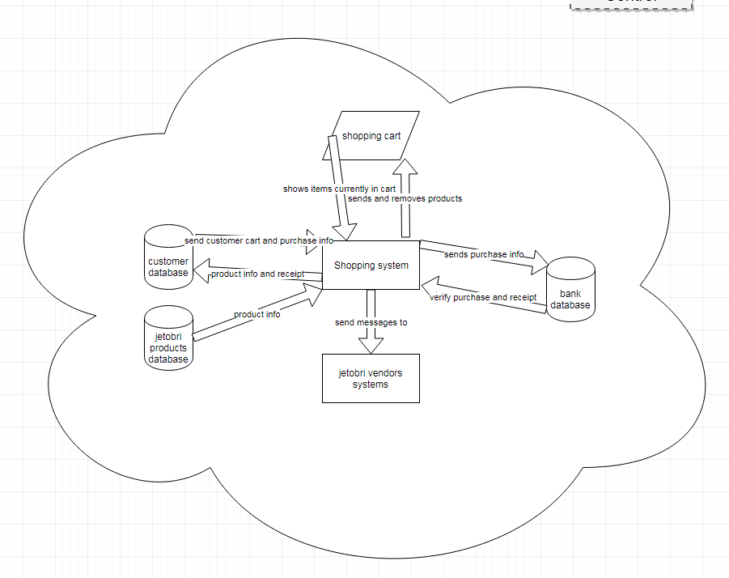

**3. Database Design**

# Tables schemes

**Table 1- Admin**

|  |  |  |  |
| --- | --- | --- | --- |
| **admin** |  |  |  |
| **Description** | This table describes the administrators that are stored inside the database | | |
| **Attribute** | **Description** | **Type** | **Value** |
| admin_id | id of admin | Integer | 11 |
| username | username of admin | Text |  |
| password | password of admin | Text |  |
|  |  |  |  |
|  |  |  |  |
|  |  |  |  |
|  |  |  |  |
|  |  |  |  |
| **Primary Key** | admin_id | | |
| **Foreign Key** |  | | |
| **SQL Code** | CREATE TABLE `admin` (  `admin_id` int(11) NOT NULL,  `username` text NOT NULL,  `password` text NOT NULL  ) ENGINE=InnoDB DEFAULT CHARSET=latin1; | | |
|  |  | | |
|  |  | | |

**Table 2- Vendor**

|  |  |  |  |
| --- | --- | --- | --- |
| **vendor** |  |  |  |
| **Description** | This table describes the vendor’s log in information that is being stored in the database | | |
| **Attribute** | **Description** | **Type** | **Value** |
| vendor_id | id of vendor | Integer | 11 |
| username | username of vendor | Text |  |
| password | password of actor | Text |  |
| **Primary Key** | vendor_id | | |
| **Foreign Key** |  | | |
| **SQL Code** | CREATE TABLE `vendor` (  `vendor_id` int(11) NOT NULL,  `username` text NOT NULL,  `password` text NOT NULL  ) ENGINE=InnoDB DEFAULT CHARSET=latin1; | | |
|  |  | | |

**Table 3 – Category**

|  |  |  |  |
| --- | --- | --- | --- |
| **category** |  |  |  |
| **Description** | This table describes the category that’s being searched in the database | | |
| **Attribute** | **Description** | **Type** | **Value** |
| id_category | id of category | Integer | 11 |
| name_category | name of category | Varchar | 250 |
|  |  |  |  |
| **Primary Key** | id_ category | | |
| **Foreign Key** |  | | |
| **SQL Code** | CREATE TABLE `category` (  `id_category` int(11) NOT NULL,  `name_category` varchar(250) NOT NULL  ) ENGINE=InnoDB DEFAULT CHARSET=latin1; | | |
|  |  | | |

**Table 4 – Vendors**

|  |  |  |  |
| --- | --- | --- | --- |
| **vendors** |  |  |  |
| **Description** | This table describes the vendor that’s being searched in the database | | |
| **Attribute** | **Description** | **Type** | **Value** |
| id_vendor | id of vendor | Integer | 11 |
| name_vendor | name of vendor | Varchar | 255 |
| **Primary Key** | id_vendor | | |
| **Foreign Key** |  | | |
| **SQL Code** | CREATE TABLE `vendors` (  `id_vendor` int(11) NOT NULL,  `name_vendor` varchar(255) DEFAULT NULL  ) ENGINE=InnoDB DEFAULT CHARSET=latin1; | | |
|  |  | | |

**Table 5 – Payment**

|  |  |  |  |
| --- | --- | --- | --- |
| **payment** |  |  |  |
| **Description** | This table describes the payment to subscribe | | |
| **Attribute** | **Description** | **Type** | **Value** |
| payment_id | id of payment | Integer | 11 |
| user_id | customer whose balanced payment is applied to | Integer | 11 |
| admin_id | admin process payment | Integer | 11 |
| Amount | amount of payment | Integer | 11 |
| Date | date of payment process | Date |  |
| **Primary Key** | payment_id | | |
| **Foreign Key** | admin_id | | |
| **SQL Code** | CREATE TABLE payment (id INT NULL PRIMARY KEY AUTO_INCREMENT, payment_id int NOT NULL, user_id INTEGER (11), FOREIGN KEY (customer_id), admin_id INTEGER(50), FOREIGN KEY(admin_id),  amount INTEGER(11), date DATE | | |
|  |  | | |

**Table 6 - Users**

|  |  |  |  |
| --- | --- | --- | --- |
| **user** |  |  |  |
| **Description** | This table list all customers or users | | |
| **Attribute** | **Description** | **Type** | **Value** |
| user_id | id of user | Integer | 11 |
| username | User’s username | varchar | 20 |
| password | User’s password | varchar | 20 |
| f_name | first name of user | Text | 50 |
| l_name | last name of user | Text | 50 |
| email | User’s email | VarChar | 255 |
|  |  |  |  |
| city | User’s city | Text | 50 |
| country | User’s country | Text | 50 |
| zip_code | User’s zip code | VarChar | 5 |
| state | User’s state | Text | 2 |
| address | User’s address | Text | 50 |
|  |  |  |  |
|  |  |  |  |
| **Primary Key** | user_id | | |
| **Foreign Key** |  | | |
| **SQL Code** | CREATE TABLE `user` (  `user_id` int(11) NOT NULL,  `username` varchar(20) DEFAULT NULL,  `password` varchar(20) DEFAULT NULL,  `f_name` text,  `l_name` text,  `email` varchar(255) DEFAULT NULL,  `address` text,  `state` text,  `zip_code` varchar(5) DEFAULT NULL,  `country` text,  `city` text  ) ENGINE=InnoDB DEFAULT CHARSET=latin1; | | |
|  |  | | |

**Table 7 - Distance**

|  |  |  |  |
| --- | --- | --- | --- |
| **distance** |  |  |  |
| **Description** | This table contains the information used to calculate the distance between the user and the destination | | |
| **Attribute** | **Description** | **Type** | **Value** |
| distance_id | id of distance | Integer | 11 |
| address | customer’s primary address | Text | 50 |
| city | second optional address | Text | 50 |
| state | state or province | Text | 2 |
| country | customer email | Text | 10 |
| zip_code | Customer’s zip code | Integer | 5 |
|  |  |  |  |
|  |  |  |  |
| **Primary Key** | distance_id | | |
| **Foreign Key** | user_id | | |
| **SQL Code** | CREATE TABLE distance (id INT NULL PRIMARY KEY AUTO_INCREMENT, distance_id int NOT NULL, address text, ‘city’ text, state text,  FOREIGN KEY (user_id), zip_code INT (5), phone INT(10) | | |
|  |  | | |

**Table 8 - Questionnaire**

|  |  |  |  |
| --- | --- | --- | --- |
| **questionnaire** |  |  |  |
| **Description** | This table contains a list of questions from the questionnaire and their answers | | |
| **Attribute** | **Description** | **Type** | **Value** |
| questionaire_id | id of questionnaire | Integer | 11 |
| numofquestion | Number of questions | Integer | 10 |
| question_answer | Answer for the question | Text | 255 |
| **Primary Key** | questionnaire_id | | |
| **Foreign Key** | user_id | | |
| **SQL Code** | CREATE TABLE city (id INT NULL PRIMARY KEY AUTO_INCREMENT, city_id int NOT NULL, numofquestion INT(10), question_answer text, questionnaire_id INT(11), FOREIGN KEY(user_id) | | |
|  |  | | |

**Table 9 - Reviews**

|  |  |  |  |
| --- | --- | --- | --- |
| **reviews** |  |  |  |
| **Description** | This table contains the reviews in the system | | |
| **Attribute** | **Description** | **Type** | **Value** |
| reviews_id | id of reviews | Integer | 11 |
| recent_reviews | Recent reviews | Integer | 11 |
| helpful_reviews | Helpful reviews | integer | 11 |
| **Primary Key** | reviews_id | | |
| **Foreign Key** | User_id | | |
| **SQL Code** | CREATE TABLE reviews (id INT NULL PRIMARY KEY AUTO_INCREMENT, reviews_id int NOT NULL, recent_reviews INT(11), helpful_reviews INT(11) FOREIGN KEY(user_id) | | |
|  |  | | |

**Table 10 – Shopping Cart**

|  |  |  |  |
| --- | --- | --- | --- |
| **cart** |  |  |  |
| **Description** | This table lists the shopping cart in the system | | |
| **Attribute** | **Description** | **Type** | **Value** |
| cart_id | id of shopping cart | Integer | 11 |
| user_id | Id of user | Integer | 11 |
| **Primary Key** | cart_id | | |
| **Foreign Key** | user_id | | |
| **SQL Code** | CREATE TABLE cart (id INT NULL PRIMARY KEY AUTO_INCREMENT, cart_id int NOT NULL, user_id INT(11), FOREIGN KEY(user_id) | | |
|  |  | | |

**Table 11 - Coupons**

|  |  |  |  |
| --- | --- | --- | --- |
| **coupons** |  |  |  |
| **Description** | This table contains a list all coupons available for the user after they’ve answered the questionnaire | | |
| **Attribute** | **Description** | **Type** | **Value** |
| coupon_id | id of staff | Integer | 11 |
|  |  |  |  |
|  |  |  |  |
|  |  |  |  |
|  |  |  |  |
|  |  |  |  |
| active | if the staff active | Boolean | 1 or 0 |
|  |  |  |  |
|  |  |  |  |
| **Primary Key** | coupon_id | | |
| **Foreign Key** | user_id, questionnaire_id | | |
| **SQL Code** | CREATE TABLE coupons (id INT NULL PRIMARY KEY AUTO_INCREMENT, coupons_id int NOT NULL, active BOOLEAN) | | |
|  |  | | |

**Table 12 - Language**

|  |  |  |  |  |
| --- | --- | --- | --- | --- |
| **language** |  |  |  |  |
| **Description** |  | This table contains a list of languages that the site can be converted to | | |
| **Attribute** | **Description** |  | **Type** | **Value** |
| language_id | id of country |  | Integer | 11 |
| Name | name of country |  | Varchar | 255 |
| **Primary Key** |  | language_id | | |
| **Foreign Key** |  |  | | |
| **SQL Code** |  | CREATE TABLE language (id INT NULL PRIMARY KEY AUTO_INCREMENT, language_id int NOT NULL, name VARCHAR(255) | | |
|  |  |  | | |

**Table 13 – Search Bar**

|  |  |  |  |  |
| --- | --- | --- | --- | --- |
| **language** |  |  |  |  |
| **Description** |  | This table contains a list of languages that the site can be converted to | | |
| **Attribute** | **Description** |  | **Type** | **Value** |
| search_id | id of search bar |  | Integer | 11 |
| Name | name of search |  | Varchar | 255 |
| **Primary Key** |  | search_id | | |
| **Foreign Key** |  |  | | |
| **SQL Code** |  | CREATE TABLE language (id INT NULL PRIMARY KEY AUTO_INCREMENT, l_id int NOT NULL, name VARCHAR(255) | | |
|  |  |  | | |

**SQL queries:**

In the admin table: SQL > SELECT ID, USERNAME, PASSWORD FROM ADMIN;

In the vendor table: SQL > SELECT ID, USERNAME, PASSWORD FROM VENDOR;

In the category table: SQL > SELECT ID, NAME OF CATEGORY FROM CATEGORY;

In the vendors table: SQL > SELECT ID, NAME OF VENDOR FROM VENDOR;

In the payment table: SQL > SELECT ID, CUSTOMER ID, STAFF ID, AMOUNT FROM PAYMENT;

In the users table: SQL > SELECT ID, USERNAME, PASSWORD, FIRST NAME, LAST NAME, EMAIL, CITY, COUNTRY, ZIP CODE, STATE, ADDRESS, FROM USERS;

In the distance table: SQL > SELECT ID, DISTANCE, ADDRESS, COUNTRY, ZIP CODE, FROM DISTANCE;

In the language table: SQL > SELECT ID, NAME, FROM LANGUAGE;

In the questionnaire table: SQL > SELECT ID, QUESTIONNAIRE, NUMOFQUESTIONS, QUESTION_ANSWER FROM QUESTIONNAIRE;

In the reviews table: SQL > SELECT ID, REVIEW, RECENT REVIEWS, HELPFUL REVIEWS, FROM REVIEWS;

In the shopping cart table: SQL > SELECT ID, CART, USER ID, FROM CART;

In the coupons table: SQL > SELECT ID, COUPON ID, FROM COUPON;

In the search bar table: SQL > SELECT ID, SEARCH, NAME, FROM SEARCH;

**4. Graphical User Interface**

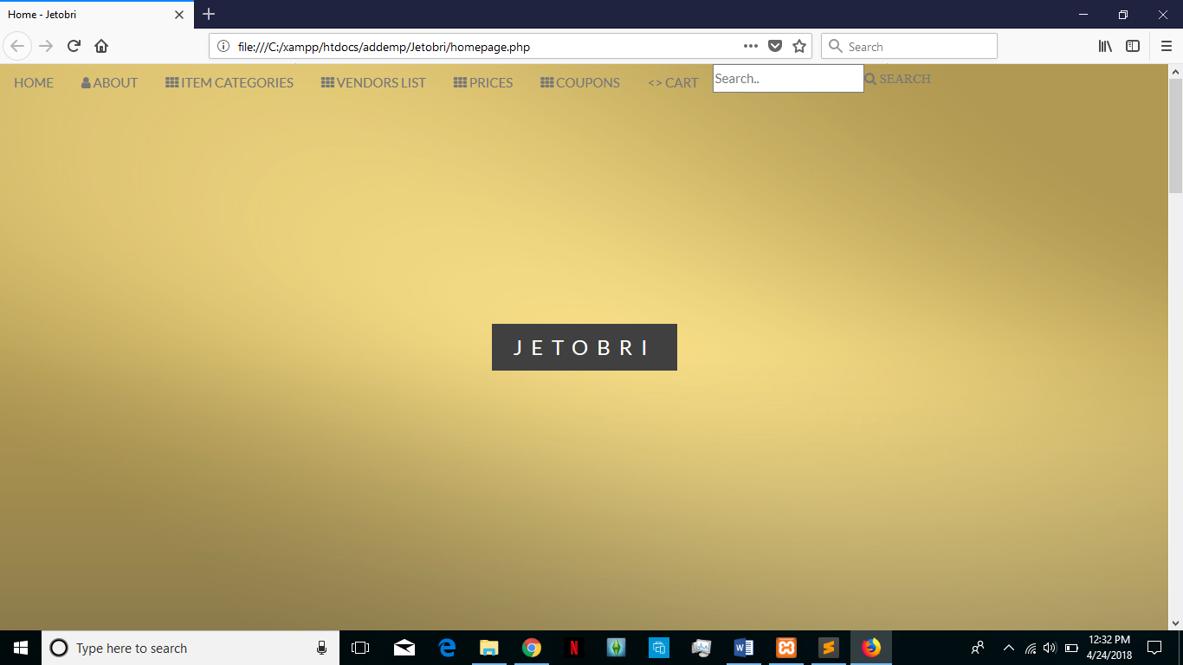

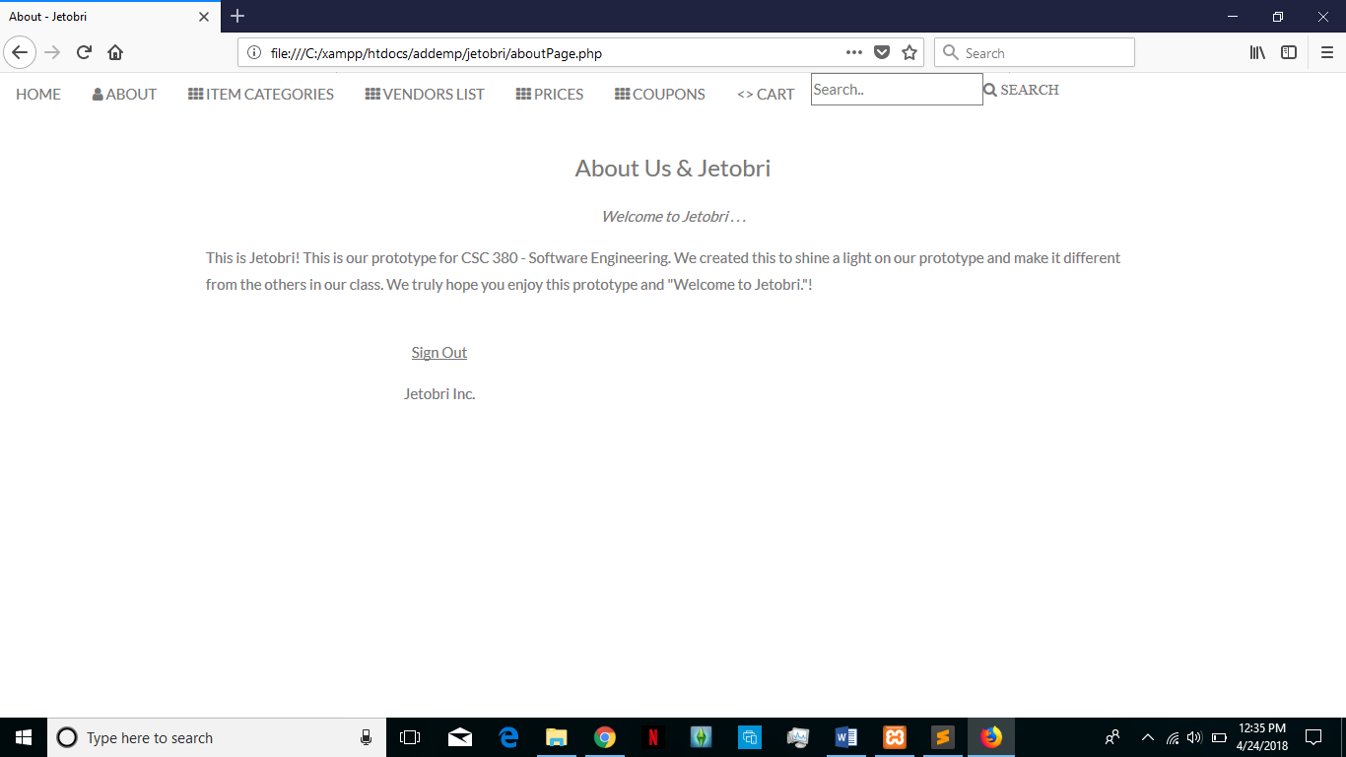

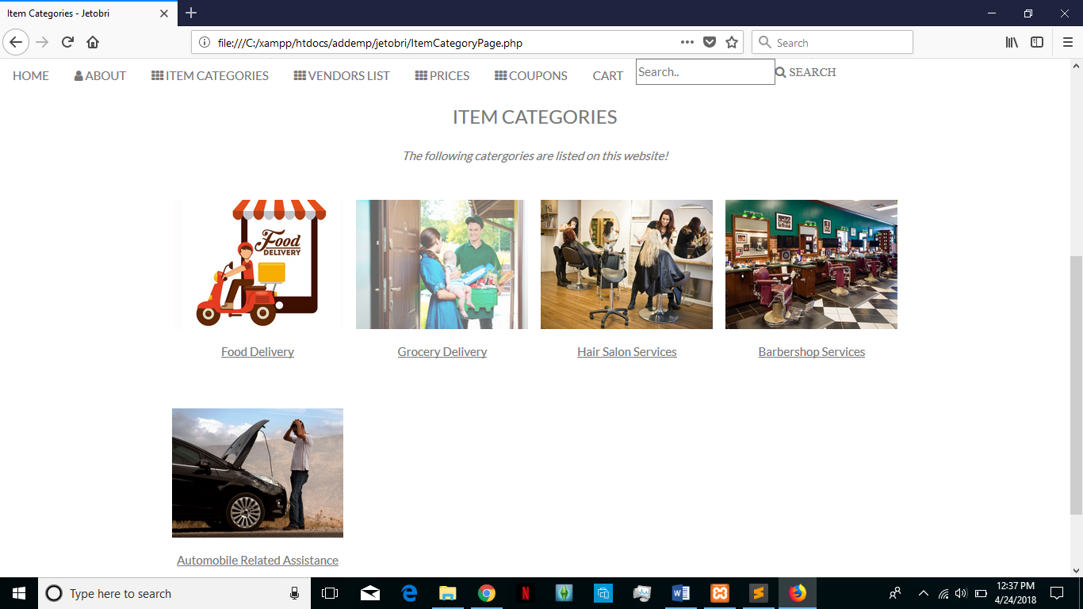

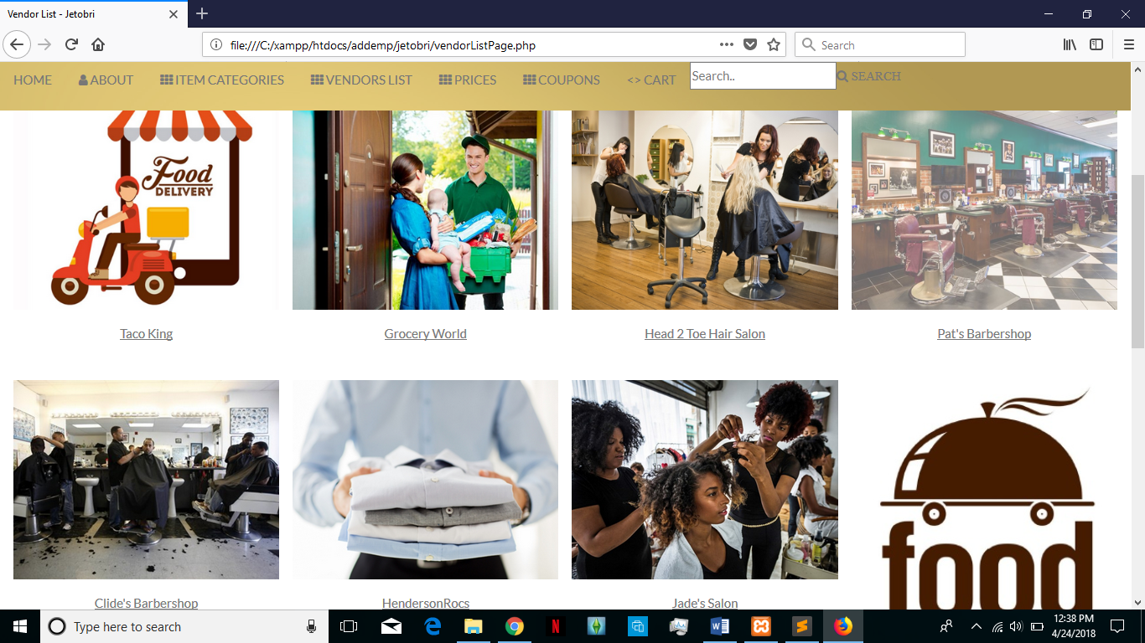

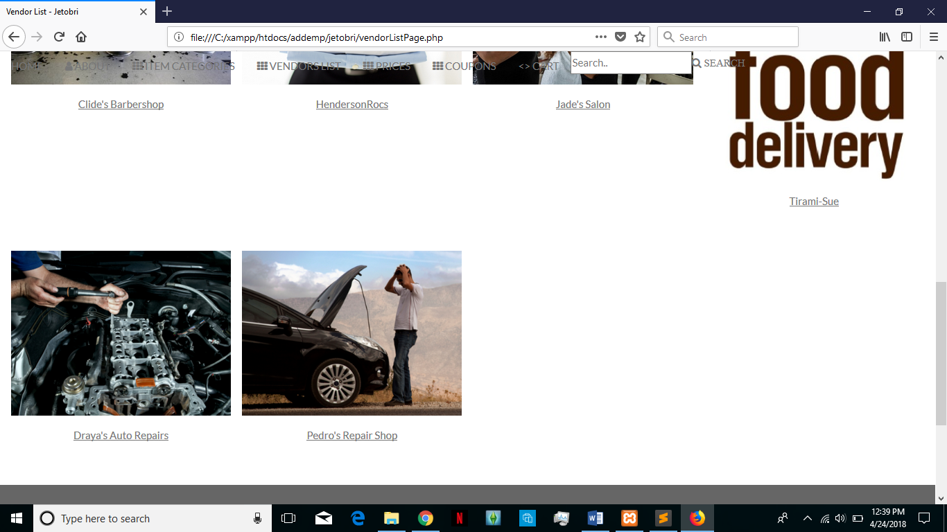

**5. Class Diagram and Classes**

The following is the class and inheritance tree diagram. 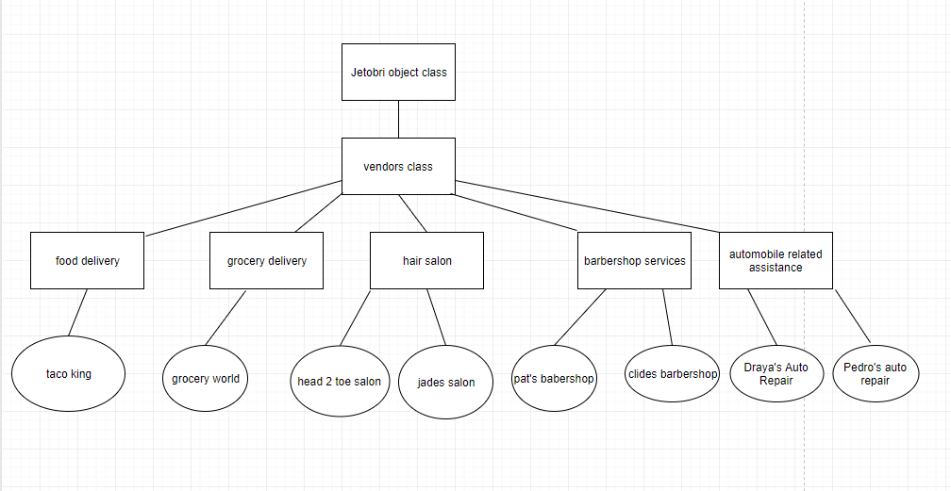

**6. Design process**

In the design phase the methodology used is the organization database design. This review addresses the enterprise-wide concerns of the organization with respect to the application being reviewed. Common review points include:

* How does this system interact with other systems in the organization?
* Has the logical data model for this application been integrated with the enterprise data model (if one exists)?
* To what extent can this application share the data of other applications?
* To what extent can other applications share this application’s data?
* How will this application integrate with the current production environment in terms of DB2 resources required? batch window? on-line response time? availability?
* Will the implementation of this application cause the data processing needs of the shop to expand? For example, will more memory, CPU power, or storage be necessary?

**7. References**

List of references used to design this document

Sommerville v9 textbook