THE PRINCIPLE OF INVERTENDO

Kamlesh Patel

Preceptors Seminar

The morning of 27 March 2019

Kanha Shanti Vanam, Hyderabad, India

Good morning and a very hearty welcome to all the preceptors here. Thank you for coming. There’s a lot to be shared. We’ll go in depth with so many topics.

The most vital aspect of our journey, the spiritual *yatra*, is that often we are not able to decide where to begin the journey. That requires some aspect of sensitivity. In order to even understand how the journey begins at various levels, we have to understand how this actual flow occurs, the flow of energy. Transmission is forceless force but it ends up creating ripples in our system. It follows a pattern exactly like an electric current. How does an electric current move? Most of you are familiar with it, but for those of who are not, there is a positive and there is a negative charge. It moves as currents, in the form of waves. Babuji also talks about the currents descending from the Source. They are not descending in straight lines. They are also following the same positive and negative pattern.

This pattern itself ends up creating a field at each point. And when something moves from one point to the next, immediately to the next, what generally happens there is invertendo. This is again Babuji’s discovery – the ‘Principle of Invertendo’. He has broadly described it in two books, *Efficacy of Raja Yoga* as well as in *The Ten Maxims*. You must have read about point 1. He says let’s divide this point 1 into two, based on actuality, what really happens there, there is an upper region and there is a lower region.

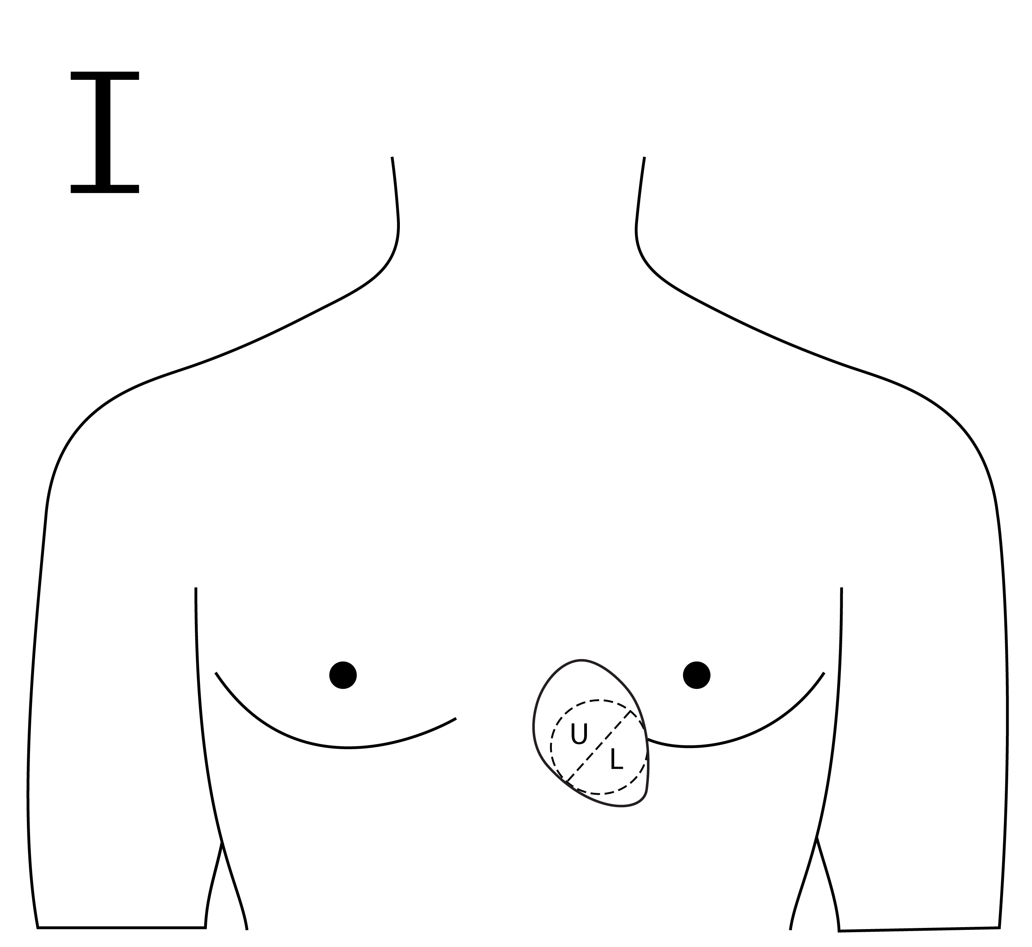

The upper region has a slightly better level of consciousness. The lower one doesn’t have that much of consciousness. It does have, but it is not as refined as the upper level. The journey also begins within the point: the upper region and the lower region. Now what happens because of this positive and negative flow? Whatever is ‘upper’ at point 1 becomes ‘lower’ at point 2 and what is lower at point 1 becomes upper at point 2, and this will continue. Now it will go lower again. So points 1, 3, 5, 7, 9, 11, 13 – all the odd numbered points – will have their upper region as upper, and their lower region as lower, while for the even numbered points – 2, 4, 6, 8 and 10 – the lower region will be in the upper part of the chakra. Do you follow me? If you don’t understand, raise your hands. Okay. There is a big number. I’ll draw it for you so you’ll understand.

[Attach Daaji’s diagrams so they can be referred to]

So let’s consider these five points of the Heart Region. What I was trying to share is that when you divide this first point, the upper part is upper, and the lower is lower. That is simple. But when you look at the second point, the direction changes. This becomes L and this becomes U. The same thing happens here [referring to the diagram]. This really doesn’t matter [referring to the fifth point]. You get it now? Okay.

And so Babuji was able to describe the sixth point, and you divide it like this. This will become lower and this will become upper. And he has taken up only these two points in the books in order to describe the Principle of Invertendo. Whatever is there on point 1 is in invertendo at point 2. So with this basic understanding, we move on.

When we do clean point A and B, even if we are not vulnerable to the idea of sensuality etc., nevertheless is will help us move further the states of superconsciousness prevailing at A2 and B2, A3 and B3. The extent to which these points are cleared up – A and B – to that extent the upper and lower regions of point 1 will be cleaned up, and to that extent superconsciousness at other higher points will also reflect; in all the points in our system. You know people say we only have thirteen points, but in reality we have sixteen. We don’t make mention of the lower three chakras, but nevertheless they are present. We can’t avoid them just because we don’t touch them. We don’t touch them in the beginning, no doubt, but towards the end of the journey it is mandatory that the Master will ensure the journey within the *Manipura*, *Swadhisthana* and *Mooladhara* chakras. Only then is there completion.

In the beginning they are not touched at all because of the dangers associated with these lower chakras. These lower chakras are present also in animals – dogs, cats, elephants and horses – all the animals do have these points. Only in human beings, the *Anahata* chakra becomes more active. But if we remain focused on the basic animalistic tendencies then we remain glued there and we don’t rise above *Anahata*.

There is also a great amount of confusion or lack of understanding. We are not able to tally the regions, like the Heart Region, which we also call the *Pind Pradesh*; the Mind Region (the Mind Region is very vast), within which there is *Brahmand*, there is *Para-Brahmand*, there is *Prapanna*, *Prapanna-Prabhu* and *Prabhu*; and then the Central Region.

Then we have these points, the chakras. On top of that Babuji complicates the whole thing with 23 circles. And we fail to understand the relationship between these circles and regions and points. Mind you, we have not gone into *koshas* as yet. But I will try – I did try to make sense out of all these things a long time back, but this PowerPoint presentation was not so ready. In France, I tried to explain it, but it was so dim and so unpresentable. So we have tried to make it more visible and more understandable.

Also I would like to share with you something alternative, the alternate method of measuring or locating the point A and B. I think all of you know, Babuji has described it in a very fantastic way of measuring two fingers this way from the left nipple, and then go three fingers down, and that’s point A, and then two fingers down is point B. But while we were releasing this book *The* *Heartfulness Way*, the publishers in United States – they are not abhyasis, but the final editing was done by ladies – found it a very interesting topic, but they found it very difficult to locate. They asked if there was an alternate method. I ended up praying to Babuji Saheb and I was guided, and based on that we have come up with an alternate way of locating points A and B. Even sisters cannot find it difficult any more. So we will begin. I would like to call this presentation ‘Spiritual Anatomy: Journey towards the Centre.’ Let’s begin with ‘Freedom’, slide number two.

So this is from the 23 circles. We begin with stages of Maya, where there is so much duality, where opposites prevail. Five circles belong to five points, each individual point. The first point you can confidently say is in the first circle, the second point in the second circle, the third in the third circle, the fourth in the fourth circle, and the fifth in the fifth circle.

Now, let’s understand. Some of you may have heard the discussion between Babuji and a sister from Denmark, where Babuji was saying that he made one sister cross 64 points. Have you heard these remarks? Then we wonder, where are all these points coming from? He described only thirteen, but that was when he wrote the book in 1948. Later on, some time in the late ’50s, and ’60s and ’70s, he continued to do more research, and the outcome was not 64 points but 65. In one case, he was able to help that sister travel up to the 64th. The 65th is awakened in only one case.

So now, we have to understand that at each point one of the *pancha bhutas* will predominate. You will come across this description in Lalaji’s dictations in the autobiography, which we will touch upon now and then. The autobiography of Babuji Maharaj has a lot of secrets. If you read it carefully, on every single day, whatever messages are given, there is a method, there is a technique, there is a hint. These hints are how we can move forward. At times he criticises his own disciples. At times he punishes them. At times he rewards them. And it’s a nice way of looking at how his heart and mind are working. Once we know how he understands us, then it is easier for us to cooperate for our own betterment.

So in one of those messages he says that in the Heart Region there are five points. The first point is the point of the heart. It is dominated by the element Earth, *pritvi*. Then he says that it is not the only element present there; there are other elements also, but in smaller amounts. If the Earth element is present, which I have reflected in this diagram as the colour yellow, the other elements are also present, starting with red, which is a reflection of the Ether element and also reflects the quality of the second point. The third point is also reflected here. If you see clockwise, here at the first point the red colour marked is at the 12 o’clock position, which is actually the second point. At the 3 o’clock position there is the Fire point depicted, or the Fire element. The black represents the Water element and the green represents the Air element. So all elements are present. Now when you combine all these elements and points A and B, according to him it constitutes 7 sub-points.

Circle number two: this is dominated by the Ether element, which is depicted as the red colour. And we actually feel that, also, when we are exposed to the second point, when it blooms and opens up. We see the red tinge within ourselves. Or when Transmission is given by the preceptor from the second point, generally (I don’t say all the time) an *abhyasi* will also feel a reddish tinge within. Here at the 12 o’clock position, it reflects the quality of the next point, just as we saw at the first point the 12 o’clock position was reflecting the quality of the second point. At the second point, the 12 o’clock position of the next element will be that of the third point. So all the elements are also present, but, here at the second, space or the Ether element will be dominant. Now these reflect five sub-points. So now you can say that you have actually traversed through seven plus five which equals twelve sub-points. So the five and seven are the journey within each point.

The third point, the third chakra: the third circle also has five elements, but the dominant element here is Fire. The 12 o’clock position is reflected here with the next point’s quality, which is Water, reflected by the black colour here. So this also represents five sub-points, and that will make our journey complete to the extent of 17 points. So likewise, it goes on. The next will be the fifth.

One interesting thing I’d like to share is that while we are at the first, the heart, though it gives satisfaction etc. in the present-day condition I would say the majority of us go through turmoil. The only peacefulness we’ll find is while arriving at the second point. Similarly, when we come to the third point, Nature bestows us when we cross this troublesome third point to the next point, which is the fourth, which is more peaceful. At number three we have an emotional roller coaster ride, but the moment we come to the fourth there is immense peace there. It is exactly like the way we feel so much peace at the second point, unlike the restlessness that prevails at the first. So at subsequent points, nature gives us a break, some restful hours.

Now once we cross this, we enter the stages of egoism. It’s all about me, mine and my doings. Here, at the sixth point, there is A1 and B1 plus the quality of the main element and the other four minor elements. It was 27 before, now you add 7 more, and it will be 34. The Cosmic Region or the *Brahmand Mandal* is restricted within the sixth circle. *Para-Brahmand* is restricted within the seventh circle. By now we have crossed 39 sub-points. Now here is the beauty: you must have seen where we have described the spiritual journey at the seventh knot in Heartfulness magazine, or behind the seventh knot actually, the *chit* lake, where there is the *Saraswati* point as well as the point of passion. Passion and knowledge are inseparable. They are so conjoined. Working on one will have a ripple effect on the other point. Trying to destroy the passion point will destroy your receptivity towards knowledge. That’s why most intellectuals are quite passionate at the sexual level.

The seventh knot reflects the Para-Cosmic Region. The eighth knot is about the *Prapanna* state, where the feeling of surrender starts. By the ninth point it matures, and we become eligible to enter from this admixture of *Prapanna* and *Prabhu* to eventually reach the state of *Prabhu*. If you see here, there are A2 and B2, which reflect the tenth point, wherefrom the state of *Prabhu* begins. Going further we enter the eleventh knot here. So we have now crossed 61 points, and by the twelfth knot we have crossed 64.

If you notice here [refers to the diagram], there are only three elements present – Ether, Water and Fire. The Air and Earth elements are missing here. That means we go beyond this Earthly existence; we start feeling that we don’t belong here, in reality. It is one thing when you are in trouble, when your heart is broken and you say “What am I doing here?” but at this point, in reality, you feel that “I really don’t belong here. I’m not of this world.”

I will share with you one of my personal encounters with Babuji Saheb. This was my last visit to him in 1982. He whispered very gently and said, “I have stopped feeling the Earthly vibrations.” I have shared this in another context. Perhaps he was hinting, “My time to go has come.” But also, I understand it is not that he entered the twelfth point then, he had always been feeling like that, perhaps, from the very first day itself: “I don’t belong here.” But all these qualities that we encounter should not be mental fabrication; it should become actual inner experience for us.

Now begins the real adventure. The twelfth point is also a kind of bridge. Just around the twelfth point, there is the *Brahmarandra* point. Now *Brahmarandra* is the point through which the soul enters the body after conception, and through which liberated souls exit. I would request you to refer to *Truth Eternal* and to read the chapter on ‘Creation and Destruction by Sound’, where Lalaji describes how the soul escapes the body at the moment of death, how each chakra collapses and dissolves into the next element, the next chakra. Now when our journey has come up to the twelfth point, the tendency of the soul is to escape. The job is done, kind of. But it is the discovery of Babuji Maharaj that he does not allow the escape to happen, because much lies ahead of us in a spiritual way. By now the Godly Region ends. It will be surprising to a lot of people – if the Godly Region ends, then where are we going? Is it beyond God? I will leave it to each one’s experience and I pray that all of us somehow make it there.

How he does it: he says there is a curved arc, like a curved window, at the twelfth point, which we cross and enter the Central Region. This entry point, according to him, is called *Satya Pad*. Entering all these rings and having the actual journey is beyond description. There is no force there. There is no effort there. It simply happens. That’s why we call the Transmission that arises or descends from the centre itself forceless force. The moment we apply force, there is always a ripple effect in the opposite direction. This ripple effect will not be there once we start swimming towards the centre.

Now, if you permit me to say, when we cross the Heart Region into *Brahmand*, we actually goes beyond the individual dualities imposed by these *pancha bhutas*. They are very heavy. Here we have tried to depict these five elements present in the Heart Region in a slightly darker colour – dark green, dark red, dark black – but as we go into the *Brahmand* and *Para-Brahmand* and *Prabhu* and further, the intensity of these elements is shown here with lightness of colour, to express that they are there but for the name’s sake.

And how can we go beyond these troubles of opposites – the war within, created by these pairs of opposites? By remaining generous to our heart: generosity, not of money, but forgiveness, allowing things to happen, acceptance. All these qualities will automatically flourish in our heart. But if our tendencies remain, to go against this, then we won’t be able to enter the *Brahmand Mandal*. A person who cannot forgive, a person who always remembers the wounds and pains inflicted upon them, and who wants to take revenge, can forget about *Brahmand Mandal*. Although, so many states are bestowed upon us by the Master in *akashi* fashion, which means in a reflected way. That means it is not your own earnings. It is like leased property, where you are there by the grace of the landlord, who doesn’t charge you rent, perhaps. If you misbehave, it dissolves just like that, whereas if you make your way through your own efforts, cooperating with the Masters, then magical thing can happen; then there is no fall. Otherwise, there is always a fall, even from the level of *Maha Parshad*, which we will come across in the autobiography. Some of you, who have heard Chariji say that the *Maha Parshad* cannot fall, will read something different with a lot of proofs in the autobiography, which I’ll be referring to so often from the evening session onward. So if you don’t have the autobiography with you, I recommend that you carry it with you throughout these preceptors’ sessions.

A lot of research and the discoveries that he made are written there. With some of the sentences that are there, I’ll ask you, “Read the whole paragraph and tell me, what is the research here? What is he trying to convey?” You can’t pick it up. Ninety per cent of the time you will miss those methods; you will miss those hints. It requires a different orientation. How to read these messages from The Brighter World by Lalaji and other great saints?

And when we move from the Cosmic Region to the Godly Region, what is required there is utter humility. It also shows the lessening of our ego. Pride is now dissolving. Only then one can enter the Godly Region. And from this Godly Region into the Central Region, it depends on our relationship with the great Master; how well surrendered we are. Only that thing will determine our entry there.

So far I’ve talked about how we can progress at the individual level. Three qualities which I have described will form a kind of a repeating story in the autobiography – how humility of Babuji, how his generosity, and how his state of surrender contributed to what he became as a Special Personality. So about other things, I think just for interest we will go through this slide, which is quite self-explanatory (3).

You see here, this Z forms a triangle between the seventh and the eighth. Let us say this is the seventh point and this is the eighth point, go one inch inside your forehead actually and then draw the line – that’s where the *Chit* Lake is present. As Babuji says, the *Chit* Lake in most people is greyish in colour, but in advanced cases it becomes reddish to kind of ruby-coloured, within which there is the point of *Saraswati* superimposed with the passion point.

*Brahmarandra* is generally where we keep the *choti* or *shikha*.

There is one easy way also to figure out where the Centre is. Do you know where they pierce the ears? Draw a line this way [demonstrates] and that is the centre. And for SDK, from the tip of the ears, go up like this [demonstrates] and that is SDK. And if you put your four fingers there, the front is the tenth point and the back is the eleventh point. So for a few points you can even easily figure it out. But the best would be to feel it within and say, “Oh, ninth point,” and close your eyes. Visit that point and meditate there, and see what happens. The qualities will come, which means the environment or the condition prevailing at that point will reflect within us.

Now some exercises for you all. I know you come from many centres all across India as well as abroad. These five days, I would like you to have this simple exercise. Each day, recollect one *abhyasi* from your centre and make a note of that person’s name. Pick another *abhyasi* for tomorrow and write down their name. On the third day, another name; fourth day, another name; fifth day, another name. Fill up these five names for yourself. Try to give them a sitting *in absentia*, which means you don’t inform them. Today you give a sitting to that person whose name is there. Tomorrow the person is somebody else, right? On the third day it is somebody else, on the fourth somebody else. So likewise you give a sitting. Then, when you are giving the sittings, try to find out how that person’s condition is, the position and approach. While you are busy with this, today you are busy with one case A, tomorrow you will be busy with case B, and on the third day you will be busy with case C. Now, when you are busy with case B, include case A also. When you are busy with case C, include A, B and the new C. So, likewise, it will be cumulative. By the time you leave from here you will be able to work on five different persons at the same time. Then this number can also increase. It has far-reaching consequences – more than you can imagine. I’ll show you where this will lead us. Remember the movie, *Karate Kid*? He is fighting with his master – every day the same exercise. I wish you would see that movie once. But the same exercise saves his life one day. This has a far-reaching impact.

[Include screen shots of Daaji demonstrating the breathing].

Also, I would like you to learn what I have been doing for many years, actually, even back to 2003 or 2004. On my own it came to my understanding that sometimes I should breathe like this. Generally we breathe in one go, one inhale, one exhale. One long breath and then you exhale. Inhale and exhale. But while we are inhaling, break it into two, three, four or five parts [demonstrates]. In one go. You understand this much? It’s like from here up to here I have to breathe right? So I do it [demonstrates] like that. Do this for three or four days. I’ll teach you the significance of it on the last day. Just remind me so I don’t forget it.

This *Karate Kid* thing and this breathing thing will prepare us for a very big thing actually, very big. It’s nothing ordinary. During the next few days if you can fast it will be nice – those of you who can. It’s not mandatory that everyone must. If you like, have a light meal if you cannot fast, but those who are diabetic please be careful.

I will be back here at 5:30 p.m. and will we will take up the reading of a few passages from the autobiography of Babuji, 1944. Thank you.