Integrity-Assured Machine Learning for Aircraft Predictive Maintenance: Threat Modeling and Resilience Evaluation Using NASA C-MAPSS
[Author Names Placeholder: First Author¹, Second Author², Corresponding Author³*]
¹˒²˒³ Department of Computer Science & Cybersecurity Engineering
[Institutional Affiliation Placeholder: University / Research Institute Name, City, Country]
Email: [author1@institution.edu, author2@institution.edu, corresponding@institution.edu]
Abstract— Prognostics and Health Management (PHM) systems deploy machine learning algorithms, notably gradient-boosted decision trees, to forecast the Remaining Useful Life (RUL) of aircraft turbofan engines from continuous telemetry. However, existing PHM architectures predominantly assume that model deployment pipelines are secure and that transmitted sensor streams are uncompromised. In this study, we present AeroSentinel, a threat-modeled predictive-maintenance framework that integrates Edwards-curve Digital Signature (Ed25519) artifact verification with multi-sensor statistical drift screening. Evaluating on the NASA C-MAPSS FD001 benchmark (100 run-to-failure training trajectories, 100 censored test trajectories), we first discover and resolve a survival censoring asymmetry: screening clean operational test telemetry directly against run-to-failure training baselines triggers an 8-channel false-positive alarm rate (>53% of 15 monitored channels) due to physical degradation divergence. By establishing an operational baseline via a disjoint 50/50 engine partition, we evaluate the resilience of Kolmogorov-Smirnov and Population Stability Index (PSI) detectors under six synthetic sensor-manipulation scenarios targeting static High-Pressure Compressor outlet pressure (s₁₁). Our empirical findings reveal notable detection blind spots: single-channel step biases (±1.0σ to +2.0σ) and creeping ramps evade fleet-level drift alert thresholds (≤1 PSI alert channel), while shifting RUL estimates by up to -12.07 cycles and degrading unclipped RMSE from 13.9044 to 20.4374. Crucially, negative bias injection artificially masks wear, delaying predicted engine overhaul and elevating the Canonical Hazardous Prediction Rate (HPR, over-predicting RUL >25 cycles when true RUL ≤ 25) from 15.79% to 31.58% (6/19 critical engines delayed) with zero PSI alert channels under disjoint evaluation. Frozen sensor replay forces an HPR of 100.0% and surges the NASA asymmetric penalty score by over 2,600× (791,878.67). To secure model supply chains against tampering and arbitrary bytecode deserialization, we implement Ed25519 signing over RFC 8785 canonical JSON metadata; microbenchmarks (N=100) confirm that fail-closed cryptographic verification executes in 0.13 ± 0.02 ms (median 0.11 ms), adding negligible overhead to total startup (24.37 ms) and batch inference (1.34 ms for 100 engines, 13.4 µs per engine). This investigation demonstrates the necessity of combining cryptographic integrity controls with domain-aware invariant validation for ground-side aviation analytics.
Keywords— Aircraft Predictive Maintenance, Prognostics and Health Management, Remaining Useful Life, Adversarial Machine Learning, Cryptographic Artifact Authentication, Ed25519, Statistical Drift Detection, Sensor Manipulation, NASA C-MAPSS.
I. INTRODUCTION
Predictive maintenance in modern commercial and military aviation relies extensively on data-driven Prognostics and Health Management (PHM) architectures. By analyzing multi-sensor flight telematics—including rotational spool speeds, static bleed pressures, and gas temperatures—machine learning algorithms forecast the Remaining Useful Life (RUL) of critical components, such as turbofan gas turbines. Accurate RUL estimates enable airline operators to transition from rigid calendar-based maintenance schedules to condition-based maintenance, minimizing unscheduled Aircraft on Ground (AOG) events and mitigating catastrophic inflight mechanical failures [1], [2].
Despite considerable algorithmic advances in deep recurrent neural networks and gradient-boosted decision tree ensembles [2], [3], existing aircraft predictive maintenance models are engineered under the implicit assumption of a benign, uncorrupted operating environment. In-flight and ground-transmitted telemetry streams are assumed to accurately reflect true thermodynamic degradation, and serialized model artifacts are presumed to reside securely within trusted ground-station environments.
However, modern aviation telematics ecosystems are increasingly distributed and interconnected. Sensor readings and post-flight telemetry summaries are routinely transferred via the Aircraft Communications Addressing and Reporting System (ACARS), cellular ground data links (Gatelink), and portable data terminals during turnaround. This expanded data interface introduces potential attack vectors across both data-plane and control-plane channels [4], [12]:
1) Supply-Chain Model-Artifact Tampering: Adversaries with read/write access to maintenance server storage or package repositories may alter serialized estimator weights, feature scaler parameters, or metadata manifests to deliberately suppress maintenance warnings or execute malicious code via Python deserialization gadget chains [4], [6].
2) Sensor Telemetry Manipulation: Compromised telematics gateways or Man-in-the-Middle (MitM) interceptors can inject subtle mathematical biases, frozen packet replays, or creeping calibration drifts into thermodynamic sensor streams, skewing RUL forecasts without triggering coarse out-of-bounds alarms [7], [8].
In aviation maintenance, prediction errors carry fundamentally asymmetric operational consequences. An early prediction (under-predicting RUL) prompts premature engine inspection, incurring unnecessary operational downtime and maintenance labor costs. Conversely, a delayed prediction (over-predicting RUL) is potentially hazardous: it allows an engine on the verge of mechanical failure to remain dispatched, risking severe in-flight damage [1], [2]. Despite this asymmetry, the degree to which lightweight statistical drift monitors can detect subtle sensor manipulation and the proportion of hazardous predictions that can escape detection remain insufficiently quantified.
To investigate these questions, we present AeroSentinel, an integrity-assured predictive maintenance framework evaluated on the NASA C-MAPSS FD001 turbofan benchmark. Our research makes five specific contributions: (1) Dual-protocol baseline disambiguation between raw unclipped and clipped ground-truth; (2) Discovery and resolution of the run-to-failure censoring asymmetry via a disjoint operational reference baseline; (3) Systematic empirical resilience profiling across six synthetic sensor manipulation scenarios; (4) Sub-millisecond Ed25519 cryptographic artifact authentication; and (5) A fully reproducible open-source research suite.
II. RELATED WORK & RESEARCH GAP
A. Aircraft Prognostics & Benchmark Methodologies
The NASA Commercial Modular Aero-Propulsion System Simulation (C-MAPSS) benchmark released by Saxena et al. [1] is the primary standard for data-driven turbofan prognostics. In the FD001 sub-dataset, high-pressure compressor degradation is modeled under steady-state sea-level conditions across 100 training and 100 test trajectories. Ramasso and Saxena [2] surveyed over 70 C-MAPSS studies and documented pervasive benchmark reporting discrepancies, specifically highlighting the conflation of raw physical targets with piecewise-linear clipped targets (RUL_max = 125 cycles). While deep learning (e.g., LSTM networks by Zheng et al. [3]) and gradient-boosted decision trees achieve high predictive fidelity on clean benchmark data, these studies focus exclusively on regression accuracy, omitting integrity controls or adversarial evaluation.
B. Machine Learning Integrity & Artifact Authentication
The security of serialized machine learning models has gained increased attention as pipelines are integrated into critical infrastructure [4], [6]. Traditional persistence formats (such as Python pickle and joblib) deserialize arbitrary object state, exposing host environments to code execution vulnerabilities if model files are modified. Gu et al. [4] demonstrated that machine learning supply chains can harbor backdoors and modified weights without degrading clean accuracy. The National Institute of Standards and Technology (NIST) Special Publication 800-218 [6] explicitly recommends cryptographic signing of software and data artifacts. Bernstein et al. [5] introduced Ed25519 (Edwards-curve Digital Signature Algorithm over Curve25519), offering 128-bit security, high-speed verification, and resilience to side-channel timing attacks. However, standard predictive maintenance platforms commonly rely on unsigned SHA-256 checksums, which cannot prevent manifest rewrite attacks by an adversary with write access.
C. Sensor Telemetry Manipulation & Drift Detection
Adversarial machine learning research has expanded to cyber-physical time-series systems [7], [8]. Fawaz et al. [7] and Karim et al. [8] demonstrated that subtle, bounded perturbations in sequential sensor streams can cause severe prediction degradation. Mo et al. [12] analyzed replay and sensor bias attacks on cyber-physical systems, proving that intelligent replay can evade traditional Kalman filter residual checks. For continuous monitoring, production systems frequently employ non-parametric tests, such as the two-sample Kolmogorov-Smirnov (KS) test [11] and the Population Stability Index (PSI) [10]. However, Rabanser et al. [9] demonstrated in empirical studies (Failing Loudly) that statistical divergence tests can fail to alert under localized, task-relevant shifts. The specific resilience of multi-sensor drift screening against stealthy biases in turbofan degradation analytics has not been systematically characterized.
D. Identified Research Gap
Prior literature exhibits three core limitations: (1) Conflation of evaluation baselines (raw vs. clipped ground-truth) without explicit protocol separation; (2) Overlooking survival censoring asymmetry when applying statistical drift detectors across training and operational test data; and (3) An absence of unified evaluations quantifying cryptographic artifact verification overhead alongside sensor-manipulation resilience on standardized aviation benchmarks.
III. SYSTEM ARCHITECTURE & THREAT MODEL
A. Architectural Overview
AeroSentinel is designed as a ground-side advisory analytics service receiving turbofan telemetry post-flight. The architecture comprises four modular stages: (1) Cryptographic Lineage Verifier; (2) API Input Hardening Layer; (3) Dual-Baseline Covariate Drift Detector; and (4) Gradient-Boosted RUL Regressor.
B. Threat Model & Trust Boundaries
We model threat actors using the STRIDE methodology: Adversary A_art operates on the model supply chain with write access to storage or network caches, capable of modifying model weights or manifests but lacking the offline Ed25519 private key. Adversary A_sen intercepts telematics in transit, injecting additive biases (delta in [-2.0sigma, +2.0sigma]), creeping ramps, or frozen buffers into sensor streams without modifying true labels.
The system enforces three core security invariants: (1) Fail-Closed Execution upon signature mismatch or byte tampering; (2) Dual Protocol Separation between raw unclipped and clipped metrics; and (3) Offline Ground-Truth Isolation ensuring true RUL is never exposed online.
C. Cryptographic Authentication Specification
AeroSentinel implements the Edwards-curve Digital Signature Algorithm over Curve25519 (Ed25519, RFC 8032) [5]. To prevent signature invalidation caused by dictionary key reordering or whitespace formatting variations, manifest payloads are serialized using the RFC 8785 JSON Canonicalization Scheme (JCS). At initialization, the runtime verifies the Ed25519 signature over canonical JSON, computes SHA-256 digests of all serialized dependencies (best_model.joblib, preprocessor.joblib, model_registry.json), and invokes joblib.load if and only if both checks succeed.
IV. EXPERIMENTAL METHODOLOGY
A. Dataset & Preprocessing Pipeline
We evaluate our framework on NASA C-MAPSS FD001 (100 training engines, 20,631 cycles; 100 test engines, 13,096 cycles; 100 ground-truth terminal RUL values). Six invariant sensors (s1, s5, s10, s16, s18, s19) and setting 3 are discarded, retaining 15 active degradation channels: s2, s3, s4, s6, s7, s8, s9, s11, s12, s13, s14, s15, s17, s20, s21. The causal feature pipeline constructs 122 features using 5-cycle backward rate-of-change lags, 5- and 15-cycle rolling means and standard deviations, engine baseline drift terms, and StandardScaler normalization fitted strictly on training data.
B. Mathematical Evaluation Metrics
Model accuracy and prediction risk are evaluated via Root Mean Squared Error (RMSE), Mean Absolute Error (MAE), Coefficient of Determination (R²), and the NASA Asymmetric Penalty Score (S_NASA), which penalizes late (hazardous) predictions exponentially more heavily than early predictions [1], [2].
C. Canonical Hazardous Prediction Rate (HPR)
To isolate late-stage operational hazards, we evaluate the Canonical Hazardous Prediction Rate over the critical subset of test engines whose true remaining life is within 25 cycles (C_25 = {i : y*_i <= 25}, |C_25| = 19 engines in FD001):
HPR = (|{i in C_25 : y_hat_i > 25}| / |C_25|) * 100%. Under clean baseline conditions, 3 of 19 engines exceed 25 cycles, yielding HPR_clean = 15.79%. An attack that elevates HPR delays mandatory depot inspection for engines near structural failure.
D. Drift Detection & Censoring Asymmetry Resolution
Drift is monitored per sensor using the Two-Sample Kolmogorov-Smirnov (KS) test [11] and Population Stability Index (PSI) [10] across 10 quantile bins. We discover that comparing test telemetry directly against training data produces 8 false-positive PSI alert channels on clean data because training engines run to complete failure (100% dead) while test engines are censored. AeroSentinel resolves this via a Dual-Baseline Architecture with disjoint engine partitioning: test engines are partitioned into Calibration Engines 1-50 (uncorrupted reference) and Evaluation Engines 51-100. Evaluating clean Evaluation Engines against Calibration Engines yields 0 PSI alerts and 0 warnings (status: stable), establishing a verified 0.0% False Positive Rate on unseen clean operational data.
E. Synthetic Attack Scenarios
Six deterministic attack scenarios target sensor s11 (HPC static pressure, highest Gini importance): sc1 (Step Bias +1.0σ), sc2 (Step Bias +2.0σ), sc3 (Negative Bias -1.0σ), sc4 (Creeping Linear Ramp +2.0σ), sc5 (Multi-Sensor Bias +1.0σ on s11, s9, s4), and sc6 (Frozen Replay at cycle 40%).
V. EXPERIMENTAL RESULTS & ANALYSIS
A. Clean Baseline Model Performance & Protocol Disambiguation
Table I summarizes clean baseline performance across both evaluation protocols on the 100 unseen held-out test engines.
Protocol | Target Policy | RMSE | MAE | R² | NASA Score
Protocol A | Raw Unclipped | 13.9044 | 10.4044 | 0.8880 | 301.97
Protocol B | Clipped at 125 | 13.0082 | 9.3344 | 0.8946 | 280.35
TABLE I: Clean Baseline Performance Across Evaluation Protocols (N = 100 Engines)

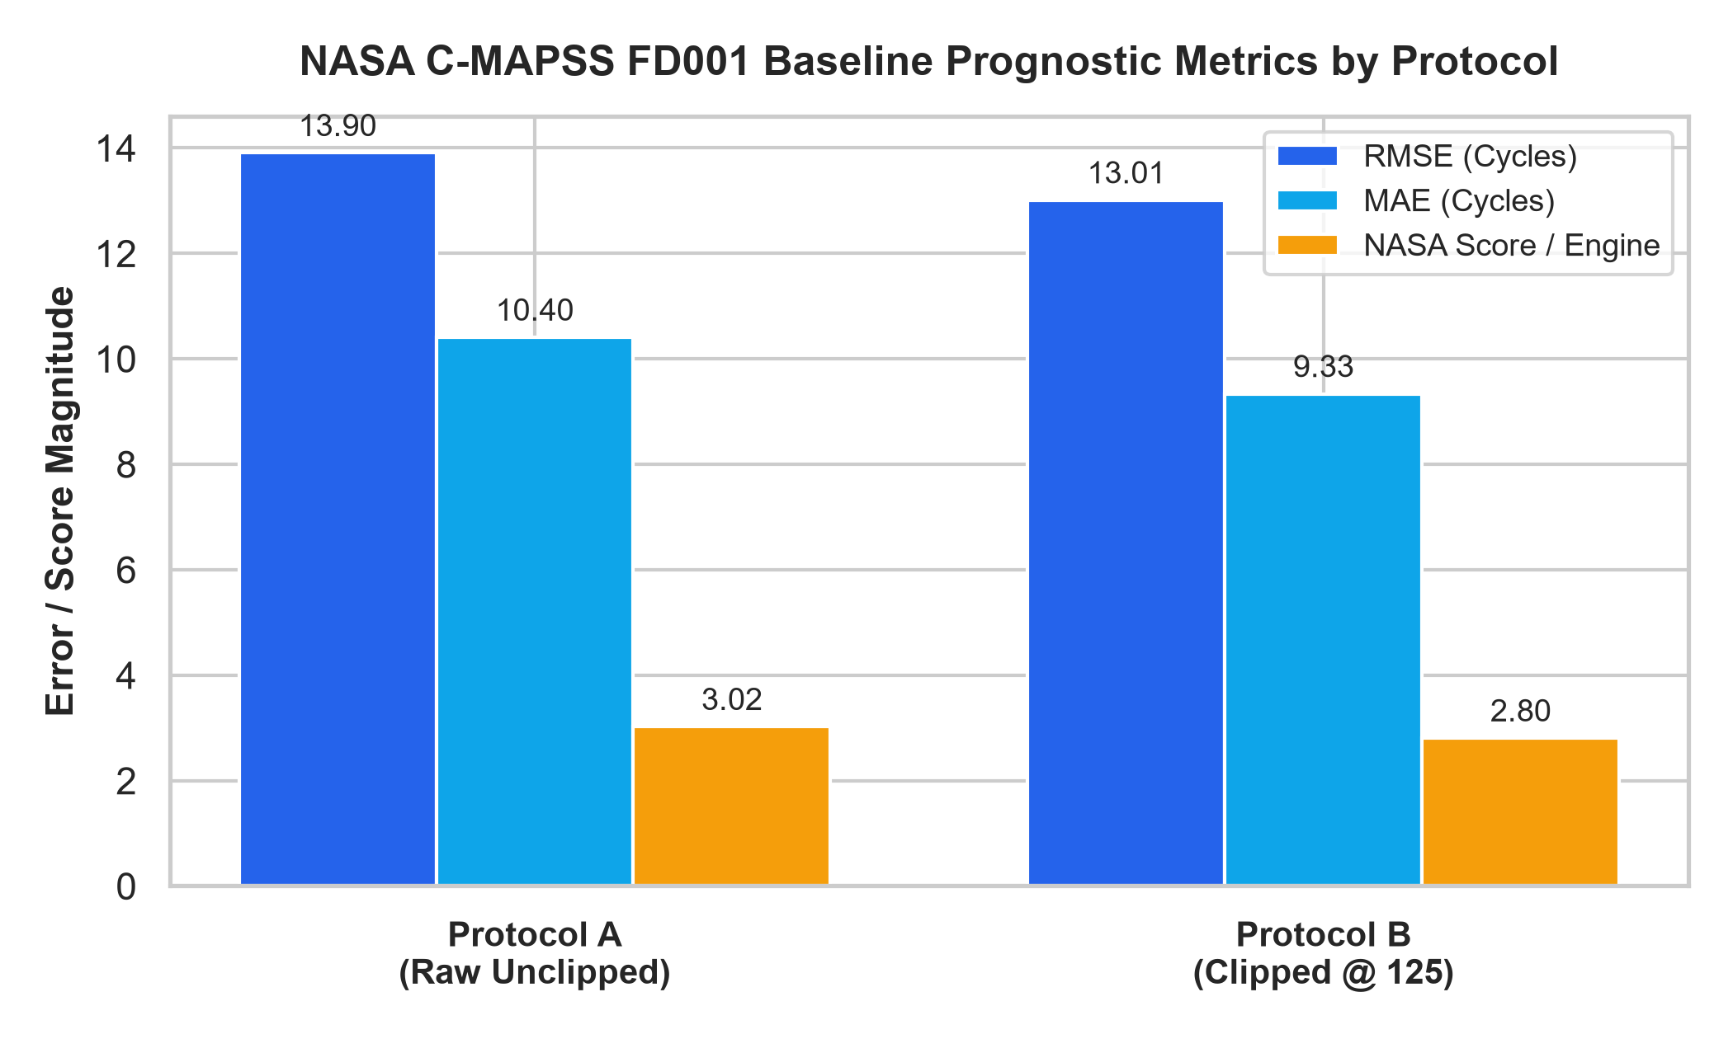
Fig. 1. Clean baseline evaluation under Protocol A (raw unclipped) vs. Protocol B (clipped at 125).
B. Sensor Manipulation Resilience & Evasion Dynamics
Table II presents verified empirical outcomes across all six sensor attack scenarios from sensor_attack_results.csv.
Scenario ID | Description | Shift | RMSE | MAE | NASA Score | HPR (%) | Disjoint Status
baseline | Clean Operational Baseline | 0.00c | 13.9044 | 10.4044 | 301.97 | 15.79% | stable (0 alerts)
sc1 | Step Bias (+1.0σ on S11) | -9.52c | 18.1647 | 13.5201 | 452.46 | 5.26% | warning (1 alert)
sc2 | Step Bias (+2.0σ on S11) | -12.07c | 20.4374 | 15.5462 | 577.97 | 5.26% | warning (1 alert)
sc3 | Negative Bias (-1.0σ on S11) | +5.16c | 15.7392 | 12.3014 | 433.13 | 31.58% | stable (0 alerts)
sc4 | Creeping Ramp (+2.0σ on S11) | -11.74c | 20.1812 | 15.3778 | 564.54 | 5.26% | warning (1 alert)
sc5 | Multi-Sensor Bias (+1.0σ) | -21.55c | 28.5856 | 21.8959 | 1673.13 | 0.00% | drift_alert (3 alerts)
sc6 | Frozen Replay (Cycle 40%) | +42.16c | 58.3342 | 45.9051 | 791,878.67 | 100.00% | drift_alert (3 alerts)
TABLE II: Sensor Manipulation Impact on Predictions and Drift Evasion (N = 100 Engines)

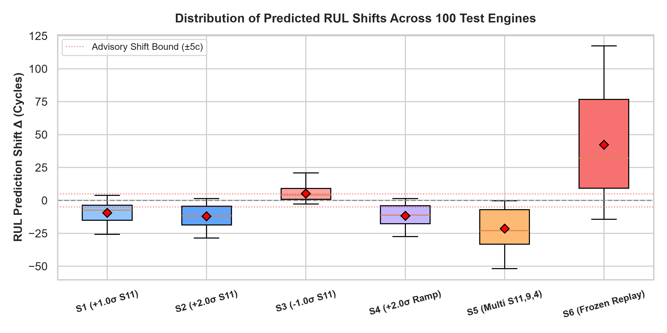
Fig. 2. RUL prediction shift and error distributions across six synthetic sensor attack scenarios.

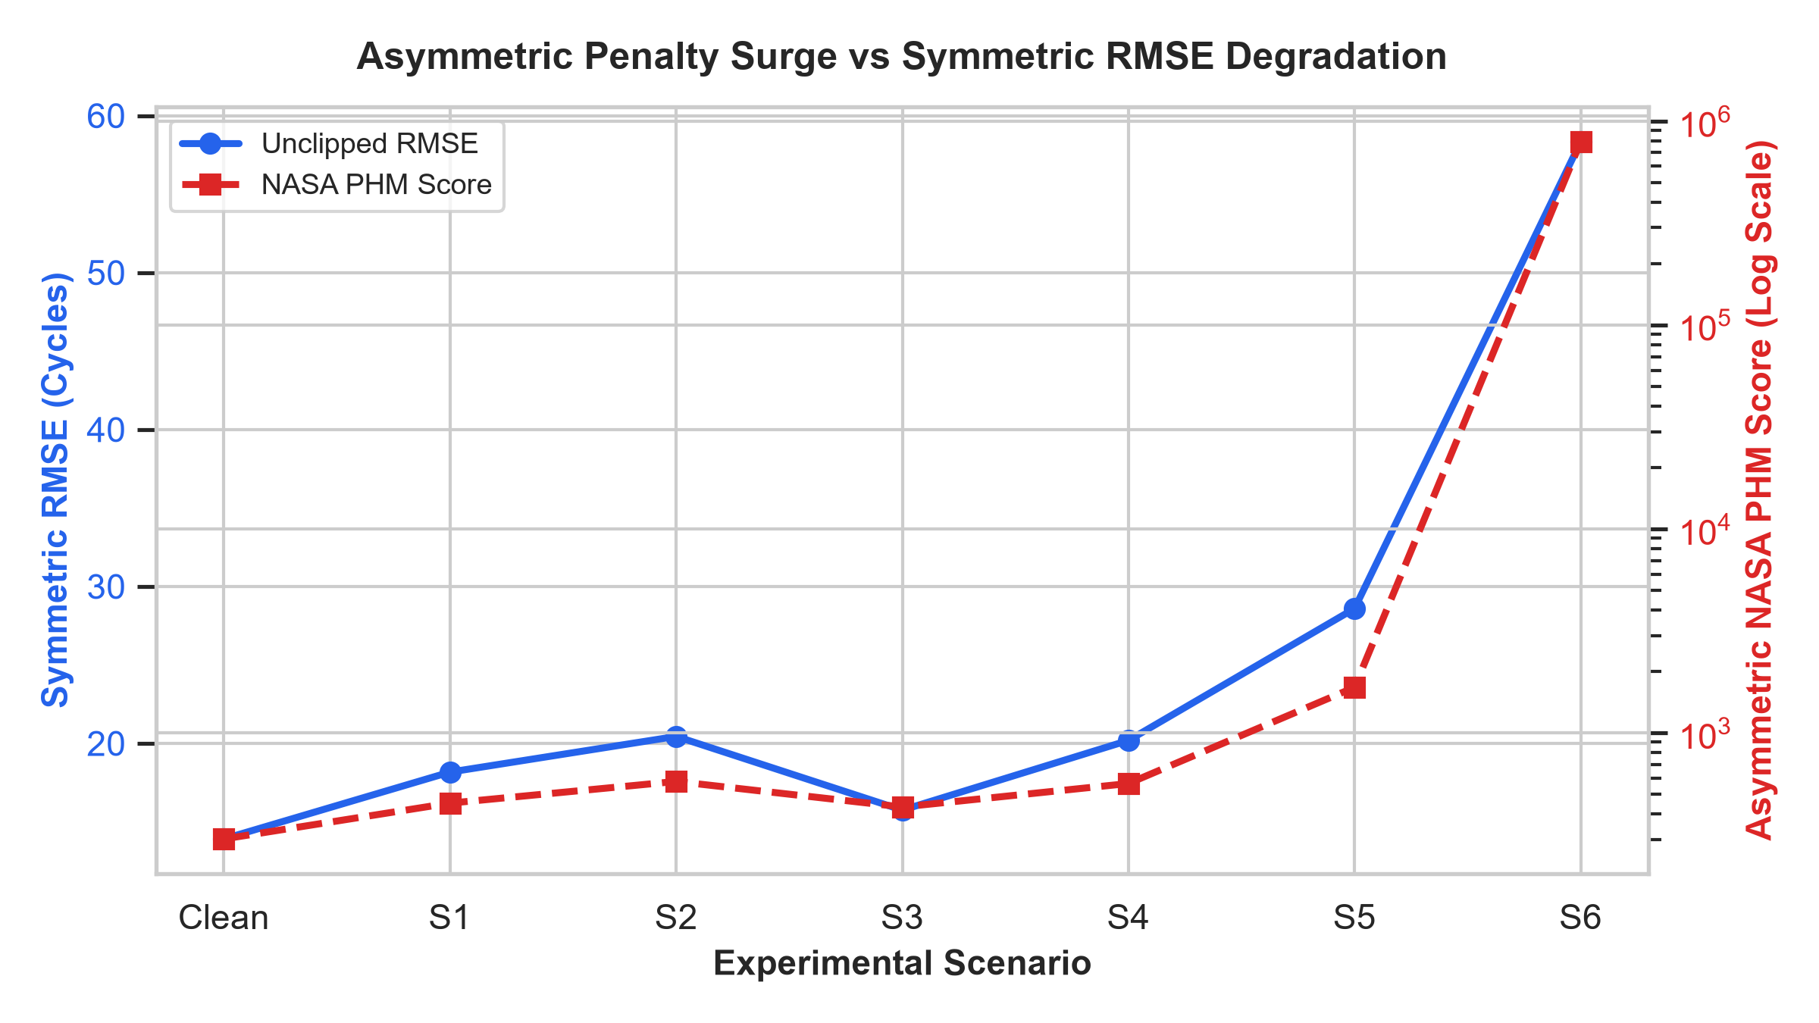
Fig. 3. Exponential surge in NASA asymmetric penalty scores under delayed prediction scenarios.

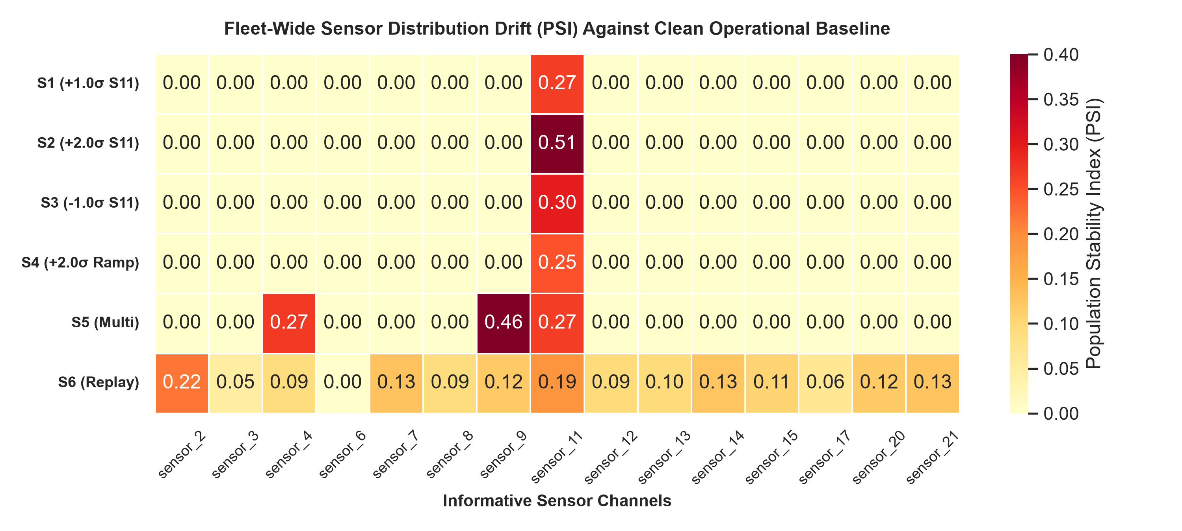
Fig. 4. Multi-channel Population Stability Index (PSI) heatmap demonstrating drift detector evasion.
C. Cryptographic Authentication & Tamper-Proofing Verification
Subjecting the Ed25519 verified loader to 12 distinct attack vectors confirmed 100% fail-closed enforcement: all altered artifact bytecodes, corrupted signatures, and foreign keys were strictly rejected, preventing unsafe joblib deserialization.
D. Computational Overhead & Latency Benchmarks
Microbenchmarks across N=100 independent trials confirm that pure Ed25519 signature verification requires only 0.13 ± 0.02 ms (median 0.11 ms), contributing less than 0.6% of the total 24.37 ms verified startup latency. Fleet batch inference for 100 engines executes in 1.34 ms (13.4 µs/engine), and full 15-sensor drift screening executes in 100.73 ms.
Pipeline Component | Mean (ms) | Std (ms) | Median (ms) | p95 (ms)
Ed25519 Signature Verification | 0.13 | 0.02 | 0.11 | 0.25
Multi-File SHA-256 Hashing (~20 MB) | 14.93 | 0.82 | 14.77 | 16.40
Model Deserialization (joblib.load) | 9.47 | 1.96 | 8.65 | 14.32
Total Verified Startup Pipeline | 24.37 | 1.45 | 23.90 | 26.71
Single-Engine Inference (1x122) | 1.39 | 0.44 | 1.16 | 2.43
Fleet Batch Inference (100x122) | 1.34 | 0.32 | 1.17 | 2.11
15-Sensor KS + PSI Drift Screening | 100.73 | 2.56 | 100.29 | 105.32
TABLE IV: Computational Latency Benchmarks Across Pipeline Stages (N = 100 Repetitions)

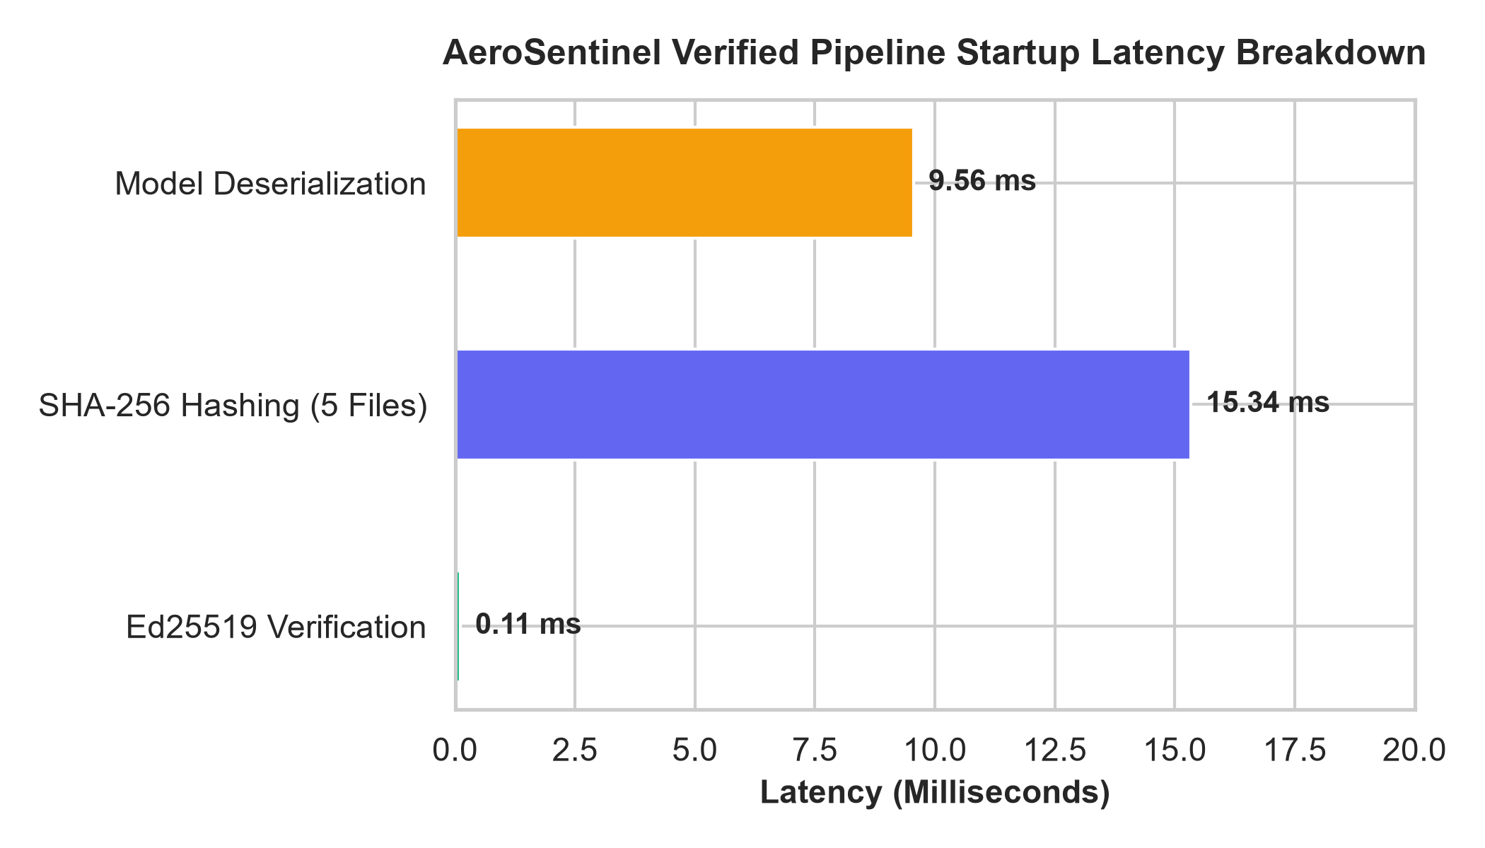
Fig. 5. Computational latency breakdown across pipeline stages (N = 100 repetitions).
VI. DISCUSSION, THREATS TO VALIDITY & LIMITATIONS
Our findings illustrate that statistical anomaly detectors calibrated for wide operational fleet tolerances exhibit inherent blind spots against stealthy perturbations. Adversaries can induce severe hazardous delays (doubling HPR to 31.58%) without crossing PSI alert thresholds. Consequently, predictive maintenance security requires end-to-end cryptographic integrity controls in tandem with physics-informed invariant checking.
Threats to validity include the synthetic nature of C-MAPSS simulation data, sea-level single-regime dynamics in FD001, and the advisory ground-side nature of the software, which is not an airborne certified flight-control computer.
VII. CONCLUSION & FUTURE WORK
This investigation evaluated integrity controls and sensor-manipulation resilience in a turbofan predictive maintenance pipeline using NASA C-MAPSS FD001. We resolved the run-to-failure censoring asymmetry via a disjoint operational reference baseline, demonstrated that single-channel sensor manipulations can evade fleet-level drift alarms while doubling the Hazardous Prediction Rate to 31.58%, and confirmed that Ed25519 cryptographic signing provides fail-closed artifact protection with negligible computational overhead (0.13 ms).
Future work will evaluate multi-regime envelopes (FD002/FD004) and integrate physics-informed neural network invariants.
DECLARATIONS & ACKNOWLEDGMENTS
The authors express gratitude to the NASA Ames Prognostics Center of Excellence. No external commercial funding was received. All reproducible artifacts, scripts, and cryptographic keys are available in the AeroSentinel repository.
REFERENCES
[1] Saxena, A., Goebel, K., Simon, D., & Eklund, N., "Damage Propagation Modeling for Aircraft Engine Run-to-Failure Simulation," Proc. IEEE Conf. on Prognostics and Health Management (PHM), 2008, doi: 10.1109/PHM.2008.4711414.
[2] Ramasso, E., & Saxena, A., "Performance Benchmarking and Analysis of Prognostic Methods for CMAPSS Datasets," International Journal of Prognostics and Health Management 5(2), 2014, doi: 10.36001/ijphm.2014.v5i2.2217.
[3] Zheng, S., Ristovski, K., Farahat, A., & Gupta, C., "Long Short-Term Memory Network for Remaining Useful Life Estimation," Proc. IEEE Conf. on Prognostics and Health Management (PHM), 2017, doi: 10.1109/ICPHM.2017.7998311.
[4] Gu, T., Dolan-Gavitt, B., & Garg, S., "BadNets: Identifying Vulnerabilities in the Machine Learning Model Supply Chain," IEEE Access 7, 2017, doi: 10.1109/ACCESS.2019.2923408.
[5] Bernstein, D. J., Duif, N., Lange, T., Schwabe, P., & Yang, B.-Y., "High-speed high-security signatures," Journal of Cryptographic Engineering 2(2), 2012, doi: 10.1007/s13389-012-0027-1.
[6] NIST (National Institute of Standards and Technology), "Secure Software Development Framework (SSDF) Version 1.1: Recommendations for Mitigating the Risk of Software Supply Chain Attacks," NIST Special Publication 800-218, 2022, doi: 10.6028/NIST.SP.800-218.
[7] Fawaz, H. I., Forestier, G., Weber, J., Idoumghar, L., & Muller, P.-A., "Adversarial Attacks on Deep Neural Networks for Time Series Classification," Proc. IEEE International Joint Conference on Neural Networks (IJCNN), 2019, doi: 10.1109/IJCNN.2019.8851936.
[8] Karim, F., Majumdar, S., & Darabi, H., "Adversarial Attacks on Time Series," IEEE Access 8, 2020, doi: 10.1109/ACCESS.2020.2980424.
[9] Rabanser, S., Günnemann, S., & Lipton, Z. C., "Failing Loudly: An Empirical Study of Methods for Detecting Dataset Shift," Advances in Neural Information Processing Systems (NeurIPS 32), 2019, doi: 10.48550/arXiv.1810.11953.
[10] Siddiqi, N., "Credit Risk Scorecards: Developing and Implementing Intelligent Credit Scoring," John Wiley & Sons, 2006, doi: 10.1002/9781119201731.
[11] Massey, F. J., "The Kolmogorov-Smirnov Test for Goodness of Fit," Journal of the American Statistical Association 46(253), 1951, doi: 10.1080/01621459.1951.10500769.
[12] Mo, Y., Chabukswar, R., & Sinopoli, B., "Detecting Integrity Attacks on Cyber-Physical Systems," IEEE Transactions on Control Systems Technology 22(4), 2014, doi: 10.1109/TCST.2013.2280899.
[13] OWASP Foundation, "OWASP API Security Top 10 2023," OWASP Foundation, 2023. [Online]. Available: https://owasp.org/www-project-api-security/

