EESTI INFOTEHNOLOOGIA KOLLEDŽ

Siim Talvik
10128891 ja A31

Praktikum IV

Digitaalloogika ja –süsteemid
Praktikumi aruanne

Esitatud: 28.10.2015

Ülesande lahenduskäik ja selgitus
Ülesandeks oli luua VHDL programmeerimiskeeles multipleksori abiga mitme tehtega ALU.
Alu on Aritmeetika–loogikaplokk.(arithmetic and logic unit).
Multipleksor võimaldab Ühe ja sama ALU puhul selekteerida erinevaid tehteid.
Alustuseks lõin ühe tavalise testpingi ja entity. Seal arendasin välja multipleksori implementatsiooni ja testisin seda. Seejärel abstrakteerisin Multipleksori eraldi komponendiks.
Edasi Lõin 4 tühja komponenti kuhu hakkasin ette antud arvutusi asetama ja ühendasin iga komponendi ALU ja testpingiga.
Iga komponenti luues lisasin testpinki sisend väärtuseid ja kontrollisin tulemusi.

Programmikood

Alu TestBench
LIBRARY ieee;
USE ieee.std_logic_1164.ALL;
use ieee.numeric_std.all; --just in case library
use ieee.std_logic_arith.all; --just in case library

ENTITY ALU_TB IS --entity of the testbench is always empty
END ALU_TB;

ARCHITECTURE behavior OF ALU_TB IS

-- Component Declaration for the Unit Under Test (UUT)
component ALU is
Port ( a : in STD_LOGIC_VECTOR (3 downto 0); --4 bit input
b : in STD_LOGIC_VECTOR (3 downto 0); -- 4 bit input
op : in STD_LOGIC_VECTOR (1 downto 0); --1 downto 0
o : out STD_LOGIC_VECTOR (3 downto 0)); --4 bit output
end component;

--Inputs from the testbench
signal a_tb : std_logic_vector(3 downto 0) := (others => '0');
signal b_tb : std_logic_vector(3 downto 0) := (others => '0');
signal op_tb : std_logic_vector(1 downto 0) := (others => '0');

--Output from the testbench
signal o_tb : std_logic_vector(3 downto 0);

begin
--component port map
uut: ALU PORT MAP (
a => a_tb,
b => b_tb,
op => op_tb,
o => o_tb
);
--write your testbench behaviour here
Stimulus: process
begin
a_tb <= "0000" after 0ns, "0001" after 5ns,
"0000" after 10ns, "0001" after 15ns,
"0000" after 20ns, "0101" after 25ns,
"0000" after 30ns, "1010" after 35ns,
"UUUU" after 40ns;
b_tb <= "0000" after 0ns, "0001" after 5ns,
"UUUU" after 10ns, "UUUU" after 15ns, --b is not used
"UUUU" after 20ns, "UUUU" after 25ns, --b is not used
"0000" after 30ns, "0101" after 35ns,
"UUUU" after 40ns;
op_tb <= "00" after 0ns, "01" after 10ns, "10" after 20ns, "11" after 30ns, "UU" after 40ns;

wait; --Suspend
end process Stimulus;

end behavior;

MultiPleksor
library IEEE;
use IEEE.STD_LOGIC_1164.ALL;

entity MUX is
Port ( a : in STD_LOGIC_VECTOR (3 downto 0); --4 bit input
b : in STD_LOGIC_VECTOR (3 downto 0); -- 4 bit input
c : in STD_LOGIC_VECTOR (3 downto 0); -- 4 bit input
d : in STD_LOGIC_VECTOR (3 downto 0); -- 4 bit input
op : in STD_LOGIC_VECTOR (1 downto 0); --2 bit input
o : out STD_LOGIC_VECTOR (3 downto 0)); --4 bit output
end MUX;

architecture RTL of MUX is

--declare components and inner signals here if needed

begin --beginning of the architecture
proc: process ( a, b, c, d, op ) begin
case op is
when "00" =>
o <= a;
when "01" =>
o <= b;
when "10" =>
o <= c;
when "11" =>
o <= d;
end case;
end process proc;
end RTL;

Esimene Funktsioon: A + B (aritmeetiline liitmine)
-- func_one.vhd created on 0:59 2015.9.28

library IEEE;
use IEEE.STD_LOGIC_1164.ALL;
use IEEE.std_logic_unsigned.all;

entity func_one is Port (
a : in STD_LOGIC_VECTOR (3 downto 0); --4 bit input
b : in STD_LOGIC_VECTOR (3 downto 0); -- 4 bit input
o : out STD_LOGIC_VECTOR (3 downto 0)); --4 bit output
end func_one;

architecture mixed of func_one is

--declare components and inner signals here if needed

begin --beginning of the architecture
o <= a+b;
end mixed;

Teine Funtksioon: shl A (nihe vasakule)
-- func_two.vhdl created on 1:16 2015.9.28

library IEEE;
use IEEE.STD_LOGIC_1164.ALL;

entity func_two is Port (
a : in STD_LOGIC_VECTOR (3 downto 0); --4 bit input
o : out STD_LOGIC_VECTOR (3 downto 0)); --4 bit output
end func_two;

architecture mixed of func_two is

--declare components and inner signals here if needed

begin --beginning of the architecture
o <= a(2) & a(1) & a(0) & '0';
end mixed;

Kolmas Funktsioon: inv A (inverteerida A väärtus)
-- func_three.vhdl created on 1:16 2015.9.28

library IEEE;
use IEEE.STD_LOGIC_1164.ALL;

entity func_three is Port (
a : in STD_LOGIC_VECTOR (3 downto 0); --4 bit input
o : out STD_LOGIC_VECTOR (3 downto 0)); --4 bit output
end func_three;

architecture mixed of func_three is

--declare components and inner signals here if needed

begin --beginning of the architecture
o <= not a;
end mixed;

Neljas Funktsioon: A xor B
-- func_four.vhdl created on 1:16 2015.9.28

library IEEE;
use IEEE.STD_LOGIC_1164.ALL;

entity func_four is Port (
a : in STD_LOGIC_VECTOR (3 downto 0); --4 bit input
b : in STD_LOGIC_VECTOR (3 downto 0); --4 bit input
o : out STD_LOGIC_VECTOR (3 downto 0)); --4 bit output
end func_four;

architecture mixed of func_four is

--declare components and inner signals here if needed

begin --beginning of the architecture
o <= a xor b;
end mixed;

Alu(Kõik koos)
library IEEE;
use IEEE.STD_LOGIC_1164.ALL;

entity ALU is --do not change entity, it must match testbench component
Port ( a : in STD_LOGIC_VECTOR (3 downto 0); --4 bit input
b : in STD_LOGIC_VECTOR (3 downto 0); -- 4 bit input
op : in STD_LOGIC_VECTOR (1 downto 0); --2 bit input
o : out STD_LOGIC_VECTOR (3 downto 0)); --4 bit output
end ALU;

architecture mixed of ALU is

component MUX is Port (
a : in STD_LOGIC_VECTOR (3 downto 0); --4 bit input
b : in STD_LOGIC_VECTOR (3 downto 0); -- 4 bit input
c : in STD_LOGIC_VECTOR (3 downto 0); -- 4 bit input
d : in STD_LOGIC_VECTOR (3 downto 0); -- 4 bit input
op : in STD_LOGIC_VECTOR (1 downto 0); --2 bit input
o : out STD_LOGIC_VECTOR (3 downto 0)); --4 bit output
end component MUX;

--declare components and inner signals here if needed

signal f1, f2, f3, f4 : STD_LOGIC_VECTOR (3 downto 0);

begin --beginning of the architecture

func_1 : func_one port map(
a => a,
b => b,
o => f1
);

func_2 : func_two port map(
a => a,
o => f2
);

func_3 : func_three port map(
a => a,
o => f3
);

func_4 : func_four port map(
a => a,
b => b,
o => f4
);

mux_1 : MUX port map(
a=> f1,
b=> f2,
c=> f3,
d=> f4,
op=> op,
o=> o
);

end mixed;

Tulemused
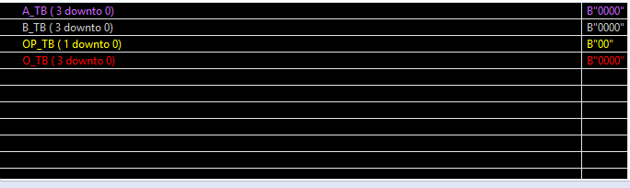Joonis 1: testpingi Signaali Definitsioonid
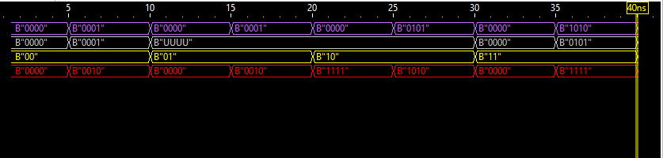Joonis 2: Testpingi tulemused

A(4bit), B(4bit) ja OP(2bit) on testimisel sisenditeks.
O(4bit) on testimisel väljundiks.
OP'ga valitakse millist funtktsiooni neljast parasjagu kasutada.
Testimisel valisin 5ns ajaliseks tsükliks. Niimoodi jäi igale funktsioonile 10ns ja igale testile 5ns.
- Funktsioon: A + B (aritmeetiline liitmine)
- Funktsioon: shl A (nihe vasakule)
- Funktsioon: inv A (inverteerida A väärtus)
- Funktsioon: A xor B

Teise ja kolmanda funktsiooni puhul kasutatakse ainult Ühte sisendit, seega on teine sisend(B) UUUU ehk undefined.

Kokkuvõte
Jõudsin lahenduse käigus soovitud tulemuseni. Nii koodi lihtsuse, kui ka arvutuslike tulemusteni.
Saadud tulemused vastavad ülesande püstiusele:
- ALU on implementeeritud struktuurselt, viie erineva komponendi baasil.
- Testpink on implementeeritud nii et iga funktsioon saaks vähemalt kaks korda testitud. Korra sisendiga '0000'(summeerides nulle) ja teine kord tavalise tehtena.
- Testpingis implementeeritud testid näitavad, et programm töötab nii nagu peaks.

