**Cloud Deployment Models Lab**



Name : Ayush Chaurasiya

Batch : B7

Sap ID : 500107811

Roll No: R2142221037

**Lab-4**

Deploying and Configuring EC2 Instances with EBS Volumes and Database Installation

**Prerequisite: Install AWS CLI Tools**

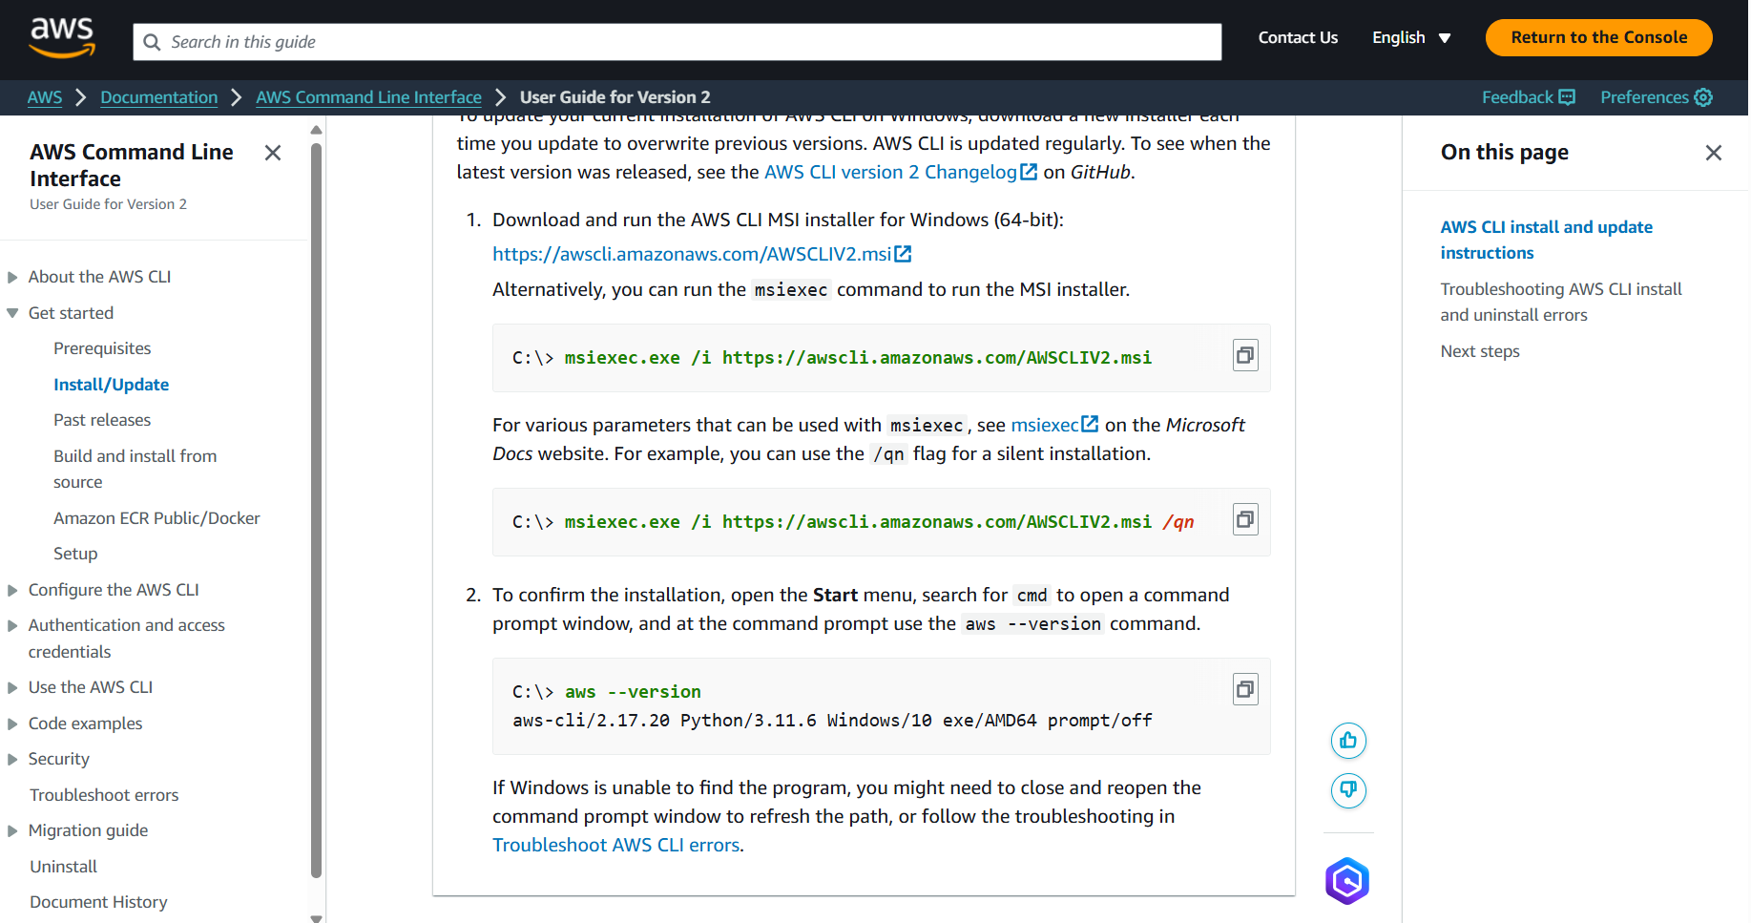 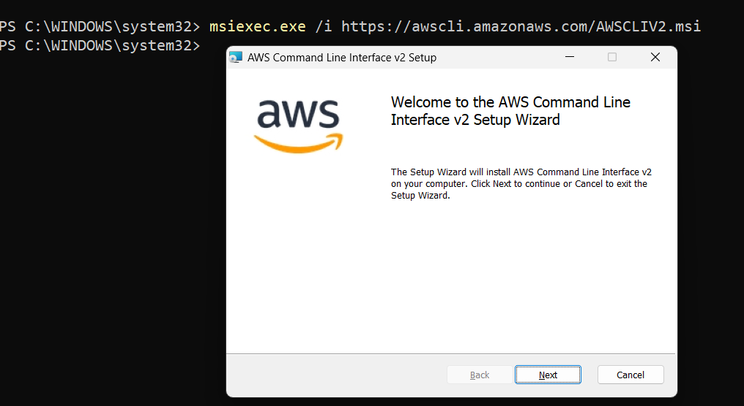

**Configure AWS account in the terminal**

**Step 1: Launch 2 EC2 Instances**

1. Open a terminal on your local machine.
2. Launch the first EC2 instance using the AWS CLI

*aws ec2 run-instances `*

*--image-id ami-0e86e20dae9224db8 `*

*--instance-type t2.micro `*

*--key-name "myKeyPair" `*

*--security-groups "default" `*

*--count 1 `*

*--tag-specifications 'ResourceType=instance,Tags=[{Key=Name,Value=EC2Instance1}]'*

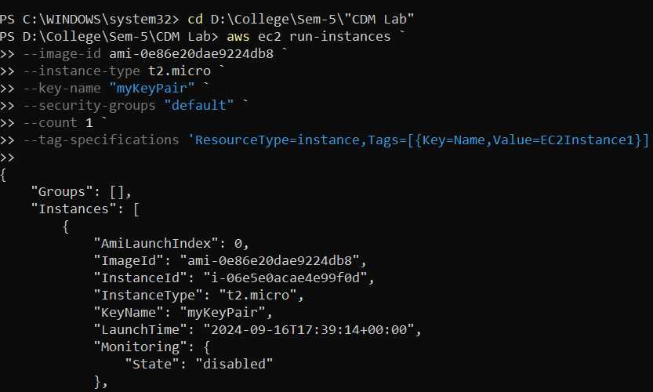

1. Verify the instances are running
2. Repeat the command for the second instance by modifying the tag name for each

**Step 2: Create and Attach EBS Volumes**

1. 1. Create the first EBS volume

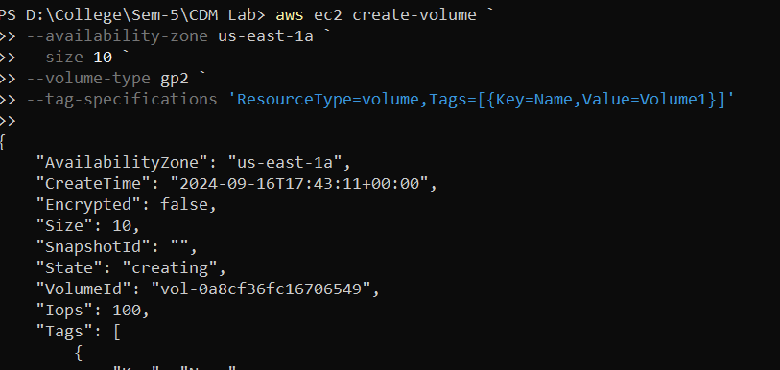

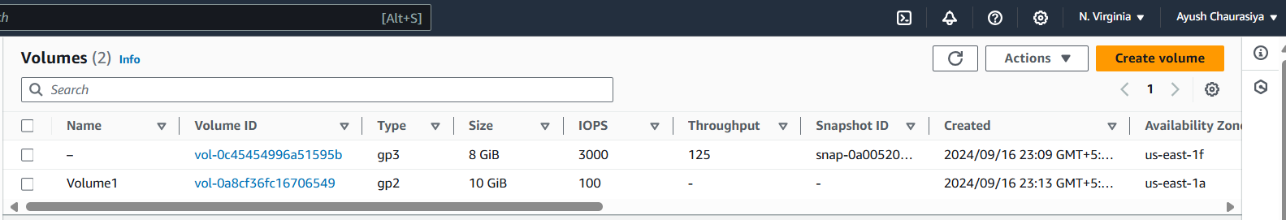

1. Attach the first EBS volume to the first EC2 instance

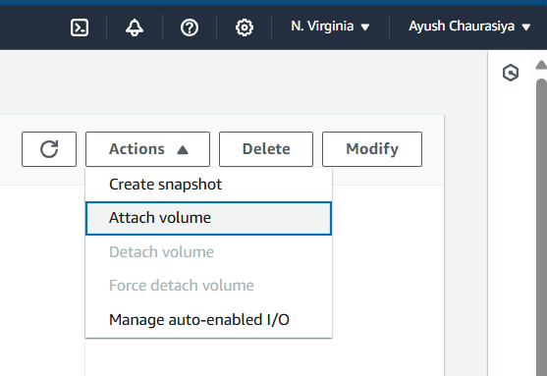 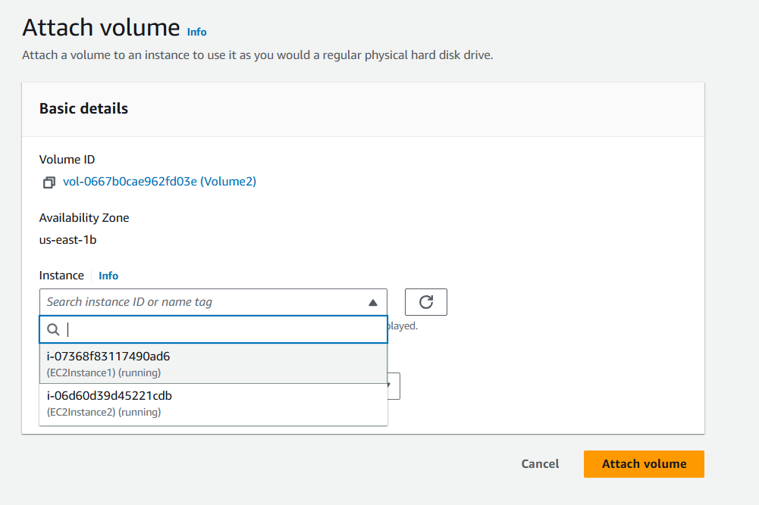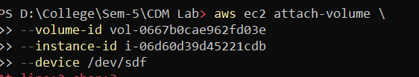

**Step 3: Install SQL Database on EC2 Instance**

1. SSH into the first EC2 instance:

*ssh -i "MyKeyPair.pem" ec2-user@<PublicIP_of_EC2Instance1>*

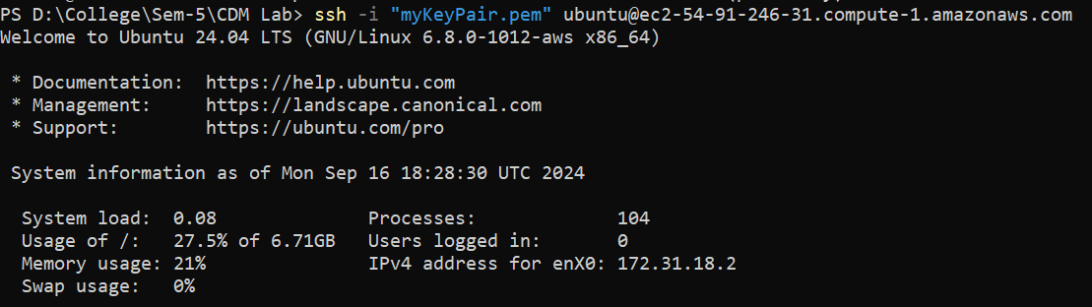

1. Update the package index:

*sudo apt update*

*sudo apt upgrade -y*

1. Install MySQL (or another database of your choice):

*sudo apt install mysql-server -y*

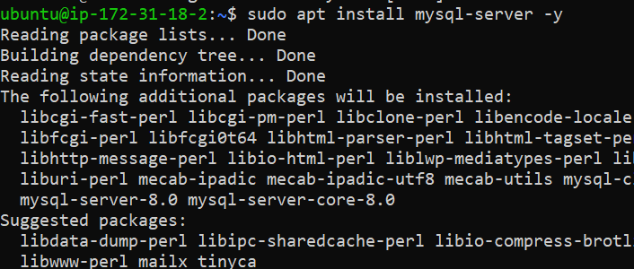

1. Start the MySQL service:

*sudo systemctl start mysqld*

**Step 4: Repeat the entire process for another instance**