Assignment_3

**Sol_2:**

Step 1: First I opened the xv6 OS file directory and searched for ls.c source code.

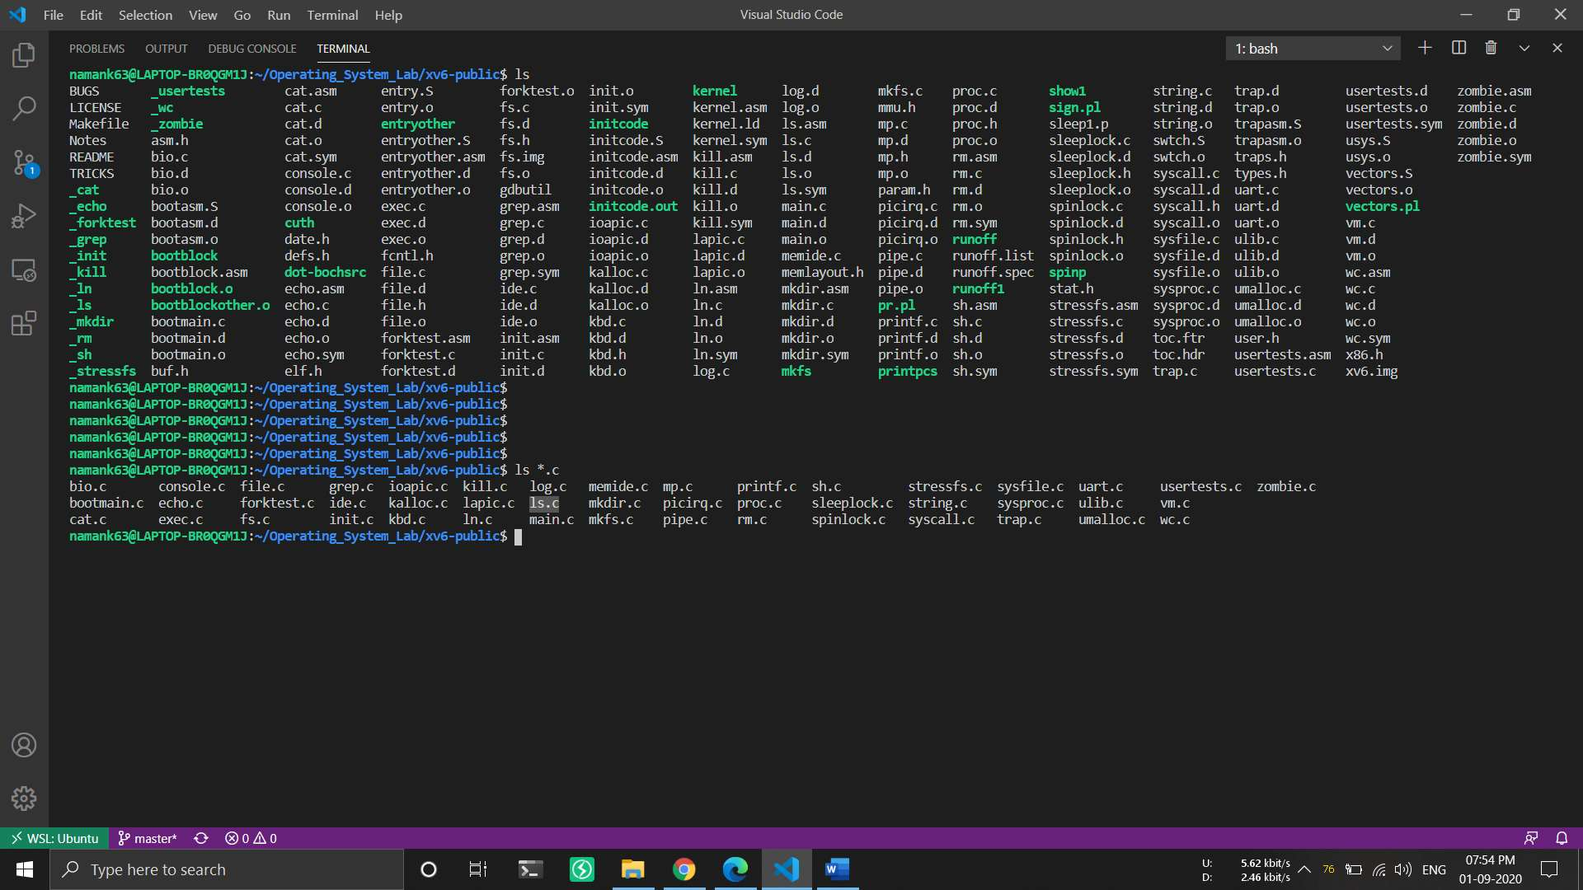

Step 2: I found the source code and observed that the second column is the printing type of file(line 48 and 68).

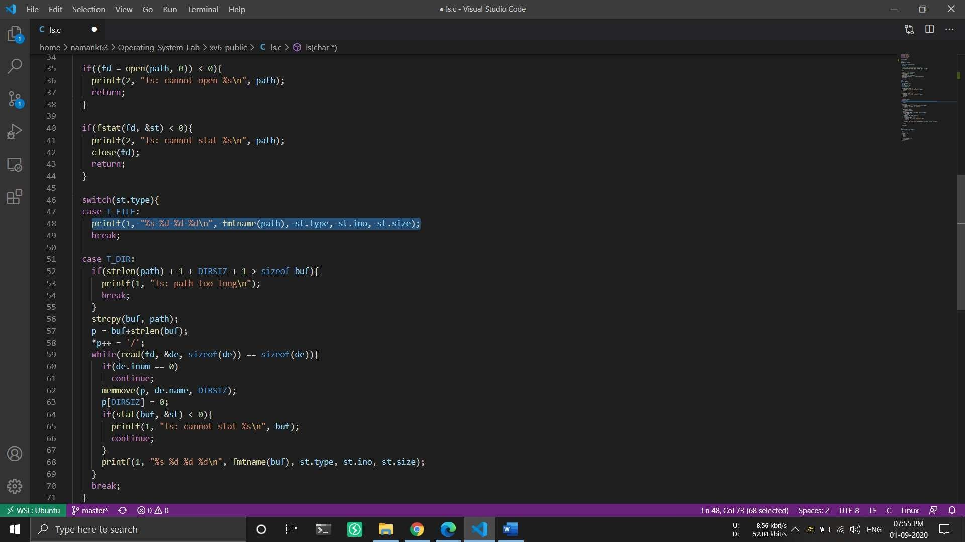

Step 3: Then I observed that st.type is used for knowing the file type and struct stat is used for defining file type.

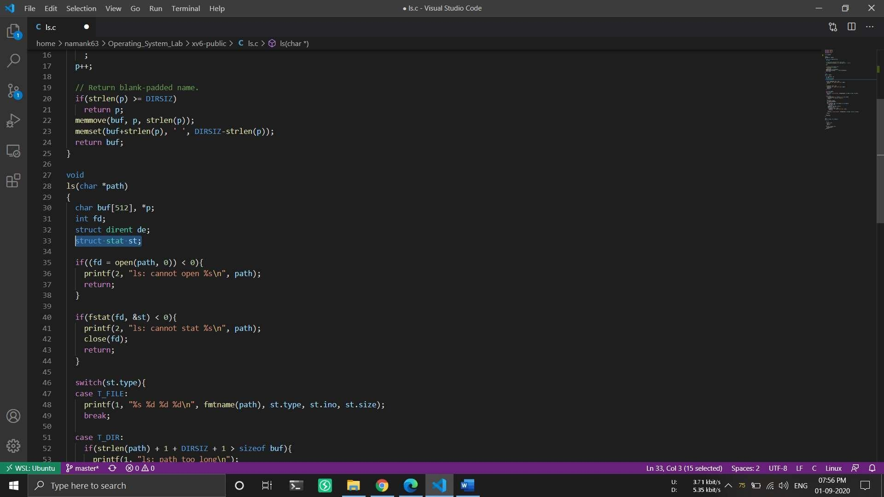

Step 4: I opened the stat.h header file and saw that 1 stand for directory, 2 stands for file and 3 stands for device.

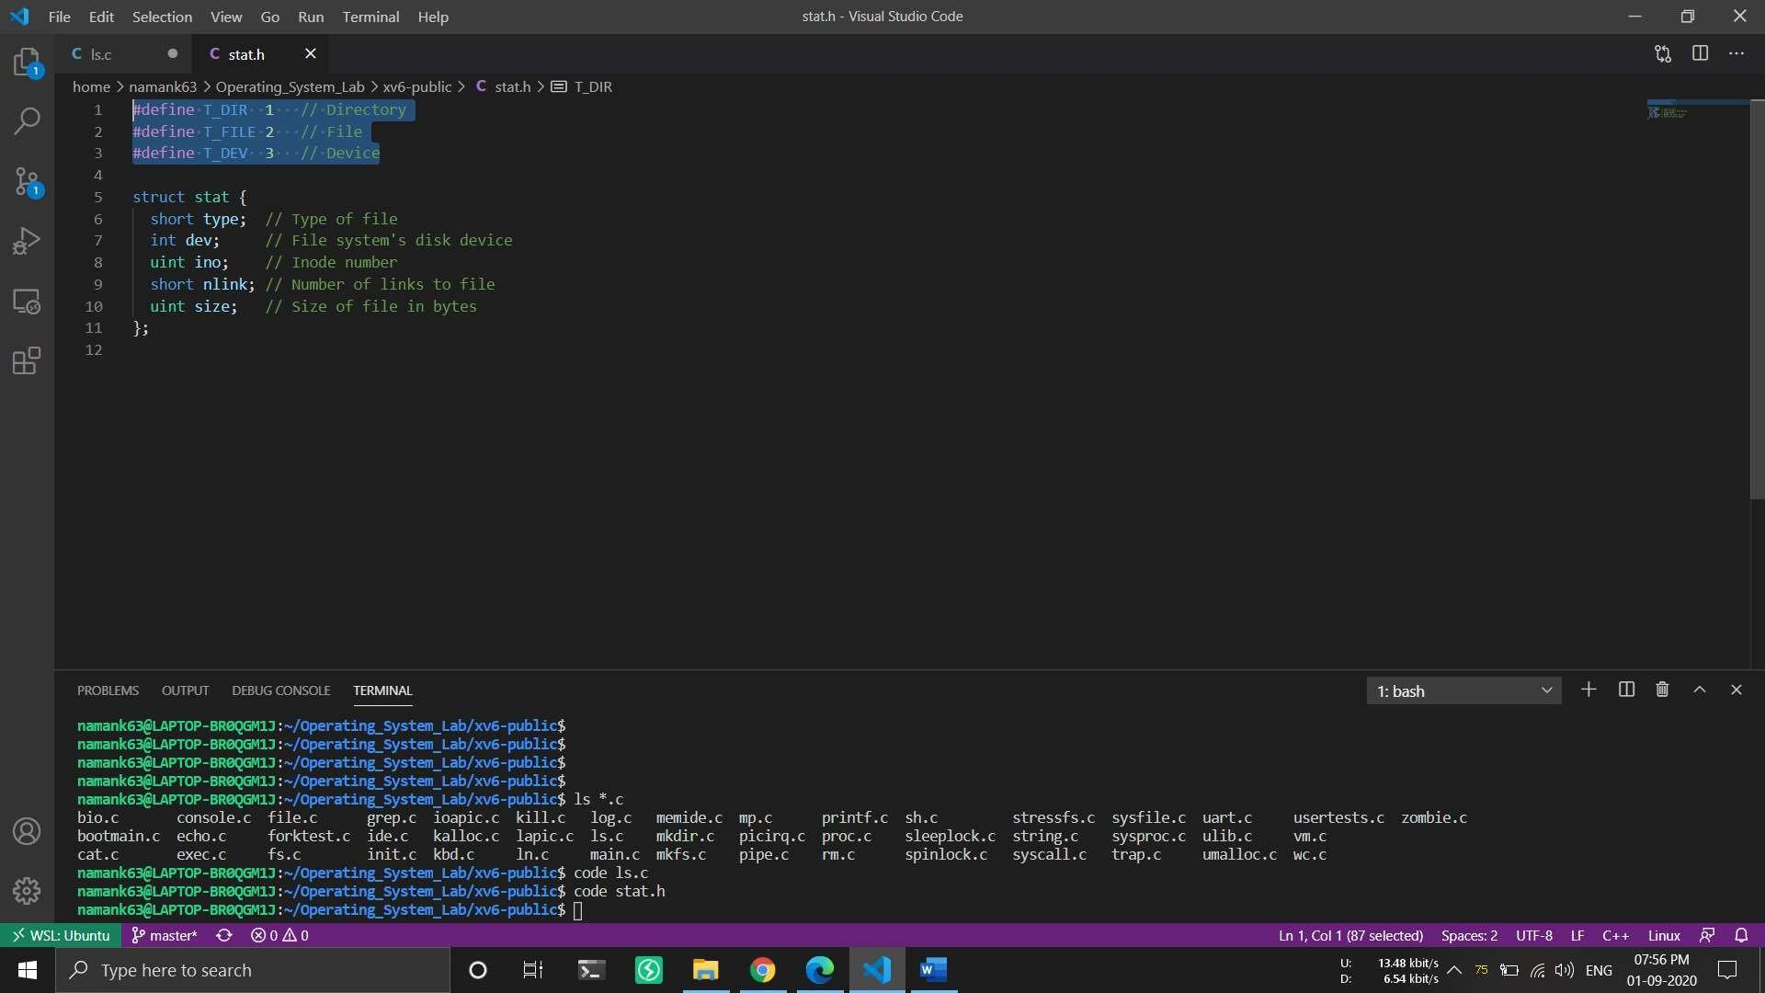

Step 5: After knowing all these, first I change the file permission of ls.c so that I can make changes in it.

Step 6: I open the ls.c source code and make a char *output variable, then before printing st.type I check if it is 1 I make output as directory if it is 2 I make output as file and for 3 I use device (line 6, 48 – 54 and 74 - 80).

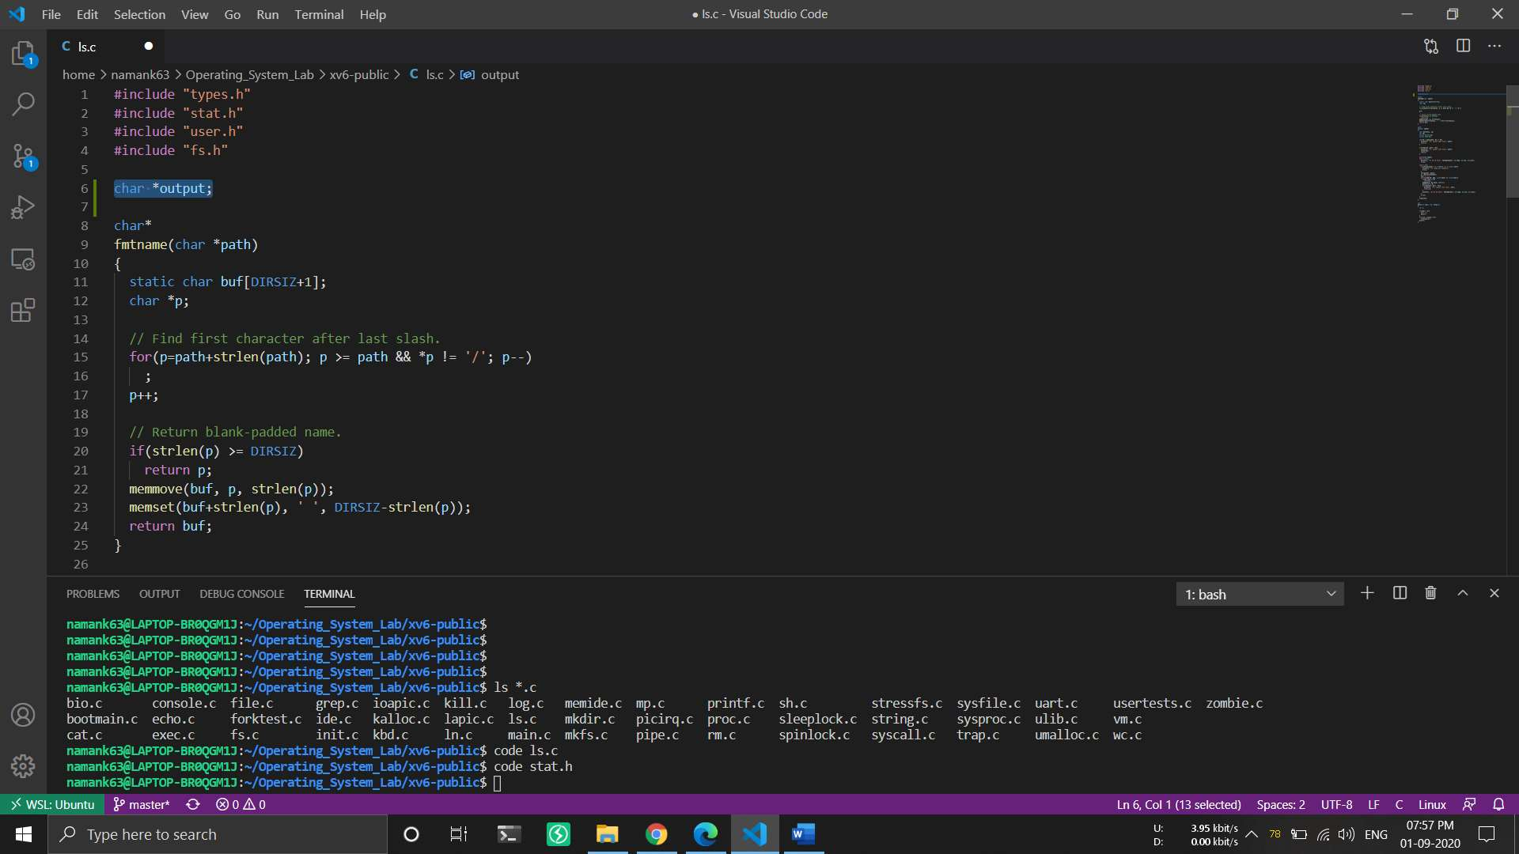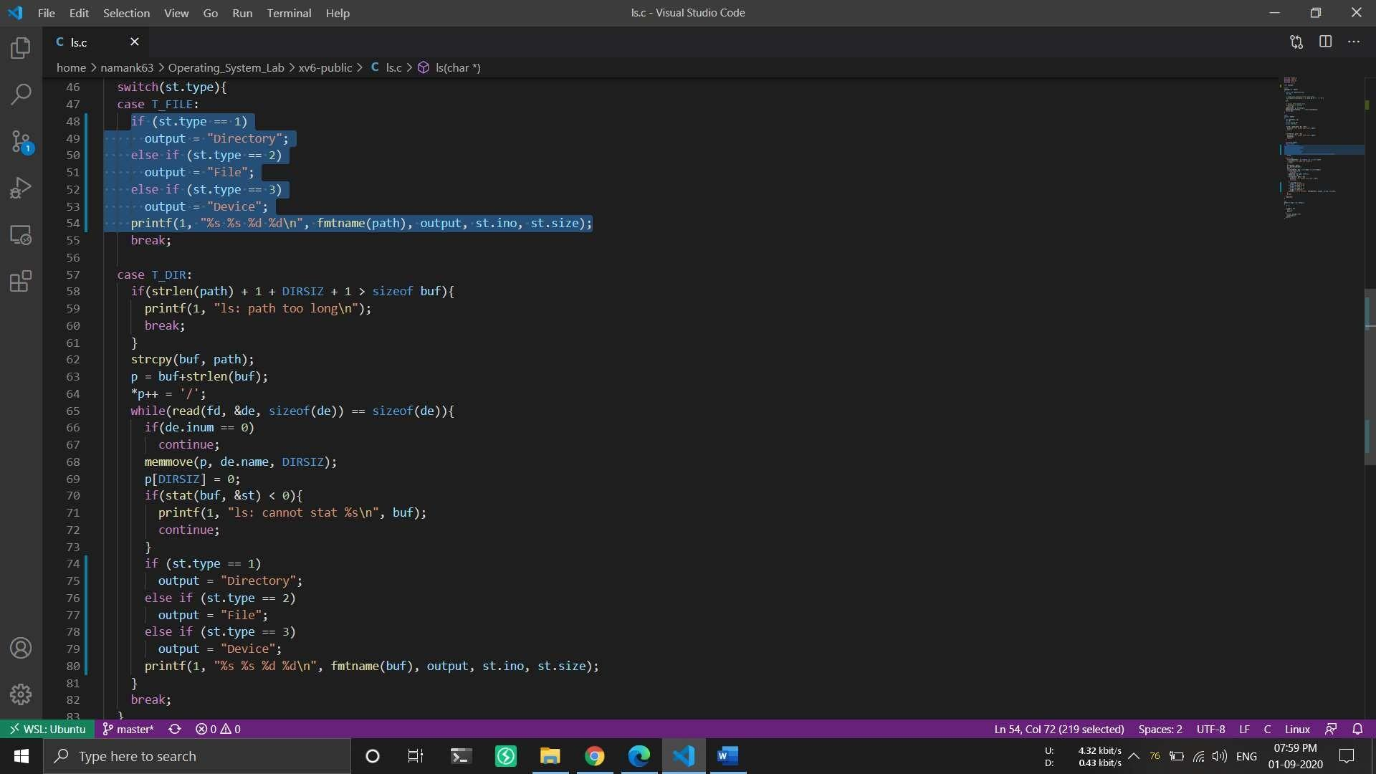

Step 7: Then I saved it and ran sudo make command.

Step 8: After that I run sudo make qemu-nox to run the OS and now when I run ls it shows more user friendly output.