Programs

1.Write a program to print “Hello” on screen.

#include <iostream>
using namespace std;
int main()
{
cout<<"Hello"<<endl;
cout<<"Coded by : Simran"<<endl;
return 0;
}
Output:

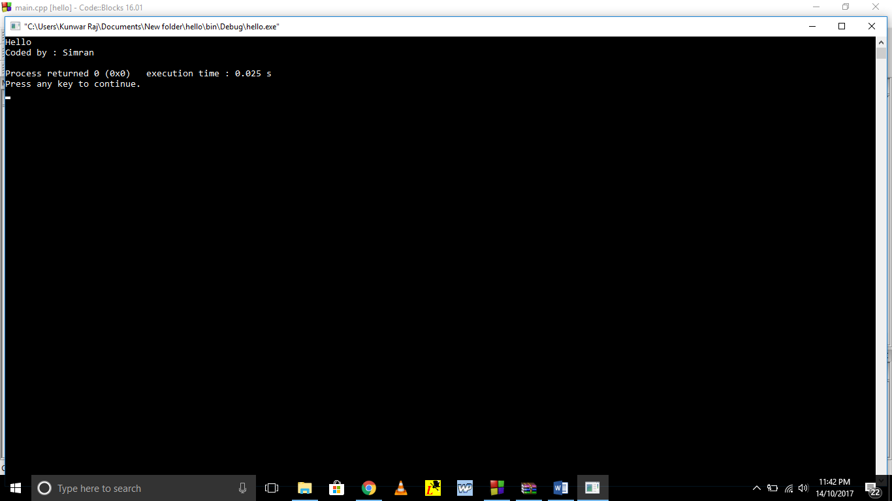
Figure.1

2.Write a program to calculate average of two numbers.

#include <iostream>
using namespace std;
int main()
{
int a,b,avg;
cout<<"Enter two numbers:";
cin>>a>>b;
avg=(a+b)/2;
cout<<"The average of two numbers:"<<avg<<endl;
cout<<"Coded by : Simran"<<endl;
return 0;
}
Output:

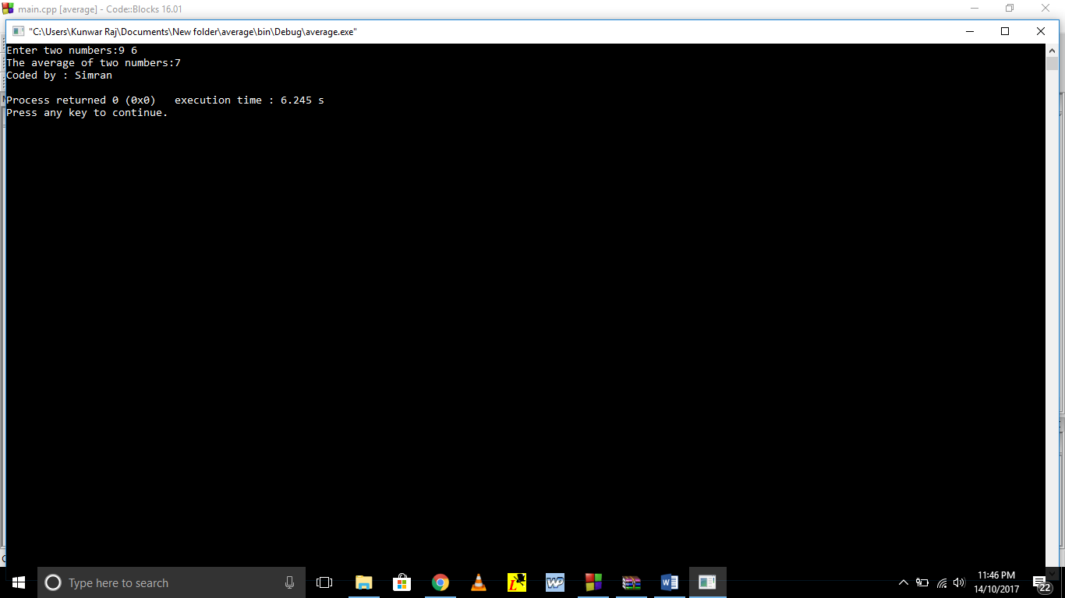
Figure.2

3. Write a program to illustrate the concept of class.

#include <iostream>
using namespace std;
class myclass
{
private:
int a,b,sum;
public:
void input()
{
cout<<"Enter two number:"<<endl;
cin>>a>>b;
}
void cal()
{
sum=a+b;
}
void display()
{
cout<<"Sum of two number is :"<<sum<<endl;
}
};
int main()
{
myclass obj;
obj.input();
obj.cal();
obj.display();
cout<<"Coded by : Simran"<<endl;
return 0;
}
Output:

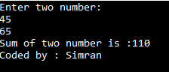
Figure.3

4.Write a program to input a character from keyboard and display corresponding ASCII value.

#include <iostream>
using namespace std;
int main()
{
char a;
cout<<"Enter any character:";
cin>>a;
cout<<"The ASCII code for this character is:"<<int(a)<<endl;
cout<<"Coded by : Simran"<<endl;
return 0;
}
Output:

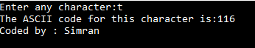
Figure.4

5.Write a program to check number is even or odd.

#include <iostream>
using namespace std;
int main()
{
int num;
cout<<"Enter any number:";
cin>>num;
if(num%2==0)
cout<<"Number is EVEN"<<endl;
else
cout<<"Number is ODD"<<endl;
cout<<"Coded by : Simran"<<endl;
return 0;
}
Output:

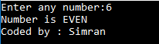
Figure.5

6.Write a program to swap two numbers using third variable.

#include <iostream>
using namespace std;
int main()
{
int a,b,c;
cout<<"Enter two numbers:\n";
cin>>a>>b;
c=a;
a=b;
b=c;
cout<<"After swapping numbers are:\n"<<a<<endl<<b<<endl;
cout<<"Coded by : Simran"<<endl;
return 0;
}
Output:

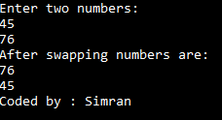
Figure.6

7.Write a program to swap two numbers without using third variable.

#include <iostream>
using namespace std;
int main()
{
int a,b;
cout<<"Enter two numbers:"<<endl;
cin>>a>>b;
a=a+b;
b=a-b;
a=a-b;
cout<<"After swapping numbers are:\n"<<a<<endl<<b<<endl;
cout<<"Coded by : Simran"<<endl;
return 0;
}
Output:

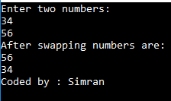
Figure.7

8.Write a program to convert the temperature from Fahrenheit to celcius.

#include <iostream>
using namespace std;
int main()
{
int tempf,tempc;
cout<<"Enter temperature in Fahrenheit:";
cin>>tempf;
tempc=((tempf-32)*5)/9;
cout<<"The temperature in Celsius:"<<tempc<<endl;
cout<<"Coded by : Simran"<<endl;
return 0;
}
Output:

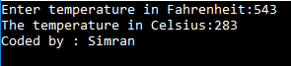
Figure.8

9.Write a program to illustrate the use of structure.

#include <iostream>
using namespace std;
struct student
{
char name[20];
int rollno;
float percentage;
}s;
int main()
{
cout<<"Enter name of student:";
cin>>s.name;
cout<<"Enter roll number of student:";
cin>>s.rollno;
cout<<"Enter percentage of student:";
cin>>s.percentage;
cout<<"The record of student is :";
cout<<endl<<"NAME\tROLL NO.\tPERCENTAGE"<<endl;
cout<<endl<<s.name<<"\t"<<s.rollno<<"\t\t"<<s.percentage<<endl;
cout<<endl<<"Coded by :Simran"<<endl;
return 0;
}
Output:

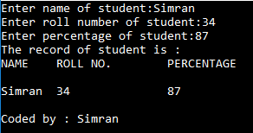
Figure.9

10.Write a program to illustrate the concept of structure and union.

#include <iostream>
using namespace std;
struct student
{
char name[20];
int rollno;
float standard;
}s;
union monitor
{
int batchno;
float percentage;
}u;
int main()
{
cout<<"Enter the name:";
cin>>s.name;
cout<<"Enter the roll number:";
cin>>s.rollno;
cout<<"Enter the standard:";
cin>>s.standard;
cout<<"Enter batch number of monitor:";
cin>>u.batchno;
cout<<"Enter the percentage of monitor:";
cin>>u.percentage;
cout<<"Record is:"<<endl;
cout<<"Name:"<<s.name<<endl<<"Roll No:"<<s.rollno<<endl;
cout<<"Standard:"<<s.standard<<endl<<"Batch number"<<u.batchno<<endl;
cout<<"Percentage:"<<u.percentage<<endl;
cout <<"Coded by : Simran"<< endl;
return 0;
}

Output:

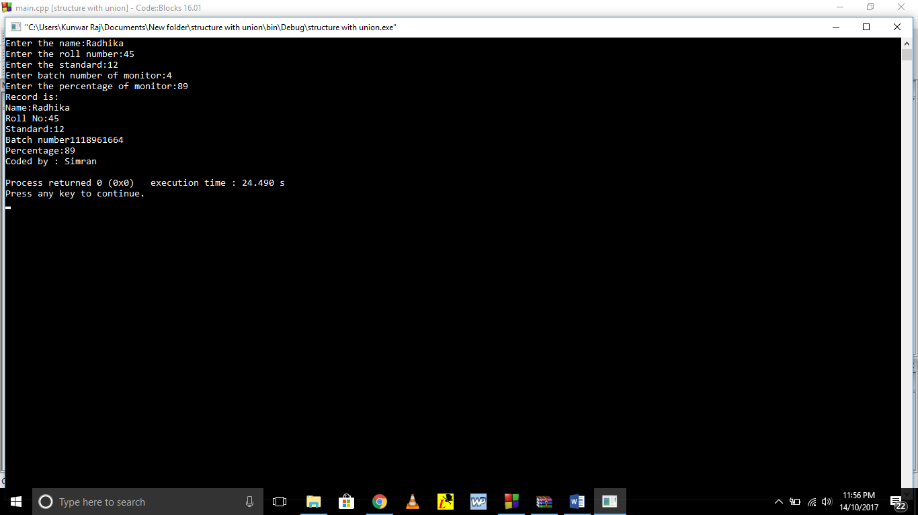
Figure.10

11.Write a program to illustrate the concept of structure with array.

#include <iostream>
using namespace std;
struct student
{
char name[20];
int rollno;
float percentage;
};
int main()
{
struct student s[10];
int n,i;
cout<<"Enter the number of students:";
cin>>n;
cout<<"Enter the record of students:"<<endl;
for(i=0;i<n;i++)
{
cout<<"Enter name of student:";
cin>>s[i].name;
cout<<"Enter roll number of student:";
cin>>s[i].rollno;
cout<<"Enter percentage of student:";
cin>>s[i].percentage;
}
cout<<"The record of students are :";
cout<<endl<<"SR NO.\tNAME\tROLL NO.\tPERCENTAGE"<<endl;
for(i=0;i<n;i++)
cout<<i<<"\t"<<s[i].name<<"\t"<<s[i].rollno<<"\t\t"<<s[i].percentage<<endl;
cout<<endl<<"Coded by :Simran"<<endl;
return 0;
}

Output:

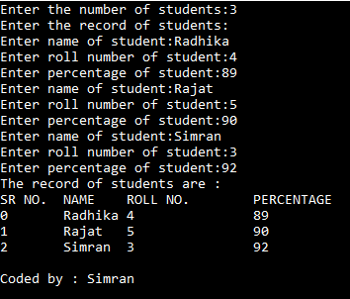
Figure.11

12.Write a program to illustrate the concept of enum.

#include <iostream>
using namespace std;
enum shape
{
circle,triangle,reactangle
};
int main()
{
int code;
cout<<"Enter shape code:";
cin>>code;
while(code>=circle||code<=reactangle)
{
switch(code)
{
case circle:
cout<<"HELLO"<<endl;
break;
case triangle:
cout<<"HI"<<endl;
break;
case reactangle:
cout<<"NO"<<endl;
}
break;
}
cout<<"Coded by : Simran"<<endl;
return 0;
}
Output:

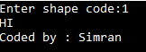
Figure.12

13.Write a program to illustrate the use of scope resolution.

#include <iostream>
using namespace std;
int m=10;
int main()
{
int m=20;
{
int k=m;
int m=30;
cout<<"we are in the inner block"<<endl;
cout<<"k="<<k<<"\n";
cout<<"m="<<m<<"\n";
cout<<"::m="<<::m<<"\n";
}
cout<<"we are in the outer block"<<endl;
cout<<"m="<<m<<"\n";
cout<<"::m="<<::m<<"\n";
cout<<"Coded by : Simran"<<endl;
return 0;
}
Output:

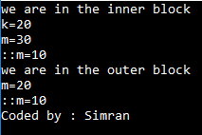
Figure.13

14.Write a program to illustrate the use of new and delete operators for allocation and deallocation of memory.

#include <iostream>
using namespace std;
int main()
{
int *p,sizee;
cout<<"Enter the size of array:";
cin>>sizee;
cout<<"Memory allocated for the array:"<<sizee<<endl;
p=new int[sizee];
cout<<"Memory deallocation take place\n";
delete p;
cout<<"Coded by : Simran"<<endl;
return 0;
}
Output:

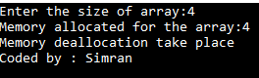
Figure.14

15.Write a program to illustrate the concept of manipulator.

#include <iostream>
#include <iomanip>
using namespace std;
int main()
{
int basic=98000;
int allowance=18000;
int total=19650;
cout<<setw(10)<<"basic:"<<setw(10)<<basic<<endl;
cout<<setw(10)<<"allowance:"<<setw(10)<<allowance<<endl;
cout<<setw(10)<<"total:"<<setw(10)<<total<<endl;
cout<<"Coded by : Simran"<<endl;
return 0;
}
Output:

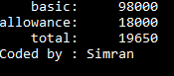
Figure.15

16.Write a program to sum of array elements.

#include <iostream>
using namespace std;
int main()
{
int a[100],i,sum=0,n;
cout<<"Enter number of elements:";
cin>>n;
cout<<"Enter elements of array:\n";
for(i=0;i<n;i++)
{
cin>>a[i];
sum+=a[i];
}
cout<<"Sum of array elements are:"<<sum<<endl;
cout<<"Coded by : Simran"<<endl;
return 0;
}
Output:

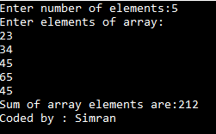
Figure.16

17.Write a program to find largest of array elements.

#include <iostream>
using namespace std;
int main()
{
int a[100],i,lar,n;
cout<<"Enter number of elements:";
cin>>n;
cout<<"Enter elements of array:\n";
for(i=0;i<n;i++)
{
cin>>a[i];
}
lar=a[0];
for(i=0;i<n;i++)
{
if(lar<a[i])
lar=a[i];
}
cout<<"Largest number of array elements are:"<<lar<<endl;
cout<<"Coded by : Simran"<<endl;
return 0;
}
Output:

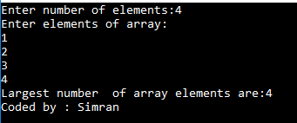
Figure.17

18.Write a program to reverse of array elements.

#include <iostream>
using namespace std;
int main()
{
int a[100],i,n;
cout<<"Enter number of elements:";
cin>>n;
cout<<"Enter elements of array:\n";
for(i=0;i<n;i++)
{
cin>>a[i];
}
cout<<"Reverse of array elements are:"<<endl;
for(i=n-1;i>=0;i--)
{
cout<<a[i]<<endl;
}
cout<<"Coded by : Simran"<<endl;
return 0;
}
Output:

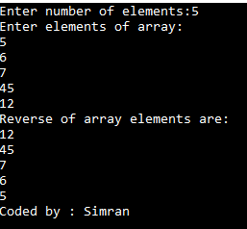
Figure.18

19.Write a program to add two matrixes.

#include <iostream>
using namespace std;
int main()
{
int a[3][3],b[3][3],c[3][3];
int i,j;
cout<<"Enter element of first matrix:\n";
for(i=0;i<3;i++)
{
for(j=0;j<3;j++)
cin>>a[i][j];
}
cout<<"Enter element of second matrix:\n";
for(i=0;i<3;i++)
{
for(j=0;j<3;j++)
cin>>b[i][j];
}
cout<<"Enter element of first matrix:\n";
for(i=0;i<3;i++)
{
for(j=0;j<3;j++)
{
c[i][j]=a[i][j]+b[i][j];
cout<<c[i][j]<<"\t";
}
cout<<endl;
}
cout<<"Coded by : Simran"<<endl;
return 0;
}

Output:

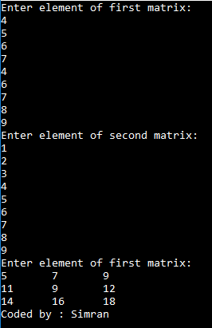
Figure.19

20.Write a program to illustrate the concept of call by value, call by reference and call by pointers.

#include <iostream>
using namespace std;
void swapp(int ,int);
void swapp1(int& ,int&);
void swapp2(int*,int*);
int main()
{
int a,b;
cout<<"Enter two number:";
cin>>a>>b;
cout<<"By call by value:"<<endl;
cout<<"numbers before swapping:"<<a<<"\t"<<b<<endl;
swapp(a,b);
cout<<"numbers after swapping:"<<a<<"\t"<<b<<endl;
cout<<"By call by reference:"<<endl;
cout<<"numbers before swapping:"<<a<<"\t"<<b<<endl;
swapp1(a,b);
cout<<"numbers after swapping:"<<a<<"\t"<<b<<endl;
cout<<"By call by pointers:"<<endl;
cout<<"numbers before swapping:"<<a<<"\t"<<b<<endl;
swapp2(&a,&b);
cout<<"numbers after swapping:"<<a<<"\t"<<b<<endl;
cout<<"Coded by : Simran"<<endl;
return 0;
}
void swapp(int x,int y)
{
int t;
t=x;
x=y;
y=t;
cout<<"number during swapping:"<<x<<"\t"<<y<<endl;
}
void swapp1(int &x,int &y)
{
int t;
t=x;
x=y;
y=t;
cout<<"number during swapping:"<<x<<"\t"<<y<<endl;
}
void swapp2(int *x,int *y)
{
int t;
t=*x;
*x=*y;
*y=t;
cout<<"number during swapping:"<<*x<<"\t"<<*y<<endl;
}
Output:

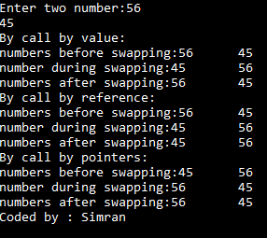
Figure.20

21.Write a program to illustrate the concept of inline function.

#include <iostream>
using namespace std;
inline double cube(double a)
{
return(a*a*a);
}
int main()
{
double a,b;
a=cube(3.0);
cout<<"Cube of number is:"<<a<<endl;
b=cube(2.5+1.5);
cout<<"Cube of number is:"<<b<<endl;
cout<<"Coded by : Simran"<<endl;
return 0;
}
Output:

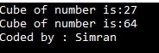
Figure.21

22.Write a program to illustrate the concept of default arrguments.

#include <iostream>
using namespace std;
void sum(int x,int y=0)
{
cout<<"Sum is :"<<x+y<<endl;
}
int main()
{
sum(10);
sum(10,0);
sum(10,10);
cout <<"Coded by : Simran"<< endl;
return 0;
}
Output:

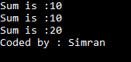
Figure.22

23.Write a program to find factorial of number using recursion concept.

#include <iostream>
using namespace std;
long fact(int n)
{
if(n==0)
return 1;
else
return(n*fact(n-1));
}
int main()
{
int num;
cout<<"Enter a number:";
cin>>num;
int m=fact(num);
cout<<"Factorial is :"<<m<<endl;
cout <<"Coded by : Simran"<< endl;
return 0;
}
Output:

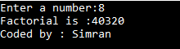
Figure.23

24.Write a program to illustrate the concept of function overloading.

#include <iostream>
using namespace std;
int sum(int ,int );
int sum(int ,int ,int );
int sum(int x,int y)
{
cout<<"Sum of two numbers are:"<<x+y<<endl;
}
int sum(int a ,int b ,int c)
{
cout<<"Sum of three numbers are:"<<a+b+c<<endl;
}
int main()
{
sum(10,20);
sum(10,20,30);
cout <<"Coded by : Simran"<< endl;
return 0;
}
Output:

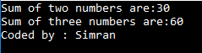
Figure.24

25.Write a program to illustrate the concept of function overriding.

#include <iostream>
using namespace std;
class base
{
public:
void show()
{
cout<<"base class"<<endl;
}
};
class derived: public base
{
public:
void show()
{
base::show();
cout<<"derived class"<<endl;
}
};
int main()
{
base b;
derived d;
b.show();
d.show();
cout<<"Coded by : Simran"<<endl;
return 0;
}
Output:

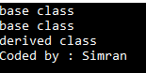
Figure.25

26.Write a program to draw a pattern of stars.

#include <iostream>
using namespace std;
int main()
{
int i,j,n;
cout<<"Enter any number:";
cin>>n;
for (i=1;i<=n;i++)
{
for(j=1;j<=i;j++)
{
cout<<"*";
}
cout<<endl;
}
cout<<"Coded by : Simran"<<endl;
return 0;
}
Output:

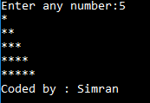
Figure.26

27.Write a program to draw pattern of numbering.

#include <iostream>
using namespace std;
int main()
{
int i,j,n;
cout<<"Enter any number:";
cin>>n;
for (i=n;i>=1;i--)
{
int a=1;
for(j=1;j<=i;j++)
{
cout<<a;
a++;
}
cout<<endl;
}
cout<<"Coded by : Simran"<<endl;
return 0;
}
Output:

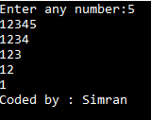
Figure.27

28.Write a program to check whether number is prime or not.

#include <iostream>
using namespace std;
int main()
{
int num,i;
cout<<"Enter any number:";
cin>>num;
if(num==1)
cout<<"Entered number is not PRIME"<<endl;
else
{
for(i=2;i<=num;i++)
{
if(num%i==0)
{
cout<<"Entered number is not PRIME"<<endl;
break;
}
else
{
cout<<"Entered number is PRIME"<<endl;
break;
}
}
}
cout<<"Coded by : Simran"<<endl;
return 0;
}
Output:

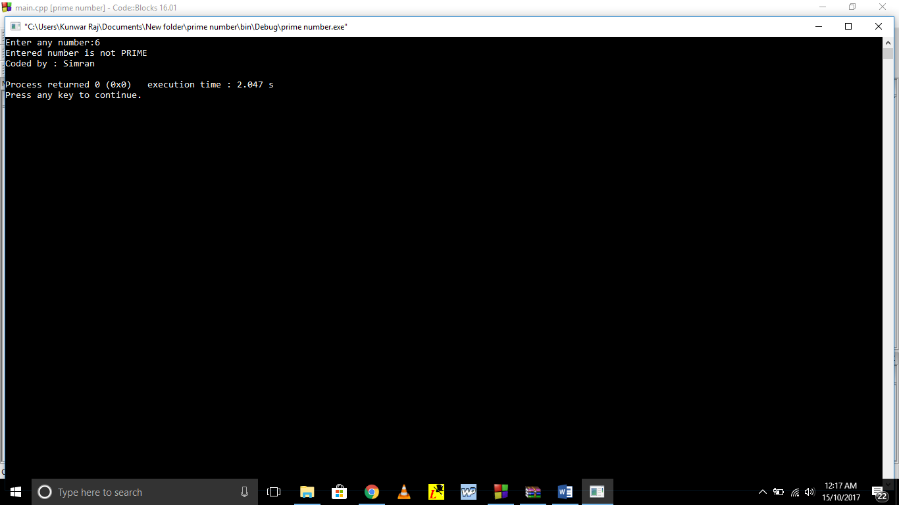
Figure.28

