

School of Future Tech

Case Study Report

on

Dev-Term Flashcards using React

by

Tanvish Poojari → 150096725203
Rima Amal Maji → 150096725215
Yash tambade → 150096725173
Simran Sutar 150096725085

Index
- Introduction to the Case Study.
- Problem Statement / Case Background (Abstract).
- Problem Statement / Case Study Design.
- Methods & Algorithms Technology Applied in the Problem Statement / Case Study.
- Problem Statement / Case Study Implementation Details and Snapshots.
- Problem Statement / Case Study Results and Conclusion.
- References

1. Introduction to the Case Study
Learning programming concepts requires continuous revision and understanding of technical terms. Many students face difficulty remembering definitions of important development-related terminology due to lack of interactive learning tools.
This case study focuses on developing a Dev-Term Flashcards Web Application using React. The system provides an engaging way for users to learn and revise programming terms through interactive flashcards.
The project demonstrates how modern frontend technologies like React can be used to create dynamic and user-friendly educational tools. It also highlights the importance of UI interactivity and state management in improving learning experiences.

2. Problem Statement / Case Background (Abstract)
Background
Traditional learning methods such as textbooks or static notes are not always effective for memorizing programming terms. Students often need a quick and interactive way to revise concepts efficiently.
Abstract
This case study presents the design and implementation of a Dev-Term Flashcards Application using React.js. The application displays programming terms on cards, and users can click on a card to flip it and view the definition.
The system uses React state management (useState) to handle user interaction and dynamically update the UI. The application improves engagement by combining learning with interactivity. It demonstrates how simple UI components and logic can be used to build an effective educational tool.

3. Case Study Design
The Dev-Term Flashcards system is designed with the following components:

Data Layer
- A collection of programming terms and definitions stored in an array (JSON format)

UI Components
- Flashcard component (front and back view)
- Container to display multiple cards

Interaction Design
- Clicking a card triggers a flip action
- Front side → Term
- Back side → Definition

Flow of System
- Load data
- Display flashcards
- Handle user click
- Update state
- Re-render UI

4. Methods & Algorithms Technology Applied in the Problem Statement / Case Study

Key Methods
State Management
- React useState hook is used to track whether a card is flipped or not
Event Handling
- Click events trigger state changes
Conditional Rendering
- Displays term or definition based on state

Technology Stack Used
- Frontend: React.js
- Languages: JavaScript, HTML, CSS
- Styling: CSS (including animations for card flip)

5. Problem Statement / Case Study Implementation Details and Snapshots.

Implementation Structure
components/Flashcard.js
- Handles individual card UI and flip logic
data.js
- Stores list of terms and definitions
App.js
- Main component that renders all flashcards

Working Process
- Terms are stored in an array
- Cards are generated using .map()
- Each card has a state (isFlipped)
- On click → state toggles
- UI updates dynamically

Snapshot
Rima -
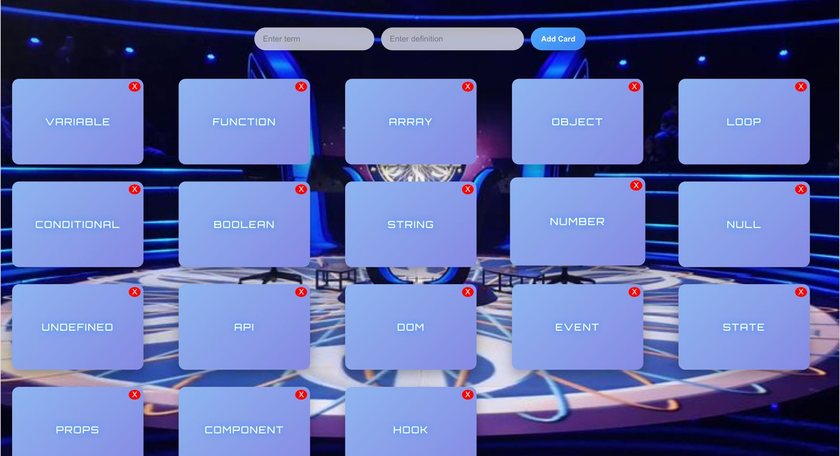
Yash -
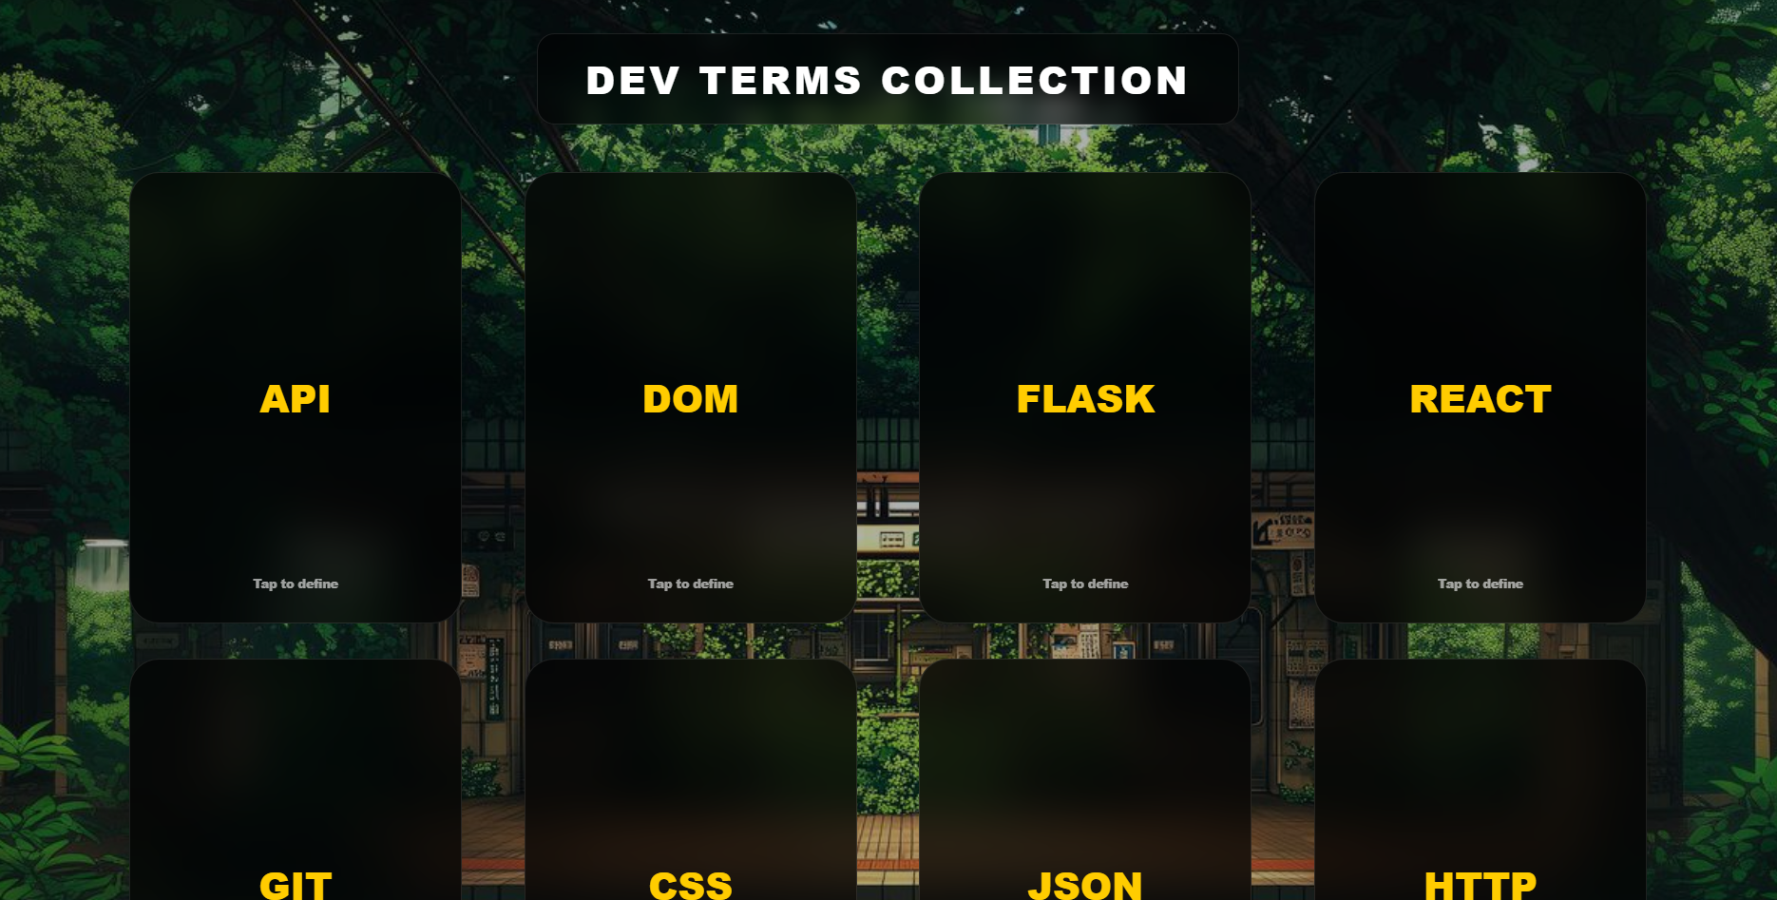

Tanvish -
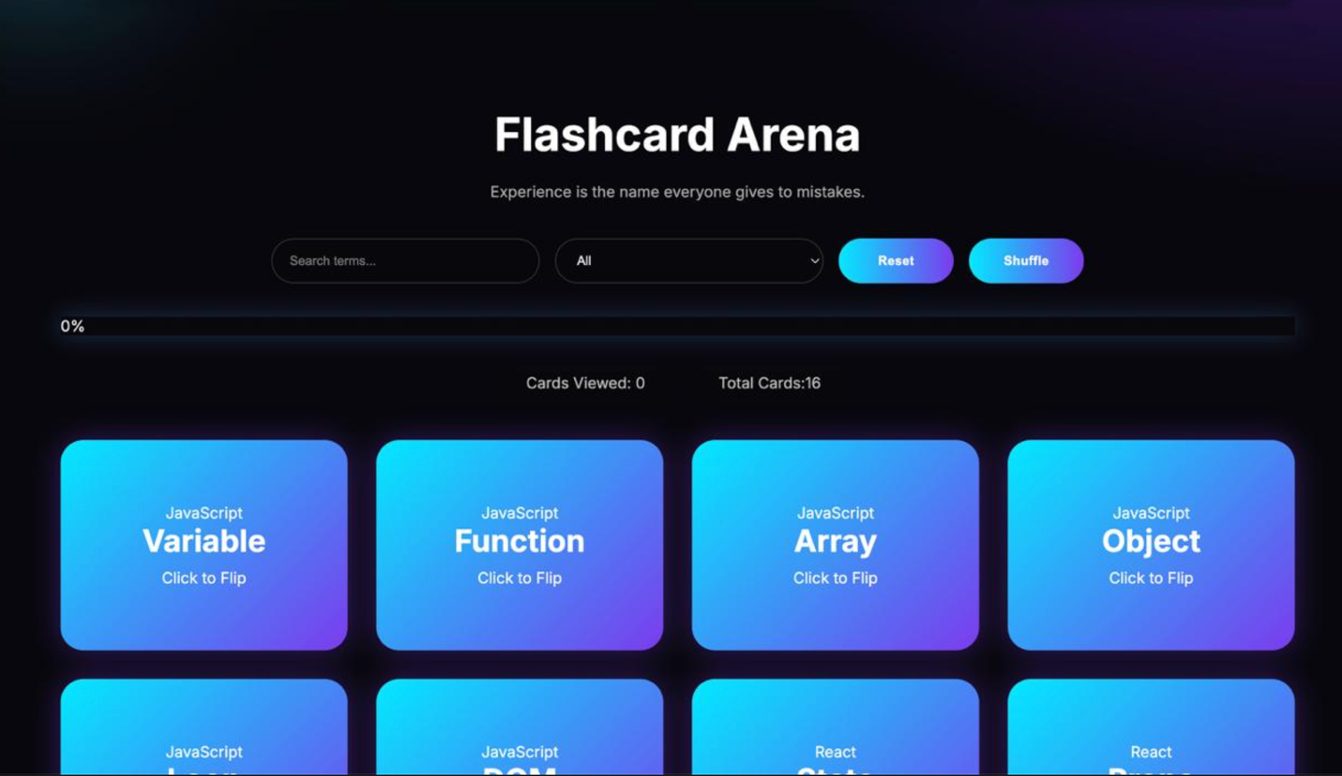

Simran -
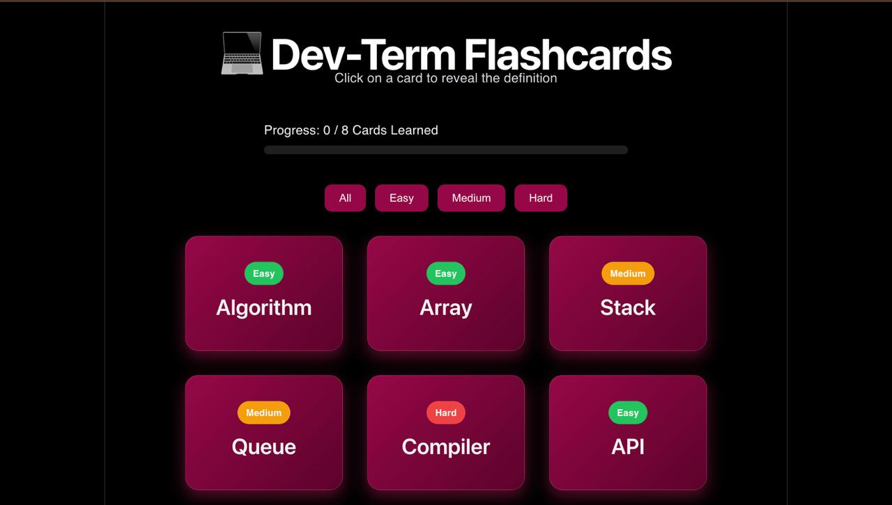

6. Problem Statement / Case Study Results and Conclusion.

Findings
- Interactive UI improves learning experience
- React state makes UI dynamic and responsive
- Simple logic can create powerful educational tools

Conclusion
This case study successfully demonstrates the development of an interactive Dev-Term Flashcards application using React. The system enhances user engagement and helps in effective learning of programming terms.
The project can be further extended by adding:
- Quiz mode
- Score tracking
- Categories (Frontend, Backend, etc.)
- Search functionality

7. References
- React Official Documentation (https://react.dev/)
- JavaScript Documentation (MDN Web Docs)
- CSS Animation Guides
- Online tutorials on React state management

