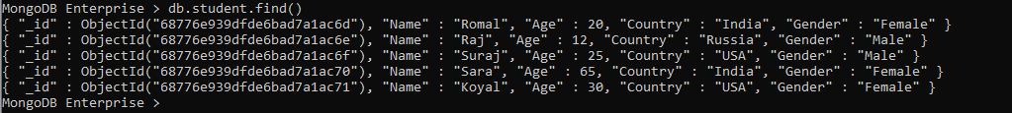

2.Update the country to UK for all female users

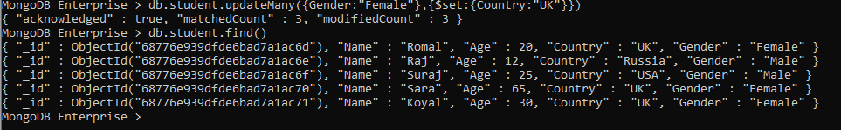

3.Add the new field company to all the documents.

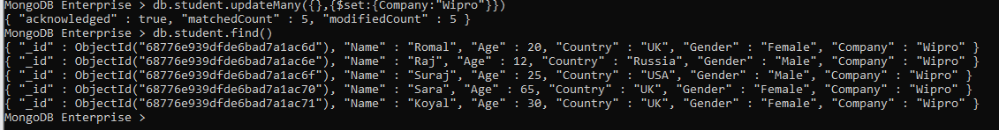

4. Delete all the documents where Gender = ‘M’.

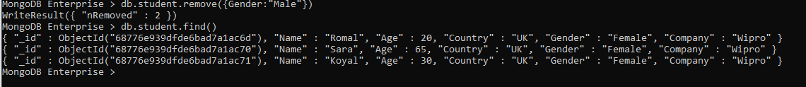

5. Find out a count of female users who stay in either India or USA.



6.Display the first name and age of all female employees.

