**Practical 3 : Aggregate Functions**

1. Insert collection in the database and display all the records.

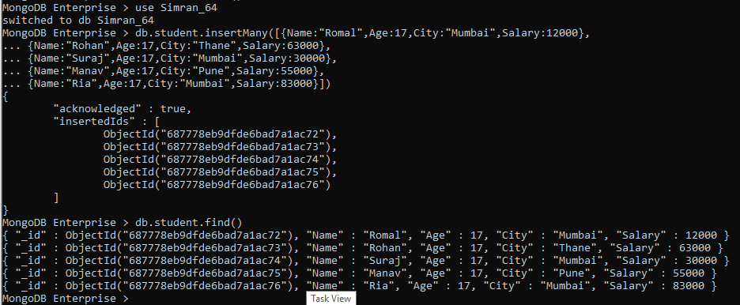

1. Group by function to get count.

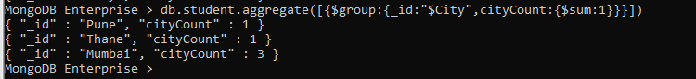

1. Sum Function

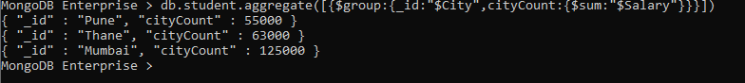

1. Average Function

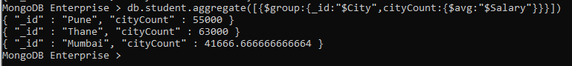

1. Min Function



1. Max Function



1. First Function



1. Last Function

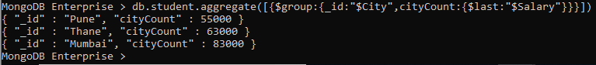

1. addToSet Function



1. Push Function

