**Practical 1 – MongoDB Basics**

A. Write a MongoDB query to create and drop database.

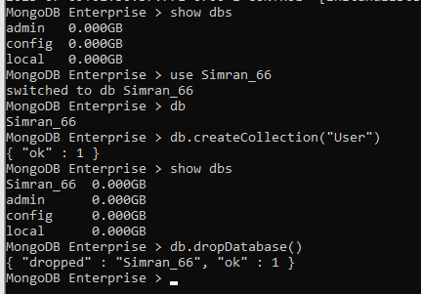

B. Write a MongoDB query to create, display and drop collection.

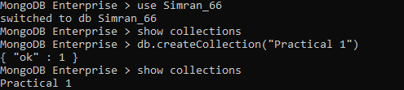

C. Write a MongoDB to insert, read, update and delete a document.

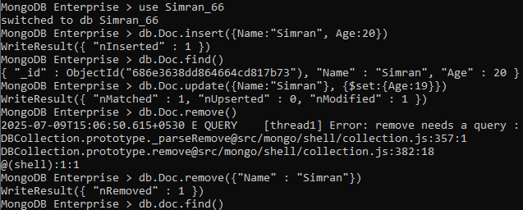

D. Employee Queries

1. Insert and display the documents in the Employee collection.

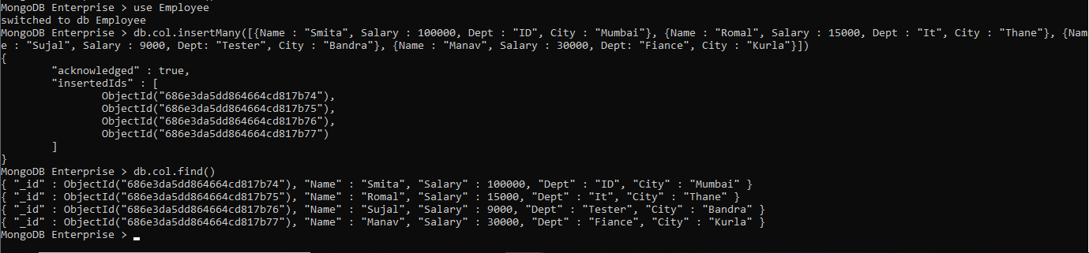

2. Display the details of employees who live in Mumbai.



3. Display details of employees staying in Kurla and salary greater than 19000.



4. Display details of the employee whose salary is greater than equal 10000 but less than 20000.



5. Display the details of employees staying in either thane or Mumbai and salary greater than 10000.



* Importing the JSON file into mongoDb

Step 1 :- Open cmd in admin mode and type **mongod** command.

Step 2 :- Start a new cmd and type a **mongo** command.

Step 3 :- Create a new database using :

use **database_name**

Now create a new collection into a database :

**db.createCollection(“collection_name”)**

Step 4 :- Open a new cmd in admin mode and type the following command to import the JSON file into a newly created database.

**mongoimport --db database_name --collection collection_name path of the JSON file**



* Creating a Backup of databases.

Step 1 :- Type the following command in a new cmd.

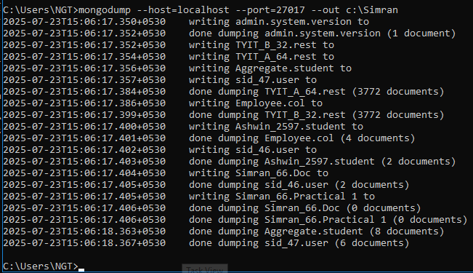

Step 2 :- Now we will delete the existing database and we will retrive the deleted database from the backup copies.

Step 3 :- Delete the database we have to type

**db.dropDatabase**



Step 4 :- Now we will take deleted database from a backup copies for the we need to type the following command in new cmd.

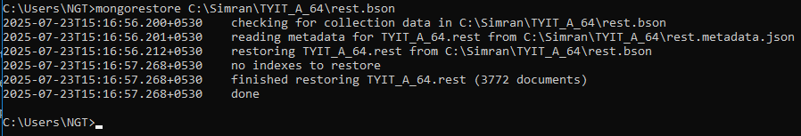

1. Write a MongoDB query in display all the documents in the collection restaurants.

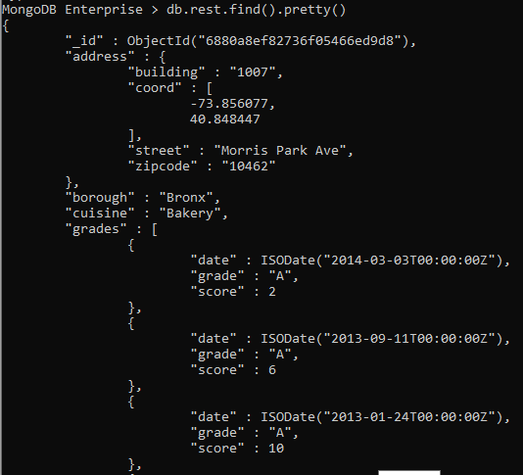

2. Write a Mongo DB Query to display the fields restaurant_id, name, borough and cuisine for all the documents in the collection restaurant.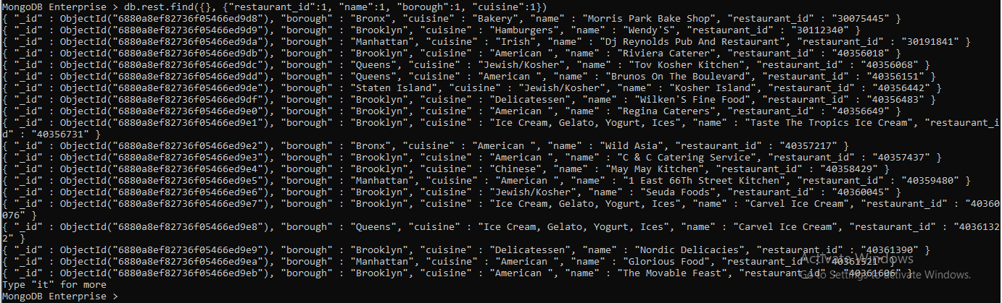

3. Write a Mongo DB query to display the field restaurant_id, name, borough, and cuisine, but exclude the field_id for all the documents in the collection restaurant.  
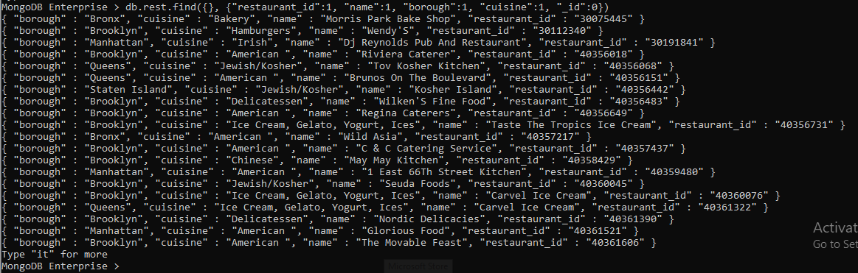

4. Write a Mongo DB query to display the field restaurant_id, name, borough, and zip code, but exclude the field _id for all the documents in the collection restaurant.

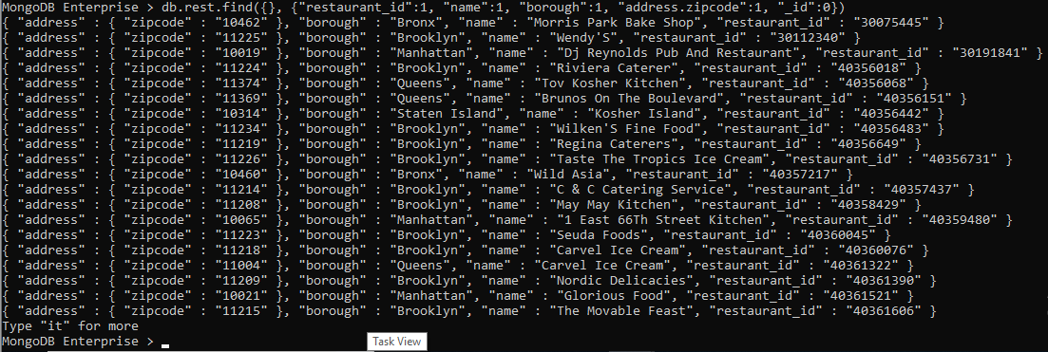

5. Write a Mongo Db query to display all the restaurante which are in the borough bronx.

