**Steps to run this project to see Dynamic Charts.:**

1. Login as an Admin. (Admin don’t have any registration page. So, you have to add a row in database.)Make a Schema name “stock_exchange”.
2. After logging into admin, click on “Sectors” and add a new Sector such as oil, coal etc.
3. Click on “Manage Exchanges” and add a new stock name like NSE, BSE.
4. Now Click on “Manage Company” and add a new company

Note:-{Please add the company code starting from 100 as the attached excel data sheet has company code as {100,101,102,103} }.

Please note while registering a new company, Sectors and Sector code will appear in drop down list.

1. Click on “import data” in the navbar.
2. Choose the excel that I have send you with the project. {Because the format has to be strictly followed.}
3. Go back to homepage.
4. Sign in as User.
5. Now to see comparison in graph of different companies. Write the company codes like this(See the screenshot below.)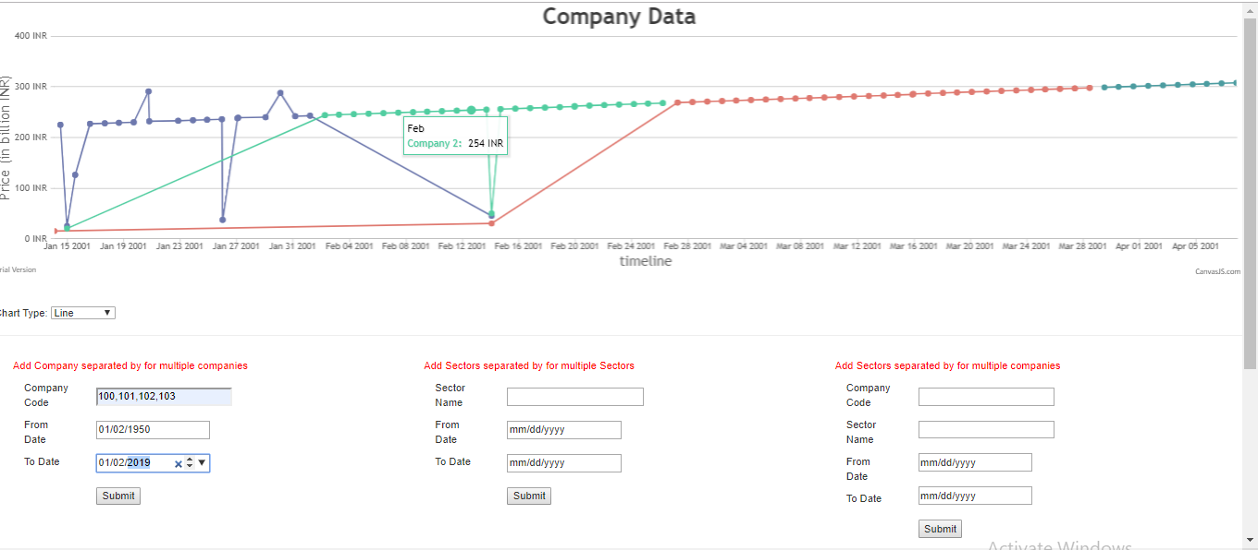

The graph is generated dynamically from the database in the excel sheet.