**WHAT ARE THE ELEMENTS OF SCANDINAVIAN DESIGN**

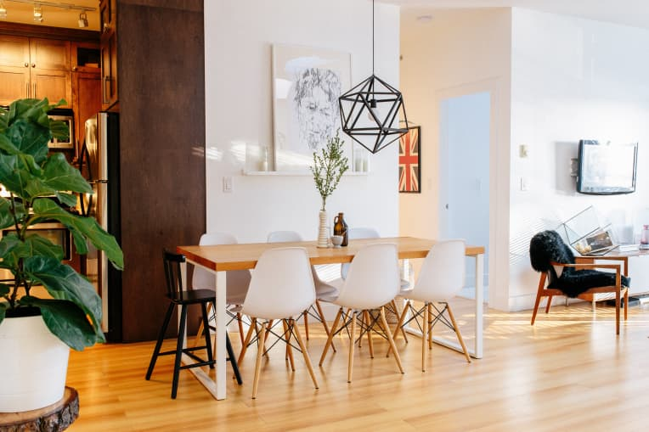

Scandinavian comprises of three Northern European countries: Denmark, Norway and, Sweden. The designers made a name for themselves in Scandinavian interiors in the 1950s and its popularity has not lest even since. Scandinavian design believes in the concept of minimalism and functionality without any sacrifice in its beauty. Here is a small tour guide to know why Scandinavian style is regarded with great favor.

**THE SEVEN ELEMENTS THAT MAKE THE SCANDINAVIAN DÉCOR SO APPEALING:**

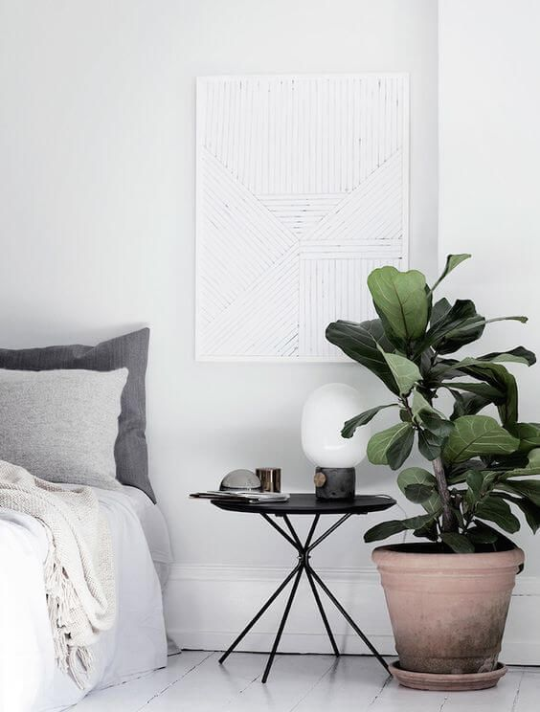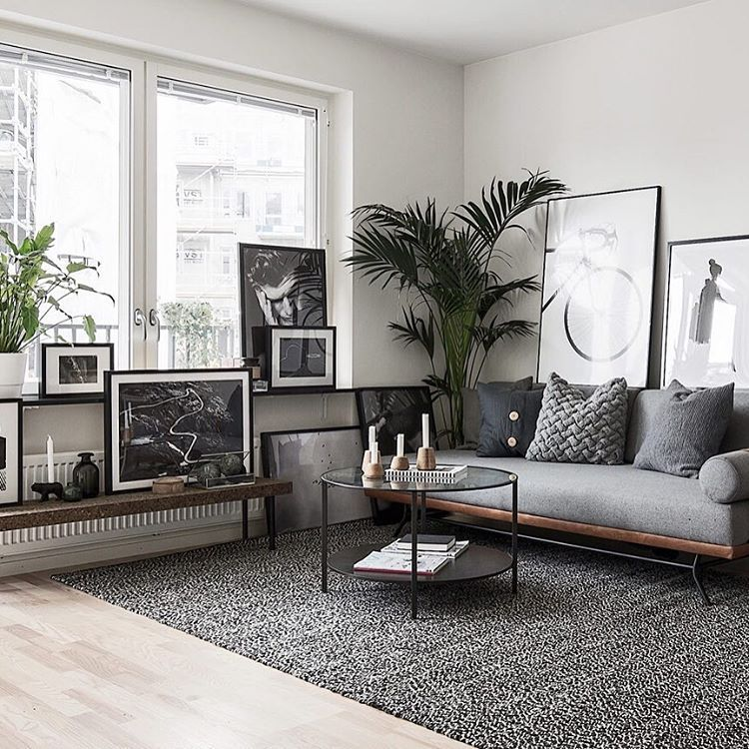

The functionality that the Scandinavian style possesses communicates with modernism and has been around longer that the IKEA. Due to its minimalist furniture and elements people have adopted this style and transformed their spaces into a moderate shelter. According to the Washington Post, Scandinavian style favors bright, airy spaces and deeply venture nature, something that is reflected in their style.

On the subject of weather, Scandinavian winters are not a trivial thing. Hence their choice of textiles and decoration are not surprising. Soft cotton throws and sheepskin rugs make the space cozy and homey. The wood floors tend to remain uncovered and lighter wood tones are frequently seen. Can a Scandinavian décor be ever thought without any houseplants? Never. The live plants are a popular choice when it comes to bringing the outdoors in.

**COLORS EVERY SCANDINAVIAN DÉCOR IS OBSSESSED WITH:**

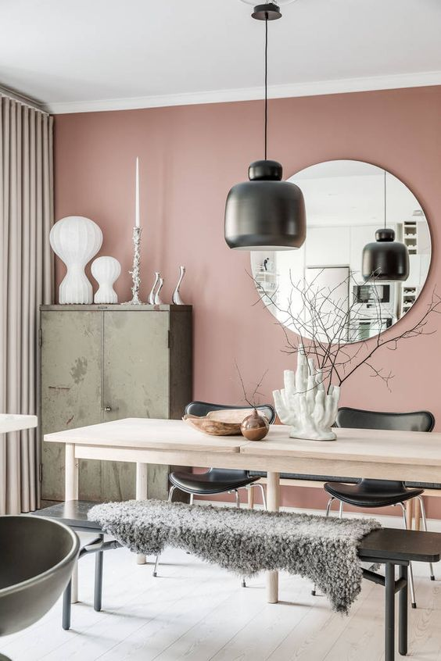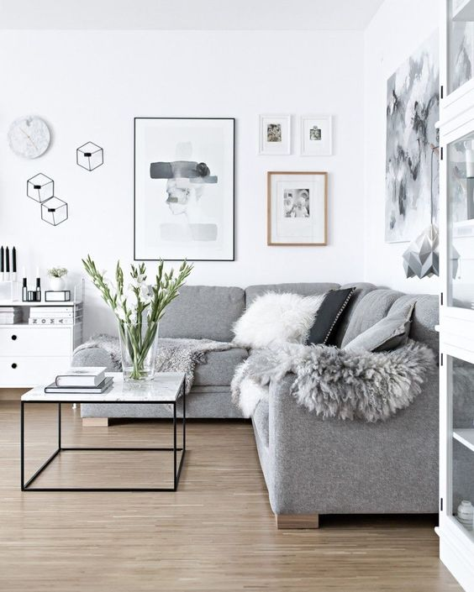

Speaking of Scandinavian décor colors, I am sure you’re stuck with a colour palette in your head. Scandinavian colours strongly favors being monochromatic. It heavily relies on neutral, bright whites with pops of black and tan. Different shades of greys and browns are used to create a clean look that doesn’t keep our eyes too busy.

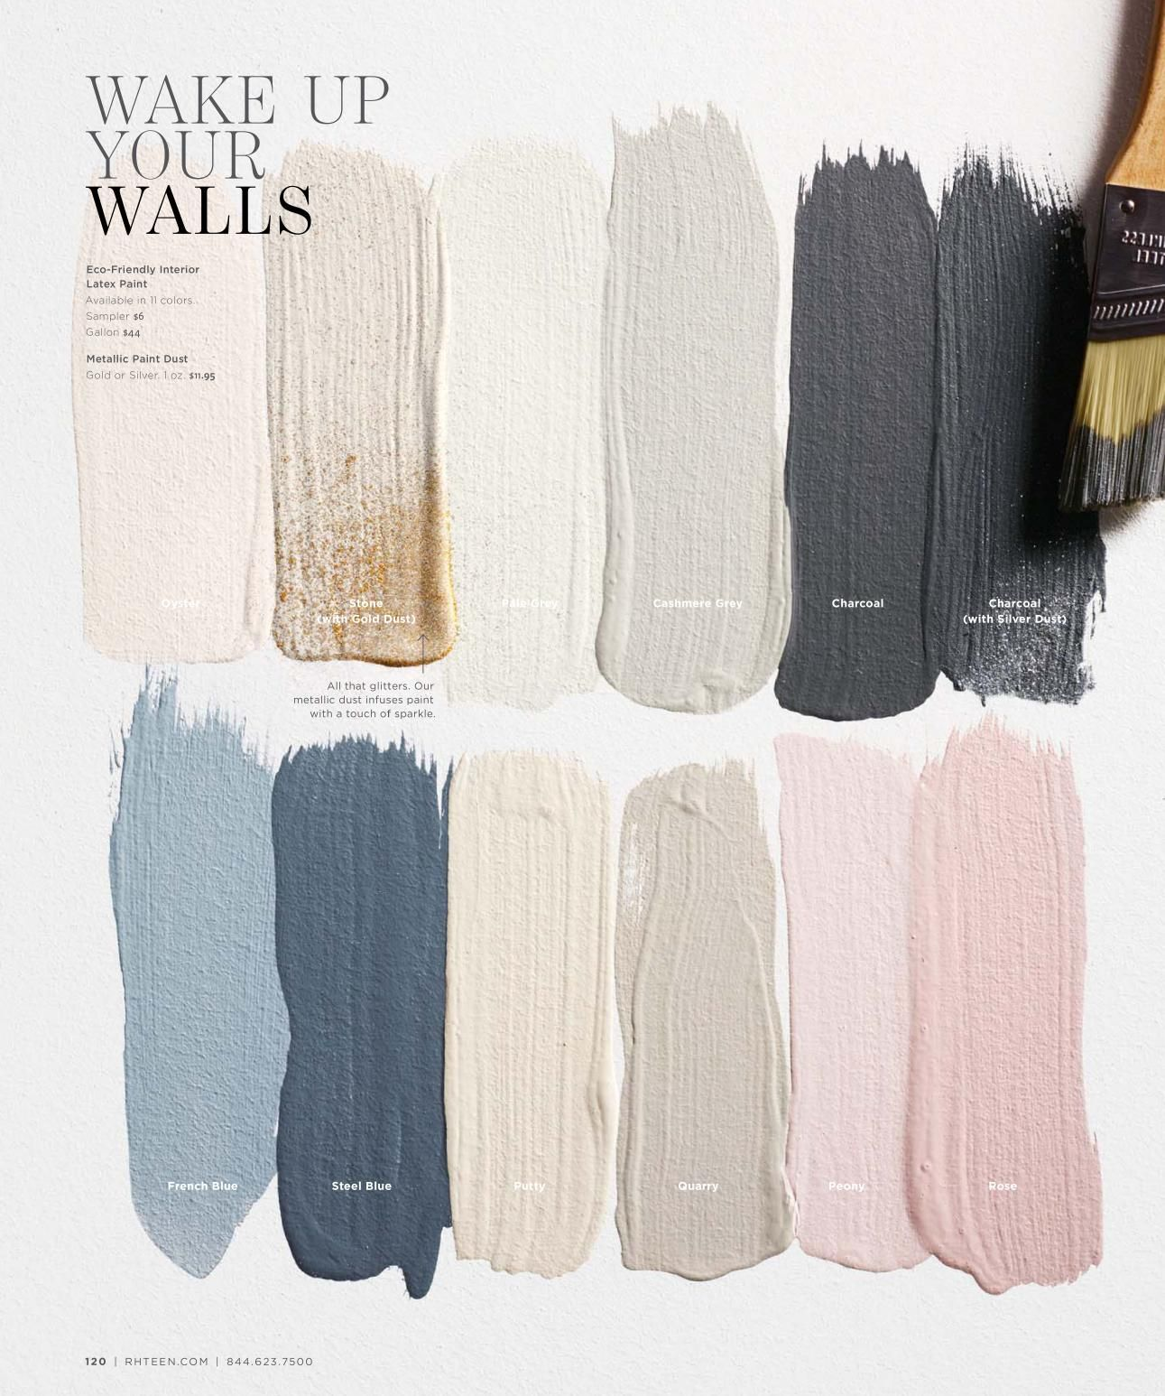

Shades like blush and grey-blue are among the most frequently used perhaps we just can’t seem to quit millennial pink. A few pop colors like dusty pink and various greens are a great choice to make the décor look more engaging.

“Trends morph. The Scandinavian style will be wonderful forever to those who love it.” Rosenthal said.

.