BLACK FRIDAY SALES ANALYSIS
By Simran, Student ID: 20262054

This report presents the complete analysis of the Black Friday retail sales dataset. It combines the Power BI visualizations and the implemented linear regression Model.
The analysis uses a retail Black Friday sales dataset containing 550,068 transaction records and 12 columns describing customers, products, location, demographics and purchase amount.
- Task 1 uses Power BI dashboards to visualize product-category distribution and relationships between transaction activity and customer characteristics.
- Task 2 develops a multivariable linear regression model in Python to predict Purchase.
- Task 3 discusses how these predictions and analytical findings can support business decisions.
The Linear regression model achieved a Mean Absolute Error (MAE) of 2,208.91, Root Mean Squared Error (RMSE) of 2,946.09 and R² of 0.6546. The training R² was 0.6619, close to the test R², suggesting the model generalizes reasonably well to unseen observations.

1. Task 1 - Visualization
  - Product Category Distribution

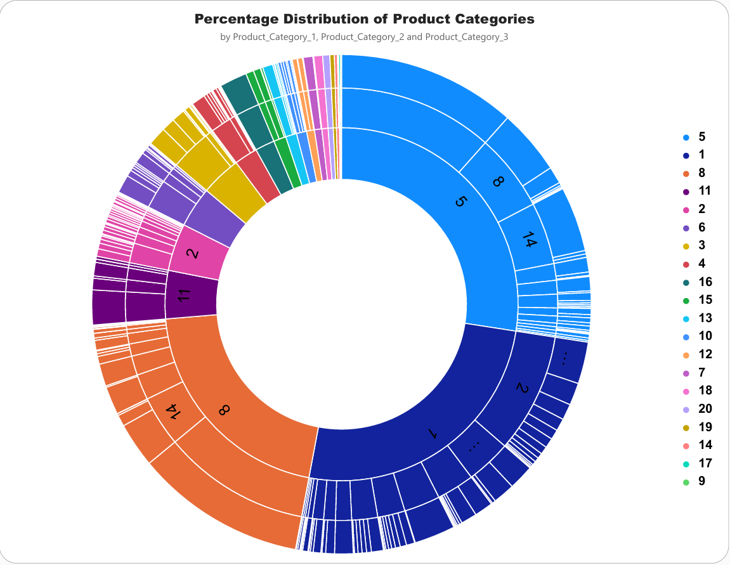
The Product Category Distribution uses a sunburst visual with Product_Category_1, Product_Category_2 and Product_Category_3 as hierarchical levels. This visual shows the relative contribution of product categories as a percentage.
The analysis shows that Product_Category_1 categories 5, 1, and 8 account for more than 50% of the total purchases, indicating that these three product categories represent the largest share of customer purchases.
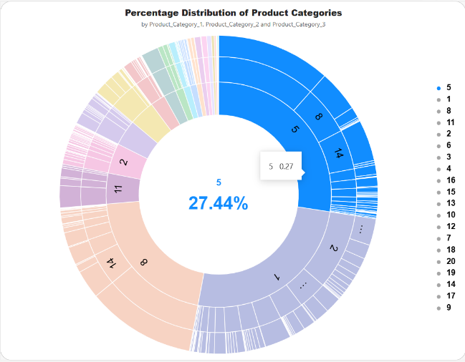
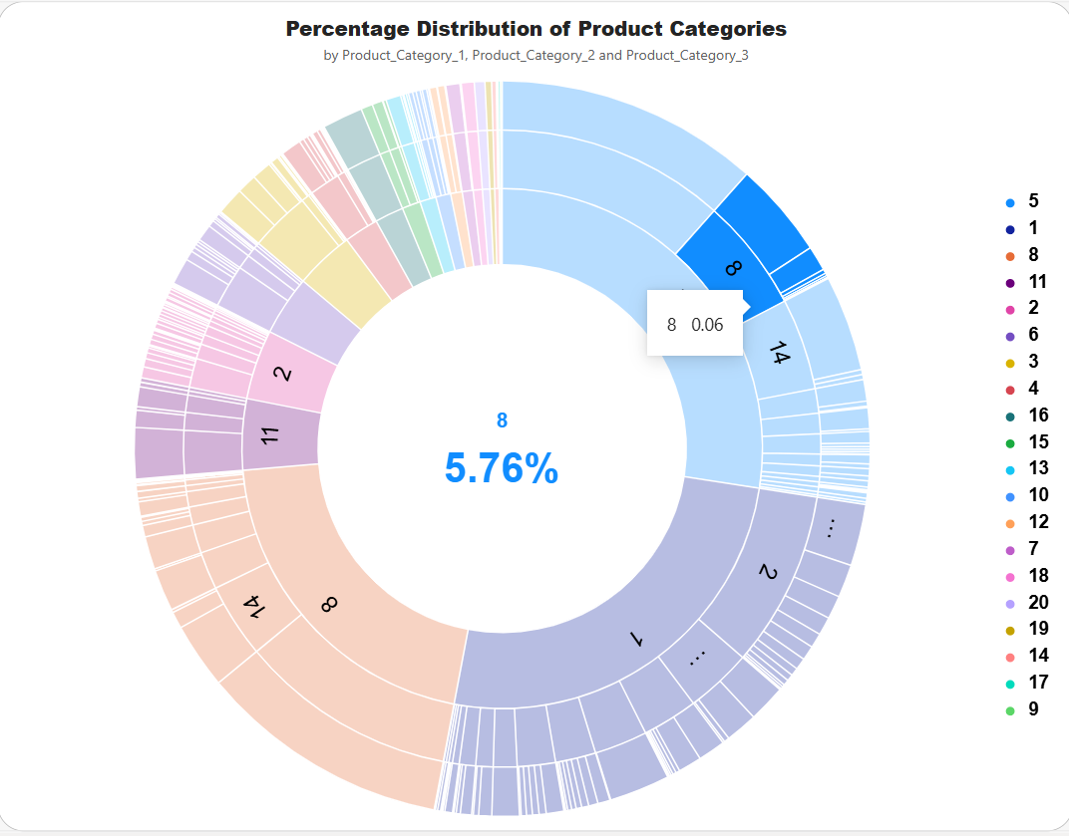
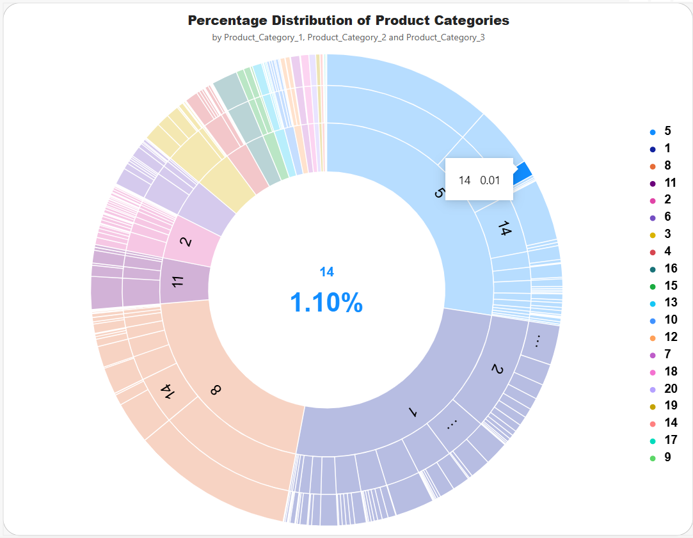
The sunburst format is appropriate for showing hierarchical category structure because it allows the viewer to see both the broad product-category level and the nested category relationships. This can help the business identify which product categories have the greatest representation in the sales data and where product demand is concentrated.

1.2 Transaction Comparison with Demographic Features
1.2.1 Gender and Number of Transactions:
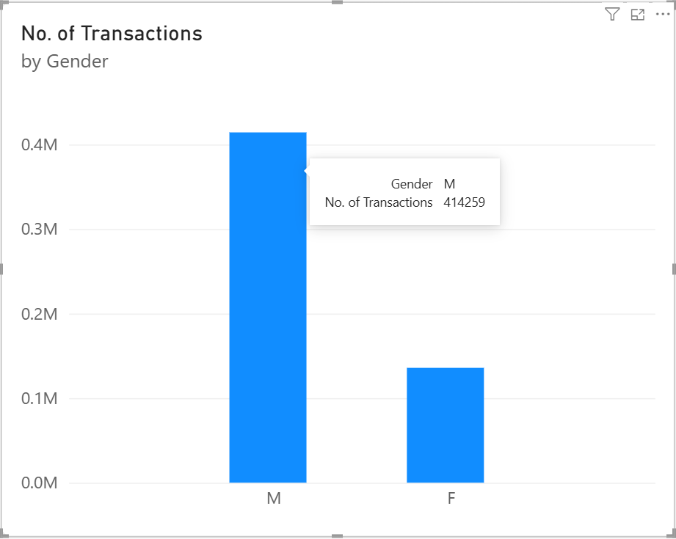
The column chart compares the number of transactions between male and female customers. Male customers account for more than 50% of total transactions, indicating higher transaction activity among male customers than female customers.

1.2.2 Age and Number of Transactions:
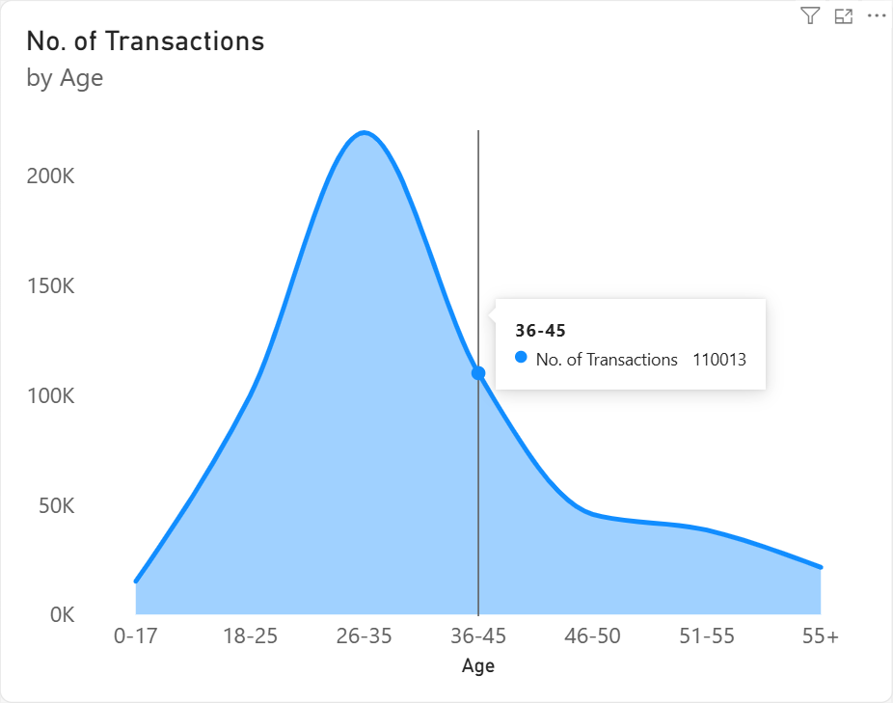
The area chart displays transaction activity across the seven age groups. It highlights the differences in transaction volume among the age categories. It can be observed that customers aged 26-45 contribute the highest number of transactions, indicating that this age range represents the most active customer group in the dataset.

1.2.3 Occupation and Number of Transactions:
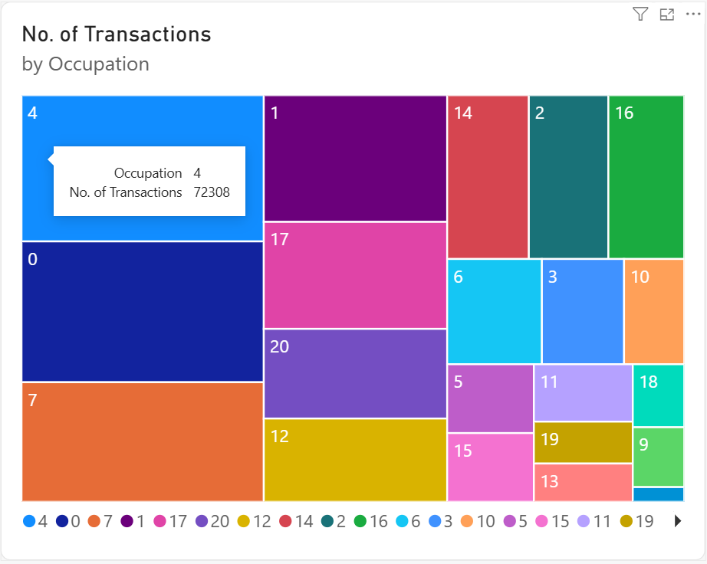
The tree map compares transaction activity across different occupation categories. Larger areas represent occupations with a higher number of transactions, making it useful for identifying the most active occupation groups. It can be observed that transactions are fairly evenly distributed across many occupation categories, with no single occupation dominating the overall transaction activity.

1.2.4 City Category and Number of Transactions:
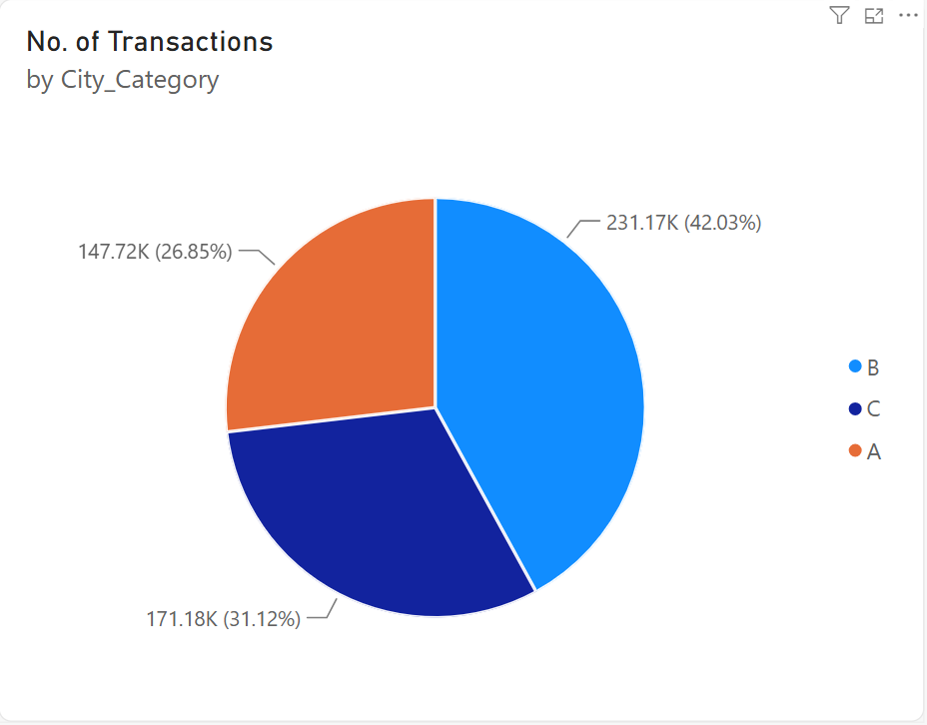
The pie chart compares transaction activity across City Categories A, B, and C. It shows the relative contribution of each city category to the overall transaction activity, making it useful for understanding differences in customer activity across locations.

1.2.5 Marital Status and Number of Transactions:
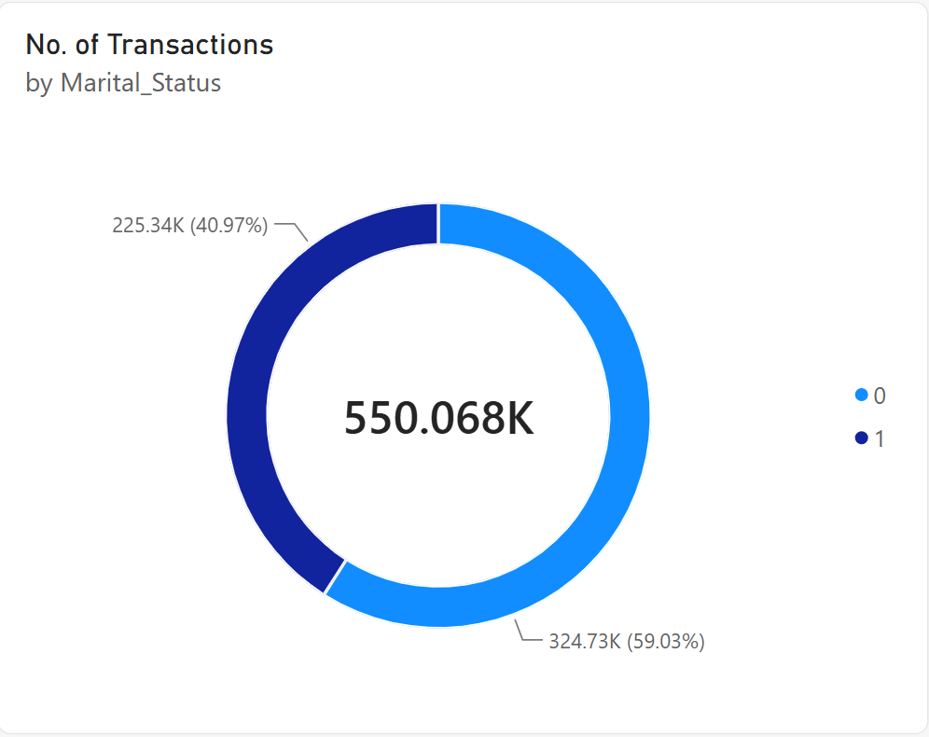
The Donut chart compares transaction activity between married and unmarried customers. It can be observed that unmarried customers dominate the transaction activity, accounting for approximately 59% of the total transactions, while married customers account for the remaining 41%.

1.2.6 Number of Transactions by Age and Gender:
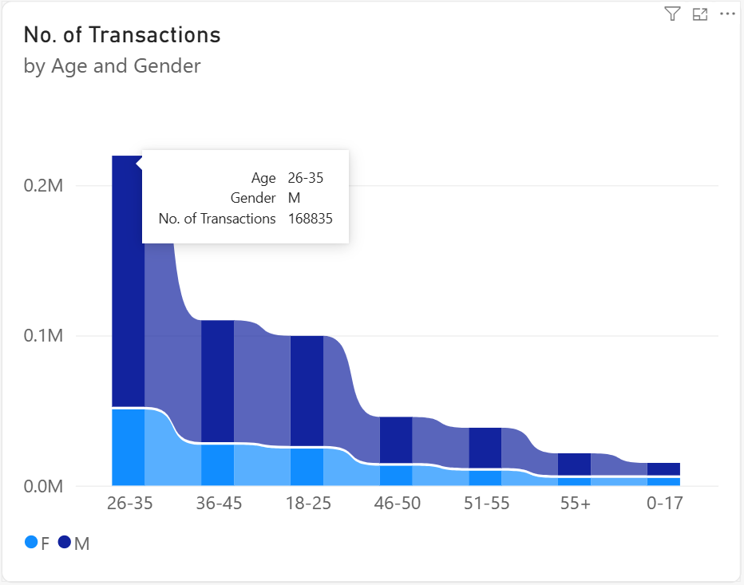
The ribbon chart compares transaction activity across different age groups while separating the results by gender. It can be observed that male customers contribute more transactions than female customers across all age groups. The 26–35 age group has the highest transaction activity, with male customers accounting for 168,835 transactions, as shown in the chart.

2. Task 2 - Linear Regression Model
2.1 Initial Data Analysis
- The dataset contains 550,068 observations and 12 columns.
- Product_Category_2 contains 173,638 missing values.
- Product_Category_3 contains 383,247 missing values.
- There are no duplicate rows present in the raw dataset.
- Purchase has no missing values and is used as the regression target.
- User_ID and Product_ID are treated as identifiers rather than predictive features.

2.2 Exploratory Data Analysis
2.2.1 Univariate Analysis
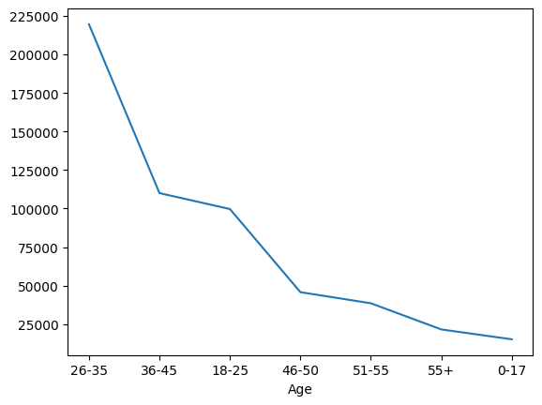
The line chart shows the number of records in each age group. It provides an overview of how transaction observations are distributed across the age categories.
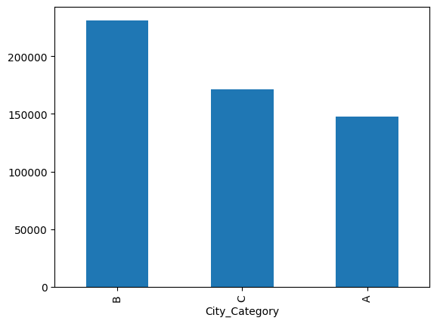
The bar chart compares the frequency of City Categories A, B and C. It shows how transaction observations are distributed geographically across the three city categories
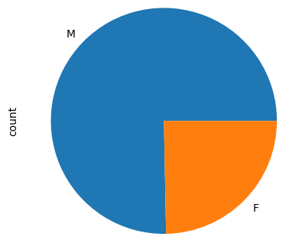
Gender Distribution
The pie chart shows the proportion of records belonging to each gender category. It provides a simple view of the gender composition of the dataset.
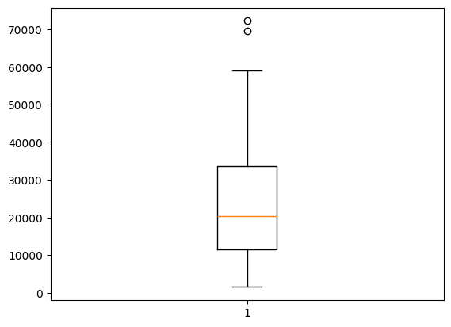
Occupation Frequency
The plot summarizes the frequency associated with the occupation categories. Because occupation is represented by numeric codes, the codes should be interpreted as categories rather than as a continuous ranking.
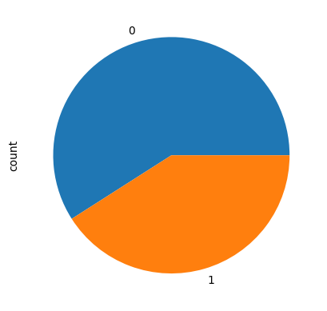
Marital Status Distribution
The pie chart shows the distribution of the two marital-status categories. It helps describe the demographic composition of the transaction dataset.
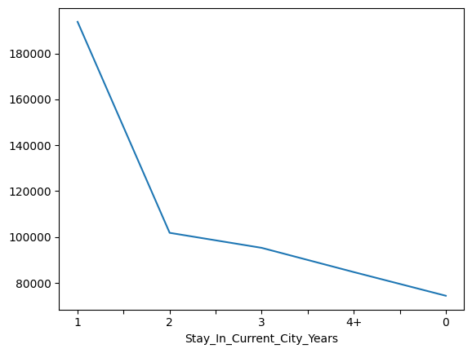
The line chart shows transaction frequency across the categories representing years spent in the current city. It provides a simple view of residential tenure among the customers.

2.2.2 Bivariate / Multivariate Analysis
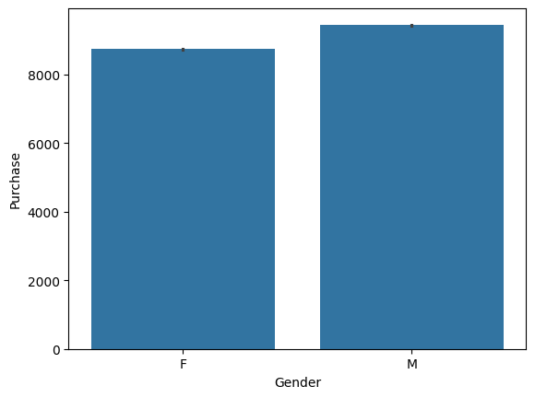
The bar plot compares purchase amount across gender. The notebook's visualisation shows a somewhat higher purchase level for male customers, although the difference should be considered alongside other customer characteristics.
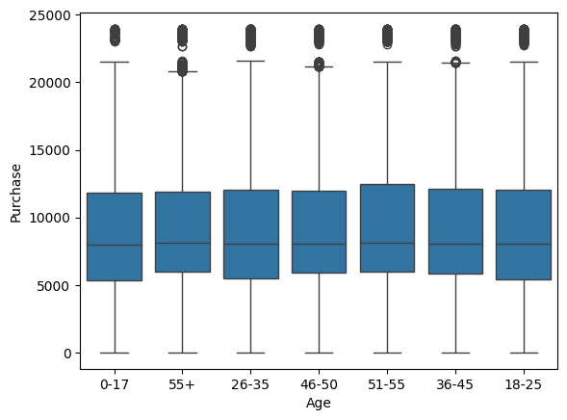
The boxplot compares purchase distributions across age groups. The groups have overlapping distributions, while high-value outliers occur in several categories.
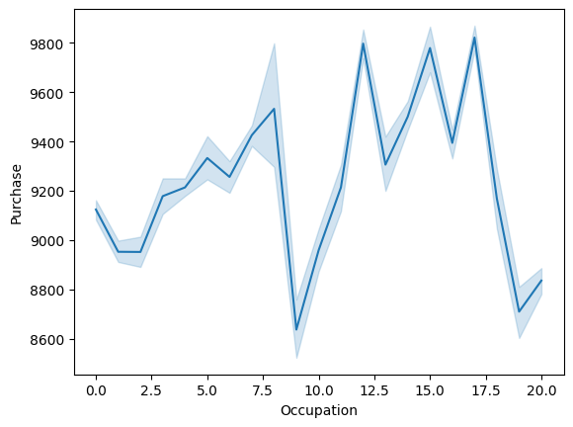
The line plot shows variation in purchase across occupation codes. Differences between categories suggest that occupation may contain useful information, but the numeric codes are categorical labels.
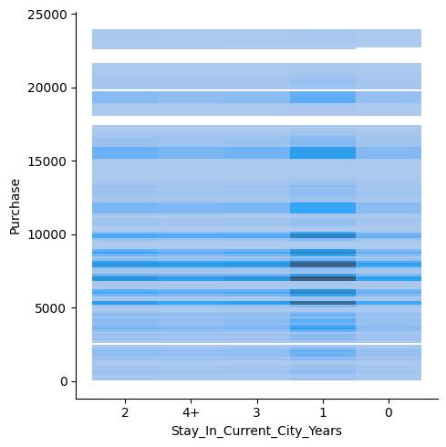
The distribution plot compares purchase values across different residential-tenure categories. It shows how purchase values are distributed based on the number of years customers have stayed in their current city. It can be observed that customers who have stayed in the city for 1 year show a higher distribution of purchase values compared with the other categories.
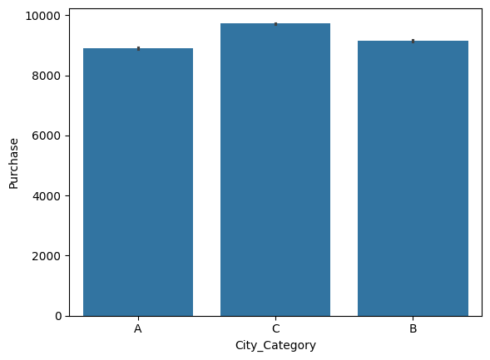
The bar plot compares purchase amount across city categories. City Category C has the highest average purchase, followed by B and A.
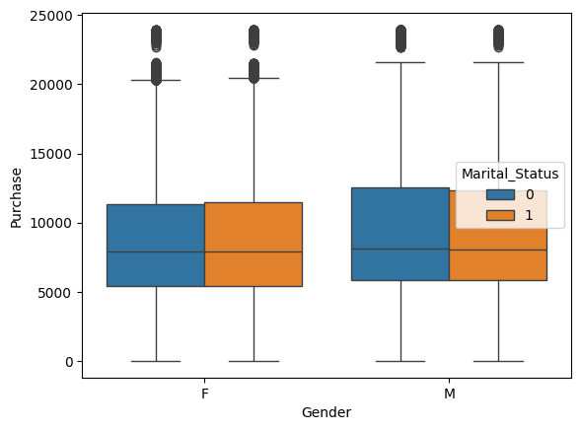
The boxplot combines gender with marital status. It allows the viewer to compare purchase distributions within demographic subgroups rather than considering gender or marital status separately.
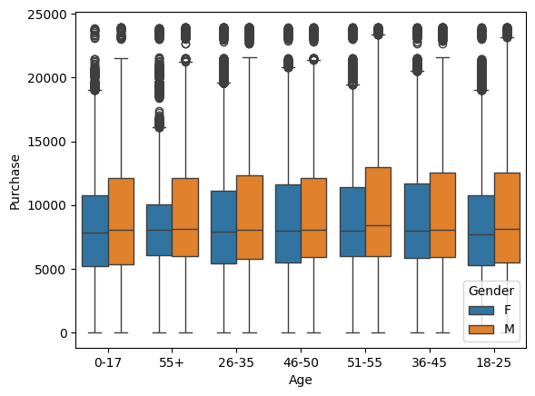
The boxplot compares age groups while separating the results by gender. It provides a more detailed view of how purchase distributions differ across combinations of age and gender.
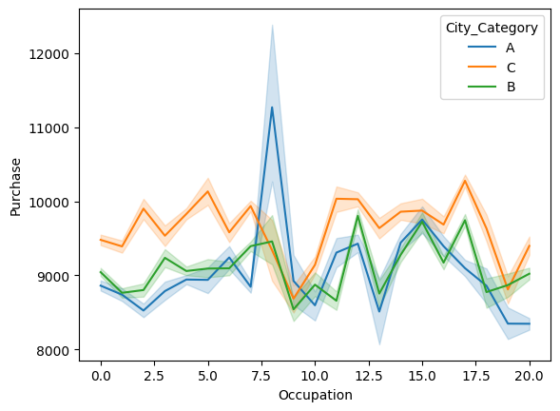
The line plot combines occupation and city category while showing purchase. It provides a multivariate view of how purchase levels vary across occupation groups within different city categories.
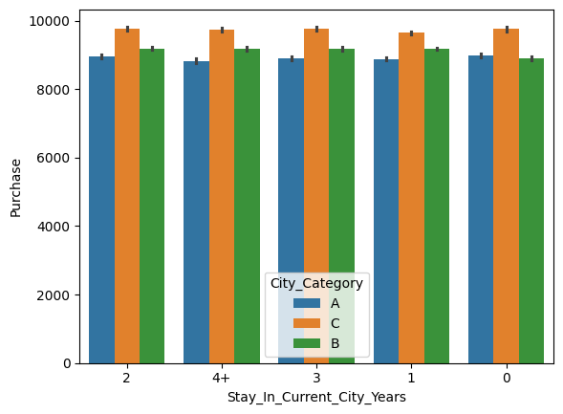
The bar plot compares purchase across residential-tenure categories and city categories. It helps identify whether the relationship between residence duration and purchase differs by city category.
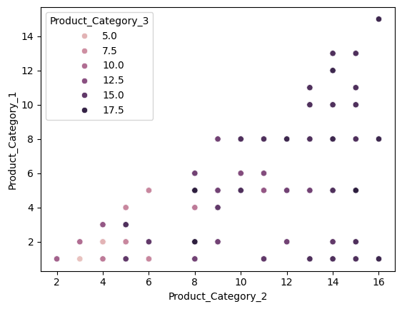
The scatter plot compares Product_Category_2 and Product_Category_1 and uses Product_Category_3 as an additional grouping variable. It provides a visual check of how product-category combinations are distributed.

2.3 Train-Test Split
The target variable, Purchase, was separated from the input features, and 80/20 train-test split was applied using random_state=42. This resulted in 440,054 observations in the training set and 110,014 observations in the test set.
2.4 Feature Pre-processing and Scaling
2.4.1 Remove Identifiers:
User_ID and Product_ID are dropped because they are identifiers and are not used as predictive features.
2.4.2 Transform Residence Variable:
The 4+ category in Stay_In_Current_City_Years is replaced with 4 to convert the variable into a numerical format.
2.4.3 Feature Engineering:
A new Product_Hierarchy feature is created by combining Product_Category_1, Product_Category_2, and Product_Category_3.
2.4.4 Age Feature Encoding – Ordinal Encoding:
The Age variable is ordinal encoded according to the following order: 0-17, 18-25, 26-35, 36-45, 46-50, 51-55, and 55+.
2.4.5 Missing Values Treatment:
Missing values in Product_Category_2 and Product_Category_3 are replaced with 0 using SimpleImputer.
2.4.6 One-Hot Encoding:
Categorical variables, including Gender, City_Category, and the product-category variables, are converted into numerical features using one-hot encoding.
2.4.7 Feature Scaling – Standard Scaler:
StandardScaler is applied to the transformed features to standardize their numerical scales before model training.
2.4.8 Linear Regression Model:
LinearRegression is fitted as the final estimator to predict the Purchase amount.

2.5 Linear Regression Model – Machine Learning Pipeline
The preprocessing operations and LinearRegression model are combined into a single scikit-learn Pipeline. This ensures that the same transformations are applied consistently during training and prediction.

2.6 Model Evaluation and Report
Metric | Result | Interpretation
MAE | 2,208.91 | The average absolute prediction error is about $2,209.
RMSE | 2,946.09 | Larger errors receive greater penalty; the value is higher than MAE.
Test R² | 0.6546 | About 65.5% of purchase variation is explained on unseen test data.
Train R² | 0.6619 | Training performance is close to test performance.

The relatively small difference between the training R² of 0.6619 and testing R² of 0.6546 suggests that the model does not show a large train-test performance gap. This indicates reasonable generalisation, although the remaining prediction error means the model should be used as decision support rather than as an exact predictor.
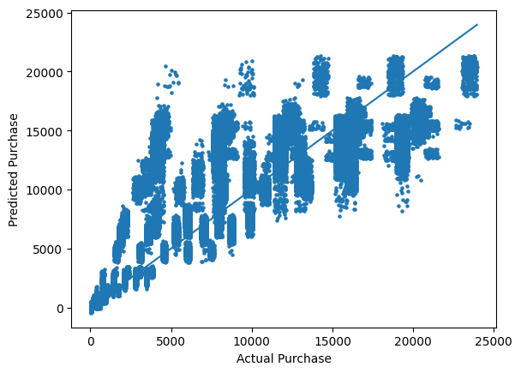
The actual-versus-predicted scatter plot compares the model's estimates with observed purchase values. Observations closer to the diagonal reference line represent more accurate predictions, while points farther from the line indicate larger errors.

2.7 Prediction for New Customers
The test.csv file contains 233,599 records and 11 predictor columns. The trained pipeline predicts a purchase amount for each new record. The predicted values are rounded to integers and added as a new Purchase column before being exported to predicted_purchase.csv.

3. Task 3 – Analytical Report
3.1. How does predicting the purchases for new customers help the business?
Predicting purchases for new customers can help the company estimate how much a customer is likely to spend during the Black Friday sales period, even before the actual purchase is made. In this analysis, the Linear Regression model uses customer and product-related characteristics to predict the Purchase amount. The trained model was then applied to the 233,599 records in the test dataset, generating a predicted purchase value for each record.
This is particularly relevant to Black Friday because the company has to prepare for a period of high customer activity within a relatively short sales window. Before the sale begins, the business needs to make decisions about products, promotions, stock levels, and which customer groups should receive greater attention. Having an estimated purchase value for new customer records gives the company another source of information that can be considered when making these decisions.
One useful application is understanding potential spending across different customer profiles. The model does not predict purchases using a single characteristic. Instead, it uses the customer and product-related features that were included in the modelling process. This means that the predicted purchase amount provides an estimate based on the combination of information available for a particular customer transaction. During Black Friday, this could help the company identify customer records associated with relatively higher or lower expected purchase values.
The prediction results can also be considered together with the patterns identified through the Power BI analysis. For example, the Product Category Distribution analysis found that Product Categories 5, 1, and 8 together account for more than 50% of total purchases. This indicates that these categories have a particularly large representation in the Black Friday sales data. If purchase predictions also indicate strong expected spending for transactions involving these categories, the company could give additional attention to their availability and promotion during the Black Friday period.
Another important finding is related to customer demographics. The analysis shows that male customers account for more than 50% of total transactions, while customers aged 26-45 contribute the highest number of transactions. The marital-status analysis further shows that unmarried customers account for approximately 59% of total transactions. These results help the company understand which customer groups are most strongly represented during Black Friday. When combined with predicted purchase amounts, they can provide a more useful picture of where customer spending may be concentrated.
The prediction model can also support Black Friday inventory planning. If the predicted purchase values are aggregated across a large number of new customer records, they could provide an indication of the level of potential sales represented by those records. This information could be considered alongside the historical transaction patterns found in the dataset. For example, greater attention could be given to product categories that already account for a large share of purchases, particularly Categories 5, 1, and 8. The aim would not be to assume that every predicted purchase will occur exactly as estimated, but to use the predictions as an additional input when preparing stock for the Black Friday event.
The analysis can also help the company understand where customer activity is concentrated and where it is more evenly distributed. For example, the occupation analysis shows that transactions are fairly evenly distributed across many occupation categories, with no single occupation dominating the transaction activity. This suggests that occupation alone may not provide as strong a basis for focusing Black Friday activities as some of the other customer characteristics identified in the analysis.
At the same time, the model has limitations that need to be considered when using its predictions. The Linear Regression model achieved a Test R² of 0.6546, meaning that approximately 65.5% of the variation in purchase amounts is explained by the model on unseen test data. The model also achieved a MAE of 2,208.91, meaning that the average absolute difference between the predicted and actual purchase values is approximately 2,209. Therefore, the predictions should not be interpreted as exact amounts that customers will spend.
The relatively small difference between the training R² of 0.6619 and the test R² of 0.6546 suggests that the model does not have a large train-test performance gap and provides reasonable generalisation to unseen observations. However, the report also notes that the remaining prediction error means the model should be used as decision support rather than an exact predictor.
Overall, the purchase prediction model gives the company an additional way to prepare for the Black Friday sales event. The company can combine predicted purchase values with the actual patterns identified from the sales data to better understand potential customer spending, focus attention on important product categories, and support inventory and promotional planning. The Power BI analysis shows where transaction activity is concentrated, while the regression model adds an estimate of purchase value for new records. Together, these results can help the business make more informed Black Friday decisions while recognising that individual purchase predictions will still contain some uncertainty.

3.2. How could the result of your analysis help the company make better decisions?
The results of this analysis can help the company make better decisions during the Black Friday sales period by providing a clearer understanding of customer transaction patterns, product demand, and expected purchase behaviour. Rather than looking at the total sales amount alone, the analysis examines different customer and product characteristics and shows where transaction activity is concentrated. These findings can help the company decide where to focus its products, promotions, and resources during Black Friday.
One of the most important findings is the Product Category Distribution. The analysis shows that Product Categories 5, 1, and 8 together account for more than 50% of total purchases. This suggests that these three categories represent a particularly large share of customer purchasing activity. For Black Friday planning, the company could give greater attention to these product categories when deciding which products require stronger stock availability or promotional visibility. Focusing on categories that already have a large share of purchases could help the company respond better to customer demand during the sales event.
The demographic analysis also provides useful information for customer-focused Black Friday marketing. The gender dashboard shows that male customers account for more than 50% of total transactions, indicating that transaction activity is higher among male customers than female customers. This does not mean that female customers should be ignored, but it gives the company an indication of where a larger proportion of transaction activity is coming from in the analysed dataset.
Age is another important factor. The area chart shows that customers aged 26-45 contribute the highest number of transactions, making this the most active age range in the dataset. This information could help the company when designing its Black Friday campaigns. For example, the business could examine whether promotions aimed at this age range generate stronger customer engagement and purchasing activity. The ribbon chart provides further detail by combining age and gender, showing that male customers contribute more transactions than female customers across all age groups, with the 26-35 age group having the highest transaction activity. Male customers in this group account for 168,835 transactions in the dashboard.
The marital-status analysis provides another useful customer insight. Unmarried customers account for approximately 59% of total transactions, compared with 41% for married customers. This gives the company another way of understanding the composition of its Black Friday customers. When considered together with age and gender, this information could help the business investigate which combinations of customer characteristics are associated with greater transaction activity.
The analysis also provides insight into customer location and residential tenure. The City Category dashboard compares transaction activity across Categories A, B, and C, allowing the company to see how transaction activity is distributed between these locations. In the notebook analysis, City Category C has the highest average purchase, followed by B and A. This could be useful when considering how Black Friday activities are distributed across different city categories. Similarly, the distribution analysis shows that customers who have stayed in the city for 1 year have a higher distribution of purchase values compared with the other residential-tenure categories.
Another useful finding comes from the occupation analysis. The transactions are fairly evenly distributed across many occupation categories, with no single occupation dominating the overall transaction activity. This means that the company does not have strong evidence from this analysis to focus its Black Friday strategy on one particular occupation. Instead, other characteristics, such as age, gender, marital status, city category, and product category, provide more noticeable patterns in the analysed data.
The Linear Regression model adds a predictive element to these findings. The model achieved a Test R² of 0.6546 and a MAE of 2,208.91. The Test R² indicates that approximately 65.5% of the variation in purchase amounts is explained by the model, while the MAE shows that the average absolute prediction error is around 2,209. These results suggest that the model can provide useful purchase estimates, but the company should not treat individual predictions as exact values.
The combination of the descriptive and predictive analysis is therefore particularly useful for Black Friday decision-making. The Power BI analysis explains what customer and product patterns are present in the sales data, while the regression model provides estimated purchase amounts for new records. For example, the company can use the identified high-activity customer groups and high-representation product categories as areas for further investigation, while using the model's purchase estimates as an additional input when considering expected sales activity.
Overall, the analysis gives the company several specific areas to consider when planning future Black Friday sales. The strong representation of Product Categories 5, 1, and 8 can inform product planning, the high transaction activity among customers aged 26-45 can inform customer analysis, and the results for gender, marital status, city category, and residential tenure provide additional information about the customer base. At the same time, the occupation results show where there is less evidence for strong concentration. By combining these findings with the purchase predictions, the company can make its Black Friday planning more evidence-based while still recognising that patterns from the analysed dataset may not exactly repeat in every future sales event.

