BLACK FRIDAY SALES ANALYSIS
By Simran, Student ID: 20262054

This report presents the complete analysis of the Black Friday retail sales dataset. It combines the Power BI visualizations and the implemented linear regression Model.
The analysis uses a retail Black Friday sales dataset containing 550,068 transaction records and 12 columns describing customers, products, location, demographics and purchase amount.
- Task 1 uses Power BI dashboards to visualize product-category distribution and relationships between transaction activity and customer characteristics.
- Task 2 develops a multivariable linear regression model in Python to predict Purchase.
- Task 3 discusses how these predictions and analytical findings can support business decisions.
The Linear regression model achieved a Mean Absolute Error (MAE) of 2,208.91, Root Mean Squared Error (RMSE) of 2,946.09 and R² of 0.6546. The training R² was 0.6619, close to the test R², suggesting the model generalizes reasonably well to unseen observations.

1. Task 1 - Visualization
  - Product Category Distribution

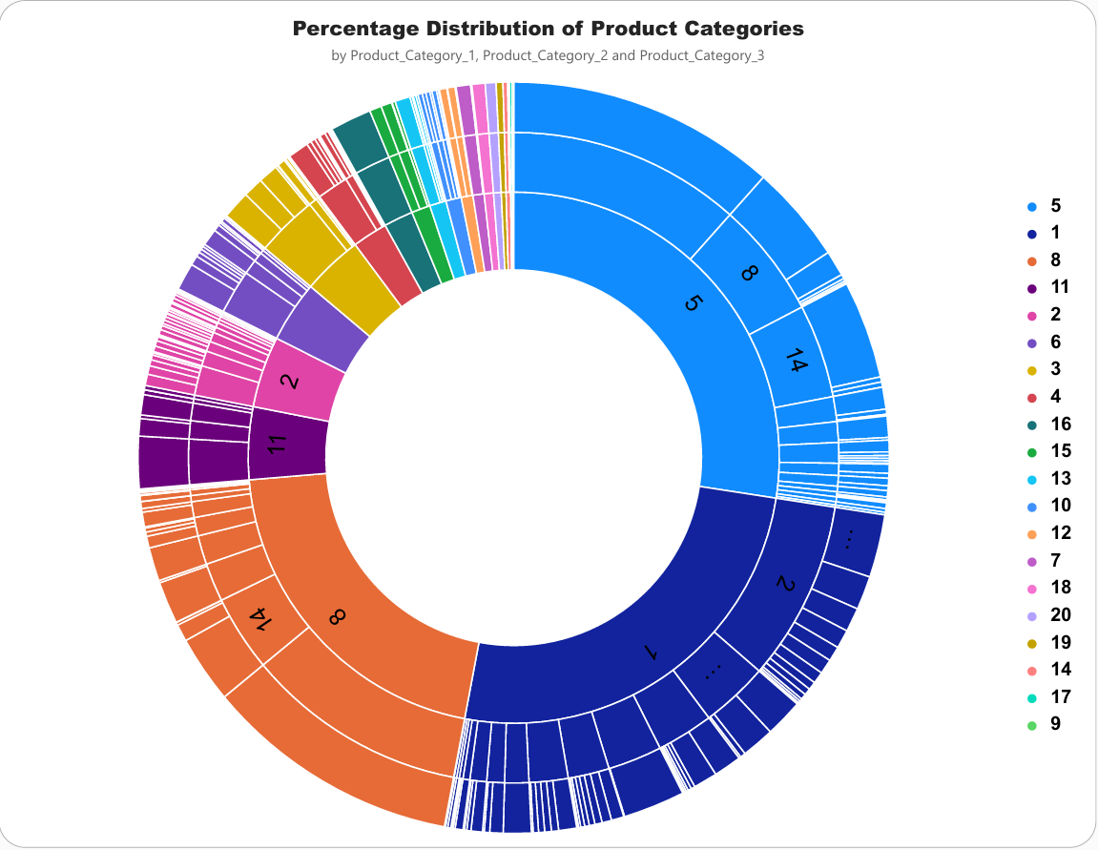
The Product Category Distribution uses a sunburst visual with Product_Category_1, Product_Category_2 and Product_Category_3 as hierarchical levels. This visual shows the relative contribution of product categories as a percentage.
The analysis shows that Product_Category_1 categories 5, 1, and 8 account for more than 50% of the total purchases, indicating that these three product categories represent the largest share of customer purchases.
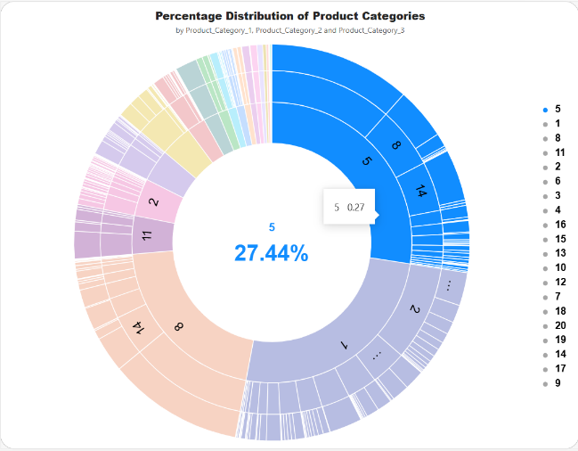
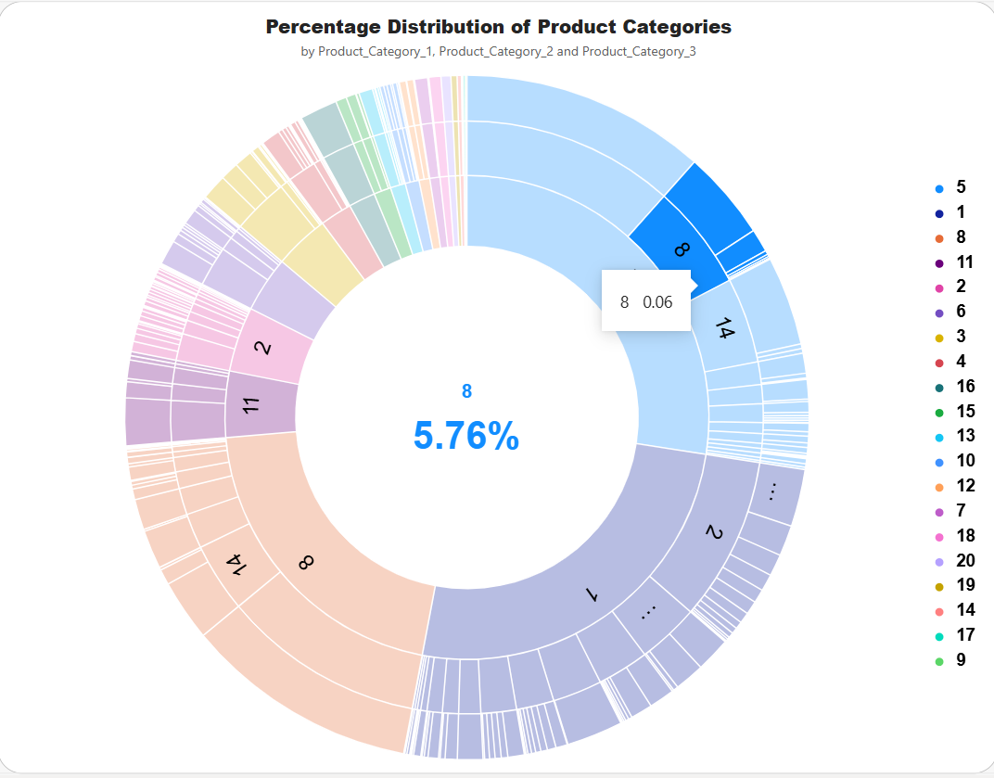
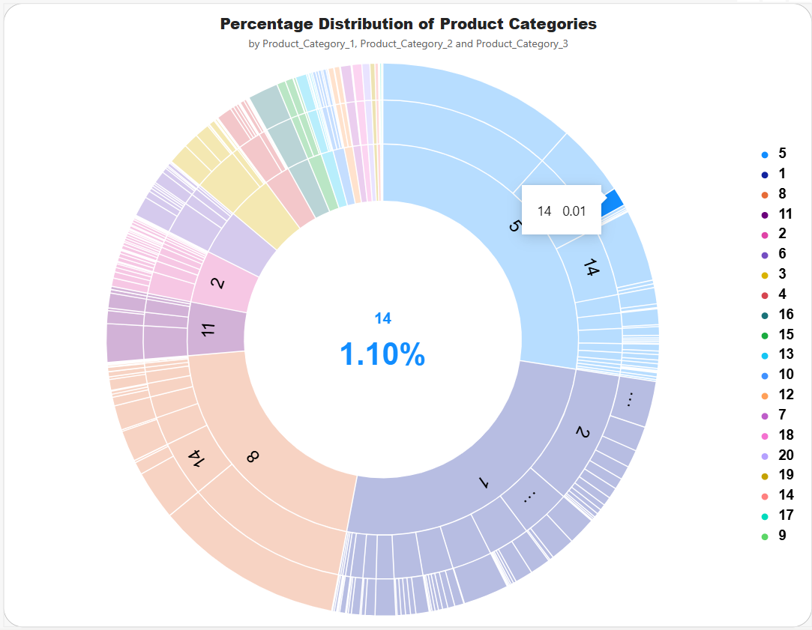
The sunburst format is appropriate for showing hierarchical category structure because it allows the viewer to see both the broad product-category level and the nested category relationships. This can help the business identify which product categories have the greatest representation in the sales data and where product demand is concentrated.

1.2 Transaction Comparison with Demographic Features
1.2.1 Gender and Number of Transactions:
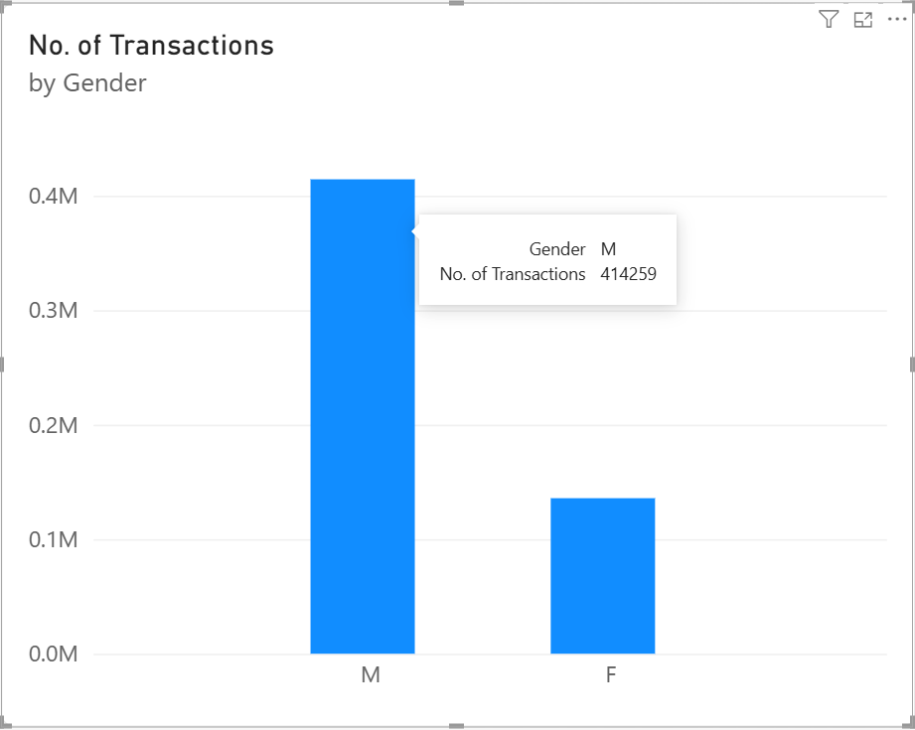
The column chart compares the number of transactions between male and female customers. Male customers account for more than 50% of total transactions, indicating higher transaction activity among male customers than female customers.

1.2.2 Age and Number of Transactions:
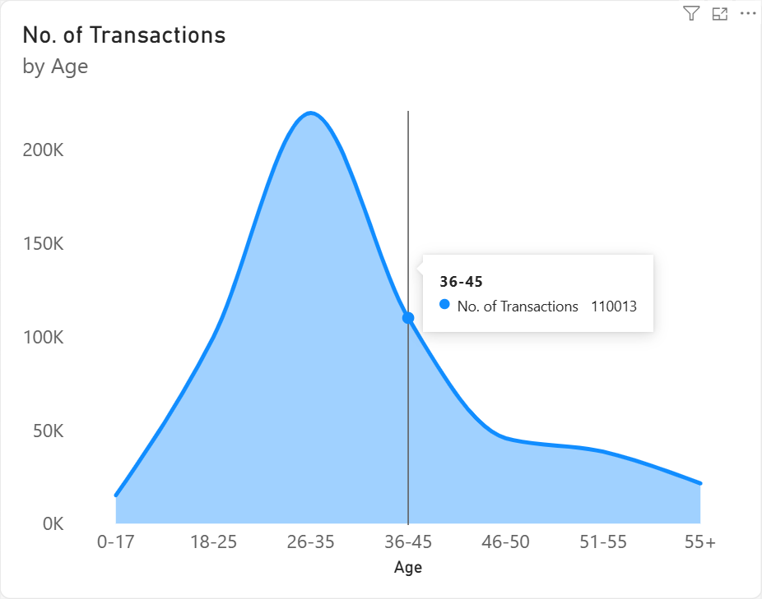
The area chart displays transaction activity across the seven age groups. It highlights the differences in transaction volume among the age categories. It can be observed that customers aged 26-45 contribute the highest number of transactions, indicating that this age range represents the most active customer group in the dataset.

1.2.3 Occupation and Number of Transactions:
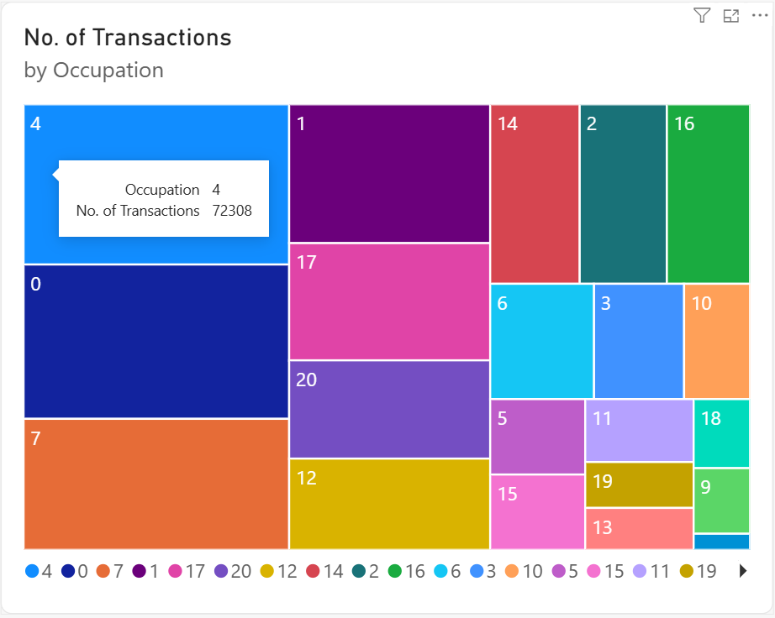
The tree map compares transaction activity across different occupation categories. Larger areas represent occupations with a higher number of transactions, making it useful for identifying the most active occupation groups. It can be observed that transactions are fairly evenly distributed across many occupation categories, with no single occupation dominating the overall transaction activity.

1.2.4 City Category and Number of Transactions:
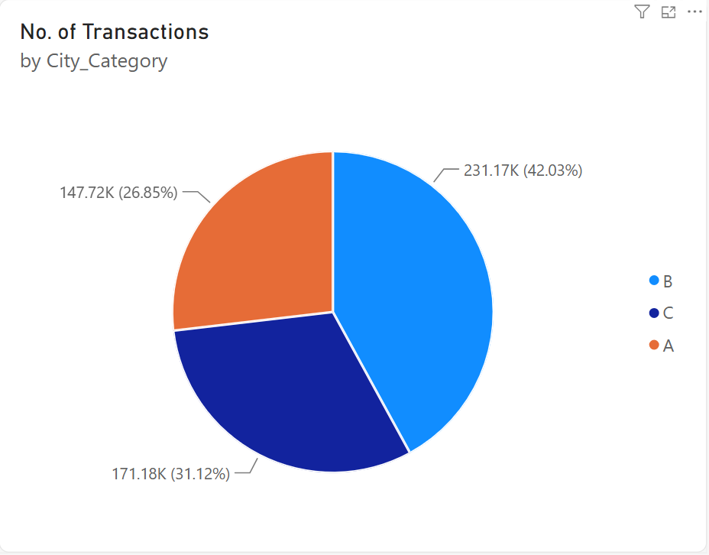
The pie chart compares transaction activity across City Categories A, B, and C. It shows the relative contribution of each city category to the overall transaction activity, making it useful for understanding differences in customer activity across locations.

1.2.5 Marital Status and Number of Transactions:
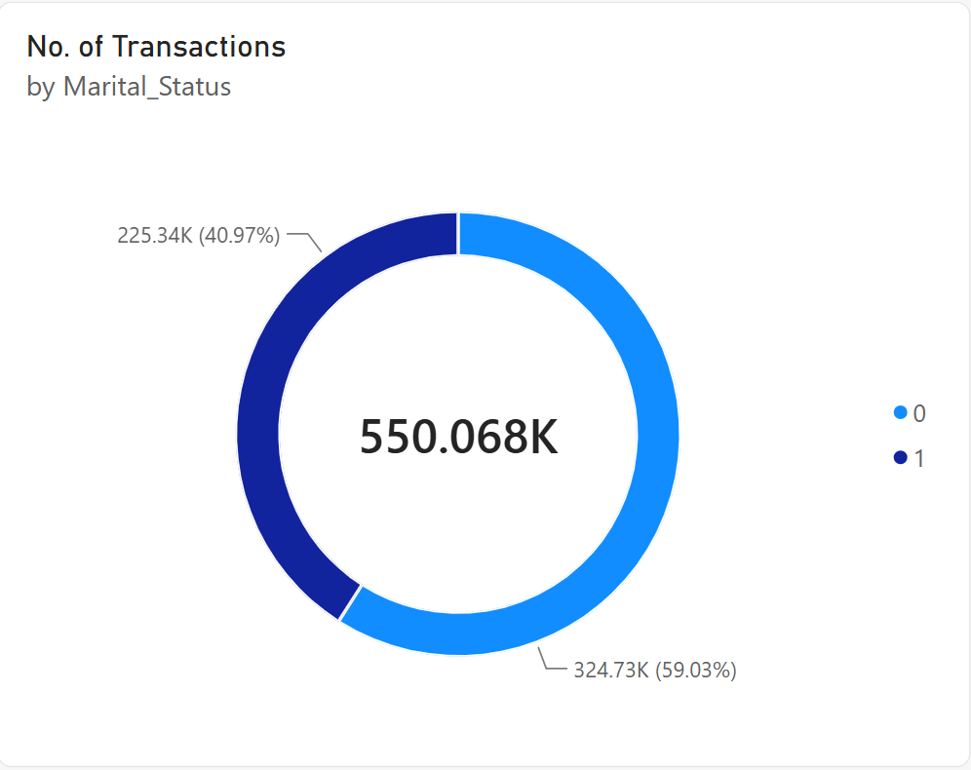
The Donut chart compares transaction activity between married and unmarried customers. It can be observed that unmarried customers dominate the transaction activity, accounting for approximately 59% of the total transactions, while married customers account for the remaining 41%.

1.2.6 Number of Transactions by Age and Gender:
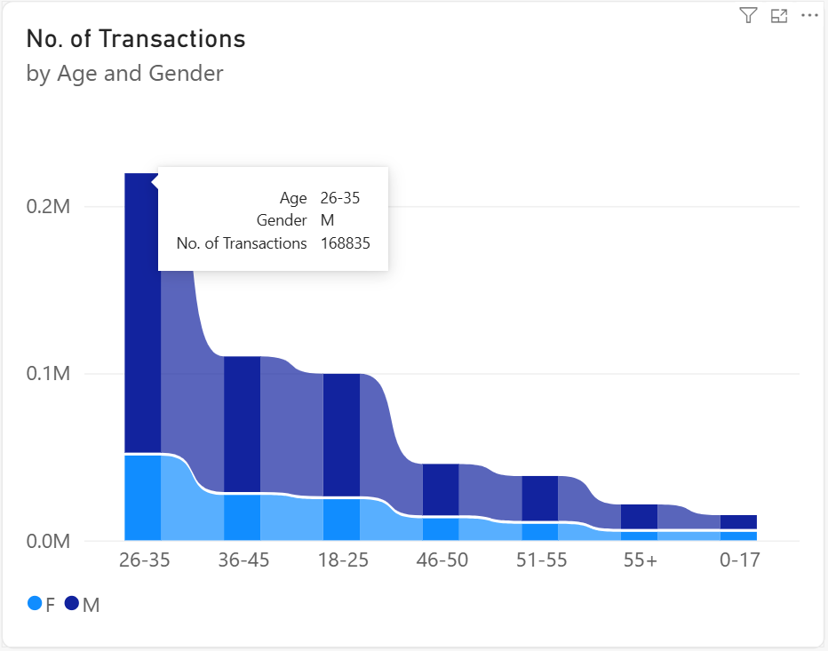
The ribbon chart compares transaction activity across different age groups while separating the results by gender. It can be observed that male customers contribute more transactions than female customers across all age groups. The 26–35 age group has the highest transaction activity, with male customers accounting for 168,835 transactions, as shown in the chart.

2. Task 2 - Linear Regression Model
2.1 Initial Data Analysis
- The dataset contains 550,068 observations and 12 columns.
- Product_Category_2 contains 173,638 missing values.
- Product_Category_3 contains 383,247 missing values.
- There are no duplicate rows present in the raw dataset.
- Purchase has no missing values and is used as the regression target.
- User_ID and Product_ID are treated as identifiers rather than predictive features.

2.2 Exploratory Data Analysis
2.2.1 Univariate Analysis
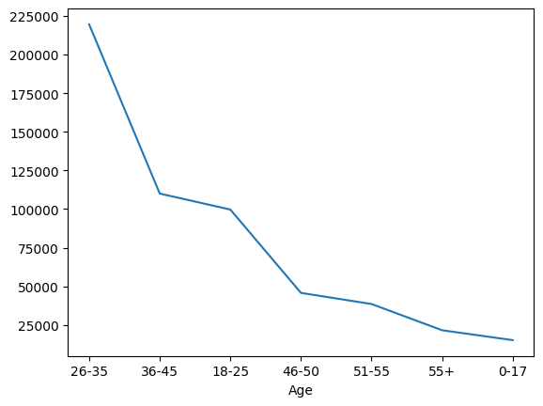
The line chart shows the number of records in each age group. It provides an overview of how transaction observations are distributed across the age categories.
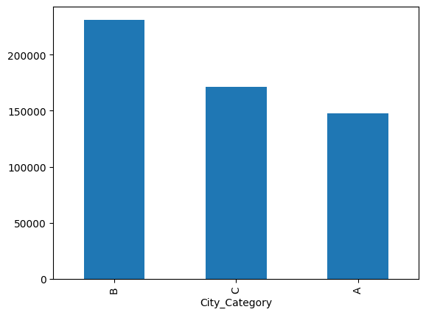
The bar chart compares the frequency of City Categories A, B and C. It shows how transaction observations are distributed geographically across the three city categories
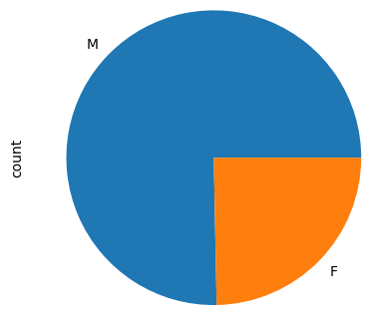
Gender Distribution
The pie chart shows the proportion of records belonging to each gender category. It provides a simple view of the gender composition of the dataset.
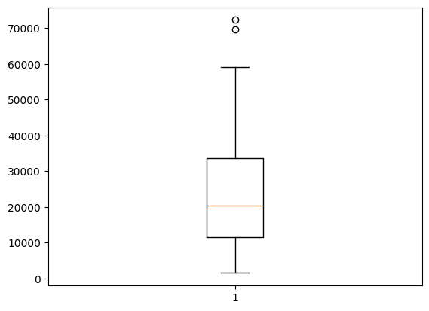
Occupation Frequency
The plot summarizes the frequency associated with the occupation categories. Because occupation is represented by numeric codes, the codes should be interpreted as categories rather than as a continuous ranking.
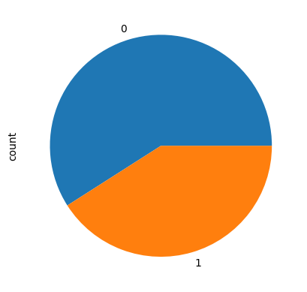
Marital Status Distribution
The pie chart shows the distribution of the two marital-status categories. It helps describe the demographic composition of the transaction dataset.
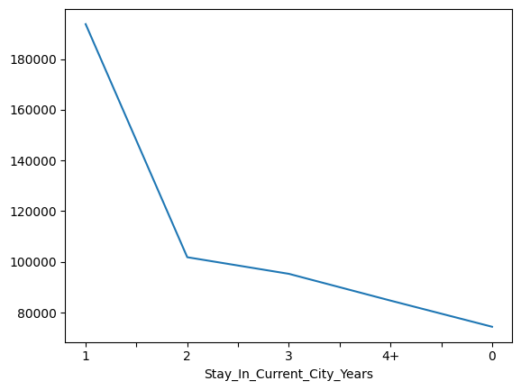
The line chart shows transaction frequency across the categories representing years spent in the current city. It provides a simple view of residential tenure among the customers.

2.2.2 Bivariate / Multivariate Analysis
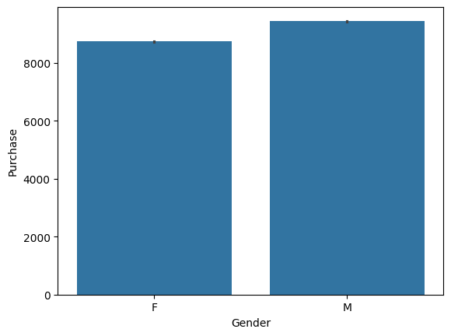
The bar plot compares purchase amount across gender. The notebook's visualisation shows a somewhat higher purchase level for male customers, although the difference should be considered alongside other customer characteristics.
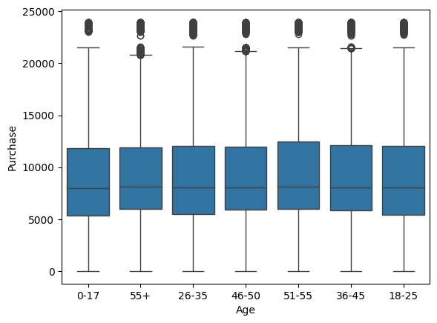
The boxplot compares purchase distributions across age groups. The groups have overlapping distributions, while high-value outliers occur in several categories.
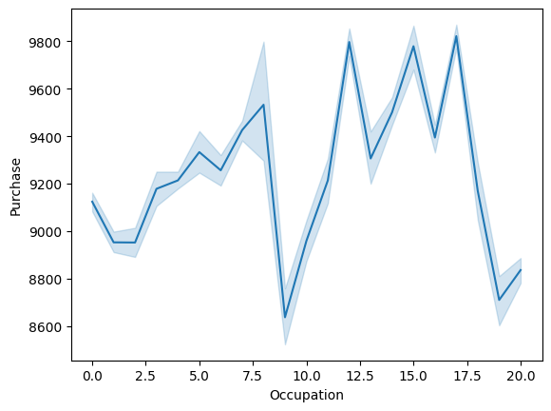
The line plot shows variation in purchase across occupation codes. Differences between categories suggest that occupation may contain useful information, but the numeric codes are categorical labels.
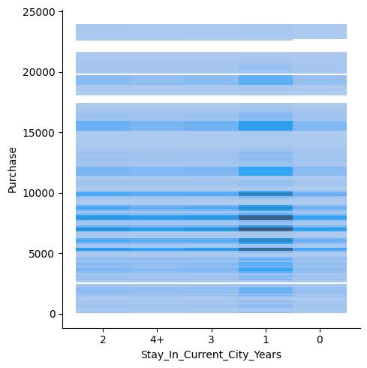
The distribution plot compares purchase values across different residential-tenure categories. It shows how purchase values are distributed based on the number of years customers have stayed in their current city. It can be observed that customers who have stayed in the city for 1 year show a higher distribution of purchase values compared with the other categories.
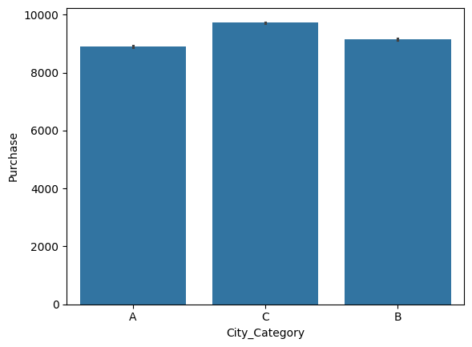
The bar plot compares purchase amount across city categories. City Category C has the highest average purchase, followed by B and A.
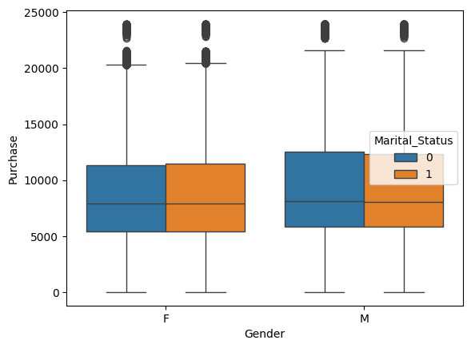
The boxplot combines gender with marital status. It allows the viewer to compare purchase distributions within demographic subgroups rather than considering gender or marital status separately.
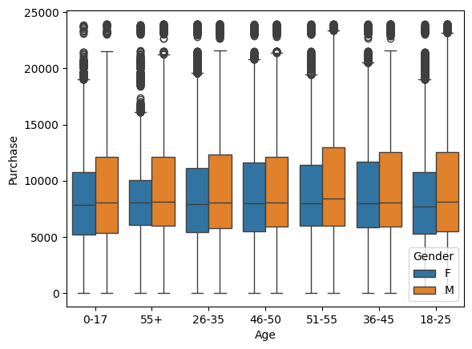
The boxplot compares age groups while separating the results by gender. It provides a more detailed view of how purchase distributions differ across combinations of age and gender.
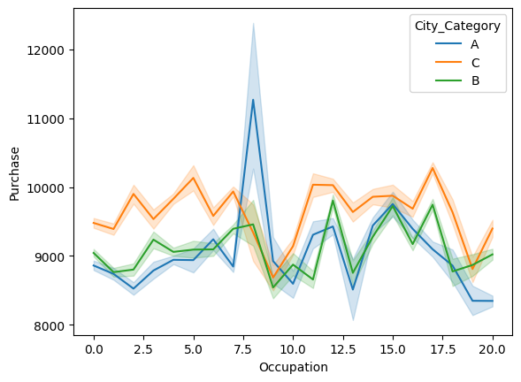
The line plot combines occupation and city category while showing purchase. It provides a multivariate view of how purchase levels vary across occupation groups within different city categories.
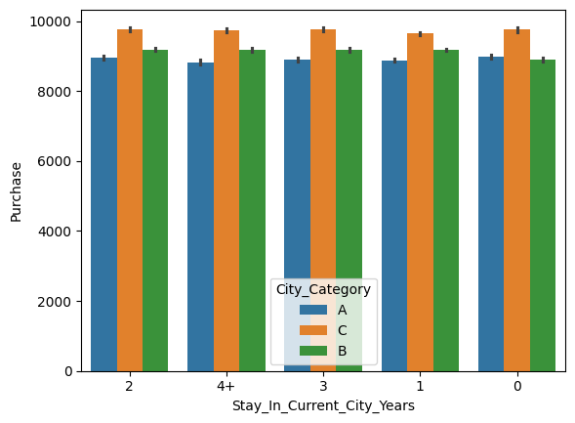
The bar plot compares purchase across residential-tenure categories and city categories. It helps identify whether the relationship between residence duration and purchase differs by city category.
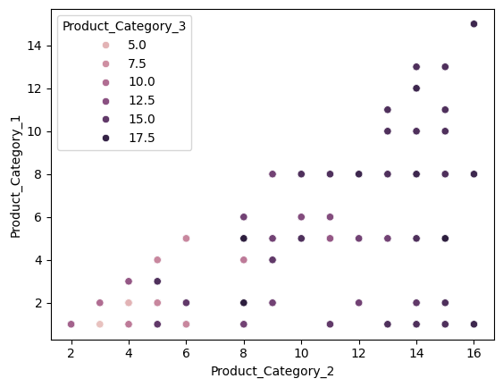
The scatter plot compares Product_Category_2 and Product_Category_1 and uses Product_Category_3 as an additional grouping variable. It provides a visual check of how product-category combinations are distributed.

2.3 Train-Test Split
The target variable, Purchase, was separated from the input features, and 80/20 train-test split was applied using random_state=42. This resulted in 440,054 observations in the training set and 110,014 observations in the test set.
2.4 Feature Pre-processing and Scaling
2.4.1 Remove Identifiers:
User_ID and Product_ID are dropped because they are identifiers and are not used as predictive features.
2.4.2 Transform Residence Variable:
The 4+ category in Stay_In_Current_City_Years is replaced with 4 to convert the variable into a numerical format.
2.4.3 Feature Engineering:
A new Product_Hierarchy feature is created by combining Product_Category_1, Product_Category_2, and Product_Category_3.
2.4.4 Age Feature Encoding – Ordinal Encoding:
The Age variable is ordinal encoded according to the following order: 0-17, 18-25, 26-35, 36-45, 46-50, 51-55, and 55+.
2.4.5 Missing Values Treatment:
Missing values in Product_Category_2 and Product_Category_3 are replaced with 0 using imputation.
2.4.6 One-Hot Encoding:
Categorical variables, including Gender, City_Category, and the product-category variables, are converted into numerical features using one-hot encoding.
2.4.7 Feature Scaling – Standard Scaler:
StandardScaler is applied to the transformed features to standardize their numerical scales before model training.
2.4.8 Linear Regression Model:
LinearRegression is fitted as the final estimator to predict the Purchase amount.

2.5 Linear Regression Model – Machine Learning Pipeline
The preprocessing operations and LinearRegression model are combined into a single scikit-learn Pipeline. This ensures that the same transformations are applied consistently during training and prediction.

2.6 Model Evaluation and Report
Metric | Result | Interpretation
MAE | 2,208.91 | The average absolute prediction error is about $2,209.
RMSE | 2,946.09 | Larger errors receive greater penalty; the value is higher than MAE.
Test R² | 0.6546 | About 65.5% of purchase variation is explained on unseen test data.
Train R² | 0.6619 | Training performance is close to test performance.

The relatively small difference between the training R² of 0.6619 and testing R² of 0.6546 suggests that the model does not show a large train-test performance gap. This indicates reasonable generalisation, although the remaining prediction error means the model should be used as decision support rather than as an exact predictor.
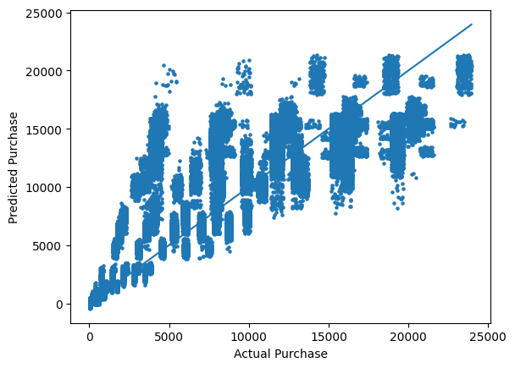
The actual-versus-predicted scatter plot compares the model's estimates with observed purchase values. Observations closer to the diagonal reference line represent more accurate predictions, while points farther from the line indicate larger errors.

2.7 Prediction for New Customers
The test.csv file contains 233,599 records and 11 predictor columns. The trained pipeline predicts a purchase amount for each new record. The predicted values are rounded to integers and added as a new Purchase column before being exported to predicted_purchase.csv.

3. Task 3 – Analytical Report
3.1. How does predicting the purchases for new customers help the business?
Here answer

3.2. How could the result of your analysis help the company make better decisions?

