**DOCURE**

**INTRODUCTION –**

This report provides a comprehensive overview of the development progress, challenges encountered, significant changes from the initial pitch, key features, tools and technologies used, collaboration methodologies, MoSCoW analysis, data flow diagram, use case diagram, and conclusion regarding the Docure healthcare solution prototype.

**DEVELOPMENT PROGRESS –**

The development of the Docure healthcare solution prototype has been a significant milestone in itself. The project's main objective is to create a functional prototype that showcases the core features envisioned during the initial pitch. The prototype development can be broken down into the following phases:

1. **Conceptualization:** The initial conceptualization of the Docure healthcare solution marked the birth of a visionary project. The team set out with a crystal-clear mission: to create a healthcare solution that simplifies and streamlines patient interactions within the complex healthcare landscape. This conceptualization phase was marked by the delineation of core features, each carefully crafted to cater to the multifaceted needs of patients and healthcare providers. The emphasis was placed on four fundamental pillars: appointment scheduling, granting users access to invaluable medical insights, providing doctor recommendations when needed, and delivering personalized wellness advice. The vision was to empower users with a platform that not only facilitates their healthcare journey but also empowers them with data-driven information and guidance.
2. **Prototyping:** The pivotal phase of prototyping served as the proving ground for the project's conceptualized features. Rapid prototyping was the method of choice, enabling the creation of a rudimentary version of the platform. The primary objective here was to assess the feasibility of these core features. It was an iterative process, driven by the need to gauge the practicality and functionality of the envisioned platform. Early on, the focus was on creating a basic version of the solution, which could then serve as a platform for gathering invaluable user feedback. This feedback would, in turn, guide the development process and shape the future of the healthcare solution.
3. **Feature Refinement:** Feedback obtained during the prototype stage played a pivotal role in refining and perfecting the core features. The iterative process aimed to enhance the accuracy and reliability of the automated insights, doctor recommendations, and the overall user experience. Every piece of user feedback, whether highlighting strengths or pointing out areas for improvement, was invaluable. It was in this phase that the rough edges were smoothed, and the core features were refined to ensure that they met the high standards set for the project. The focus was not just on functionality but on ensuring that users could trust the information provided by the system.
4. **User Testing:** The user testing phase was a critical juncture in the project's development. A carefully selected group of users actively participated in the testing phase, offering their first-hand insights into the functionality and usability of the prototype. Their involvement provided a real-world perspective on how the healthcare solution would be experienced by its intended users. Through this process, the project received an invaluable stream of user-driven input, helping to uncover strengths, weaknesses, and opportunities for enhancement. This feedback loop was instrumental in shaping the subsequent stages of development, ensuring that the project aligned with the actual needs and preferences of its users.
5. **Iterative Development:** The project's commitment to user-centric design and functionality was evident in the adoption of an iterative development approach. This method allowed for ongoing improvements, ensuring that the healthcare solution evolved in response to user feedback, design enhancements, and functional adjustments. With each iteration, the project inched closer to its goal of creating a healthcare platform that was both user-friendly and technologically robust. It was a dynamic process, characterized by adaptability and an unwavering commitment to excellence.
6. **Focus on Security:** Data security and privacy considerations were paramount even in the prototype stage. While the project was in its early phases, the team laid the groundwork for robust data protection measures. This commitment to security was not merely a checkbox but a fundamental principle. Data security, especially in the healthcare domain, required meticulous planning and adherence to the highest standards. The focus on security encompassed everything from data encryption to access control, ensuring that user data remained private and protected throughout the healthcare solution's development. Data security was not an afterthought but an integral part of the project's DNA, reflecting the team's dedication to the trust and well-being of its user

**CHALLENGES -**

While in the prototype stage, the Docure project encountered several challenges that provided valuable insights:

1. **User Engagement:** Encouraging user engagement with a healthcare prototype emerged as a formidable challenge. While the project held great potential, motivating users to actively participate and provide feedback was not a straightforward task. The complexity of healthcare-related solutions, combined with users' natural hesitancy in adopting new platforms, underscored the need for incentives or a compelling value proposition. The challenge was to communicate the prototype's potential benefits effectively and encourage users to invest their time and insights into shaping its development.
2. **Usability:** The usability of the prototype was a central challenge. Crafting an interface that catered to users with varying levels of tech-savviness required careful consideration. The diverse user base had varying comfort levels with technology, and the goal was to make the platform intuitive and accessible to all. Streamlining the user experience became a top priority, and it was essential to ensure that users could easily navigate the platform and derive value from it without feeling overwhelmed. Usability issues, if not addressed, could deter users and impede the project's progress.
3. **Data Integration:** Basic data integration tests unveiled the intricacies of interfacing with healthcare institutions. These entities often employed varying data formats and systems, each with its unique complexities. This challenge highlighted the need for flexibility and adaptability in data integration. Ensuring that the platform could effectively communicate and integrate with a multitude of healthcare providers and systems while maintaining data integrity was a complex task. Solving this challenge was crucial for the project's success as seamless data integration was at the core of its value proposition.
4. **Limited Scalability:** The prototype was initially designed for limited use, which brought about concerns regarding scalability. While the focus during this stage was on testing the functionality and user experience, the challenge of accommodating a larger user base and expanding the platform's reach had not been fully addressed. The prototype's architecture and infrastructure needed to be evaluated and potentially redesigned to ensure that it could support a growing number of users without compromising performance, data security, and user experience. Scalability would be a key factor in the project's success once it transitioned from a prototype to a full-fledged healthcare solution.

**SIGNIFICANT CHANGES FROM INITIAL PITCH -**

At the prototype stage, the core features outlined in the initial pitch have remained largely consistent. However, there have been some changes and adjustments:

1. **Enhanced User Experience:** The user experience, a cornerstone of the project's success, has undergone significant enhancements in response to user feedback. At this stage, the prototype development process focused keenly on refining the user interface and the overall design. The initial concept was solid, but the feedback from users underscored the importance of making the platform more appealing and user-friendly. The design elements, including the layout, colour scheme, and navigational features, have been reconsidered and improved to ensure that users find the platform visually engaging and intuitive. Enhancements in the user experience are vital not only for attracting users but also for retaining them and ensuring that they engage with the platform consistently.
2. **Iterative Development:** The prototype stage has highlighted the paramount importance of iterative development. While the core features were well-defined in the initial pitch, the hands-on experience of working with the prototype underscored the significance of making continuous improvements. Iterative development involves a cyclical process of refinement based on user feedback and insights gained from testing. This approach allows the development team to fine-tune features and functionalities, addressing initial limitations that might not have been apparent in the project's conceptual stages. The iterative process helps the project to evolve and adapt in response to user needs and changing circumstances, ultimately leading to a more robust and user-friendly healthcare solution.

**KEY FEATURES -**

The prototype of Docure includes the following key features:

1. **Appointment Scheduling:** The platform empowers users with the ability to seamlessly schedule appointments with healthcare providers. This feature simplifies the often complex and time-consuming process of accessing healthcare services. Whether it's a routine check-up or a specific medical consultation, users can book appointments at their convenience, reducing the friction that often accompanies healthcare access. It promotes a proactive approach to health management, enabling users to take charge of their well-being.
2. **Automated Insights:** The prototype of Docure goes beyond appointment scheduling to provide users with preliminary automated insights. Drawing from sample medical reports, this feature offers users a valuable glimpse of the kind of information they could receive through the platform. Automated insights provide a window into the power of data-driven healthcare. Users can gain early access to vital information about their health, enabling them to make informed decisions and take proactive steps towards better health.
3. **Doctor Recommendations:** In the event that the platform detects anomalies or concerns within medical reports, it offers users hypothetical doctor recommendations. This feature underscores the platform's potential as a healthcare decision-support tool. It goes beyond data presentation by providing users with actionable guidance. Doctor recommendations empower users to navigate complex medical data and make informed choices about their health. This feature bridges the gap between data and action, enhancing the user's healthcare journey.
4. **Wellness Advice:** Users of the Docure prototype also benefit from access to sample wellness advice. This component of the platform is indicative of its potential to support holistic health and well-being. Wellness advice encompasses a broad range of guidance, from lifestyle recommendations to dietary suggestions, and it encourages users to adopt a proactive stance in maintaining and enhancing their overall health. This feature aligns with the belief that healthcare extends beyond medical treatment and encompasses daily choices that impact well-being.
5. **3rd Party API Integrations:** Third-party MedTech applications like Insurance companies, Blood Banks etc can leverage the Docure API to seamlessly integrate its features into their services, enhancing the overall value they offer to their users. By integrating with Docure, these applications can provide users with the ability to schedule appointments, access automated insights, and receive doctor recommendations based on medical reports. Additionally, they can tap into the benefits of efficient patient management and simplified electronic medical record (EMR) recordkeeping. This integration empowers third-party MedTech applications to provide a more comprehensive and patient-centric healthcare experience, ensuring that their users have access to the full range of Docure's capabilities to optimize their well-being and healthcare management.
6. **Sample Medical Reports:** The prototype offers users an initial understanding of how actual medical data might be displayed and handled within the platform. Sample medical reports serve as a preview of the platform's capabilities in managing and presenting healthcare information. Users can familiarize themselves with the way their medical data is processed and displayed, fostering transparency and trust in the platform's ability to handle sensitive information securely.

**TOOLS AND TECHNOLOGIES USED -**

During the prototype stage, several tools and technologies were employed to create a functional model of Docure:

1. **Project Development:** JIRA and MIRO were used to develop the scrum board.
2. **Wireframes**: In the early stages of our prototype development, we employed Figma to create basic wireframes for our project.
3. **Basic Data Security:** The prototype incorporated basic encryption and security measures to protect user data, even though it was not yet fully compliant with healthcare regulations.
4. **Testing Environments:** Separate testing environments were set up to evaluate the prototype's functionality and usability.

**COLLABORATION METHODOLOGIES -**

Collaboration during the prototype stage has been instrumental in driving the project forward:

1. **Cross-Functional Teams:** Collaboration was fostered through cross-functional teams comprising developers, designers, and domain experts. This holistic approach ensured that the development process took into account not only the technical aspects but also the user experience, domain-specific knowledge, and the overall vision of the project. Cross-functional teams allowed for a comprehensive exploration of the prototype's development, ensuring that all aspects were considered.
2. **Agile Development:** The project adhered to an agile development approach, which enabled flexibility and adaptability in response to changing requirements and emerging challenges. Agile methodologies, such as Scrum or Kanban, facilitated rapid development cycles, frequent reassessment of project priorities, and the ability to pivot quickly. This approach ensured that the project remained nimble and responsive to evolving needs and user feedback.
3. **Regular Feedback Loops:** Frequent feedback loops were established with users, marking a dynamic and user-centric collaboration methodology. These loops allowed for the rapid gathering of user insights, which, in turn, facilitated quick adjustments and improvements. By actively seeking and incorporating user feedback, the project was able to adapt in real time, aligning its development with the actual experiences and expectations of its user base.
4. **Scrum Meetings:** Regular Scrum meetings were held to review progress, address challenges, and plan the next steps. These meetings provided a structured platform for team communication and collaboration. Scrum's emphasis on transparency, inspection, and adaptation ensured that the project stayed on course, made informed decisions, and remained adaptable in the face of evolving requirements and unexpected challenges.
5. **Iterative Development:** The adoption of an iterative development approach was instrumental in shaping the project. It allowed for quick adjustments based on user feedback and the emergence of new challenges. The iterative process ensured that the project evolved and improved over time, maintaining a commitment to user-centric design and functionality. This methodology was a driving force behind the project's adaptability and resilience.
6. **Rapid Prototyping:** Rapid prototyping was a creative and experimental collaboration methodology. It enabled the team to test various design and functionality options rapidly, refining the core features based on the insights gained from these prototypes. This method allowed for innovation and exploration, ensuring that the project's user experience was continually refined and optimized.

**MoSCoW ANALYSIS -**

**Must Have:**

1. **Point of Contact with Doctors/Specialists:** The essential functionality enabling direct communication between users and healthcare professionals, ensuring seamless consultations and interactions.
2. **Diagnostic Abilities:** The core feature facilitating preliminary diagnostics and health assessment to assist users in understanding their health concerns.
3. **Live Updates on Tests/Medical History:** Real-time access to test results and comprehensive medical history, providing users with updated health information for informed decision-making.

**Should Have:**

1. **Scheduling and Calendars:** An important feature allowing users to schedule appointments efficiently, providing convenience and better access to healthcare services.
2. **Health Insights and Tips:** Valuable feature offering health insights and tips for improved wellness, enhancing user engagement and promoting proactive health management.

**Could Have:**

1. **Public Access to Health Records:** Nice-to-have feature allowing public access to health records, enhancing transparency but not crucial for immediate functionality.
2. **AI-Based Diagnostics:** A feature leveraging AI for diagnostics, offering potential future enhancements to health assessment capabilities.

**Won't Have:**

1. **Application for Users and Hospitals:** Features related to creating separate applications for hospitals or specific user databases are outside the current scope.
2. **Database of Users:** The creation of an exclusive user database beyond essential functionalities is not aligned with the immediate objectives.
3. **Document Uploading System:** While useful, this feature is not planned for immediate implementation due to its non-critical nature.
4. **Health Record Data Integration:** Advanced integration beyond fundamental functionalities is not currently planned for immediate development.
5. **Generative AI Insights:** Advanced generative AI capabilities are not considered a priority for the current phase of the project.

The MoSCoW Analysis prioritizes the project's features and elements based on criticality and relevance to the project's immediate objectives. This prioritization ensures a focused approach to the development of the Docure healthcare solution prototype, emphasizing essential functionalities before considering secondary enhancements or non-essential features.

The analysis aids in streamlining project development by guiding the team to concentrate on vital aspects critical to the prototype's success while maintaining flexibility for potential future improvements or additions.

**DATA FLOW DIAGRAM –**

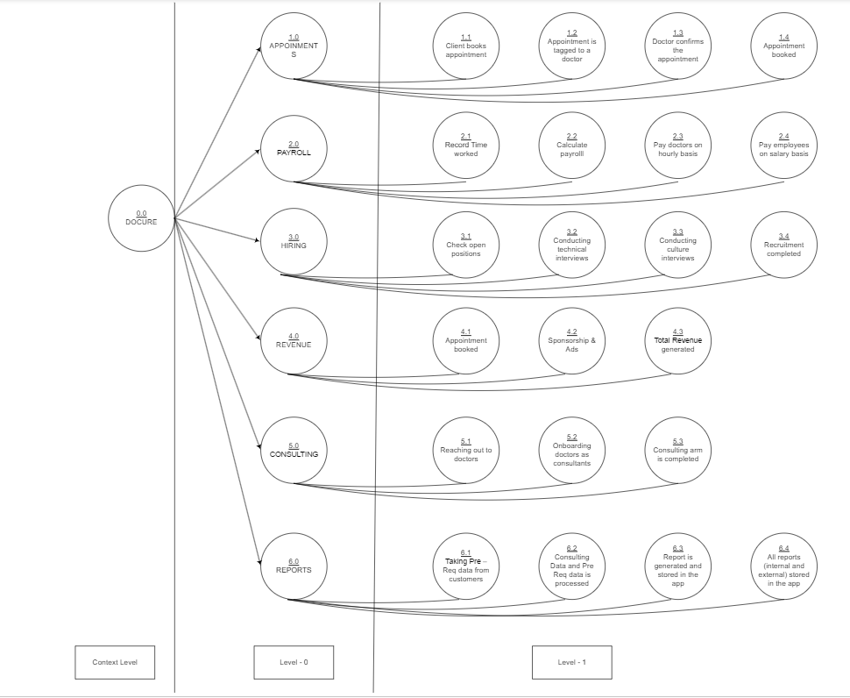

The provided diagram illustrates a hierarchical representation of a system categorized into five distinct levels, each depicting varying levels of task granularity.

**System Levels and Task Breakdown**

**Level 0: Main Tasks**

At the apex of the system architecture lies Level 0, encompassing the core functionalities of the system:

* **Appointment:** Handling client appointment management.
* **Payroll:** Managing time records and remunerations.
* **Revenue:** Addressing revenue generation avenues.
* **Consulting:** Engaging with doctors as consultants.
* **Reports:** Compilation and storage of system-generated reports.

**Level 1: Detailed Task Breakdown**

Level 1 delves deeper into the main tasks outlined in Level 0, breaking them down into finer subtasks:

* **Appointment:** Includes client booking, doctor confirmation, and app-based tagging.
* **Payroll:** Encompasses time recording, payroll calculation, and varied remuneration methods.
* **Revenue:** Involves appointment bookings and sponsorship/advertisement avenues.
* **Consulting:** Extends to doctor engagement and onboarding as consultants.
* **Reports:** Entails data acquisition, processing, and comprehensive storage of generated reports.

**Level 2: Further Task Granularity**

This level specifies additional detailed tasks:

* **Appointment:** Involves patient notification through Doce com and updating appointment statuses in Appaniteni.
* **Payroll:** Encompasses the interviewing process and technical interview completion.
* **Consulting:** Incorporates hiring procedures.

**Level 3 and Level 4: Subsidiary Tasks**

Level 3 and Level 4, while limited in description, pertain to tasks related to checking open positions and mobile app development using App Inventor, respectively.

**Task Dependencies and Contextual Levels**

The diagram adeptly captures task dependencies via directional arrows, elucidating the sequential flow between tasks. For instance, dependencies between the tasks of booking an appointment and confirmation by the doctor indicate task completion prerequisites.

Moreover, the contextual levels assigned to each task signify the depth of information required to execute the respective tasks. A higher context level implies a more comprehensive need for system information to accomplish the task efficiently.

**USE CASE DIAGRAM –**

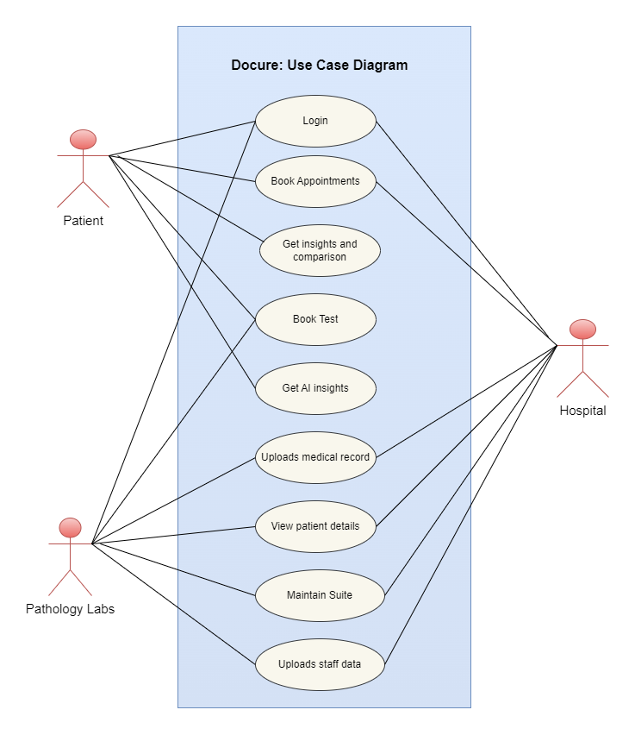

The diagram delineates an overview of an innovative system leveraging Artificial Intelligence (AI) to automate the process of appointment booking within the healthcare domain. The system architecture encompasses four key components:

**1. AI Appointment Scheduler**

At the system's nucleus resides the AI Appointment Scheduler, a pivotal component orchestrating appointment scheduling between patients and doctors. Its functionality involves considering multifaceted parameters such as doctor availability, patient preferences, and urgency factors to optimize appointment allocation.

**2. Patient Portal**

The Patient Portal serves as an interactive web-based platform empowering patients to engage with the system. Its features include facilitating appointment bookings, offering access to appointment history, and enabling the management of personal medical records.

**3. Doctor Dashboard**

The Doctor Dashboard, a web-based interface, caters to doctors' needs within the system. It provides functionalities allowing doctors to view their appointment schedules, manage their patient base, and access pertinent medical records of their patients.

**4. Data Storage**

Critical to the system's functionality is the Data Storage component, responsible for housing and managing diverse data sets encompassing patient information, doctor details, and appointment records. Typically, this component is structured using a relational database management system (RDBMS).

**System Workflow and Interaction**

The interaction between components is orchestrated in a sequential manner:

1. **Patient Request**: Initiating the process, a patient logs into the Patient Portal to request an appointment booking.
2. **Scheduler Interaction**: The Patient Portal transmits the appointment request to the AI Appointment Scheduler.
3. **AI-driven Scheduling**: Leveraging AI algorithms, the Scheduler optimizes and schedules the appointment based on specified preferences and doctor availability.
4. **Confirmation and Transmission**: Upon scheduling, the appointment details are relayed back to the Patient Portal for confirmation by the patient.
5. **Doctor Engagement**: Upon patient confirmation, the appointment particulars are dispatched to the Doctor Dashboard for the doctor's acknowledgment.

**System Benefits**

The system furnishes several advantages:

* **Workload Reduction:** Automation reduces staff workload, allowing them to focus on other critical tasks.
* **Enhanced Patient Satisfaction:** Offering patients an effortless and convenient approach to appointment bookings.
* **Heightened Efficiency:** AI-driven scheduling potentially minimizes wait times, enhancing operational efficiency.

**Component Detailing**

**AI Appointment Scheduler:**

This pivotal component employs an array of machine learning algorithms to optimize appointment scheduling:

* **Consideration Factors:** Patient preferences, doctor availability, and appointment urgency are key factors influencing scheduling decisions.

**Patient Portal:**

A user-friendly web-based application offering patients functionalities for appointment management and medical records access.

**Doctor Dashboard:**

A dedicated interface for doctors enabling appointment oversight, patient management, and access to patient medical records.

**Data Storage:**

A foundational component housing crucial system data encompassing patient records, doctor information, and appointment details, conventionally managed through an RDBMS.

**System Complexity and Design**

The system amalgamates diverse technologies; however, its structural blueprint is relatively straightforward. The AI Appointment Scheduler stands as the linchpin, orchestrating appointments optimally. The Patient Portal and Doctor Dashboard provide streamlined user interactions, while the Data Storage component ensures secure data management.

The system is still in developmental stages but holds immense potential to revolutionize healthcare appointment booking processes through its AI-driven automation.

This detailed breakdown elucidates the interplay between the system's components, their functionalities, and the overall promise this innovative system holds within the healthcare industry.

**CONCLUSION -**

The development of the Docure healthcare solution prototype marks a pivotal stage in the project's evolutionary journey. At this juncture, the project is laser-focused on several critical objectives, each of which contributes to the realization of its overarching vision. This stage serves as an essential testing ground where the project's core features, user experience, and initial challenges are actively addressed, all of which are pivotal for the project's ultimate success and impact on the healthcare sector.

The Docure project, in its prototype stage, is not just a collection of code and design elements. It is a vision coming to life, a commitment to transforming the way patients interact with healthcare providers. While the road ahead is undoubtedly challenging, the project's resilience and adaptability ensure that it is well-prepared to meet and overcome the obstacles. The insights gained during this prototype journey are not just data points; they are the building blocks of a healthcare solution poised to make a meaningful difference. The project's dedication to refining its features, enhancing the user experience, and addressing challenges reflects a deep commitment to delivering a healthcare solution that stands at the forefront of innovation and user-centric design. It is a journey well begun, with a destination promising a brighter and more streamlined future for healthcare interactions.