QUES NO. 12:-

AIM:- Design a system for cars such that whenever someone walks along its front side red LED starts blinking once every 10ms and if someone walks along its back green LED starts blinking once every 20ms

CIRCUIT DIAGRAM:-

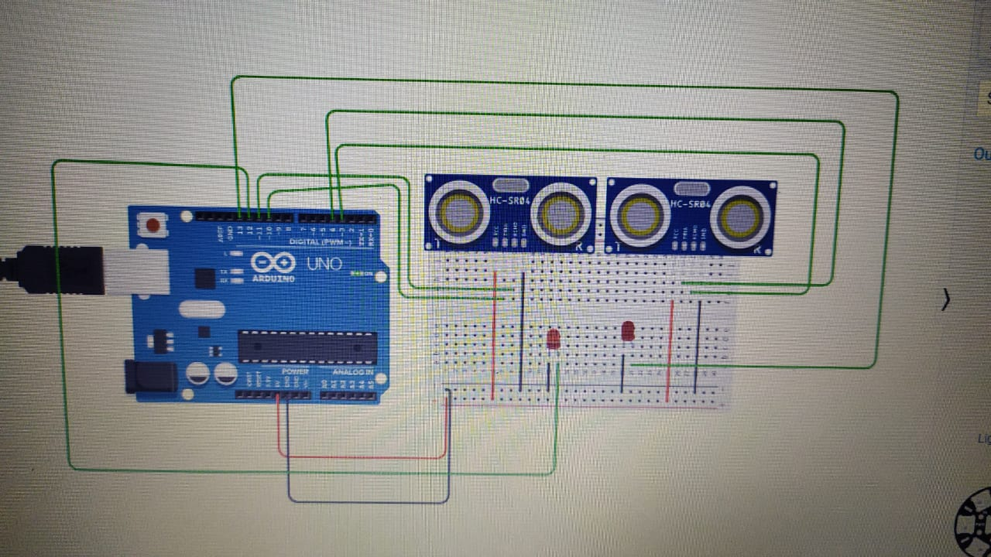

THEORY:- The HC-SR04 Ultrasonic distance sensor consists of two [ultrasonic transducers](https://en.wikipedia.org/wiki/Ultrasonic_transducer). The one acts as a transmitter which converts electrical signal into 40 KHz ultrasonic sound pulses. The receiver listens for the transmitted pulses. If it receives them it produces an output pulse whose width can be used to determine the distance the pulse travelled.

The sensor is small, easy to use in any robotics project and offers excellent non-contact range detection between 2 cm to 400 cm (that’s about an inch to 13 feet) with an accuracy of 3mm. Since it operates on 5 volts, it can be hooked directly to an Arduino or any other 5V logic microcontrollers.

LEARNING OUTCOMES:-

1 To Describe how ultrasonic sensors work.

2. To Compare the ultrasonic sensor to how humans and bats estimate distance.

3. To Program the LEGO MINDSTORMS EV3 robot with the ultrasonic sensor.

4. To Provide a basic explanation of how sensors are integrated into robots via careful programming

PRECAUTIONS:-

1.Do not use a voltage in excess of the operation voltage range.  
Appying a voltage in excess of the operation voltage range, or applying AC power (100 V AC or greater) to a DC power model sensor may result in explosion or fire.

2.Do not short-circuit the load. Explosion or fire may result.

3.Do not reverse the power supply polarity or otherwise wire incorrectly.  
Explosion or fire may result.

4.Do not use in an environment where there are explosive combustible gases.