LAB-4

A lab Submitted

in Partial Fulfilment of the Requirements

for the Degree of

# Bachelor of Technology

/

# BTech (CSE)

As part of **“JAVA PROGRAMMING ”** course

By

Sarthak Jindal

To

**Dr. Arpit Bhardwaj**



SCHOOL OF ENGINEERING AND TECHNOLOGY

BML MUNJAL UNIVERSITY GURGAON

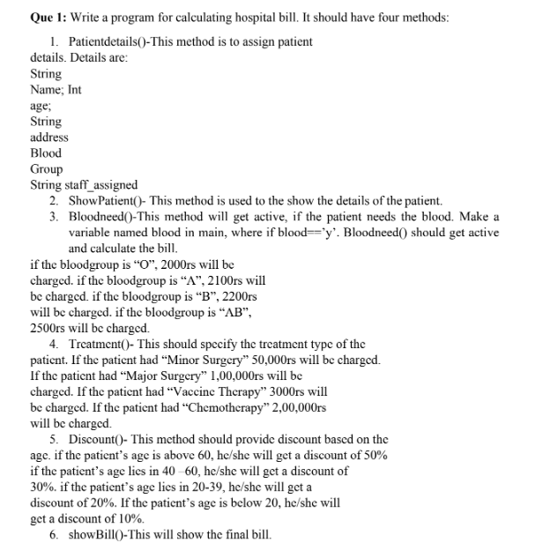

*import* java.util.Objects;  
*import* java.util.Scanner;  
  
*class* hospitaldata{  
 String name,address,Blood_group,staff_assigned;  
 *int* age;  
 *double* blood_charge=0.0;  
 String type;  
  
 *void* Pateintdetails(String name,String address,String blood,String staff,*int* age){  
 System.***out***.println("\nPatient Details");  
 *this*.name=name;  
 *this*.age=age;  
 *this*.address=address;  
 *this*.Blood_group=blood;  
 *this*.staff_assigned=staff;  
  
  
 }  
 *void* showpatient(){  
 System.***out***.println("Patient name- "+ *this*.name);  
 System.***out***.println("Age - "+ *this*.age);  
 System.***out***.println("Blood group- "+ *this*.Blood_group);  
 System.***out***.println("Address of Patient- "+ *this*.address);  
 System.***out***.println("Staff Assigned- "+ *this*.staff_assigned);  
 }  
  
 *void* Bloodneed(String Blood_group){  
 *if*(Objects.*equals*(Blood_group, "O")){  
  
 blood_charge+=2000;  
  
 }  
 *else if*(Objects.*equals*(Blood_group, "A")){  
  
 blood_charge+=2100;  
  
  
 }  
 *else if*(Objects.*equals*(Blood_group, "B")){  
 System.***out***.print("The charge for the blood group is Rs.");  
 blood_charge+=2200;  
  
 }  
 *else if*(Objects.*equals*(Blood_group, "AB")){  
  
 blood_charge+=2500;  
  
 }  
 *else*{  
 System.***out***.println("The blood group is not avilable");  
 }  
  
 }  
 *void* Treatment(String type){  
 *if*(Objects.*equals*(type,"Minor Surgery")){  
 blood_charge+=50000;  
 }  
 *else if*(Objects.*equals*(type,"Major Surgery")){  
 blood_charge+=100000;  
 }  
 *else if*(Objects.*equals*(type,"Vaccine Therapy")){  
 blood_charge+=300;  
 }  
 *else if*(Objects.*equals*(type,"Chemotherapy")){  
 blood_charge+=200000;  
 }  
  
 }  
 *void* Discount(*int* age){  
 *if*(age>60){  
 blood_charge=blood_charge-((50*blood_charge)/100);  
 }  
 *else if*(age>=40 && age <=60){  
 blood_charge=blood_charge-((30*blood_charge)/100);  
  
 }  
 *else if*(age>=20 && age <=39){  
 blood_charge=blood_charge-((20*blood_charge)/100);  
  
 }  
 *else if*(age<20){  
 blood_charge=blood_charge-((10*blood_charge)/100);  
  
 }  
  
 }  
 *void* showBill(){  
 System.***out***.println("The total bill is "+blood_charge);  
 }  
  
  
  
  
}  
*public class* hospital {  
 *public static void* main(String[] args) {  
 Scanner sc= *new* Scanner(System.***in***);  
 *char* blood;  
 String treatment;  
 String pname,paddress,pbloodg,staff;  
 *int* page;  
 System.***out***.println("Enter the patient details");  
 System.***out***.print("Name ");  
 pname= sc.next();  
 System.***out***.print("Age ");  
 page=sc.nextInt();  
 System.***out***.print("Address ");  
 paddress= sc.next();  
 System.***out***.print("Blood group ");  
 pbloodg= sc.next();  
 System.***out***.print("Staff Assigned ");  
 staff=sc.next();  
  
  
  
  
 hospitaldata p1=*new* hospitaldata();  
 p1.Pateintdetails(pname,paddress,pbloodg,staff,page);  
 p1.showpatient();  
 System.***out***.println("\nDoes patient has blood requirement-->y for Yes, n- for No");  
 blood=sc.next().charAt(0);  
 *if*(blood=='y'){  
 p1.Bloodneed(pbloodg);  
 }*else*{  
 System.***out***.println("The patient does not need blood");  
 }  
 System.***out***.println("\nEnter the treatment patient required");  
 treatment=sc.next();  
 p1.Treatment(treatment);  
 p1.Discount(page);  
 p1.showBill();  
  
  
 }  
}

**OUTPUT:-**

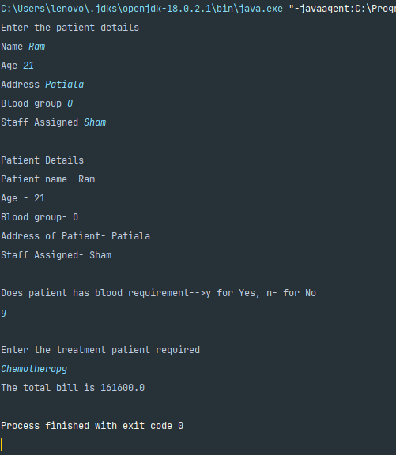

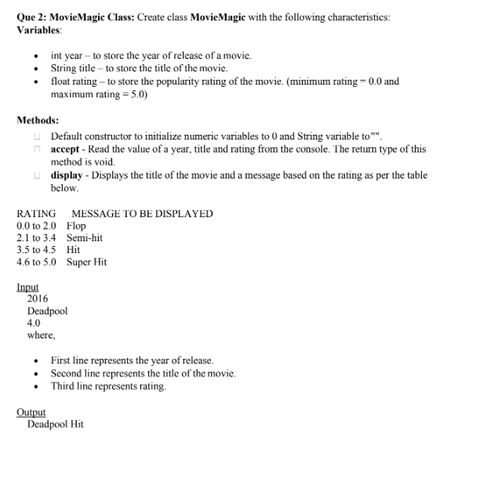

*import* java.util.Scanner;  
  
*public class* MovieMagic  
{  
 *private int* year;  
 *private* String title;  
 *private float* rating;  
  
 *public* MovieMagic() {  
 year = 0;  
 title = "";  
 rating = 0.0f;  
 }  
  
 *public void* accept() {  
 Scanner in = *new* Scanner(System.***in***);  
  
 System.***out***.print("Enter Year of Movie: ");  
 year = in.nextInt();  
 System.***out***.print("Enter Title of Movie: ");  
 title = in.next();  
 System.***out***.print("Enter Rating of Movie: ");  
 rating = in.nextFloat();  
 }  
  
 *public void* display() {  
 String message = "Invalid Rating";  
 *if* (rating <= 2.0f)  
 message = "Flop";  
 *else if* (rating <= 3.4f)  
 message = "Semi-Hit";  
 *else if* (rating <= 4.4f)  
 message = "Hit";  
 *else if* (rating <= 5.0f)  
 message = "Super-Hit";  
  
 System.***out***.print(title+" ");  
 System.***out***.println(message);  
 }  
  
 *public static void* main(String args[]) {  
 MovieMagic obj = *new* MovieMagic();  
 obj.accept();  
 obj.display();  
 }  
}

**output-**

