Java - Exception Handling

An exception is an event, which occurs during the execution of a program, that disrupts the normal flow of the program's instructions.
When an error occurs within a method, the method creates an object and hands it off to the runtime system. The object, called an exception object, contains information about the error, including its type and the state of the program when the error occurred. Creating an exception object and handing it to the runtime system is called throwing an exception.
After a method throws an exception, the runtime system attempts to find something to handle it. The set of possible "somethings" to handle the exception is the ordered list of methods that had been called to get to the method where the error occurred. The list of methods is known as the call stack (see the next figure).
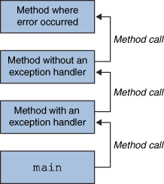
The call stack.
The runtime system searches the call stack for a method that contains a block of code that can handle the exception. This block of code is called an exception handler. The search begins with the method in which the error occurred and proceeds through the call stack in the reverse order in which the methods were called. When an appropriate handler is found, the runtime system passes the exception to the handler. An exception handler is considered appropriate if the type of the exception object thrown matches the type that can be handled by the handler.
The exception handler chosen is said to catch the exception. If the runtime system exhaustively searches all the methods on the call stack without finding an appropriate exception handler, as shown in the next figure, the runtime system (and, consequently, the program) terminates.
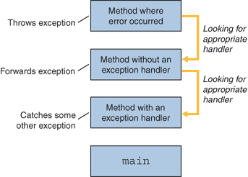
Searching the call stack for the exception handler.
Using exceptions to manage errors has following advantages over traditional error-management techniques:

- Separating Error-Handling Code from "Regular" Code
- Propagating Errors Up the Call Stack
- Grouping and Differentiating Error Types

A program can catch exceptions by using a combination of the try, catch, and finally blocks.
- The try block identifies a block of code in which an exception can occur.
- The catch block identifies a block of code, known as an exception handler, that can handle a particular type of exception.
- The finally block identifies a block of code that is guaranteed to execute, and is the right place to close files, recover resources, and otherwise clean up after the code enclosed in the try block.
Class Hierarchy

Object
Throwable
Error
Exception
RuntimeException
IOException

