Java Database Connectivity (JDBC)
JDBC stands for "Java DataBase Connectivity". It is an API (Application Programming Interface) which consists of a set of Java classes, interfaces and exceptions and a specification to which both JDBC driver vendors and JDBC developers adhere when developing applications.
JDBC is a very popular data access standard. RDBMS (Relational Database Management Systems) or third-party vendors develop drivers which adhere to the JDBC specification. Other developers use these drivers to develop applications which access those databases.
The JDBC API is a Java API that can access any kind of tabular data, especially data stored in a Relational Database.
JDBC helps you to write java applications that manage these three programming activities:
- Connect to a data source, like a database
- Send queries and update statements to the database
- Retrieve and process the results received from the database in answer to your query

JDBC Architecture

The JDBC API supports both two-tier and three-tier processing models for database access.
Two-tier Architecture for Data Access.
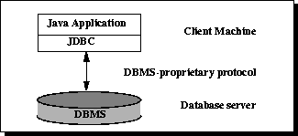
In the two-tier model, a Java application talks directly to the data source. This requires a JDBC driver that can communicate with the particular data source being accessed. A user's commands are delivered to the database or other data source, and the results of those statements are sent back to the user. The data source may be located on another machine to which the user is connected via a network. This is referred to as a client/server configuration, with the user's machine as the client, and the machine housing the data source as the server.
In the three-tier model, commands are sent to a "middle tier" of services, which then sends the commands to the data source. The data source processes the commands and sends the results back to the middle tier, which then sends them to the user. MIS directors find the three-tier model very attractive because the middle tier makes it possible to maintain control over access and the kinds of updates that can be made to corporate data. Another advantage is that it simplifies the deployment of applications. Finally, in many cases, the three-tier architecture can provide performance advantages.
Three-tier Architecture for Data Access.
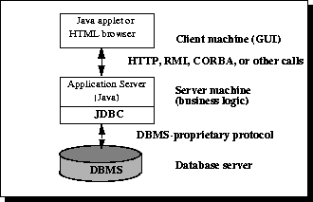
Until recently, the middle tier has often been written in languages such as C or C++, which offer fast performance. However, with the introduction of optimizing compilers that translate Java bytecode into efficient machine-specific code and technologies such as Enterprise JavaBeans, the Java platform is fast becoming the standard platform for middle-tier development. This is a big plus, making it possible to take advantage of Java's robustness, multithreading, and security features.
With enterprises increasingly using the Java programming language for writing server code, the JDBC API is being used more and more in the middle tier of a three-tier architecture. Some of the features that make JDBC a server technology are its support for connection pooling, distributed transactions, and disconnected rowsets. The JDBC API is also what allows access to a data source from a Java middle tier.

Different database systems have surprisingly little in common: just a similar purpose and a mostly compatible query language. Beyond that, every database has its own API that you must learn to write programs that interact with the database. This has meant that writing code capable of interfacing with databases from more than one vendor has been a daunting challenge. Cross-database APIs exist, most notably Microsoft's ODBC API, but these tend to find themselves, at best, limited to a particular platform.
JDBC is Sun's attempt to create a platform-neutral interface between databases and Java. With JDBC, you can count on a standard set of database access features and (usually) a particular subset of SQL, SQL-92. The JDBC API defines a set of interfaces that encapsulate major database functionality, including running queries, processing results, and determining configuration information. A database vendor or third-party developer writes a JDBC driver, which is a set of classes that implements these interfaces for a particular database system. An application can use a number of drivers interchangeably. Following figure shows how an application uses JDBC to interact with one or more databases without knowing about the underlying driver implementations.

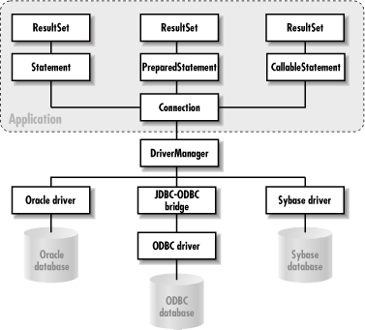

JDBC Components
JDBC includes four components:
- The JDBC API: -
The JDBC API provides programmatic access to relational data from the Java programming language. Using the JDBC API, applications can execute SQL statements, retrieve results, and propagate changes back to an underlying data source. The JDBC API can also interact with multiple data sources in a distributed, heterogeneous environment.
The JDBC API is part of the Java platform, which includes the Java Standard Edition (Java SE ) and the Java Enterprise Edition (Java EE). The JDBC 4.0 API is divided into two packages: java.sql and javax.sql. Both packages are included in the Java SE and Java EE platforms.

- JDBC Driver Manager: -
The JDBC DriverManager class defines objects which can connect Java applications to a JDBC driver. DriverManager has traditionally been the backbone of the JDBC architecture. It is quite small and simple.
The Standard Extension packages javax.naming and javax.sql let you use a DataSource object registered with a Java Naming and Directory Interface (JNDI) naming service to establish a connection with a data source. You can use either connecting mechanism, but using a DataSource object is recommended whenever possible.

- JDBC Test Suite : -
The JDBC driver test suite helps you to determine that JDBC drivers will run your program. These tests are not comprehensive or exhaustive, but they do exercise many of the important features in the JDBC API.

- JDBC-ODBC Bridge: -
The Java Software bridge provides JDBC access via ODBC drivers. Note that you need to load ODBC binary code onto each client machine that uses this driver. As a result, the ODBC driver is most appropriate on a corporate network where client installations are not a major problem, or for application server code written in Java in a three-tier architecture.

JDBC Drivers
JDBC drivers are available for most database platforms, from a number of vendors and in a number of different flavors. There are four categories of drivers:
Type 1 (JDBC-ODBC bridge drivers )
Type 1 drivers use a bridge technology to connect a Java client to an ODBC database system. The JDBC-ODBC Bridge from Sun and InterSolv is the only existing example of a Type 1 driver. Type 1 drivers require some sort of non-Java software to be installed on the machine rjunning your code, and they are implemented using native code.
Type 2 (Native-API partly Java drivers)

Type 2 drivers use a native code library to access a database, wrapping a thin layer of Java around the native library. For example, with Oracle databases, the native access might be through the Oracle Call Interface (OCI) libraries that were originally designed for C/C++ programmers. Type 2 drivers are implemented with native code, so they may perform better than all-Java drivers, but they also add an element of risk, as a defect in the native code can crash the Java Virtual Machine.
Type 3 (Net-protocol All-Java drivers)

Type 3 drivers define a generic network protocol that interfaces with a piece of custom middleware. The middleware component might use any other type of driver to provide the actual database access. BEA's WebLogic product line (formerly known as WebLogic Tengah and before that as jdbcKona/T3) is an example. These drivers are especially useful for applet deployment, since the actual JDBC classes can be written entirely in Java and downloaded by the client on the fly.
Type 4 (Native-protocol All-Java drivers)

Type 4 drivers are written entirely in Java. They understand database-specific networking protocols and can access the database directly without any additional software. These drivers are also well suited for applet programming, provided that the Java security manager allows TCP/IP connections to the database server.

Following are the basic steps to create JDBC Application: -
1. Load the Drivers
2. Define the connection URL
3. Establish the connection
4. Create a statement
5. Execute a query
6. Process the results
7. Close the connection

