Java - Networking

Networking Basics

Computers running on the Internet communicate to each other using either the Transmission Control Protocol (TCP) or the User Datagram Protocol (UDP), as this diagram illustrates:
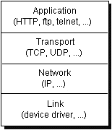

When you write Java programs that communicate over the network, you are programming at the application layer. Typically, you don't need to concern yourself with the TCP and UDP layers. Instead, you can use the classes in the java.net package. These classes provide system-independent network communication. However, to decide which Java classes your programs should use, you do need to understand how TCP and UDP differ.

TCP
TCP provides a point-to-point channel for applications that require reliable communications. The Hypertext Transfer Protocol (HTTP), File Transfer Protocol (FTP), and Telnet are all examples of applications that require a reliable communication channel. The order in which the data is sent and received over the network is critical to the success of these applications. When HTTP is used to read from a URL, the data must be received in the order in which it was sent. Otherwise, you end up with a jumbled HTML file, a corrupt zip file, or some other invalid information.

Definition:

TCP (Transmission Control Protocol) is a connection-based protocol that provides a reliable flow of data between two computers.

UDP
The UDP protocol provides for communication that is not guaranteed between two applications on the network. UDP is not connection-based like TCP. Rather, it sends independent packets of data, called datagrams, from one application to another. Sending datagrams is much like sending a letter through the postal service: The order of delivery is not important and is not guaranteed, and each message is independent of any other.
Note:
Many firewalls and routers have been configured not to allow UDP packets. If you're having trouble connecting to a service outside your firewall, or if clients are having trouble connecting to your service, ask your system administrator if UDP is permitted.

Understanding Ports
Generally speaking, a computer has a single physical connection to the network. All data destined for a particular computer arrives through that connection. However, the data may be intended for different applications running on the computer. So how does the computer know to which application to forward the data? Through the use of ports.
Data transmitted over the Internet is accompanied by addressing information that identifies the computer and the port for which it is destined. The computer is identified by its 32-bit IP address, which IP uses to deliver data to the right computer on the network. Ports are identified by a 16-bit number, which TCP and UDP use to deliver the data to the right application.
In connection-based communication such as TCP, a server application binds a socket to a specific port number. This has the effect of registering the server with the system to receive all data destined for that port. A client can then rendezvous with the server at the server's port, as illustrated here:

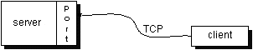

Definition: The TCP and UDP protocols use ports to map incoming data to a particular process running on a computer.
In datagram-based communication such as UDP, the datagram packet contains the port number of its destination and UDP routes the packet to the appropriate application, as illustrated in this figure:
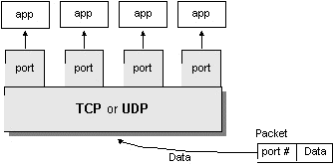
Port numbers range from 0 to 65,535 because ports are represented by 16-bit numbers. The port numbers ranging from 0 - 1023 are restricted; they are reserved for use by well-known services such as HTTP and FTP and other system services. These ports are called well-known ports. Your applications should not attempt to bind to them.
Socket
A socket is one endpoint of a two-way communication link between two programs running on the network. A socket is bound to a port number so that the TCP layer can identify the application that data is destined to be sent.

