Swing
Swing are light weight components which dependent on java API's. So same look and feel on all Operating Systems. All swing components are designed using architecture Model View Controller (MVC).

Model - Storage
View - Presentation
Controller – Event Handling

View
Controller
VDU
Model
Keyboard
Mouse

Swing is a part of the Java Foundation Classes (JFC) library, is an extension of Abstract Window Toolkit (awt). It offers much improved functionality as compare to awt, like new components, expanded component features, better event handling and drag and drop support.

Netscape and sun has jointly produced the original swing set of components as part of the Java Foundation Classes (JFC). Swing and JFC are not the same thing, rather swing is a part of the JFC library. JFC provides the following featues: -

- swing (The large UI package)
- cut & paste (Clipboard support)
- Accessibility features
- The desktop color features
- java 2D

The five APIs of the java Foundation Classes
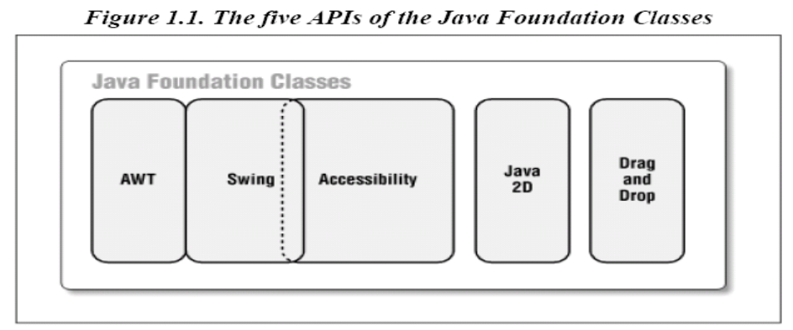
Four new components have been introduced in Swing to deal with the complexities involved in mixing up the heavy weight and the lightweight components in the same container.
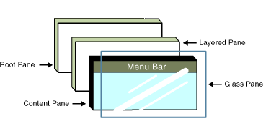

Type of Panes

- RootPane
- Layered Pane
- ContentPane
- Menu Bar
- GlassPane

List of Swing Components

- JButton
- JCheckBox
- JCheckBoxMenuItem
- JColorChooser
- JComboBox
- JDialog
- JFileChooser
- JFormattedTextField
- JFrame
- JLabel
- JLayeredPane
- JList
- JMenu
- JMenuBar
- JMenuItem
- JOptionPane
- JPanel
- JPasswordField
- JToolTip
- JTree
- JPopupMenu
- JPopupMenu.Separator
- JProgressBar
- JRadioButton
- JRadioButtonMenuItem
- JRootPane
- JScrollBar
- JScrollPane
- JSeparator
- JSlider
- JSpinner
- JTabbedPane
- JTable
- JTextArea
- JTextField
- JTextPane
- JToggleButton
- JToolBar
- JToolBar.Separator

Pluggable Look-and-Feels
One of the most exciting aspects of the Swing classes is the ability to dictate the look-and-feel (L&F) of each of the components, even resetting the look-and-feel at runtime. Look-and-feels have become an important issue in GUI development over the past five years. Most users are familiar with the Motif style of user interface, which was common in Windows 3.1 and is still in wide use on Unix platforms. Microsoft has since deviated from that standard with a much more optimized look-and-feel in their Windows 95/98 and NT 4.0 operating systems. In addition, the Macintosh computer system has its own branded look-and-feel, which most Apple users feel comfortable with. Swing is capable of emulating several look-and-feels, and currently includes support for Windows 98 and Unix Motif.[3] This comes in handy when a user would like to work in the L&F environment which he or she is most comfortable with. In addition, Swing can allow the user to switch look-and feels at runtime without having to close the current application. This way, a user can experiment to see which L&F is best for them with instantaneous feedback. And, if you're feeling really ambitious as a developer (perhaps a game developer), you can create your own look-and-feel for each one of the Swing components!

Swing comes with a default look-and-feel called "Metal," which was developed while the Swing classes were in the beta-release phase. This look-and-feel combines some of the best graphical elements in today's L&Fs and even adds a few surprises of its own. You can use many look and feel with Swing, including the new Metal look-and-feel. All Swing L&Fs are built from a set of base classes called the Basic L&F. However, though we may refer to the Basic L&F from time to time, you can't use it on its own.
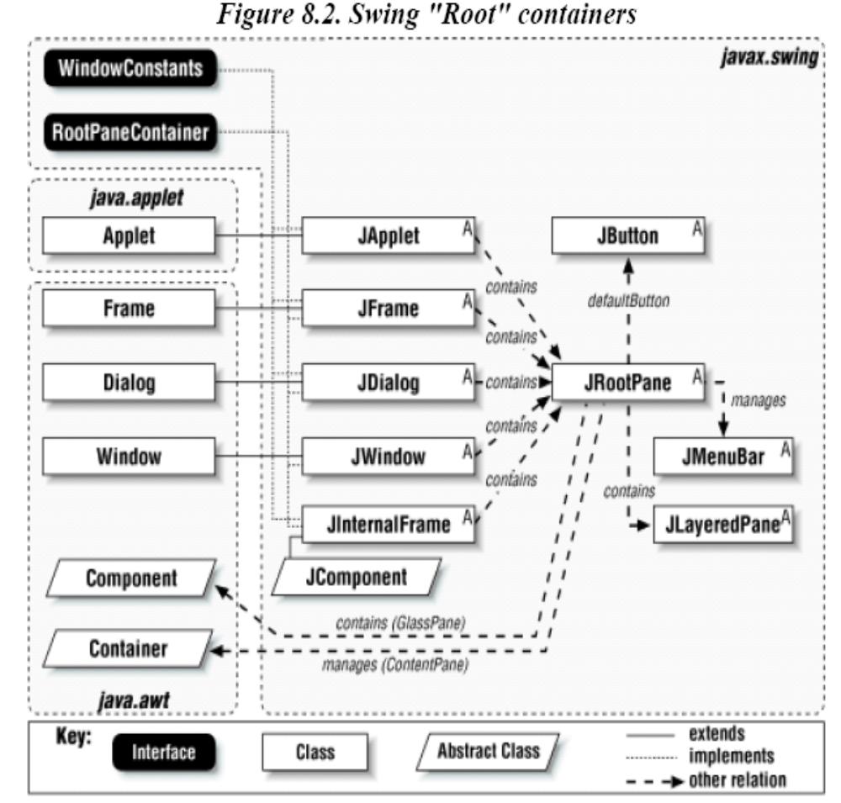
Top level containers
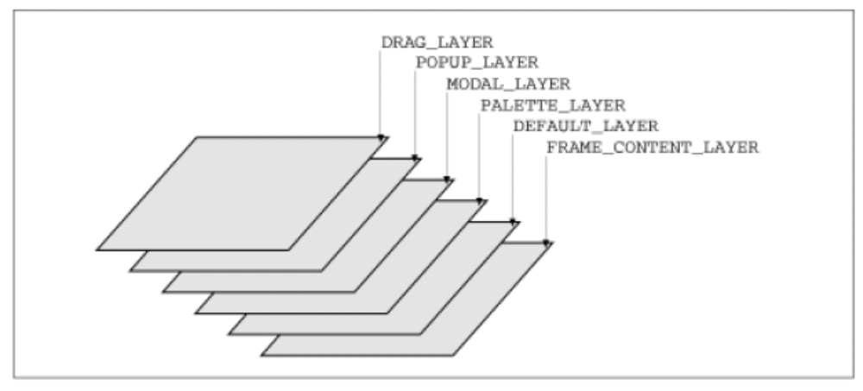
Predefined Layers
Layered Pane Constants
