1: INTRODUCTION

A quick glance at an image is sufficient for a human to point out and describe an immense amount of details about the visual scene. However, this incredible ability of humans has proven to be a difficult task for our machine. The majority of available work in visual recognition has focused on labeling images with a fixed set of visual categories and great progress has been achieved in these endeavors. In this project , we strive to take a step towards the goal of generating dense descriptions of images.

1.1 Our Model



The ultimate goal of our model is to generate captions of image regions. During training, the input to our model is a set of images and their corresponding sentence descriptions .We first present a model that aligns sentence snippets to the visual regions that they describe through a multimodal embedding. We then treat these correspondences as training data for a second, multi-modal Recurrent Neural Network model that learns to generate the snippets.

1.2 Neural Network

An Artificial Neural Network (ANN) is an information processing paradigm that is inspired by the way biological nervous systems, such as the brain, process information. The key element of this paradigm is the novel structure of the information processing system. It is composed of a large number of highly interconnected processing elements (neurones) working in unison to solve specific problems. ANNs, like people, learn by example. An ANN is configured for a specific application, such as pattern recognition or data classification, through a learning process. Learning in biological systems involves adjustments to the synaptic connections that exist between the neurones. This is true of ANNs as well.

1.2.1 CNN

Convolutional Neural Networks (CNN) are made up of neurons that have learnable weights and biases. Each neuron receives some inputs, performs a dot product and optionally follows it with a non-linearity. The whole network still expresses a single differentiable score function: from the raw image pixels on one end to class scores at the other. And they still have a loss on the last (fully-connected) layer and all the tips/tricks we developed for learning regular Neural Networks still apply.

- Convo

The Conv layer is the core building block of a Convolutional Network that does most of the computational heavy lifting. CONV layer will compute the output of neurons that are connected to local regions in the input, each computing a dot product between their weights and a small region they are connected to in the input volume. This may result in volume such as [32x32x12] if we decided to use 12 filters.
- Relu

RELU layer will apply an elementwise activation function, such as the max(0,x)max(0,x) thresholding at zero. This leaves the size of the volume unchanged ([32x32x12]).
- Pooling

POOL layer will perform a downsampling operation along the spatial dimensions (width, height), resulting in volume such as [16x16x12].

1.2.2 RNN

The idea behind Recurrent Neural Network (RNNs) is to make use of sequential information. In a traditional neural network we assume that all inputs (and outputs) are independent of each other. But for many tasks that’s a very bad idea. If you want to predict the next word in a sentence you better know which words came before it. RNNs are called recurrent because they perform the same task for every element of a sequence, with the output being depended on the previous computations. Another way to think about RNNs is that they have a “memory” which captures information about what has been calculated so far. In theory RNNs can make use of information in arbitrarily long sequences, but in practice they are limited to looking back only a few steps (more on this later)

1.2.3 Loss Function

Sometimes referred to as the cost function or error function (not to be confused with the Gauss error function), the loss function is a function that maps values of one or more variables onto a real number intuitively representing some "cost" associated with those values. For backpropagation, the loss function calculates the difference between the network output and its expected output, after a case propagates through the network.

1.2.4 Forward

The feedforward neural network was the first and simplest type of artificial neural network devised. In this network, the information moves in only one direction, forward, from the input nodes, through the hidden nodes and to the output nodes. There are no cycles or loops in the network

1.2.5 Back Propagation

Backpropagation is a method used in artificial neural networks to calculate the error contribution of each neuron after a batch of data (in image recognition, multiple images) is processed. It is a special case of an older and more general technique called automatic differentiation. In the context of learning, backpropagation is commonly used by the gradient descent optimization algorithm to adjust the weight of neurons by calculating the gradient of the loss function. This technique is also sometimes called backward propagation of errors, because the error is calculated at the output and distributed back through the network layers.

1.2.6 Optimation

optim is a quite general optimizer, for minimizing any function with respect to a set of parameters. In our case, our function will be the loss of our network, given an input, and a set of weights. The goal of training a neural net is to optimize the weights to give the lowest loss over our validation set, by using the training set as a proxy. So, we are going to use optim to minimize the loss with respect to the weights, over our training set.

.

2: SYSTEM REQUIREMENTS AND ANALYSIS

The system requirement can be classified into two categories:

- Hardware Requirement

- Software Requirement

2.1 Hardware Requirement:

System Requirements at developer’s side:

Windows OS
- Microsoft Windows 7/8/10 (32-bit or 64-bit)
- 4 GB RAM minimum, 8 GB RAM recommended
- 5 GB of available disk space minimum, 10 GB Recommended
- 1280 x 800 minimum screen resolution
- Intel processor with support for Intel VT-x, Intel EM64T (Intel 64), and Execute Disable (XD) Bit functionality, AMD processor with support for AMD Virtualization (AMD-V), or NVDIA GEFORCE processor

Mac OS
- Mac OS X 10.8.5 or higher, up to 10.11.4 (El Capitan)
- 2 GB RAM minimum, 8 GB RAM recommended
- 1280 x 800 minimum screen resolution
- 5 GB of available disk space minimum, 10 GB Recommended
- Intel processor with support for Intel VT-x, Intel EM64T (Intel 64), and Execute Disable (XD) Bit functionality, AMD processor with support for AMD Virtualization (AMD-V), or NVDIA GEFORCE processor

Linux OS
- GNOME or KDE desktop: Tested on Ubuntu 12.04, Precise Pangolin (64-bit distribution capable of running 32-bit applications)
- 64-bit distribution capable of running 32-bit applications
- GNU C Library (glibc) 2.11 or later
- 4 GB RAM minimum, 8 GB RAM recommended
- 5 GB of available disk space minimum, 10 GB Recommended
- 1280 x 800 minimum screen resolution
- Intel processor with support for Intel VT-x, Intel EM64T (Intel 64), and Execute Disable (XD) Bit functionality, AMD processor with support for AMD Virtualization (AMD-V), or NVDIA GEFORCE processor

2.2 Software Requirement:

- Lua

Lua is a powerful, fast, lightweight and embeddable programming language. It is used by many frameworks, games and other applications. While it can be used by itself, it has been designed to be easy to embed in another application. It is implemented in ANSI C, a subset of the C programming language that is very portable, which means it can run on many systems and many devices where most other scripting languages would not be able to run.

- Torch
Torch is a scientific computing framework with wide support for machine learning algorithms that puts GPUs first. It is easy to use and efficient, thanks to an easy and fast scripting language, LuaJIT, and an underlying C/CUDA implementation.
- Luarocks

LuaRocks is a package manager for the Lua programming language that provides a standard format for distributing Lua modules, a tool designed to easily manage the installation of rocks, and a server for distributing them.
Some packages which are installed from Luarocks.
- Image – It is used for image processing
- Nn – Allows you to work with different architectures and stacks different nets together
- Nngraph – Provides graphs tools for “NN” library
- Cutorch – Provides GPU support
- Cunn -Provides additional modules over the nn library, mainly converting those nn modules to GPU CUDA versions transparently

- CUDA

CUDA is a parallel computing platform and application programming interface (API) model created by Nvidia . It allows software developers and software engineers to use a CUDA-enabled graphics processing unit (GPU) for general purpose processing – an approach termed GPGPU (General-Purpose computing on Graphics Processing Units). The CUDA platform is a software layer that gives direct access to the GPU's virtual instruction set and parallel computational elements, for the execution of compute kernels

- cuDNN
The NVIDIA CUDA Deep Neural Network library (cuDNN) is a GPU-accelerated library of primitives for deep neural networks. cuDNN provides highly tuned implementations for standard routines such as forward and backward convolution, pooling, normalization, and activation layers. cuDNN is part of the NVIDIA Deep Learning SDK.

3: System Design and Working

Artificial Captioner is a model that generates natural language descriptions of images .It’s approach leverages datasets of images and their sentence descriptions to learn about the intermodal correspondences between language and visual data. Our alignment model is based on a novel combination of Convolutional Neural Networks over image regions and identify the features of images using convo layer and pooling layer and then Recurrent Neural Networks is used over sentences.

3.1 User Input

The input is a dataset of images and 5 sentence descriptions . The dataset of images can be downloaded from MSCOCO dataset. The dataset of images there will be train and val folders both containing images . After getting Dataset we will download corresponding annotations of images using ipython notebook and will merge them and will create a JSON file in which there will be 5 sentence for each images with image address and image ID. The JSON file created using ipython notebook will be in RAW format so we will process it before training to remove any bad words , corrupted images ,etc . After processing Raw JSON file we will get a processed JSON file and a H5 file in which is designed to store a large number of data . And then we will feed these both file for training .

3.2 Training Stage

In the training stage, the images are fed as input to RNN and the RNN is asked to predict the words of the sentence, conditioned on the current word and previous context as mediated by the hidden layers of the neural network. In this stage, the parameters of the networks are trained with backpropagation.
It will take JSON file and H5 file which are processed as input and then will perform Forward Pass and will calculate Loss Function using this formula.

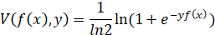

A feed-forward neural network can be thought of as the composition of number of functions
f(x)=fL(…f2(f1(x;w1);w2)…),wL).f(x)=fL(…f2(f1(x;w1);w2)…),wL).

Each function flfl takes as input a datum xlxl and a parameter vector wlwl and produces as output a datum xl+1xl+1. While the type and sequence of functions is usually handcrafted, the parameters w=(w1,…,wL)w=(w1,…,wL) are learned from data in order to solve a target problem, for example classifying images or sounds.
In a convolutional neural network data and functions have additional structure. The data x1,
…,xnx1,…,xn are images, sounds, or more in general maps from a lattice¹ to one or more real numbers. In particular, since the rest of the practical will focus on computer vision applications, data will be 2D arrays of pixels. Formally, each xixi will be a M×N×KM×N×K real array of M×NM×N pixels and KK channels per pixel. Hence the first two dimensions of the array span space, while the last one spans channels. Note that only the input x=x1x=x1of the network is an actual image, while the remaining data are intermediate feature maps.
There are several other important operators in a CNN. One of them is pooling. A pooling operator operates on individual feature channels, coalescing nearby feature values into one by the application of a suitable operator. Common choices include max-pooling (using the max operator) or sum-pooling (using summation). For example, max-pooling is defined as:
yijk=max{yi′j′k:i≤i′<i+p,j≤j′<j+p}

3.3 Prediction Stage
In the prediction stage, a set of images is passed to RNN and the RNN generates the sentence one word at a time. It will take Folder’s address which will be containing images and Model’s address which is being trained on Convolution neural networks
Multimodal RNN outperforms retrieval baseline. Our first comparison is to a nearest neighbor retrieval baseline Here, we annotate each test image with a sentence of the most similar training set image as determined by L2 norm over VGGNet fc7 features. Table 2 shows that the Multimodal RNN confidently outperforms this retrieval method. Hence, even with 113,000 train set images in MSCOCO the retrieval approach is inadequate. Additionally, the RNN takes only a fraction of a second to evaluate per image.
VGGnet- It usually refers to a deep convolutional network for object recognition developed and trained by Oxford's renowned Visual Geometry Group (VGG), which achieved very good performance on the ImageNet dataset.
It is quite famous because not only it works well, but the Oxford team have made the structure and the weights of the trained network freely available online.

4: Result

Artificial Captioner was successfully built and tested for a number of test cases helping in achieving the goal as set during the start of this project.

4.1 Conclusion


The application satisfies all the provided specification.

4.2 Future Scope

As Machine Learning is growing day by day we can look forward to growth of our project.
- War Sniffing – With the help of our model and nanotechnology we can create a small robot which can help in War and Terrorist attacks types of event as we can track them and can learn about their strategies
- In medical field - Images can provided either by a patient or a doctor of visible symptoms of a disease and get a description of the disease.
- A device can be made for blind people, let them experience what is happening in surroundings.

4.3 Summary

This project aims at predicting captions for any image which is being given for input.

Artificial Captioner provides a model that generates natural language descriptions of image regions based on weak labels in form of a dataset of images and sentences, and with very few hard coded assumption.

SYSTEM DESIGN

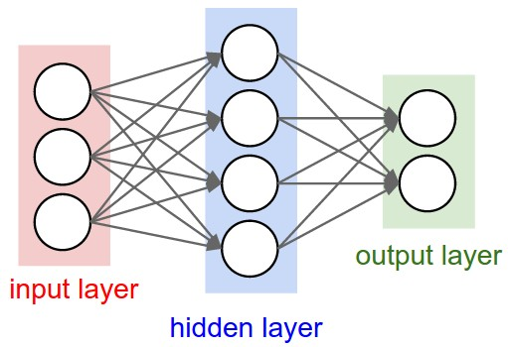

Fig 3.1

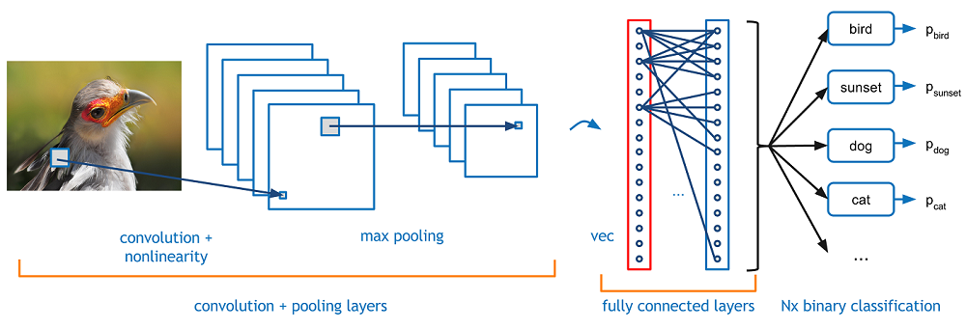

Fig 3.2

Data Flow Diagram

OUR MODEL

AFTER OPTIMISING LOSS FUNCTION
LOSS FUNCTION

NEURAL NETWORK

TRAINING

JSON FILE H5 FILE

PREPROCESSING

JSON RAW FILE

+

IMAGES DATASET ANNOTATIONS

Fig 3.3

References

- https://www.lua.org/docs.html
- http://torch.ch/docs/developer-docs.html
- https://www.coursera.org/learn/machine-learning
- http://cocodataset.org/
- https://www.wikipedia.com
- http://www.robots.ox.ac.uk/~vgg/
- http://cs231n.github.io/optimization-2/
- http://cs231n.github.io/convolutional-networks/#pool
- http://www.wildml.com/2015/09/recurrent-neural-networks-tutorial-part-1-introduction-to-rnns/
- http://machinelearninguru.com/deep_learning/data_preparation/hdf5/hdf5.html

SCREENSHOT 1

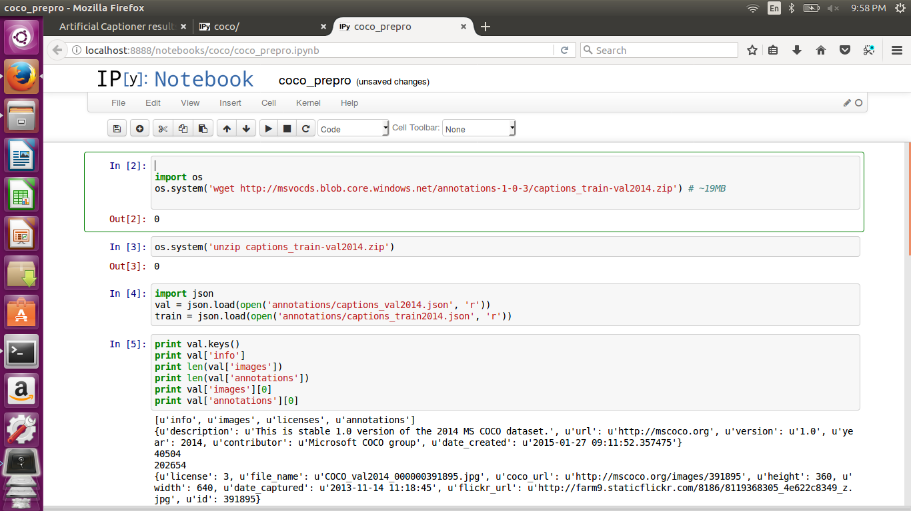

SCREENSHOT 2

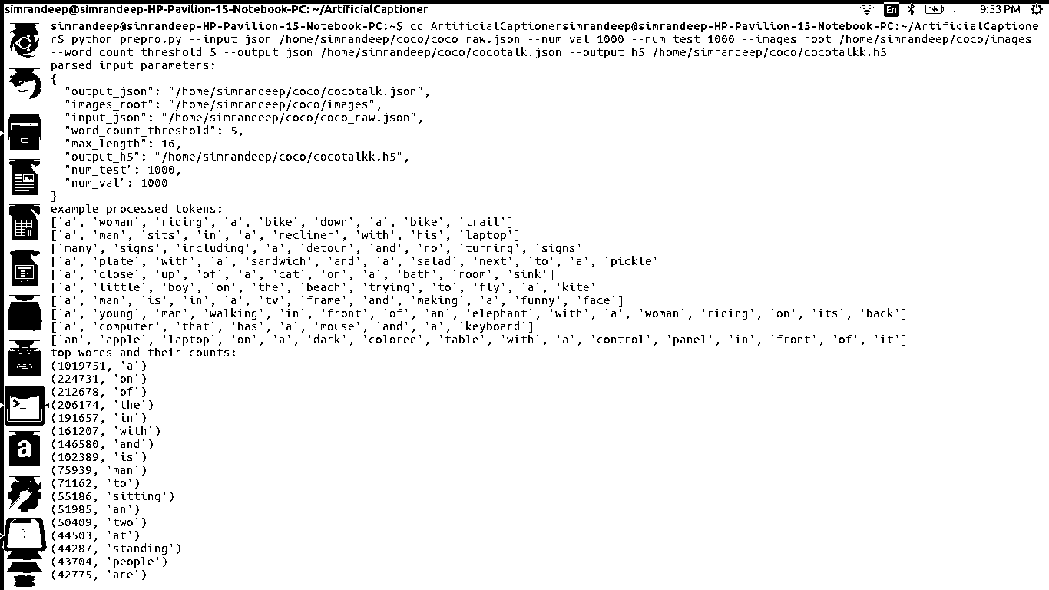

SCREENSHOT 3

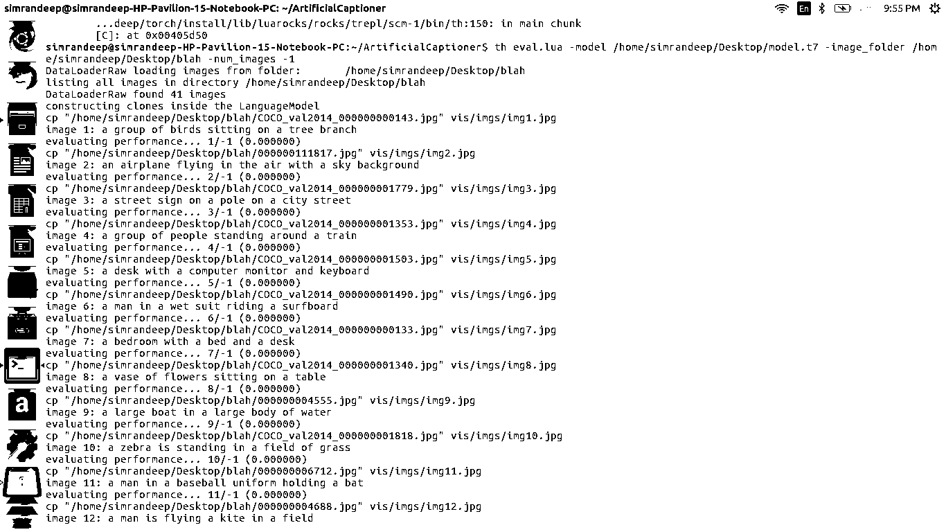

SCREENSHOT 4

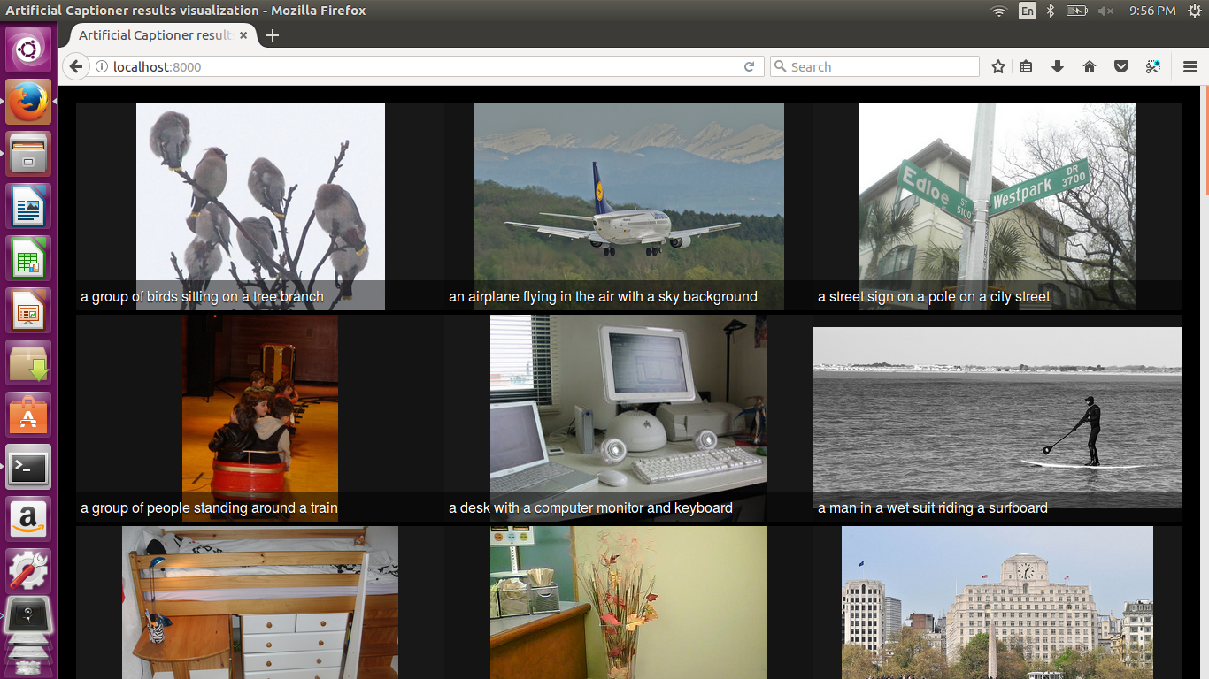

SCREENSHOT 5

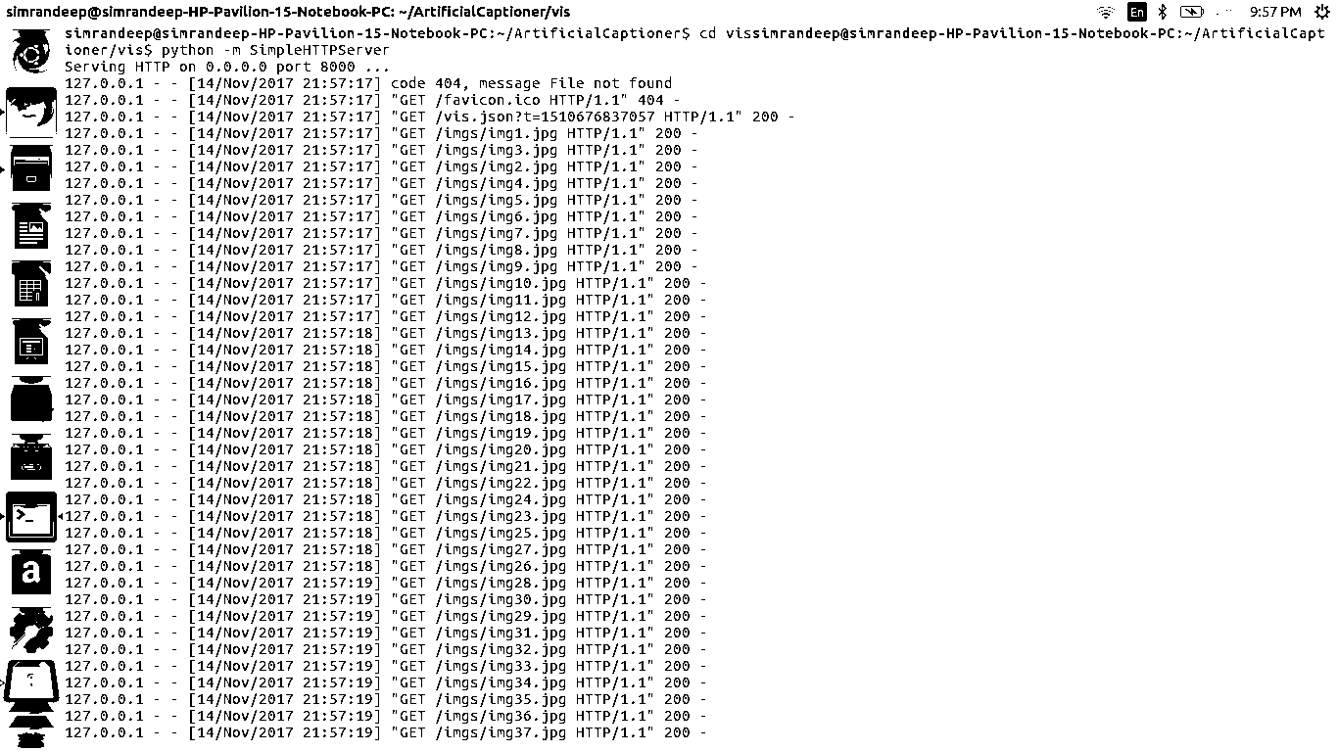

SOURCE CODE

require 'torch'
require 'nn'
require 'nngraph'

require 'loadcaffe'

local utils = require 'misc.utils'
require 'misc.DataLoader'
require 'misc.LanguageModel'
local net_utils = require 'misc.net_utils'
require 'misc.optim_updates'

cmd = torch.CmdLine()
cmd:text()
cmd:text('Train an Image Captioning model')
cmd:text()
cmd:text('Options')

cmd:option('-input_h5','coco/data.h5','path to the h5file containing the preprocessed dataset')
cmd:option('-input_json','coco/data.json','path to the json file containing additional info and vocab')
cmd:option('-cnn_proto','model/VGG_ILSVRC_16_layers_deploy.prototxt','path to CNN prototxt file in Caffe format. Note this MUST be a VGGNet-16 right now.')
cmd:option('-cnn_model','model/VGG_ILSVRC_16_layers.caffemodel','path to CNN model file containing the weights, Caffe format. Note this MUST be a VGGNet-16 right now.')
cmd:option('-start_from', '', 'path to a model checkpoint to initialize model weights from. Empty = don\'t')

cmd:option('-rnn_size',512,'size of the rnn in number of hidden nodes in each layer')
cmd:option('-input_encoding_size',512,'the encoding size of each token in the vocabulary, and the image.')

cmd:option('-max_iters', -1, 'max number of iterations to run for (-1 = run forever)')
cmd:option('-batch_size',16,'what is the batch size in number of images per batch? (there will be x seq_per_img sentences)')
cmd:option('-grad_clip',0.1,'clip gradients at this value (note should be lower than usual 5 because we normalize grads by both batch and seq_length)')
cmd:option('-drop_prob_lm', 0.5, 'strength of dropout in the Language Model RNN')
cmd:option('-finetune_cnn_after', -1, 'After what iteration do we start finetuning the CNN? (-1 = disable; never finetune, 0 = finetune from start)')
cmd:option('-seq_per_img',5,'number of captions to sample for each image during training. Done for efficiency since CNN forward pass is expensive. E.g. coco has 5 sents/image')

cmd:option('-optim','adam','what update to use? rmsprop|sgd|sgdmom|adagrad|adam')
cmd:option('-learning_rate',4e-4,'learning rate')
cmd:option('-learning_rate_decay_start', -1, 'at what iteration to start decaying learning rate? (-1 = dont)')
cmd:option('-learning_rate_decay_every', 50000, 'every how many iterations thereafter to drop LR by half?')
cmd:option('-optim_alpha',0.8,'alpha for adagrad/rmsprop/momentum/adam')
cmd:option('-optim_beta',0.999,'beta used for adam')
cmd:option('-optim_epsilon',1e-8,'epsilon that goes into denominator for smoothing')
cmd:option('-cnn_optim','adam','optimization to use for CNN')
cmd:option('-cnn_optim_alpha',0.8,'alpha for momentum of CNN')
cmd:option('-cnn_optim_beta',0.999,'alpha for momentum of CNN')
cmd:option('-cnn_learning_rate',1e-5,'learning rate for the CNN')
cmd:option('-cnn_weight_decay', 0, 'L2 weight decay just for the CNN')
cmd:option('-val_images_use', 3200, 'how many images to use when periodically evaluating the validation loss? (-1 = all)')
cmd:option('-save_checkpoint_every', 2500, 'how often to save a model checkpoint?')
cmd:option('-checkpoint_path', '', 'folder to save checkpoints into (empty = this folder)')
cmd:option('-language_eval', 0, 'Evaluate language as well (1 = yes, 0 = no)? BLEU/CIDEr/METEOR/ROUGE_L? requires coco-caption code from Github.')
cmd:option('-losses_log_every', 25, 'How often do we snapshot losses, for inclusion in the progress dump? (0 = disable)')
cmd:option('-backend', 'cudnn', 'nn|cudnn')
cmd:option('-id', '', 'an id identifying this run/job. used in cross-val and appended when writing progress files')
cmd:option('-seed', 123, 'random number generator seed to use')
cmd:option('-gpuid', 0, 'which gpu to use. -1 = use CPU')
cmd:text()
local opt = cmd:parse(arg)
torch.manualSeed(opt.seed)
torch.setdefaulttensortype('torch.FloatTensor') -- for CPU

if opt.gpuid >= 0 then
require 'cutorch'
require 'cunn'
if opt.backend == 'cudnn' then require 'cudnn' end
cutorch.manualSeed(opt.seed)
cutorch.setDevice(opt.gpuid + 1) -- note +1 because lua is 1-indexed
end
local loader = DataLoader{h5_file = opt.input_h5, json_file = opt.input_json}
local protos = {}
if string.len(opt.start_from) > 0 then
-- load protos from file
print('initializing weights from ' .. opt.start_from)
local loaded_checkpoint = torch.load(opt.start_from)
protos = loaded_checkpoint.protos
net_utils.unsanitize_gradients(protos.cnn)
local lm_modules = protos.lm:getModulesList()
for k,v in pairs(lm_modules) do net_utils.unsanitize_gradients(v) end
protos.crit = nn.LanguageModelCriterion() -- not in checkpoints, create manually
protos.expander = nn.FeatExpander(opt.seq_per_img) -- not in checkpoints, create manually
else
-- create protos from scratch
-- intialize language model
local lmOpt = {}
lmOpt.vocab_size = loader:getVocabSize()
lmOpt.input_encoding_size = opt.input_encoding_size
lmOpt.rnn_size = opt.rnn_size
lmOpt.num_layers = 1
lmOpt.dropout = opt.drop_prob_lm
lmOpt.seq_length = loader:getSeqLength()
lmOpt.batch_size = opt.batch_size * opt.seq_per_img
protos.lm = nn.LanguageModel(lmOpt)

local cnn_backend = opt.backend
if opt.gpuid == -1 then cnn_backend = 'nn' end
local cnn_raw = loadcaffe.load(opt.cnn_proto, opt.cnn_model, cnn_backend)
protos.cnn = net_utils.build_cnn(cnn_raw, {encoding_size = opt.input_encoding_size, backend = cnn_backend})

protos.expander = nn.FeatExpander(opt.seq_per_img)

protos.crit = nn.LanguageModelCriterion()
end

if opt.gpuid >= 0 then
for k,v in pairs(protos) do v:cuda() end
end

local params, grad_params = protos.lm:getParameters()
local cnn_params, cnn_grad_params = protos.cnn:getParameters()
print('total number of parameters in LM: ', params:nElement())
print('total number of parameters in CNN: ', cnn_params:nElement())
assert(params:nElement() == grad_params:nElement())
assert(cnn_params:nElement() == cnn_grad_params:nElement())

local thin_lm = protos.lm:clone()
thin_lm.core:share(protos.lm.core, 'weight', 'bias')
thin_lm.lookup_table:share(protos.lm.lookup_table, 'weight', 'bias')
local thin_cnn = protos.cnn:clone('weight', 'bias')
net_utils.sanitize_gradients(thin_cnn)
local lm_modules = thin_lm:getModulesList()
for k,v in pairs(lm_modules) do net_utils.sanitize_gradients(v) end

protos.lm:createClones()

collectgarbage()
local function eval_split(split, evalopt)
local verbose = utils.getopt(evalopt, 'verbose', true)
local val_images_use = utils.getopt(evalopt, 'val_images_use', true)

protos.cnn:evaluate()
protos.lm:evaluate()
loader:resetIterator(split)
local n = 0
local loss_sum = 0
local loss_evals = 0
local predictions = {}
local vocab = loader:getVocab()
while true do
local data = loader:getBatch{batch_size = opt.batch_size, split = split, seq_per_img = opt.seq_per_img}
data.images = net_utils.prepro(data.images, false, opt.gpuid >= 0)
n = n + data.images:size(1)

local feats = protos.cnn:forward(data.images)
local expanded_feats = protos.expander:forward(feats)
local logprobs = protos.lm:forward{expanded_feats, data.labels}
local loss = protos.crit:forward(logprobs, data.labels)
loss_sum = loss_sum + loss
loss_evals = loss_evals + 1

local seq = protos.lm:sample(feats)
local sents = net_utils.decode_sequence(vocab, seq)
for k=1,#sents do
local entry = {image_id = data.infos[k].id, caption = sents[k]}
table.insert(predictions, entry)
if verbose then
print(string.format('image %s: %s', entry.image_id, entry.caption))
end
end

local ix0 = data.bounds.it_pos_now
local ix1 = math.min(data.bounds.it_max, val_images_use)
if verbose then
print(string.format('evaluating validation performance... %d/%d (%f)', ix0-1, ix1, loss))
end

if loss_evals % 10 == 0 then collectgarbage() end
if data.bounds.wrapped then break end
if n >= val_images_use then break end
end

local lang_stats
if opt.language_eval == 1 then
lang_stats = net_utils.language_eval(predictions, opt.id)
end

return loss_sum/loss_evals, predictions, lang_stats
end

local iter = 0
local function lossFun()
protos.cnn:training()
protos.lm:training()
grad_params:zero()
if opt.finetune_cnn_after >= 0 and iter >= opt.finetune_cnn_after then
cnn_grad_params:zero()
end
local data = loader:getBatch{batch_size = opt.batch_size, split = 'train', seq_per_img = opt.seq_per_img}
data.images = net_utils.prepro(data.images, true, opt.gpuid >= 0)
local feats = protos.cnn:forward(data.images)

local expanded_feats = protos.expander:forward(feats)

local logprobs = protos.lm:forward{expanded_feats, data.labels}

local loss = protos.crit:forward(logprobs, data.labels)
local dlogprobs = protos.crit:backward(logprobs, data.labels)

local dexpanded_feats, ddummy = unpack(protos.lm:backward({expanded_feats, data.labels}, dlogprobs))

if opt.finetune_cnn_after >= 0 and iter >= opt.finetune_cnn_after then
local dfeats = protos.expander:backward(feats, dexpanded_feats)
local dx = protos.cnn:backward(data.images, dfeats)
end

grad_params:clamp(-opt.grad_clip, opt.grad_clip)

if opt.cnn_weight_decay > 0 then
cnn_grad_params:add(opt.cnn_weight_decay, cnn_params)

cnn_grad_params:clamp(-opt.grad_clip, opt.grad_clip)
end
local losses = { total_loss = loss }
return losses
end

local loss0
local optim_state = {}
local cnn_optim_state = {}
local loss_history = {}
local val_lang_stats_history = {}
local val_loss_history = {}
local best_score
while true do

local losses = lossFun()
if iter % opt.losses_log_every == 0 then loss_history[iter] = losses.total_loss end
print(string.format('iter %d: %f', iter, losses.total_loss))

if (iter % opt.save_checkpoint_every == 0 or iter == opt.max_iters) then

local val_loss, val_predictions, lang_stats = eval_split('val', {val_images_use = opt.val_images_use})
print('validation loss: ', val_loss)
print(lang_stats)
val_loss_history[iter] = val_loss
if lang_stats then
val_lang_stats_history[iter] = lang_stats
end

local checkpoint_path = path.join(opt.checkpoint_path, 'model_id' .. opt.id)

local checkpoint = {}
checkpoint.opt = opt
checkpoint.iter = iter
checkpoint.loss_history = loss_history
checkpoint.val_loss_history = val_loss_history
checkpoint.val_predictions = val_predictions

checkpoint.val_lang_stats_history = val_lang_stats_history

utils.write_json(checkpoint_path .. '.json', checkpoint)
print('wrote json checkpoint to ' .. checkpoint_path .. '.json')

local current_score
if lang_stats then
current_score = lang_stats['CIDEr']
else
current_score = -val_loss
end
if best_score == nil or current_score > best_score then
best_score = current_score
if iter > 0 then

local save_protos = {}
save_protos.lm = thin_lm
save_protos.cnn = thin_cnn
checkpoint.protos = save_protos

checkpoint.vocab = loader:getVocab()
torch.save(checkpoint_path .. '.t7', checkpoint)
print('wrote checkpoint to ' .. checkpoint_path .. '.t7')
end
end
end

local learning_rate = opt.learning_rate
local cnn_learning_rate = opt.cnn_learning_rate
if iter > opt.learning_rate_decay_start and opt.learning_rate_decay_start >= 0 then
local frac = (iter - opt.learning_rate_decay_start) / opt.learning_rate_decay_every
local decay_factor = math.pow(0.5, frac)
learning_rate = learning_rate * decay_factor

cnn_learning_rate = cnn_learning_rate * decay_factor
end

if opt.optim == 'rmsprop' then
rmsprop(params, grad_params, learning_rate, opt.optim_alpha, opt.optim_epsilon, optim_state)
elseif opt.optim == 'adagrad' then
adagrad(params, grad_params, learning_rate, opt.optim_epsilon, optim_state)
elseif opt.optim == 'sgd' then
sgd(params, grad_params, opt.learning_rate)
elseif opt.optim == 'sgdm' then
sgdm(params, grad_params, learning_rate, opt.optim_alpha, optim_state)
elseif opt.optim == 'sgdmom' then
sgdmom(params, grad_params, learning_rate, opt.optim_alpha, optim_state)
elseif opt.optim == 'adam' then
adam(params, grad_params, learning_rate, opt.optim_alpha, opt.optim_beta, opt.optim_epsilon, optim_state)
else
error('bad option opt.optim')
end

if opt.finetune_cnn_after >= 0 and iter >= opt.finetune_cnn_after then
if opt.cnn_optim == 'sgd' then
sgd(cnn_params, cnn_grad_params, cnn_learning_rate)
elseif opt.cnn_optim == 'sgdm' then
sgdm(cnn_params, cnn_grad_params, cnn_learning_rate, opt.cnn_optim_alpha, cnn_optim_state)
elseif opt.cnn_optim == 'adam' then
adam(cnn_params, cnn_grad_params, cnn_learning_rate, opt.cnn_optim_alpha, opt.cnn_optim_beta, opt.optim_epsilon, cnn_optim_state)
else
error('bad option for opt.cnn_optim')
end
end

iter = iter + 1
if iter % 10 == 0 then collectgarbage() end -- good idea to do this once in a while, i think
if loss0 == nil then loss0 = losses.total_loss end
if losses.total_loss > loss0 * 20 then
print('loss seems to be exploding, quitting.')
break
end
if opt.max_iters > 0 and iter >= opt.max_iters then break end -- stopping criterion

end

